

Division of
Special Education/
Early Intervention Services

200 West Baltimore Street
9th Floor
Baltimore, MD 21201

2000200
200200
200200200

Request For Proposal (RFP)

IDEA State Discretionary Grant Proposal
State Fiscal Year (SFY) 2016 for
Institutions of Higher Education (IHE)
and
Non-Local School Systems (Non-LSS)

Deadline for Submission: April 30, 2015

Submit to Cheryl Edwards by email at
Cheryl.Edwards@maryland.gov

Table of Contents
Table of Contents 1
Summary Timetable 2
1.0 Proposal Description 3
2.0 Proposal Format and Submission Requirement 7
3.0 Proposal Abstract 8
4.0 Proposal Narrative 8
4.1 – Extent of Need 8
4.2 – Goals, Objectives and Milestones 8
4.3 – Implementation Plan Strategies, Activities, Roles, Resources 9
4.4 – Professional Learning Plan 9
4.5 – Evaluation and Dissemination 10
5.0 Grant Budget (C-1-25) and Budget Detail 10
6.0 Required Forms, Statements and Audit Report 11
7.0 Grant Management 12
7.1 – Notification of Award 12
7.2 – Fiscal Procedures 12
7.3 – Post Award Changes/Grant Amendments 12
7.4 – Project Closeout, Suspension and Termination 12
7.5 – Record Retention 13
7.6 – Reporting Requirements 13
7.7 – Acknowledgement of Support and Disclaimer 14
APPENDIX A
Proposal Cover Sheet
Proposal Checklist
Proposal Abstract
Proposal Narrative Template (include résumé/CV for key personnel with this section)
Professional Learning Plan Template
Sample Grant Budget and Budget Detail (Templates)
APPENDIX B
W- 9 Form
Assurances
IHE/Non-LSS Certification
General Education Provisions Act
System for Award Management
Certifications Regarding Lobbying, Debarment, Suspension, Other Responsibility Matters, and Drug-Free Workplace
Single Audit
Department of Education General Education Provisions Act (GEPA) Notice
General Education Provisions Act (GEPA) Statement

SFY 2016 IDEA State Discretionary Grants
Institutions of Higher Education and Non-Local School Systems

Summary Timetable
March 10, 2015 | Annual Grants Webinar/Meeting for Project Directors and/or designee(s) and fiscal staff. Meeting location: MD State Department of Education, 200 West Baltimore Street, 9th Floor Conference Room, Baltimore, MD 21201.
March 17, 2015 | Technical Assistance (TA) call - 10:00 a.m. to 11:00 a.m.
April 30, 2015 | Due date for the IHEs and Non-LSSs to submit SFY 2016 proposals to the DSE/EIS.
July 1, 2015 | Start date for SFY 2016 discretionary grants allocated from approvable, timely submissions.
October 31, 2015 | Due date for quarterly DSE/EIS Standardized Invoice #1 if not submitting monthly invoices. (Exception: Expenditures for a one time activity/event are submitted as one final invoice.)
January 31, 2016 | Due date for Interim Progress/Cumulative Variance Report.
February 28, 2016 | Due date for quarterly DSE/EIS Standardized Invoice #2 if not submitting monthly invoices. (Exception: Expenditures for a one time activity/event are submitted as one final invoice.)
June 30, 2016 | Due date for quarterly DSE/EIS Standardized Invoice #3 if not submitting monthly invoices. (Exception: Expenditures for a one time activity/event are submitted as one final invoice.)
August 15, 2016 | Last day for requesting grant amendments for grants ending on  September 30, 2016.
September 30, 2016 | End date for SFY 2016 discretionary grants.
November 30, 2016 | Last day to submit the Final Progress/Cumulative Variance Report and the Non-LSS Final Financial Report for grants ending on September 30, 2016.  Final Invoices, if not submitted by 9/30/2016, must accompany the Final Progress/Cumulative Variance Report and the Non-LSS Final Financial Report and submitted, by or before, no later than November 30, 2016.

1.0 Proposal Description

name of grant: Individuals with Disabilities Education Act (IDEA) Discretionary State Grants

legislative  authority: | The above are federal discretionary funds provided to the State to support capacity building activities and innovation to improve the delivery of services and results for infants, toddlers, children and youth with disabilities and their families under Public Law (PL) 108-446, IDEA 2004 Part B  (34 CFR§300.704(b)(4)(viii)) and Part C (34 CFR§303.8-416).
purpose of Discretionary grants: | Discretionary grants are to be used to address State identified priorities related to narrowing the achievement gap for children and youth with disabilities and their families. The four action imperatives identified by the Maryland State Department of Education, (MSDE) Division of Special Education/Early Intervention Services (DSE/EIS) and its stakeholders are:  - Early childhood service delivery systems must be aligned and all providers must be highly effective and qualified.  - Teacher/service provider training programs need to be designed to prepare all teachers/service providers to teach students with disabilities.  - All students with disabilities must have access to rigorous universally designed instruction, targeted interventions, and appropriate assessments that move students toward college and career readiness.  - Transition service providers need to be knowledgeable and equipped to support students with disabilities in post-secondary completion and employment.  Evidence-based practices, strategic collaboration, family partnerships and data-informed decisions must be included in each identified strategy.
Grant activities: | For State Fiscal Year (SFY) 2016, the IDEA State Discretionary Grant will fund projects with a focus on:  - Non-LSS activities related to capacity building to improve the delivery of services and results for infants, toddlers, children and youth with disabilities and their families:  - Early Childhood,  - Professional Learning,  - Access, equity, progress, and  - Secondary transition.  - IHE activities related to pre-service and/or in service training, and sustaining and retaining special education teacher placements. These activities include the development of:  - New dual certification special education/early intervention undergraduate or graduate programs;  - New universally designed dual certification early childhood general education- special education/early intervention undergraduate programs;  - Courses for general education to increase their competencies in specialized instruction;  - Courses for educators to increase their competencies in mathematical assessment and specialized instruction for all students;  - Course content for delivery, using a face-to-face, online, and/or hybrid format which focuses on the essential core competencies, skills, and resources needed by the Local School System (LSS) and Public Agency (PA) leadership who govern programs for young children with disabilities, birth through age 21;  - Course content for delivery using an face-to-face, online, and/or hybrid format which focuses on the essential core competencies, skills, and resources, needed by the LSS and PA service providers (e.g., special educators, Speech and Language Pathologists, Occupational Therapists, Physical Therapists, etc.) who work with young children with disabilities, birth through age 5;  - Add-on special education certification programs for secondary content teachers, particularly in the Science, technology, Engineering, and Mathematics (STEM) content areas;  - Evidence-based transition programs and services to increase the number of youth with disabilities who are actively engaged in post-secondary activities; and  - Mentoring and coaching programs for special education Maryland Approved Alternative Preparation Programs (MAAPP) and/or conditional teachers.
Fund Restrictions: | - Funds must not be used to supplant existing programs/activities or personnel.  - The hourly rate for mentoring/coaching may not exceed $40.00 per hour.  - Consultants may not be paid more than $500 per day without prior approval from MSDE, DSE/EIS.  - Tuition reimbursement costs must be preapproved by the Assistant State Superintendent.  - Contracts must be sound, complete, and, at a minimum include the following components:  - description/scope of the service(s),  - estimate of time required,  - rate of compensation,  - termination provisions,  - qualifications of the individual rendering service(s), and  - description of deliverables (including date(s) due).  - Vendor/contractor selection must include:  - clear and accurate description of the technical requirements for the service/product to be produced,  - identify all requirements which the offeror(s) must fulfill and all other factors to be used in evaluating bids/proposals,  - cost/price analysis (may be done in various ways) e.g. comparison of price quotations, market prices, and similar indicia,  - efforts to utilize small businesses, minority owned firms, and women enterprises, whenever possible, and  - consideration given to breaking out procurements to obtain a more economical purchase (e.g. lease v. purchase). (2 CFR §§200.317-326)  - Fixed costs are allowable to the extent that the benefits are reasonable and required by law. Upon receipt of the Proposal, the MSDE will review and approve these costs.  - Indirect costs may be included in the grant Proposal at a maximum rate of 10%.  “Indirect Costs are those:  - incurred for a common or joint purposes benefitting more than one cost objective; and  - not readily assignable to the cost objectives specifically benefitted, without effort disproportionate to the results achieved.  The term “indirect costs,” as used herein, applies to costs of this type  originating in the grantee department and those incurred by other  departments in supplying goods and services.” Financial Reporting  Manual for Maryland Public Schools, Revised 2009:  - Unallowable costs include, but are not limited to:  - the cost of severance payments (except when allowed), sabbatical leave, and bonuses;  - payments for unused sick leave or annual leave except when an employee terminates or retires;  - alcoholic beverages;  - bad debts;  - advertising and public relations costs – other than specified;  - costs of meetings, conventions, convocations, or other events related to other activities of the governmental/nonprofit unit; including costs of displays, demonstrations, and exhibits, costs of meeting rooms, hospitality suites, and other special facilities used in conjunction with shows and other special events, costs of promotional items and memorabilia, including models, gifts, and souvenirs; and  - Entertainment costs – which includes amusement, diversion, and social activities and any costs directly associated with such costs (such as tickets to shows or sports events, meals, lodging, rentals, transportation, and gratuities) are unallowable.  (2 CFR §200 Subpart E and The Financial Reporting Manual for Maryland Public Schools, Revised 2009; Cost principles and State Funded Grants, Appendix F.)  - Accounting records must be supported by cancelled checks, paid bills, payrolls, time and attendance records, contract and subgrant award documents. (2 CFR §200.302).  the general education provisions act section 427:  The General Education Provisions Act (GEPA) provision requires that all applicants for new federal awards must include a description, a GEPA Statement, of the steps the applicant will take to ensure equitable access to, and participation in, this federally-assisted program for students, teachers, and other program beneficiaries regardless of gender, race, national origin, color, disability, or age. Based on circumstances, applicants should determine whether these or other barriers may prevent students, teachers, etc. from access to participation in the federally-funded project or activity. A plan to address barriers, applicable to the applicant’s circumstances, must be clear and succinct. This provision was enacted as part of the Improving America’s School Act of 1994, (PL 103-382). Complete a GEPA statement on the form provided in Appendix B.
reporting requirements:  reporting requirements for one time activity:  ACCOUNTABILITY: | Grantees must submit:  - For a grant with a start date of 7/1/2015, an Interim Progress/Cumulative Variance Report no later than January 31, 2016 (see below for reporting requirements for one time activities).  - For grants that begin on a different date (other than 7/1/2015) please refer to the reporting date(s) listed under Additional Information on the Notice of Grant Award (NGA) (see below for reporting requirements for one time activities).  - For a grant with a start date of 7/1/2015, the Final Progress/Cumulative Variance Report and the Non-LSS Final Financial Report are due, on or before, November 30, 2016 (see below for reporting requirements for one time activities).  When a grant is awarded to support a one-time activity/event, the Grantee must invoice as soon as possible after the event. The reporting dates for one time activity is included in the Additional Information section on the NGA. The Interim Progress/Cumulative Variance Report is not required for a one time activity. However, the Final Progress/Cumulative Variance Report and the Non-LSS Final Financial Report are due with the submission of the final invoice to the MSDE, DSE/EIS. These progress reports are available on the MSDE website at: http://marylandpublicschools.org/MSDE/divisions/earlyinterv/fmb/Non-LSS-IHE.html  For assistance contact Cheryl Edwards at Cheryl.Edwards@maryland.gov or at  410-767-7512  Uniform Administrative Requirements, Cost Principles, and  Audit Requirements for Federal Awards:  All SFY 2016 DSE/EIS subawards of federal funds must be used and accounted for consistent with all program requirements, State and federal statutes and regulations, grant conditions, and the new Uniform Administrative Requirements, Cost Principles, and Audit Requirements for Federal Awards (2 CFR §200).  Resources related to the new Uniform Guidance are available at: https://cfo.gov/cofar/.  Subrecipient Monitoring:  In accordance with 2 CFR §§200.328 and 200.331, the DSE/EIS will monitor the activities of subrecipients of federal funds as necessary to ensure the subaward is used for authorized purposes, in compliance with Federal statues, regulations, and the terms and conditions of the subaward; and that subaward performance goals are achieved. Monitoring activities may include, but are not limited to, the provision of training and technical assistance and on-site reviews of operations. Monitoring activities must include:  - Review of required financial and programmatic reports;  - Follow-up to ensure timely and appropriate action on all deficiencies pertaining to the DSE/EIS subaward detected through audits, on site reviews and other means; and  - Issuance of management decisions for audit findings pertaining the DSE/EIS subaward, as required by 2 CFR §200.521.

2.0 Proposal Format and Submission Requirement
All pages of the Proposal must be numbered. All parts of the Proposal must be submitted together, and the Proposal must be submitted electronically no later than the due date: April 30, 2015.

Grant Proposals must include the following:
- Proposal Cover Sheet*
- Table of Contents
- Proposal Checklist*
- Proposal Abstract*
- Proposal Narrative*
- Grant Budget C-1-25**
- Budget Detail**
- W-9 Form (applicable to all new grantee and grantees requiring address change)*
- Assurances*
- IHE/Non-LSS Certification*
- The Department of Education’s General Education Provisions Act (GEPA) Statement* (excluding the instructions)
- System for Award Management (SAM) - Active Certification
- Certifications Regarding Lobbying, Debarment, Suspension, Other Responsibility Matters, and Drug-Free Workplace*
- If applicable, the most recent Single Audit Report (referenced on IHE/Non-LSS Certification page).

*Required forms are in Appendices A and B. **The Grant Budget C-1-25 and Budget Detail Excel forms are available on the MSDE website under at http://marylandpublicschools.org/MSDE/divisions/ earlyinterv/fmb/2015-03-10.html.

3.0 Proposal Abstract

The proposal abstract should summarize overall project goals and focus. Be sure to include the number of students to be served or the anticipated number of attendees for meetings/training, or courses to be developed. Use the form provided in Appendix A to present the information.

4.0 Proposal Narrative

It is important to follow the suggested outline when writing the Proposal as this format will be used as a guide in the Proposal review process. Remember to label the narrative sections with the headings as indicated below. An example template is included in Appendix A. The rubric for competitive proposals is provided at: http://marylandpublicschools.org/MSDE/divisions/earlyinterv/fmb/2015-03-10.html.

Applicants are strongly encouraged to review the scoring guidelines before writing/submitting proposals.

4.1 – Extent of Need
Include the following:
- The main problem to be addressed;
- The specific population and demographics;
- Multiple data sources used to identify the need or problem (e.g., national or State, quantitative data such as test scores or educational level, and/or qualitative data such as interviews or focus groups);
- Why current or past efforts failed or are inadequate to address the need or problem; and
- The applicant’s history or expertise in dealing with the problem as well as past successes.

4.2 – Goals, Objectives and Milestones
In this section, state the overall goal(s), objectives and milestones of the project.

The Goal statement(s) is measurable, realistic, long range, and based on outcomes not process. The goal statement(s) includes all five clarifying elements: deadline, specific quantitative level of success, target population, baseline, and a means of measuring success.

By the end of the grant period (deadline), at least 80% (specific and quantitative level of success) of the students who entered the additional certification program (target population) will have successfully completed all requirements and obtained their special education certification (means of measuring success), a 10% increase over the previous cohort (baseline).

Objectives must be directly related to a goal(s). The objectives are measurable, realistic, and short-term
(1 year), and based on outcomes not process. The objective(s) includes all 5 clarifying elements.

By (date (deadline)), at least 80% (specific and quantitative level of success) of the program participants (target population) will have passed the final exam with a score of 80% or higher (means of measuring success), a 10% increase over current levels (baseline).

Milestones are provided for each objective and are measurable, realistic, short-term (at least quarterly), and based on outcomes not process. The milestone(s) includes all 5 clarifying elements.

By (date (deadline)), 70% (specific and quantitative level of success) of the participating cohort taking STEM classes (target population) will pass the mid-term exam with 65% of the students receiving a grade of B or better (means of measuring success, which is a 10% increase over the previous year.

4.3 – Implementation Plan
Strategies, Activities, Roles, Resources
This section details the strategies, activities, staff roles and responsibilities and resources needed to achieve the goal(s), objectives and milestones. An example template is included in Appendix A.

Strategies are broad approaches (methods, procedures, techniques) employed to accomplish goal(s) and should be research or evidence-based. State why and how strategies were chosen and how they will help achieve the specific objectives. In the justification, cite research or evidence of the strategies.

Activities are the specific steps taken to accomplish the objectives. Examples include specific teacher in-service and/or mentoring sessions. Direct services may occur on a single date (e.g., a conference) or over a period of time (e.g., the use of an innovative curriculum).

Staff Roles and Responsibilities include all key personnel responsible for each activity and their role in implementing the activity. Attach a résumé or curriculum vitae for each key personnel.

Resources include all materials and/or equipment needed to support the activities in the proposal.

4.4 – Professional Learning Plan
If the activities include professional development, the proposal needs to include a Professional Development Plan that aligns with one or more of The Standards for Professional Learning by Learning Forward, which can be accessed at: http://www.learningforward.org/.

- Learning Communities: Professional learning that increases educator effectiveness and results for all students occurs within learning communities committed to continuous improvement, collective responsibility, and goal alignment.
- Leadership: Professional learning that increases educator effectiveness and results for all students requires skillful leaders who develop capacity, advocate, and create support systems for professional learning.
- Resources: Professional learning that increases educator effectiveness and results for all students requires prioritizing, monitoring, and coordinating resources for educator learning.
- Data: Professional learning that increases educator effectiveness and results for all students uses a variety of sources and types of student, educator, and system data to plan, assess, and evaluate professional learning.
- Learning Designs: Professional learning that increases educator effectiveness and results for all students integrates theories, research, and models of human learning to achieve its intended outcomes.
- Implementation: Professional learning that increases educator effectiveness and results for all students applies research on change and sustains support for implementation of professional learning for long term change.
- Outcomes: Professional learning that increases educator effectiveness and results for all students aligns its outcomes with educator performance and student curriculum standards.

4.5 – Evaluation and Dissemination
The evaluation plan must be linked to goals, objectives and milestones. Evaluation is used to effect change and these subsequent changes and results should be disseminated to community stakeholders.

The Evaluation section should include:
- Evaluation Questions: What questions will the evaluation seek to answer, based on the project’s goal and objectives, implementation plan, and anticipated outcomes? Examine the relationship between the expected outcomes, the efforts, and what is important to evaluate.
- Evaluation Strategy: What approach will be taken to find answers to the evaluation questions? What criteria will be used to assess lessons learned from the project? What populations will be included in the evaluation?
- Data: What measurement instruments will be used? How will baselines be established? How will project staff collect data from the various sites and organizations involved in the project? The type of data and method of data collection will depend on the nature of the program, the questions, and the evaluation strategy. There should be a combination of quantitative (test scores, attendance, etc.) and qualitative (surveys, interviews with students, etc.) data identified.
- Evaluator: Identify the staff/evaluator responsible for conducting the evaluation. Provide a detailed job description and qualifications of the evaluator.

The Dissemination section explains how and how often information will be communicated to local stakeholders and specifies who these stakeholders are. It includes how project information will be made available to a larger audience through the Internet, national conferences, demonstrations, and/or reports. Include descriptions of the types of reports and other products developed during the course of the project. Grantee shall insure that programs and projects that offer web-based or technology band instructional products or programs which are funded in total or in part through this grant will operate in compliance with Section 508 of the Federal Rehabilitation Act of 1973 as amended and Section 7-910 of the Education Article, Annotated Code of Maryland.

5.0 Grant Budget (C-1-25) and Budget Detail

The Grant Budget (C-1-25) form should show all planned expenditures for the project. Indirect costs are allowed at a maximum rate of 10%.

The Grant Budget Detail must contain a rationale for each category/object of the grant budget
(C-1-25) expenditures and for matching funds, if applicable (See Sample Budget Detail below (which does not include a column for matching funds)). The Proposal's budget must also reflect sufficient funds to carry out a thorough and useful evaluation. Applicants must show how the amounts requested were determined. Follow the Sample Budget below, for the categories that are applicable, as a guide in providing detailed information for each proposed line of expenditure.

The Grant Budget (C-1-25) and Budget Detail Excel forms are available on the MSDE website at http://marylandpublicschools.org/MSDE/divisions/earlyinterv/fmb/2015-03-10.html. The templates in Appendix A are for informational purposes only.

SAMPLE BUDGET DETAIL
GRANT NAME | CATEGORY/PROGRAM | OBJECT | DESCRIPTION | TOTAL
Professional Immersion Training & Technical Assistance | 206-09 | 1 - Salaries & Wages | Joe Marks [Program Manager] annual salary is $36,000. Joe will spend 30% of his time on project activities during the project period. Requesting salary in the amount of $10,800. | $10,800
 | 206-09 | 2 - Contracted Services | Presenter at conference on 10/21/2014. 3 hours x $150.00/hr + $450.00 | $450.00
 | 206-09 | 3 - Supplies & Materials | 60 training booklets x $120.00/each ($7,200.00). Travel for Program Manager to participate in site observation. Requesting $201.60 ($0.56/ml x 12 trips x 30 miles/trip) | $7,401.60
 | 206-09 | 4 - Other Charges | Fringe benefits for Joe Marks at 10% ( $10,800 *10% = $1,080.00) | $1,080.00
 |  |  |  | $ 19,731.60

6.0 Required Forms, Statements and Audit Report

Grant Proposals must be accompanied by (See Appendix B):
- W-9 Form (applicable to new grantees and grantees requiring address change),
- Assurances,
- IHE/Non-LSS Certification,
- The Department of Education’s General Education Provisions Act (GEPA) Statement (excluding the 2 pages of the GEPA Notice),
- System for Award Certification (SAM) - Active Certification,
- Certifications Regarding Lobbying, Debarment, Suspension, Other Responsibility Matters, and Drug-Free Workplace,
- Letters of Support (applicable to collaborative efforts), and
- If applicable, the most recent Single Audit Report (referenced on IHE/Non-LSS Certification page).

7.0 Grant Management

7.1 – Notification of Award
A Notice of Grant Award (NGA) will be issued after approval of the Proposal and acceptance of the negotiated grant award amount. Notification of awards will be made through correspondence from the Assistant State Superintendent, DSE/EIS.

7.2 – Fiscal Procedures
All funds awarded must be assigned to a specific account in a finance/accounting system. If an organization receives more than one grant award, separate accounts must be established to track expenditures for each award. Payment will be made under Payment Schedule Code 0, which indicates that payments will be based on actual expenditures via the submission of monthly or quarterly invoices, at a minimum, except for grants in support of a one-time activity/event, to the assigned MSDE, DSE/EIS staff, without which no payments shall be made. When submitting an invoice the expenditure detail (lower half of the Invoice) rows must be completed on the DSE/EIS Standardized Invoice.

7.3 – Post Award Changes/Grant Amendments
Grantees must obtain prior written approval for:
- Change to the scope or objectives of the approved project (even if there is not an associated budget revision requiring prior approval);
- Change in the key person specified in the Proposal or award document;
- Changes to the budget exceeding $1,000 or 15 percent in any category/object, whichever is greater, and
- The absence for more than 3 months or a 25 percent reduction in time devoted to the project, by the approved project director or the principal investigator.

In addition, if the project activities dates will change significantly after the Proposal submission, a revised time line for the listed activities must be submitted for review and approval.

Citation: Revision of budget and program plans: 2 CFR §200.308 and Assurances Numbers 7 and 8.

7.4 – Project Closeout, Suspension and Termination
Closeout: Each grant shall be closed as promptly as feasible after expiration or termination of the grant or project. Grants awarded to support a one-time activity/event must be invoiced and closed as soon as possible after the event. In closing the grant, the following shall be observed:
- The grantee shall submit all financial, performance, evaluation, and other reports required by the terms of the grant and specified on the Notice of Grant Award (NGA). The Final Progress/Cumulative Variance Report, the final invoice and the Non-LSS Final Financial Report are due, on or before, November 30, 2016. When the latter is approved by the MSDE, if there is a balance, the remaining grant funds will be cancelled.
- The grantee shall immediately refund, in accordance with instructions from the DSE/EIS, any unobligated balances.
- The closeout of a grant does not affect the retention period for State and/or federal rights of access to grant records.

Suspension: If a grantee materially fails to comply with the terms of a grant, the DSE/EIS may, upon reasonable notice to the grantee, suspend the grant in whole or in part. The notice of suspension will state the reasons for the suspension, any corrective action required of the grant recipient, and the effective date. Suspensions shall remain in effect until the grant recipient has taken action satisfactory to the DSE/EIS or given evidence satisfactory to the DSE/EIS that such corrective action will be taken or until the DSE/EIS terminates the grant.

Termination: The DSE/EIS may terminate any grant in whole or in part at any time before the date of expiration, whenever the DSE/EIS determines that the grant recipient has materially failed to comply with the terms of the grant. The DSE/EIS shall promptly notify the grant recipient in writing of the termination and the reason(s) for the termination, and the effective date.

The grantee may terminate the grant in whole or in part upon written notification to the DSE/EIS setting forth the reasons for such termination, the effective date, and, in the case of partial terminations, the portion to be terminated. However, if, in the case of a partial termination, the DSE/EIS determines that the remaining portion of the grant will not accomplish the purposes for which the grant was awarded, the DSE/EIS may terminate the grant in its entirety. Regardless of the reason for the termination of a grant, the grantee is required to submit the final reports.

Closeout of a grant does not affect the right of the DSE/EIS to disallow costs and recover funds on the basis of a later audit or review, nor does closeout affect the grantee’s obligation to return any funds due as a result of later refunds, corrections, or other transactions.

7.5 – Record Retention
A grantee shall retain records, including but not limited to the following, for a period of three (3) years, in accordance with 2 CFR §200.333:

- Records of significant project experience and evaluation results;
- Records that show the amount of funds under the grant, how the funds were expended, all costs and contributions provided from other sources, and other records to facilitate an effective audit (note that timesheets should be kept for volunteer hours, as well as for all paid hours), and total cost of project; and
- Participant data (list the activities; specify names, dates and places).

7.6 – Reporting Requirements
To ensure accountability and sound fiscal management, the DSE/EIS monitors grant activities. In addition to requiring the interim and final reports, the DSE/EIS staff conducts site visits, engages in telephone interviews, and may also request additional written materials.
- The Interim Progress/Cumulative Variance Report, the Final Progress/Cumulative Variance Report, and the Non-LSS Final Financial Report are required from all grantees (for a one-time activity/event - see 4th bullet below).
  - For the Interim Progress/Cumulative Variance Report to be acceptable, it must include:
    - formative evaluation;
    - how much of the grant has been spent and how much remains in each line item of the original accepted budget proposal or of the approved adjusted budget;
    - responses to the other questions posed on the interim report form; and
- Evidence that the project is progressing sufficiently to continue.

- The Final Progress/Cumulative Variance Report and the Non-LSS Final Financial Reports:
    - Failure to submit the Final Progress/Cumulative Variance Report and the Non-LSS Final Financial Report timely may make the project director ineligible to apply for future grants.
    - The Final Progress/Cumulative Variance Report includes a comprehensive evaluation of the grant. This evaluation will include the evaluation plan components from the accepted Proposal. The evaluation should restate the objectives included in the Proposal and discuss how the project outcomes compare to those stated in the Proposal and the evaluation instrument(s).
    - Any unspent grant funds should be returned with the Non-LSS Final Financial Report.
- Grantees may be required to periodically submit other written updates, in addition to the reports listed above. The MSDE, DSE/EIS may require written project updates (format to be specified) in accordance with the federal reporting requirements
- When funding is to support a one-time activity/event, grantees are strongly encouraged to submit the invoice for payment promptly after the activity/event occurs. The Final Progress/Cumulative Variance Report, the Non-LSS Final Financial Report and the final invoice must be submitted together so that the final payment can be made.

The documents below are for subsequent reporting and/or invoicing. Each of these Excel forms is available on the MSDE website at: http://marylandpublicschools.org/ MSDE/divisions/earlyinterv/fmb/Non-LSS-IHE.html.

- Interim Progress/Cumulative Variance Report
- Final Progress/Cumulative Variance Report
- Non-LSS Final Financial Report
- MSDE DSE/EIS Standardized Invoice
- Request for Grant Amendment (C-1-25 Forms)

7.7 – Acknowledgement of Support and Disclaimer
An acknowledgment of the MSDE, DSE/EIS must appear in any publication of materials based on or developed under this project (See the Assurances).
- Materials except those published in academic journals must also contain the following disclaimer:
“Opinions, findings, and conclusions expressed herein do not necessarily reflect the position or policy of the Maryland State Department of Education, and no official endorsement should be inferred.”
- All media announcements and public information pertaining to activities funded by this grant program should acknowledge support of the Maryland State Department of Education, Division of Special Education/Early Intervention Services.
- If any article resulting from work under this grant is published in a professional journal or publication, two reprints of the publication should be sent to the Maryland State Department of Education, Division of Special Education/Early Intervention Service clearly labeled with appropriate identifying information.

APPENDIX A
______________________________________________________________________________

- Proposal Cover Sheet

- Proposal Checklist

- Proposal Abstract

- Proposal Narrative Template

- Professional Development Plan Template (if applicable)

- Sample Grant Budget (C-1-25) and Budget Detail * (signature(s) required on the budget page)

*Grantees must complete the actual Grant Budget (C-1-25) and Budget Detail Excel forms available on the MSDE website at http://marylandpublicschools.org/MSDE/divisions/earlyinterv/ fmb/2015-03-10.html .

MARYLAND STATE DEPARTMENT OF EDUCATION
Division of Special Education, Early Intervention Services

SFY 2016 IDEA Discretionary State Discretionary Grant Proposal
Non-Local School Systems and Institutions of Higher Education

Proposal Cover Sheet

Name of Institution/Organization:

DUNS #

Federal Tax ID #:____________________________________________________________________________

Title of Grant /Project Priority Addressed:

Grant Amount Requested:

Project Director/Principal Investigator

Telephone: FAX Number:

E-mail:

Mailing Address:

Grants Office Contact, Name & Title:

E-mail address: Telephone:

Mailing Address:

Finance or Business Office Contact, Name & Title:

E-mail address: Phone number:

Certification by authorizing official (Executive Director, V.P. level, or above):

Name: Title:

Signature: Date

MARYLAND STATE DEPARTMENT OF EDUCATION
Division of Special Education, Early Intervention Services

SFY 2016 IDEA State Discretionary Grant Proposal
Non-Local School Systems and Institutions of Higher Education

Proposal Checklist
(To be completed and included with the Proposal)

Each Proposal must contain the following information, assembled in the order indicated below.

_______ Proposal Cover Sheet*
_______ Table of Contents
_______ Proposal Checklist*
_______ Proposal Abstract*
_______ Proposal Narrative
_______ 4.1 Extent of Need
_______ 4.2 Goals, Objectives and Milestones
_______ 4.3 Strategies, Activities, Roles, and Resources
_______ 4.4 Professional Learning Plan, if applicable
_______ 4.5 Evaluation and Dissemination
_______ Resume(s)/curriculum vitas of key project staff supported with grant funds
_______ Budget and Budget Detail**
_______ W-9 Form (signature(s)* required for new grantee and grantees requiring address change)
_______ Assurances* (signature required)
_______ IHE/Non-LSS Certification* (signature(s) required)
_______ Department of Education General Education Provisions Act (GEPA) Statement*
_______ System for Award Management (SAM) Active Certification
Certifications Regarding Lobbying, Debarment, Suspension, Other Responsibility
Matters, and Drug-Free Workplace* (signature(s) required)
_______ Letters of Support, if applicable

*Use the appropriate forms included in Appendices A and B
**Complete the Grant Budget (C-1-25) and Budget Detail Excel forms available on the MSDE website.
MARYLAND STATE DEPARTMENT OF EDUCATION
Division of Special Education, Early Intervention Services

SFY 2016 IDEA State Discretionary Grant Proposal
Non-Local School Systems and Institutions of Higher Education

Proposal Abstract

Name of Institution/Organization:
Project Title:

Summarize overall project goals and focus, including the specific priorities, being addressed
(See pp. 3 – 4, Proposal Description). Be sure to include the number of students to be served or the anticipated number of attendees for meetings/trainings. (Note that the abstract may be reproduced as is or edited by MSDE for inclusion in press releases and other publications describing the grant program.)

Proposal Narrative Template (include résumé/CV for key personnel with this section)
Referenced in Section 4.0

Extent of Need

Goal(s)

Objective(s)

Milestone(s)

Strategy/Activity | Participants (include number) | Person (s) Responsible (include role) | Resources | Timeline | Evaluation

Professional Learning Plan Template
Referenced in Section 4.0

Need to be addressed:
Professional Development Activity | The Standards for Professional Learning | Participants (include number) | Resources | Person (s) Responsible (include role) | Timeline | Evaluation

Sample Grant Budget and Budget Detail (Templates)
Referenced in Section 5.0

Complete the Grant Budget C-1-25 and Budget Detail Excel forms available on the MSDE website at: http://marylandpublicschools.org/MSDE/divisions/earlyinterv/fmb/2015-03-10.html
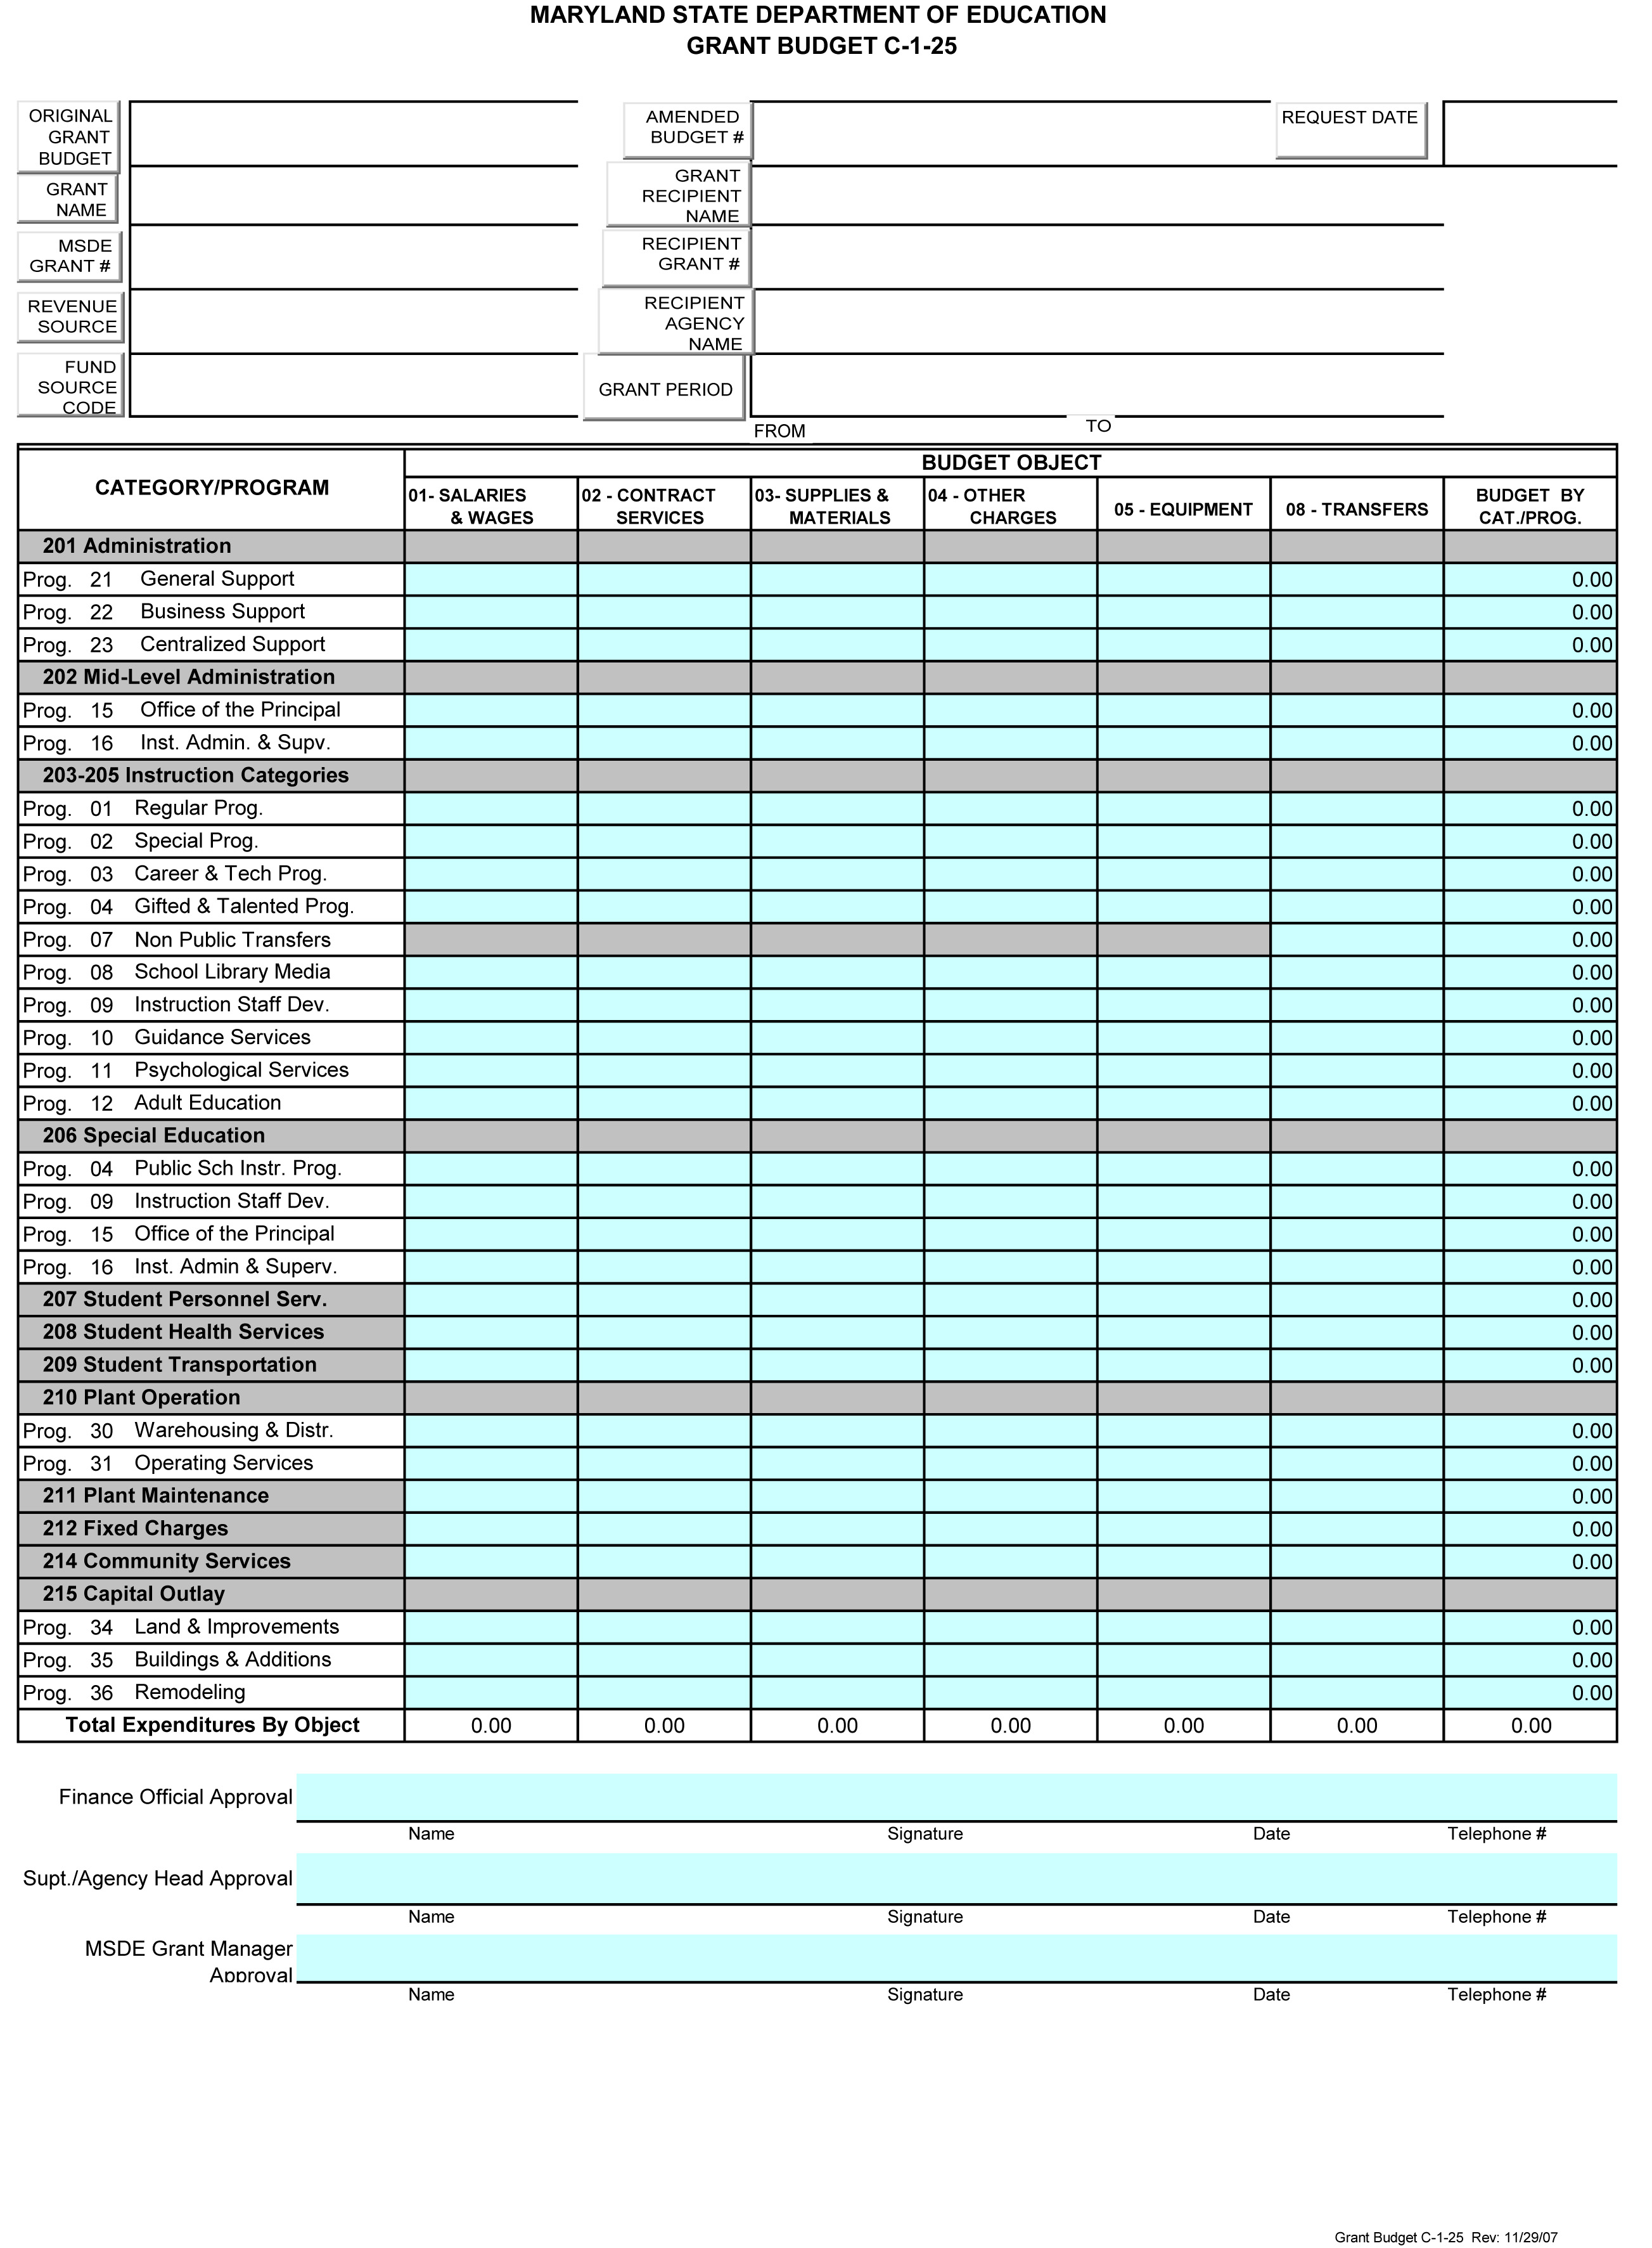

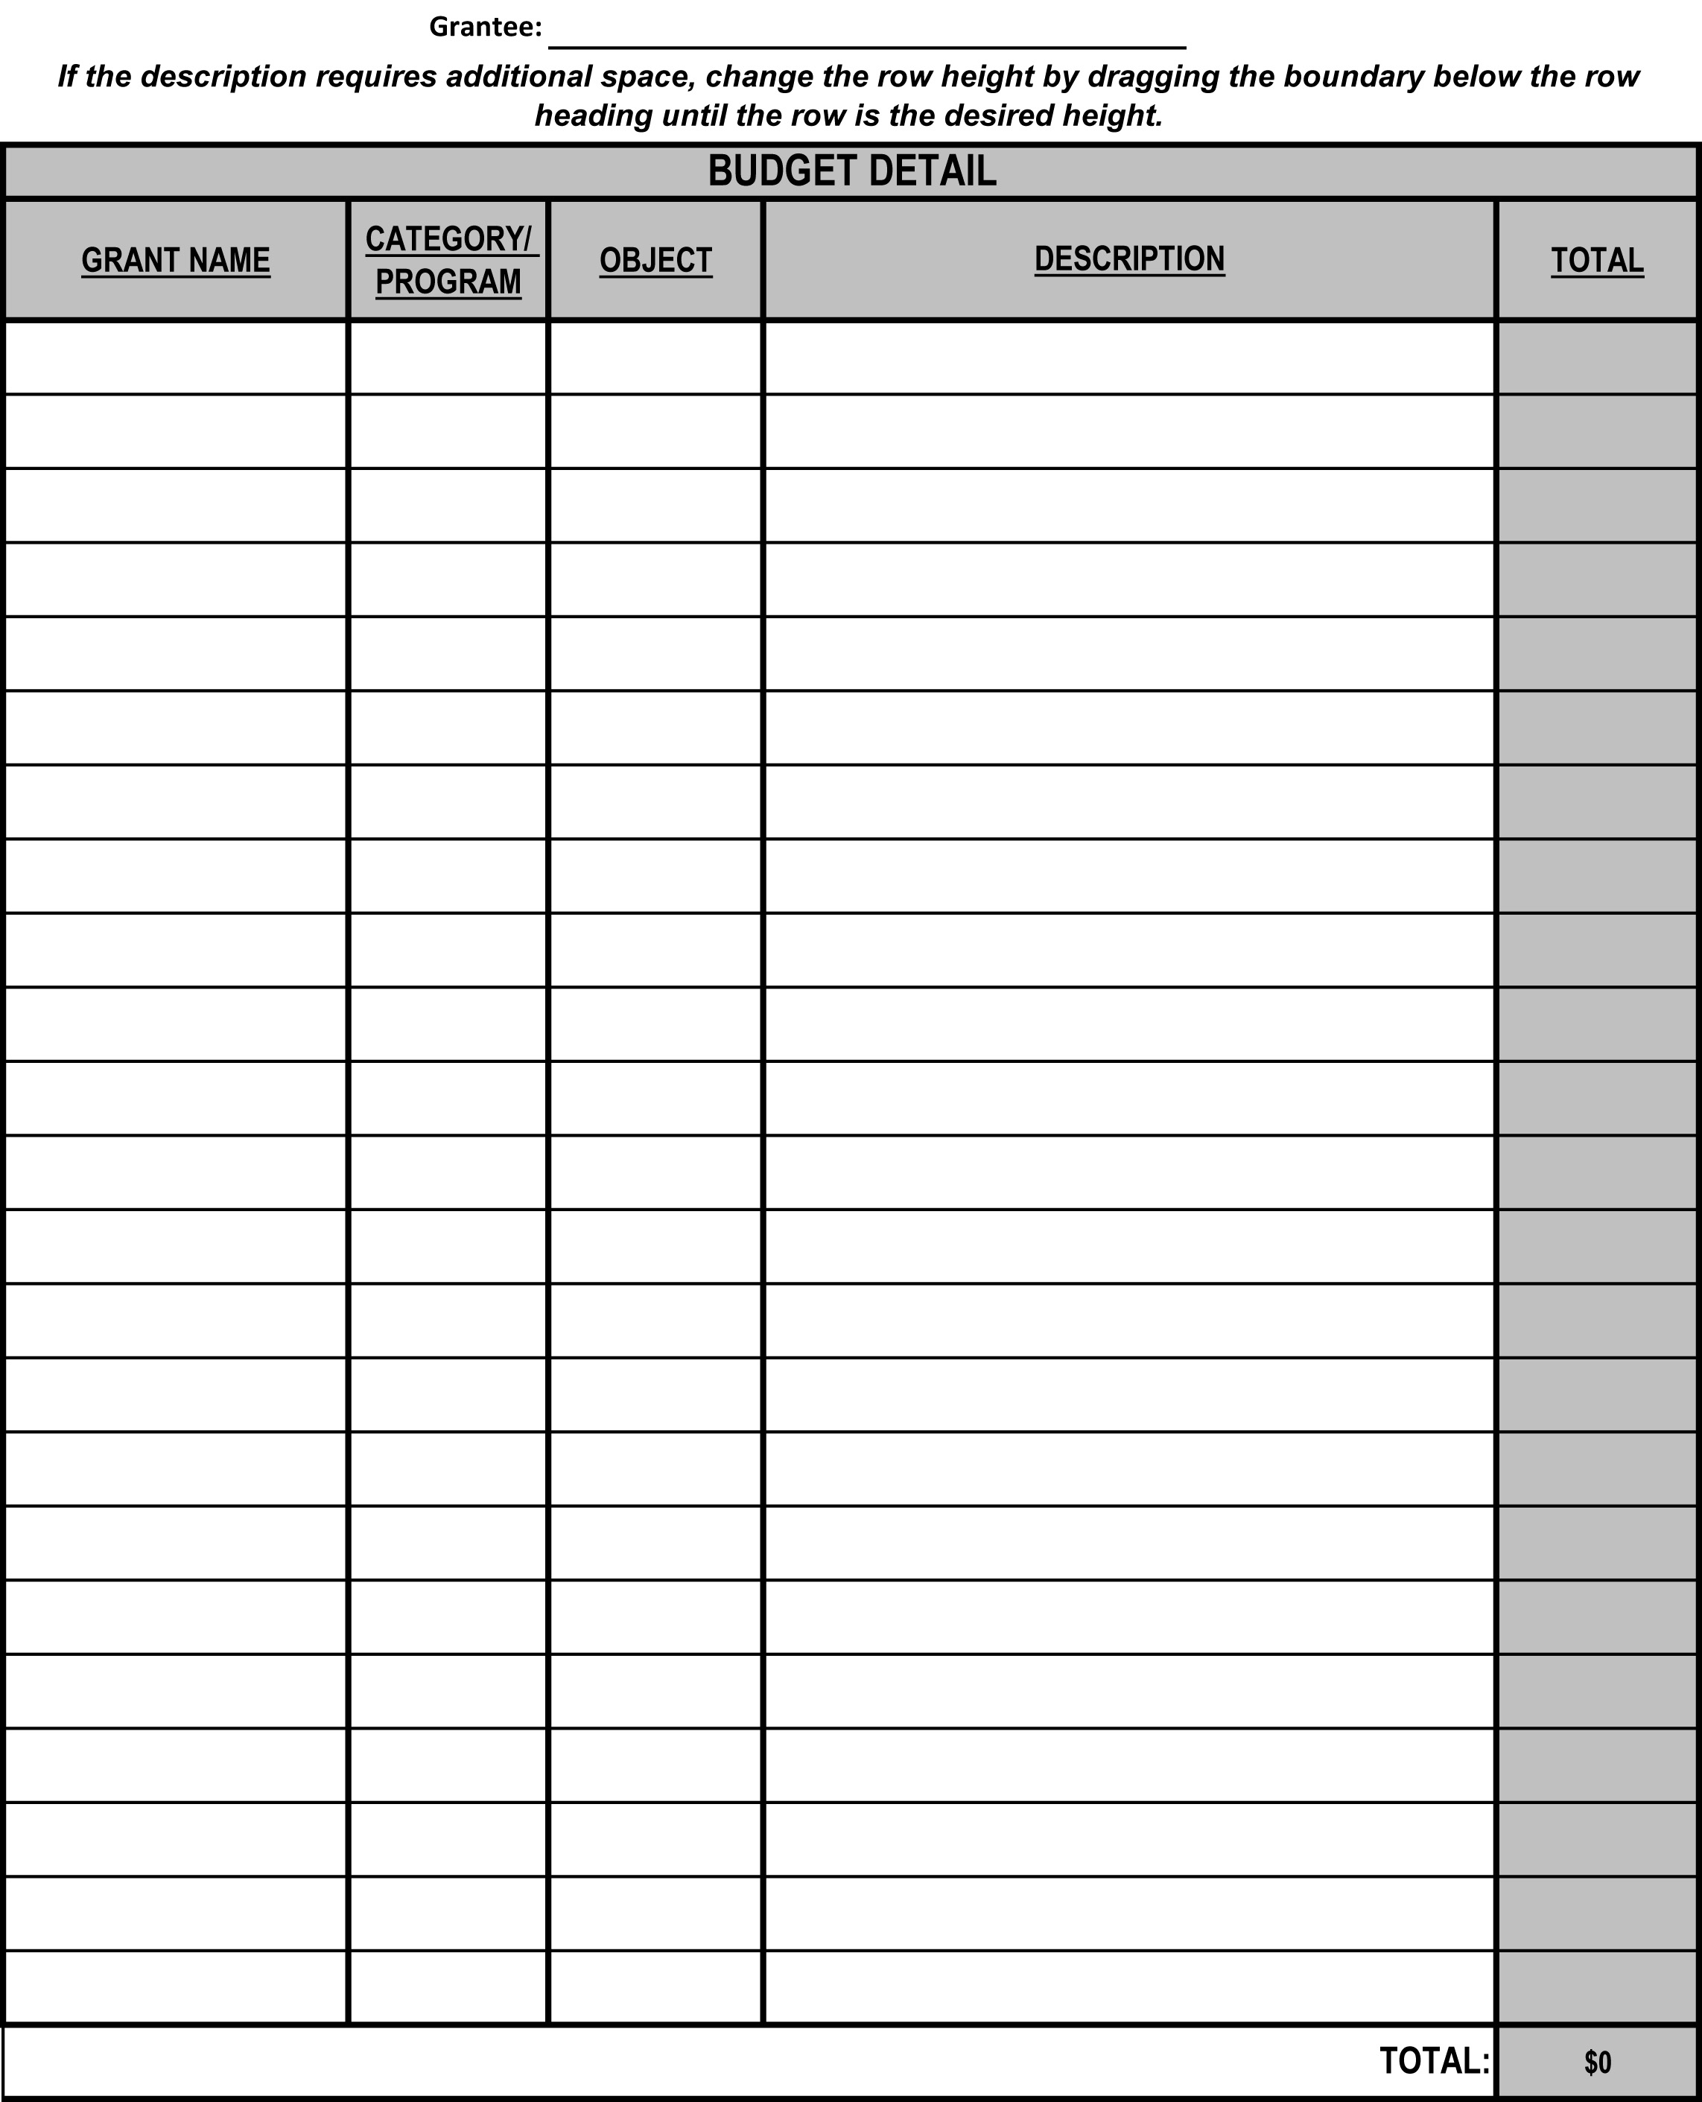

APPENDIX B
Referenced in Section 6.0
_____________________________________________________

W- 9 Form (applicable to new grantees and grantees requiring address changes)
Assurances (signature required)
IHE/Non-LSS Certification (signature required)
General Education Provisions Act (GEPA) Statement
System for Award Management (SAM) - Active Certification
Certifications Regarding Lobbying, Debarment, Suspension, Other Responsibility
Matters, and Drug-Free Workplace (signature required)
Single Audit (if applicable)

ASSURANCES

By receiving funds under this grant award, I hereby agree, as grantee, to comply with the following terms and conditions:

- Programs and projects funded in total or in part through this grant shall operate in compliance with State and federal statutes and regulations, including but not limited to the 1964 Civil Rights Act and amendments, the Code of Federal Regulations (CFR) 34, the Elementary and Secondary Education Act, Education Department General Administrative Regulations (EDGAR), the General Education Provisions Act (GEPA) and the Americans with Disabilities Act (ADA). Vendors, subgrantees, and/or consultants; including officers and employees shall comply with the Family Education Rights and Privacy Act at all times (20 U.S.C. §123g).

- Grantee shall assure that its facilities are accessible to individuals with disabilities as required by the ADA and applicable regulations. The grantee shall not discriminate against individuals with disabilities in the provision of its services and programs unless to do so would be an undue burden or result in fundamental alteration in the program as those terms are used in the ADA and its implementing regulation. The State reserves the right to inspect the grantee's facilities at any time to determine if the grantee is in compliance with ADA. The grantee shall bear sole responsibility for assuring that its programs conforms for the section 501c. of the ADA (42 USC 12201) as a bona fide benefit plan. The grantee shall indemnify and hold the State harmless in any administrative proceeding or action brought pursuant to the ADA for all damages, attorneys' fees, litigation expenses and costs, if such action or proceeding arises from the acts of grantee, grantee's employees, agents or subgrantees.

- By accepting federal funds, the recipients certify that they have complied with Federal Executive Order 12549, Debarment and Suspension set forth in 2 CFR §180, and that, a signed Certification Regarding Debarment, Suspension, Ineligibility and Voluntary Exclusion form has been filed with Maryland State Department of Education Project Monitor.

- Grantee shall establish and maintain fiscal control, fund accounting procedures by fund, as set forth in 2 CFR §200 and in applicable statute and regulation. By accepting federal funds, the recipient agrees that the amount of the grant award is contingent upon the receipt of federal funds. Grantee shall retain all records of its financial transactions and accounts relating to this grant for a period of five years, or longer if required by federal regulation. Such records shall be made available for inspection and audit by authorized representatives of MSDE.

- Entities expending federal funds of $750,000 or more in a single fiscal year, must have an annual financial and compliance audit in accordance with 2 CFR Subpart F 200.500 et. seq.

- The Maryland State Department of Education (MSDE) may, as it deems necessary, supervise, evaluate and provide guidance and direction to grantee in the conduct of activities performed under this grant. However, MSDE's failure to supervise, evaluate or provide guidance and direction shall not relieve grantee of any liability for failure to comply with the terms of the grant award.

- Grantee shall adhere to MSDE reporting requirements, including the submission of all required reports. Failure to submit complete, accurate, and timely progress and final reports may result in the withholding of subsequent grant payments until such time as the reports are filed.

- Grantee must receive prior written approval from the MSDE Program Monitor before implementing any programmatic changes with respect to the purposes for which the grant was awarded. Unless a division implements a stricter policy, grantee must receive prior written approval from the MSDE Program Monitor for any budgetary realignment of $1,000 or 15% of total object, program or category of expenditure, whichever is greater. Grantee must support the request with the reason for the requested change. Budget realignments must be submitted at least 45 days prior to the end of the grant period.

- Requests for grant extension, when allowed, must be submitted at least 45 days prior to the end of the grant period.

- Grantee shall insure that programs and projects that offer web-based or technology band instructional products or programs which are funded in total or in part through this grant will operate in compliance with Section 508 of the Federal Rehabilitation Act of 1973 as amended and Section 7-910 of the Education Article, Annotated Code of Maryland.

- Grantee shall repay any funds that have been determined through the federal or State audit process to have been misspent, misapplied, or otherwise not properly accounted for, and further agrees to pay any collection fees that may subsequently be imposed by the federal and/or State government. The repayment may be made by an offset to funds that are otherwise due the grantee.

I further certify that all of the facts, figures and representations made with respect to the grant application and grant award, including exhibits and attachments, are true and correct to the best of my knowledge, information, and belief.

Head of Grantee Agency | Date
IHE/Non-LSS Certification

The undersigned certify, to the best of their ability, that all of the facts, figures, and representations made with respect to SFY 2016 Proposal for federal funds and budget submission, including exhibits and attachments, are true and correct. Furthermore, we provide assurance of the IHE/Non-LSSs compliance with federal and State regulations and reports on the proposed expenditures of allocated federal funds. This is to also certify that the IHE/Non-LSS has current policies and procedures that are available for review and that those policies and procedures include IDEA 2004 and the revised Code of Maryland Regulations. All other policies, procedures, and information are superseded by the Proposal.

In addition, the IHE/Non-LSS, if using federal funds to support permanent staff positions is aware that this grant is awarded based on the availability of discretionary funds, and as such, cannot be guaranteed for the continued support of permanent staff positions beyond the grant period.

Entities expending federal funds of $750,000 or more in a single fiscal year, must have an annual financial and compliance audit in accordance with 2 CFR Subpart F 200.500 et. seq. The Entity completing this application is is not required to file a Single Audit (check the appropriate box). If required, attach the most recent Single Audit Report.

The undersigned further certify that grantee work products resulting from grant funds must be reviewed and approved by the MSDE; all intellectual property rights, records, documents, reports, and other materials shall be the property of MSDE, and no such materials shall be subject to copyright, patent, or trademark, by or on behalf of, any subgrantee.

We further certify that the signatures on all assurance forms submitted as part of the LAFF will apply to all SFY 2016 MSDE awards to the LSS/PA and that the signed Assurances will be affixed to every NGA issued to the LSS/PA throughout the term of the SFY 2016 awards.

____________________________________________________
Project Director (Signature) Date
____________________________________________________
Finance Officer/Designee (Signature) Date
MSDE APPROVAL
(FOR MSDE USE ONLY)

____________________________________________________
Assistant State Superintendent, Division of Special Education/ Date
Early Intervention Services (Signature)

Directions (2 pages) for completing the GEPA Statement

Department of Education General Education Provisions Act (GEPA) Notice
OMB Control No. 1890-0007

NOTICE TO ALL APPLICANTS

The purpose of this enclosure is to inform you about a new provision in the Department of Education’s General Education Provisions Act (GEPA) that applies to applicants for new grant awards under Department programs. This provision is Section 427 of GEPA, enacted as part of the Improving America’s Schools Act of 1994 (Public Law (P.L.) 103-382).
To Whom Does This Provision Apply?

Section 427 of GEPA affects applicants for new grant awards under this program. ALL APPLICANTS FOR NEW AWARDS MUST INCLUDE INFORMATION IN THEIR PROPOSALS TO ADDRESS THIS NEW PROVISION IN ORDER TO RECEIVE FUNDING UNDER THIS PROGRAM.

(If this program is a State-formula grant program, a State needs to provide this description only for projects or activities that it carries out with funds reserved for State-level uses. In addition, local school districts or other eligible applicants that apply to the State for funding need to provide this description in their Proposals to the State for funding. The State would be responsible for ensuring that the school district or other local entity has submitted a sufficient Section 427 statement as described below.)

What Does This Provision Require?

Section 427 requires each applicant for funds (other than an individual person) to include in its Proposal a description of the steps the applicant proposes to take to ensure equitable access to, and participation in, its Federally-assisted program for students, teachers, and other program beneficiaries with special needs. This provision allows applicants discretion in developing the required description. The statute highlights six types of barriers that can impede equitable access or participation: gender, race, national origin, color, disability, or age. Based on local circumstances, you should determine whether these or other barriers may prevent your students, teachers, etc. from such access or participation in, the Federally-funded project or activity. The description in your Proposal of steps to be taken to overcome these barriers need not be lengthy; you may provide a clear and succinct description of how you plan to address those barriers that are applicable to your circumstances. In addition, the information may be provided in a single narrative, or, if appropriate, may be discussed in connection with related topics in the Proposal.

Section 427 is not intended to duplicate the requirements of civil rights statutes, but rather to ensure that, in designing their projects, applicants for Federal funds address equity concerns that may affect the ability of certain potential beneficiaries to fully participate in the project and to achieve to high standards. Consistent with program requirements and its approved Proposal, an applicant may use the Federal funds awarded to it to eliminate barriers it identifies.

Examples of How an Applicant Might Satisfy the Requirement of This Provision?

The following examples may help illustrate how an applicant may comply with Section 427.

- An applicant that proposes to carry out an adult literacy project serving, among others, adults with limited English proficiency, might describe in its Proposal how it intends to distribute a brochure about the proposed project to such potential participants in their native language.

- An applicant that proposes to develop instructional materials for classroom use might describe how it will make the materials available on audio tape or in Braille for students who are blind.

- An applicant that proposes to carry out a model science program for secondary students and is concerned that girls may be less likely than boys to enroll in the course, might indicate how it intends to conduct “outreach” efforts to girls, to encourage their enrollment.

We recognize that many applicants may already be implementing effective steps to ensure equity of access and participation in their grant programs, and we appreciate your cooperation in responding to the requirements of this provision.

Estimated Burden Statement of GEPA Requirements

According to the Paperwork Reduction Act of 1995, no persons are required to respond to a collection of information unless such collection displays a valid OMB control number. The valid OMB control number for this information collection is 1890-0007. The time required to complete this information collection is estimated to average 1.5 hours per response, including the time to review instructions, search existing data resources, gather the data needed, and complete and review the information collection. If you have any comments concerning the accuracy of the time estimate(s) or suggestions for improving this form, please write to: Director, Grants Policy and Oversight Staff, U.S. Department of Education, 400 Maryland Avenue, SW (Room 3652, GSA Regional Office Building No. 3), Washington, DC 20202-4248.

General Education Provisions Act (GEPA) Statement
Referenced in 2.0 and 6.0

As required on page 5, describe the steps proposed to ensure equitable access to, and equitable participation in the project by addressing the special needs of students, teachers, and other program beneficiaries in order to overcome barriers to equitable participation. Do not include the preceding directions (2 pages) in the proposal.

System for Award Management (SAM)

SAM – How to obtain Active Certification:

Grantees can acquire and submit an active SAM certificate by logging into the sam.gov system using their credentials and taking a screenshot of their entity’s sam.gov record.

This will document that a grantee is: (1) registered with a DUNS number and (2) the grantee is not suspended or debarred.

The U.S. federal government’s System for Award Management (SAM) validates the Taxpayer Identification Number (TIN) and Taxpayer Name of each new and updating registrant with the Internal Revenue Service (IRS).

This is one step in the process. The registration will NOT be considered Active until a Commercial And Government Entity (CAGE) Code is validated or assigned by the Defense Logistics Agency (DLA), if applicable.* Please note that the registration must be in Submitted status in order for a CAGE Code to be assigned or validated.

Follow the instructions below to check the status of your registration and to submit your record, if you have not already done so.
1.) Log into SAM with your username and password
2.) Click on Register/Update Entity
3.) Click on Incomplete Registrations
4.) Select the entity
5.) Click on View to view the status of your registration
6.) Click on Update to complete the process and submit. Please note that federal regulation requires review of every page in the registration in order to submit. So, start at the beginning, review/update the content as required and click Save and Continue on each page. At the end, be sure to click Submit. You will see a “congratulations” message on the screen when you successfully submit your registration.
You will receive a confirmation email once the registration is activated.

You may check your status at any time by following steps 1 through 5 above. If your registration does not reach the Active status within 7 business days, you may contact the SAM help desk, the Federal Service Desk, at www.fsd.gov or by telephone at 866-606-8220 (toll free) or at 334-206-7828 (international).

*The Commercial And Government Entity (CAGE) Code is a five-character ID number used extensively within the federal government. The Defense Logistics Information Service (DLIS), who administers the CAGE Code system, has a CAGE Code Search feature on the internet (the link is below) that will help you determine if a code has been previously assigned to your organization: http://www.logisticsinformationservice.dla.mil/BINCS/begin_search.aspx

For those not listed in the database, the CAGE request process is incorporated into the SAM registration. Therefore, your entity will be assigned a CAGE Code during the processing of your registration. Once your registration is active, you can view your CAGE Code on the web by logging into your SAM account.

Note: Foreign organizations that perform work outside the United States are required to register in SAM in order to receive a contract. They must first obtain a North Atlantic Treaty Organization (NATO) CAGE (NCAGE) Code from the appropriate source. The NCAGE Code can be obtained directly from the Codification Bureau in their country. Please view the up-to-date list of countries and the information necessary to contact the Codification Bureau by visiting their web site at http://www.dlis.dla.mil/Forms/Form_AC135.asp.

For assistance, please contact the Federal Service Desk at www.fsd.gov or by telephone at 866-606-8220 (toll free) or at 334-206-7828 (international).

The System for Award Management (SAM) Administrator: https://www.sam.gov

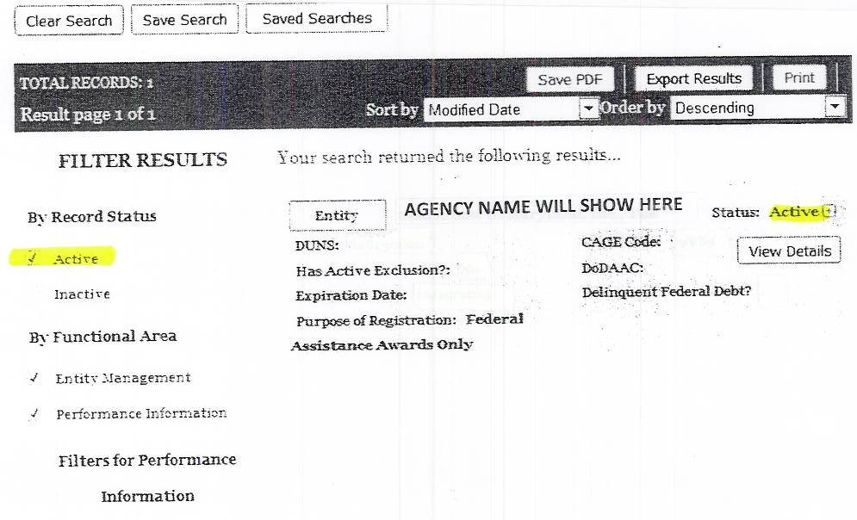

Certifications Regarding Lobbying, Debarment, Suspension,
Other Responsibility Matters, and Drug-Free Workplace

LOBBYING
As required by Section 1352, Title 31 of the U.S. Code, and implemented at 34 CFR Part 82, for persons entering into a grant or cooperative agreement over $100,000, as defined at 34 CFR Part 82, Sections 82.105 and 82.110, the applicant certifies that:
a. No Federal appropriated funds have been paid or will be paid, by or on behalf of the undersigned, to any person for influencing or attempting to influence an officer or employee of any agency, a Member of Congress, an officer or employee of Congress, or an employee of a Member of Congress in connection with the making of any Federal grant, the entering into of any cooperative agreement, and the extension, continuation, renewal, amendment, or modification of any Federal grant or cooperative agreement;
b. If any funds other than Federal appropriated funds have been paid or will be paid to any person for influencing or attempting to influence an officer or employee of any agency, a Member of Congress, an officer or employee of Congress, or an employee of a Member of Congress in connection with this Federal grant or cooperative agreement, the undersigned shall complete and submit Standard Form-LLL, “Disclosure Form to Report Lobbying,” in accordance with its instructions;
c. The undersigned shall require that the language of this certification be included in the award documents for all subawards at all tiers (including subgrants, contracts under grants and cooperative agreements, and subcontracts) and that all subrecipients shall certify and disclose accordingly.

DEBARMENT, SUSPENSION, AND OTHER RESPONSIBILITY MATTERS
As required by Executive Order 12549, Debarment and Suspension, and implemented at 2 CFR Part 3485, for prospective participants in primary covered transactions, as defined at 2 CFR Part 3485, Section 3485.22,
A. The applicant certifies that it and its principals:
a. Are not presently debarred, suspended, proposed for debarment, declared ineligible, or voluntarily excluded from covered transactions by any Federal department or agency;
b. Have not within a three-year period preceding this application been convicted of or had a civil judgment rendered against them for commission of fraud or a criminal offense in connection with obtaining, attempting to obtain, or performing a public (federal, State, or local) transaction or contract under a public transaction; violation of federal or State antitrust statutes or commission of embezzlement, theft, forgery, bribery, falsification or destruction of records, making false statements, or receiving stolen property;
c. Are not presently indicted for or otherwise criminally or civilly charged by a governmental entity (federal, State, or local) with commission of any of the offenses enumerated in paragraph (2)(b) of this certification; and
d. Have not within a three-year period preceding this application had one or more public transactions (Federal, State, or local) terminated for cause or default; and
B. Where the applicant is unable to certify to any of the statements in this certification, he or she shall attach an explanation to this application.

DRUG-FREE WORKPLACE (GRANTEES OTHER THAN INDIVIDUALS)
As required by the Drug-Free Workplace Act of 1988, and implemented at 34 CFR Part 84, Subpart F, for grantees, as defined at 34 CFR Part 84, Sections 84.605 and 84.610,

A. The applicant certifies that it will or will continue to provide a drug-free workplace by:
a. Publishing a statement notifying employees that the unlawful manufacture, distribution, dispensing, possession, or use of a controlled substance is prohibited in the grantee’s workplace and specifying the actions that will be taken against employees for violation of such prohibition;
b. Establishing an on-going drug-free awareness program to inform employees about:
(1) The dangers of drug abuse in the workplace;
(2) The grantee’s policy of maintaining a drug-free workplace;
(3) Any available drug counseling, rehabilitation, and employee assistance programs; and
(4) The penalties that may be imposed upon employees for drug abuse violations occurring in the workplace;
c. Making it a requirement that each employee to be engaged in the performance of the grant be given a copy of the statement required by paragraph (a);
d. Notifying the employee in the statement required by paragraph (a) that, as a condition of employment under the grant, the employee will:
(1) Abide by the terms of the statement; and
(2) Notify the employer in writing of his or her conviction for a violation of a criminal drug statute occurring in the workplace no later than five calendar days after such conviction;
e. Notifying the agency, in writing, within 10 calendar days after receiving notice under subparagraph (d)(2) from an employee or otherwise receiving actual notice of such conviction. Employers of convicted employees must provide notice, including position title, to: Director, Grants Policy and Oversight Staff, U.S. Department of Education, 400 Maryland Avenue, S.W. (Room 3652, GSA Regional Office Building No. 3), Washington, DC 202024248. Notice shall include the identification number(s) of each affected grant;
f. Taking one of the following actions, within 30 calendar days of receiving notice under subparagraph (d)(2), with respect to any employee who is so convicted:
(1) Taking appropriate personnel action against such an employee, up to and including termination, consistent with the requirements of the Rehabilitation Act of 1973, as amended; or
(2) Requiring such employee to participate satisfactorily in a drug abuse assistance or rehabilitation program approved for such purposes by a federal, State, or local health, law enforcement, or other appropriate agency;
g. Making a good faith effort to continue to maintain a drug-free workplace through implementation of paragraphs (a), (b), (c), (d), (e), and (f).

The undersigned certify grantee compliance with the above requirements.

____________________________________________ _________
Agency Director
Date

____________________________________________ _________
Program Director
Date

Maryland State Department of Education
Division of Special Education/Early Intervention Services

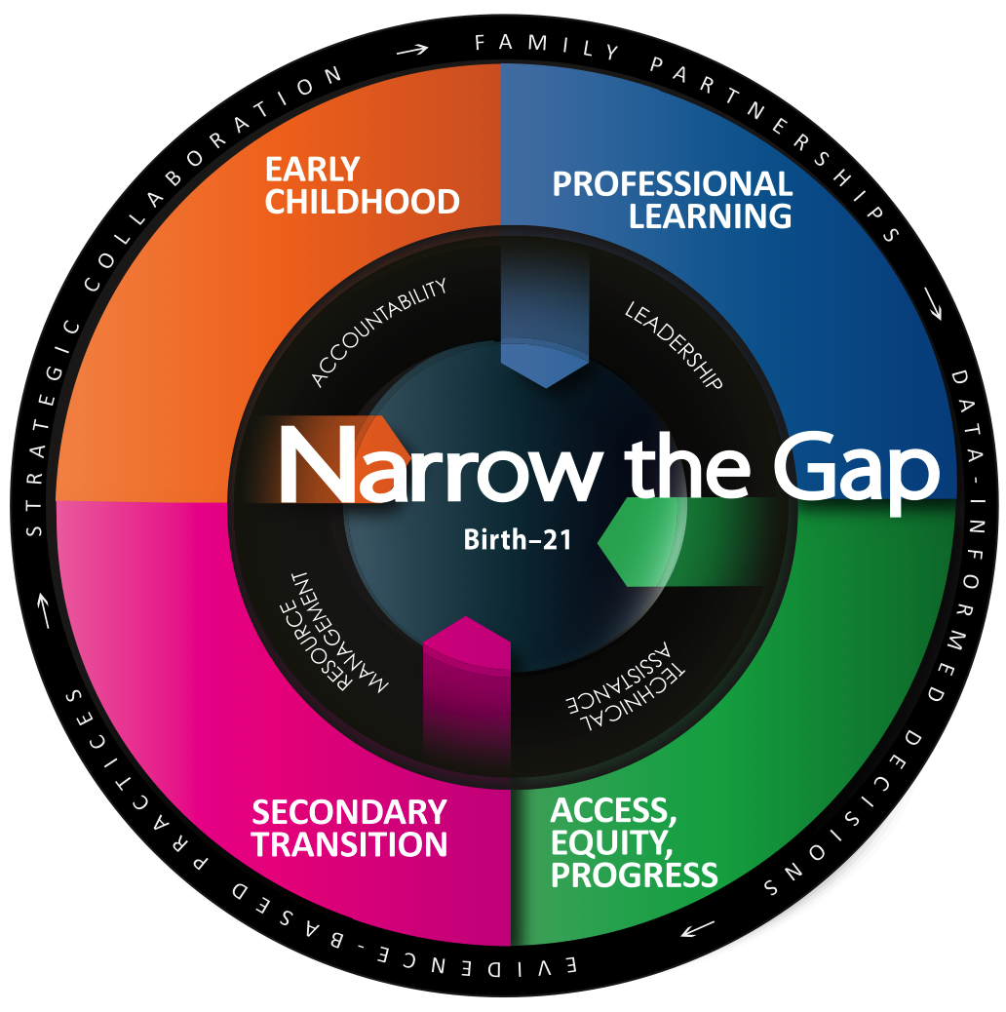

For assistance with this document, please contact Ms. Cheryl Edwards at 410-767-7512, or Cheryl.Edwards@maryland.gov

