PRINCE GEORGE’S COUNTY PUBLIC SCHOOLS

FINAL SUBMISSION
TITLE I SCHOOL IMPROVEMENT 1003(G) GRANT APPLICATION

Contents:
- Oxon Hill Middle School Application
- Thomas Johnson Middle School Application
- Budget Documentation
- Required Budget Summary
- Consolidated Budgets
- C-125 Budget Request Forms
- Technical Presentation to Vendors
- Memorandum of Understanding (MOU) Draft
  - Attachment A – Mosaica RFP
  - Attachment B

Submitted: May 26, 2011

Dr. William R. Hite, Jr., Superintendent of Schools
Dr. Duane Arbogast, Chief Academic Officer

OXON HILL
MIDDLE SCHOOL APPLICATION

Title I
School Improvement

Title I 1003(g)

Grant Period
July 1, 2010 - September 30, 2012
Prince George’s County Public Schools
Oxon Hill Middle School

Request for
Grant
Proposals

Maryland State Department of Education

200 West Baltimore Street
Baltimore, MD 21201

Deadline Dates
First Draft: March 4, 2011
Second Draft: March 25, 2011
Final Submission: April 21, 2011

PRINCE GEORGE’S COUNTY PUBLIC SCHOOLS
EXECUTIVE SUMMARY
Title I SIG 1003g Grant 2011

Prince George’s County Public Schools (PGCPS) has almost one year of experience in turnaround schools. This year has affirmed some convictions and created new insights. These insights allow the district to develop a realistic vision of the implications of turnaround.
The affirmation of convictions is based on many of the nationally recognized best practices for Turnarounds are identified in The Turnaround Challenge published by the Mass Insight Education and Research Institute in 2007. The Mass Insight report, along with other available research, serves as the framework for the district’s theory of action. This report notes that high achievement for underperforming schools can be categorized into three strategies - Readiness to Learn, Readiness to Teach and Readiness to Act.
Readiness to Learn is focused on the students and creating an environment that allows them to feel secure and inspired to learn. Turnaround need to develop strategies and systems to address the many outside issues that students bring to the classroom. The school should foster positive and enduring relationships between the teachers and students to maintain the commitment to learn.
Readiness to Teach is based on a shared accountability for student results across the staff. The instruction provided should be personalized based on data and flexible based on student need. Professional development should be provided through many paths such as collaboration, classroom evaluation, training and other best practices.
Readiness to Act allows school leaders to make local decisions about how to manage budgets, staff, curricula, and programs. Schools should be relentlessly creative in identifying resources from the community, agencies, parents and other partnerships to support the students. Schools should expect to be flexible and remain focused on children.
These convictions are tempered with the reality of time, capacity and policies and procedures.
Time: Addressing the needs of low performing schools requires time. Rushing into a plan under time constraint does not allow for a deep analysis of the issues and strategic planning of the responses. The process of the needs assessment should really be conducted by district experts, but it should also include those who will be responsible for implementing the day to day strategies of the plan. This needs assessment would include a review of the capacity of the staff to implement the changes of reform. Once the assessment is done, and the correct staff are in place, a time for re-culturing is necessary before the beginning of the new school year. This re-culturing includes addressing Readiness to Learn and Readiness to Teach. As the school year progresses, the school needs time to assess the implementation of the strategies and allow for the reform to take shape.
Capacity addresses the real issues of attracting and developing the staff prepared for the reform efforts. In a district in which every traditional middle school is in school improvement, and in which most are in either alternative governance or turnaround status, the pool of adults experienced in turnaround reform is shallow. In addition, the district is facing an unprecedented budget reduction which has resulted in the reduction of staff. Consequently, the opportunity to attract external candidates to the reform is impeded by the surplus of staff. The negotiated agreement serves to protect internal candidates in the area of job security, so replacing staff becomes increasingly more difficult.
Capacity also addresses the ability to staff to absorb and internalize new ways of thinking around Readiness to Learn and Readiness to Teach. Much work must be done long before the school bell rings to ensure that a coherent message is internalized by all staff.
Finally, the district’s capacity to reallocate resources to low performing schools continues to become a difficulty as the district addresses a $155,000,000 shortfall due to decline enrollments and a suffering economic climate.
Policies and Procedures The district is under-going significant changes in policy and procedures. The district leads the nation in tying teacher effectiveness to compensation. In addition, the district has utilized both grant and federal Race to the Top funds to develop strategies around teacher and principal recruitment, development and retention. The bargaining units have been willing partners in these reforms. However, we have not reached consensus on incentives for working in low performing schools, the ability to move staff at will, or modifications in job placement. The district recognizes the important relationship it has with the bargaining units and wishes to proceed in a climate of consensus
Policies and procedures also limit flexibility in terms of the school calendar and transportation. Significant changes to address reform movements require funding from the grant and cannot be supported by district general funds.
Given the vision and constraints outlined above, the district would like to proceed with an alternative pathway for the next round of SIG applications. The district sees the need for a coordinated effort around Readiness to Learn, Teach and Act. The district believes that an external partner offers the best option for this coherence. Therefore, the district has developed an RFP for an Educational Management Organization to coordinate the components of turning around low performing schools. The RFP is currently open. The district will select a provider to:
- Complete the needs assessment in terms of assessing staff capacity around implementing reforms
- Write the specific strategies to be utilized
- Develop the metrics for success
- Advise in the retention of staff
- Provide the necessary professional development to re-culture the school prior to the beginning of the school year.
In addition to the selection of the EMO, the district proposes supplementing the current Turnaround Office with additional content expertise support.
The goal is to name the EMO and complete the needs assessment prior to the final draft submission in April. The March 4th draft highlights the process the district will use in selecting the EMO.
The district is identifying only two of the five eligible schools for the SIG grant: Oxon Hill Middle School and Thomas Johnson Middle School. The district feels this will not dilute the funding stream and allows a concentration on schools that would not otherwise receive additional support. This will be a wonderful opportunity for these two schools to move to high performance.
Requirements for the Educational Management Organization
- READINESS TO LEARN
- School Culture and Student Buy-in (2 pages) Demonstrate your past success with establishing a prescribed school culture based on: high expectations for all stakeholders, social and emotional development strategies, student engagement, inculcation of school mission and vision, development of systems for mentor, advisor and teacher relationships, development of personalized learning environments and strategies, creation of school-based rituals, and maintenance of behavioral norms. If currently operating a Restart school(s), detail specific lessons learned in promoting and implementing an effective new school culture within the former school climate.
- Describe the culture and climate (academic and non-academic) envisioned for the Restart school(s). Within this context, discuss plans to build a culture of academic achievement, student motivation to succeed, safety, discipline and engagement, as well as methods for addressing students’ poverty-driven deficits. Describe how your team will use your planning period to begin implementing the school vision and achieving stakeholder buy-in. Briefly describe what you foresee as the most significant barriers to the achievement of your Restart school’s culture/climate, and specify your approach to reducing these barriers. Speak directly to how your organization will listen to the community concerns regarding the Restart decision and help build understanding of the need for change and for a new vision.
- Discipline and Safety (2 pages) Discuss safety and disciplinary issues that you expect to encounter at the Restart school(s) that may or may not be similar to schools within your existing portfolio. Describe programmatic measures that you have adopted at other schools to ensure safety, and discuss how safety issues will be addressed and how unsafe activities will be prevented in your Restart school(s) from day one.
- Social and Emotional Supports (2 pages) Demonstrate your current successes in the creation, implementation, evaluation and modification of social and emotional development strategies for students. Specifically, discuss how these strategies support the underserved populations that you serve, and how they work to increase student achievement, and the ability and willingness to learn among all students.
- READINESS TO TEACH
- Education Plan (2 pages) Describe the educational philosophy of your organization and the curriculum model and methodologies used in your schools will support the advancement of the PGCPS’s Board of Education’s Theory of Action. Describe the mission of your organization and how it is supported and achieved through the instructional methods used in your schools. Describe how you will vary or enhance your educational philosophy and methods in a Restart setting.
- Proposed Curriculum (2 pages + Attachment) Attach a curriculum map specific to the Restart school(s). Explain your rationale for the innovative curriculum choices used to support the underperforming student populations you seek to serve, including course scope and sequence. Focus on your intervention and remediation strategies as they pertain to academics, bringing students up to grade level, and literally ‘turning around’ a school with a low-performing, high poverty student population.
- Articulate how the educational program of the Restart school(s) will use differentiated instructional strategies to promote the incremental academic growth of all enrolled students, whether at, above, or below grade level.
- Remediation and Accelerated Learning (2 pages)
  - Describe how the Restart school will identify and assess below grade level students at the start of the first school year and ongoing. Describe the specific services and supports that will be provided to meet the needs of students who are performing below grade level. Briefly outline how strategies to support your underperforming general education population will differ from those in place to support your special education students. Beyond remediation, discuss the different mediums and pathways for accelerating students’ progress at the rate of growth necessary to prepare them for promotion and graduation.
- Discuss how the Restart school leadership and faculty will identify and assess accelerated students upon enrollment and ongoing. Describe the specific programs, supports and opportunities provided to meet the needs of accelerated students.
- Assessments and Performance Goals (2 pages) Provide a five-year data-driven performance assessment plan that builds in ongoing assessment, systematized feedback, and flexibility to make changes based on results. Describe annual performance systems that will directly monitor value-added growth and overall school performance targets over time. Discuss plans in terms of two phases: 1) realistic 2-year Restart goals based on increasing incremental student achievement growth, and 2) long term goals (five years or more) to produce steady, incremental growth annually and over time, with a strategy to transition into a high performing school.
- Serving Specialized Populations (2 pages) Specialized Instruction: Articulate how the educational program of the proposed Restart school will reinforce a commitment to differentiated methods of instruction that serve the needs of all enrolled students, including students with disabilities, English Language Learner (ELL) students and homeless students.
- Explain how the proposed school will assess, review, revise and implement IEPs.
- Describe how the proposed school will provide students with disabilities a free, appropriate public education in the least restrictive environment.
- Describe how the proposed school will accommodate students with disabilities who require extended school year services.
- Explain how the proposed school will meet the needs of students in at-risk situations, including but not limited to low achievement, poverty, behavioral issues, truancy, drugs, pregnancy, and emotional issues.
- Explain how the proposed school will identify and meet the needs of ELL students, including curriculum and instructional program/practices to accommodate this group.
- Homelessness: Provide support for the academic success and personal development of homeless students enrolled in the proposed Restart school by addressing questions 1–6 below.
- How will the proposed school ensure immediate enrollment as well as sensitive, inclusive treatment of homeless students? What steps will the school take to retain this population?
- How will homeless students be included in all proposed school programs and activities, and receive additional support services?
- How will the proposed school’s administration annually prepare and train staff regarding the needs and rights of homeless students?
- How will parents of students who are homeless be included in any governing or advisory bodies as well as other school activities which are available to all families in the proposed school?
- How will the proposed school provide transportation to a student and, if appropriate, the student’s parents, if it is the “school of origin” for the homeless student?
- How will the proposed school coordinate with other entities to comprehensively serve the needs of students without housing?
- Leadership (2 pages + Attachment)
- Describe the responsibilities, qualifications, and level of experience required for principal candidates within your current school portfolio. Describe the specific qualities your organization seeks in the proposed Restart principal candidates, and explain how these skill sets differ from or build upon those required of traditional new school leaders. Discuss how you will ensure that your candidates possess the characteristics necessary for effective Restart school management, such as ability to secure additional resources, engage with underperforming students, demonstrate an entrepreneurial spirit, and leverage important partnerships.
- Discuss existing programs or pipelines that your organization has developed to train and produce high quality leaders for new schools within your portfolio.
- Staffing and Recruitment (2 pages + Attachments)
- Provide a description of the staffing model for your proposed school, including all academic and non-academic personnel, and the number and type of positions. Describe how this model differs from your traditional staffing model, as well as which positions have been added or amended to support and manage specific Restart school needs.
- Attach a comprehensive, school-level organizational chart showing lines of authority, responsibility, and accountability among school staff at one of your current schools/campuses. Discuss how this model organizational chart may be altered to add additional or modified positions to best support a Restart school.
- Professional Culture, Staff Buy-in, and Teacher Retention (2 pages) Discuss how your organization will work with school leadership to develop shared accountability and responsibility for achievement across teachers and staff in the Restart environment.
- Professional Development (2 pages + Attachment)
- Describe the ongoing professional development programs for leaders, teachers and staff at the proposed school(s), and explain how the program specifically addresses the unique vision, goals and challenges of a Restart model, including but not limited to collaborative leadership, social and emotional student supports, underperforming student populations, etc. Include details regarding the Restart school’s induction plan. Explain how the professional development program will be adaptive to concerns identified through interim assessment or other means throughout the year. Development program will accommodate and encourage both general and special education teachers to effectively support students with disabilities and other special needs.
- Provide a plan for formal and informal teacher/staff evaluations linked to performance goals and student achievement, and include whether these will be driven at the Restart school or the organization/network level. Discuss palpable intervention strategies for teachers performing below expectations.
- Explain how professional development resources, best practices, and pedagogical area expertise will be shared across the organization/network. List any specific events or workshops that are provided for all schools within the network and whether Restart schools will have targeted services.
- Promotion and Graduation Policies (1 page) Explain how you will incorporate added supports to ensure that students meet the requirements for Board policies regarding promotion and graduation. Describe how you will assist and support students who are not promoted on schedule, including acceleration plans and intervention strategies
- READINESS TO ACT
- School Day and School Calendar (2 pages + Attachment) Describe how additional hours, days or programs will be leveraged differently in Restart schools as compared to your “new start” schools to address remediation, social and emotional supports, and co- and extracurricular activities.
- Community Strategy and Involvement (3 pages)
- Describe how existing connections to community members and resources have contributed to the mission and success of your schools and your organization. Provide concrete examples of community engagement practices currently implemented, and describe how these relationships support a sense of community and culture instilled within existing schools/campuses. Provide evidence of community buy-in and support from community providers of all types, including but not limited to parents, community and faith-based organizations, social service providers, etc., at existing campuses.
- Discuss your plans to garner support and interest within the community once available Restart buildings are announced and you are participating in community forums, public hearings, and school implementation. Describe what steps will be taken to incorporate community stakeholders into your Restart school development process.
- Describe opportunities for parents and families to engage in and help support the proposed Restart school(s). How will you seek parent, guardian and family buy-in in your effort to cultivate a fresh school climate among existing students and families?
- School Oversight (3 pages + Attachment) Board Structure and Membership: Describe the structure and primary role of the Board of Directors of the organization that will enter into contract with PGCPS. Describe the composition of the Board of Directors, including key skills and constituencies that are represented. Discuss how the Board of Directors will support the proposed school’s Restart mission, how often it meets, and how it will interact with the Restart school.

Title I 1003(g) School
Improvement GRANT
July 1, 2010- September 30, 2012

Request for Proposal Cover Sheet

LOCAL SCHOOL SYSTEM: prince George’s County Public Schools
contact person: Duane Arbogast
POSITION/TITLE: Chief Academic Officer
address: 14201 School lane
upper marlboro, md 20772
telephone number: 301-952-6233
fax number: 301-952-6992
e-mail: allan.arbogast@pgcps.org

DATE SUBMITTED: May 26, 2011

MSDE Project Contact
Maria E. Lamb, Director
Program Improvement and Family Support Branch
Title I School Improvement Grants
(410) 767-0286 phone
(410) 333-8010 fax
melamb@msde.state.md.us E-mail

PART II: Schools to be Served by LEA
Section A
Indicate the schools the LEA will serve by completing Table A.1 below. The list of eligible schools may be found in Appendix A.2. Add more rows as needed.
For Tier I and Tier II schools, identify the Intervention Model Selected for each school. Descriptions of each model are included in Appendix C.
Note: An LEA that has nine or more Tier I and Tier II schools may not implement the transformation model in more than 50 percent of those schools.
Table A.1
Schools to Be Served by the LEA
 | School Name | NCES ID # | MSDE ID # | Tier I | Tier II | Tier III | Title I SW or TAS | Intervention Model Selected
 |  |  |  |  |  |  |  | Turnaround | Restart | School Closure | Transformation
1 | Thomas Johnson Middle School | 240051001175 | 20409 |  | X |  |  |  | X
2 | Oxon Hill Middle School | 240051001471 | 12434 |  | X |  |  |  | X
Section B: The following areas will be addressed for each participating school through the completion of the model template.

Cover Sheet- Tier I and Tier II Schools
School Name:  Oxon Hill Middle School  Address:  9570 Fort Foote Road  Fort Washington, MD 20744 | LEA Point of Contact (POC)  Name & Position:  Duane Arbogast, Chief Academic Officer  Phone#: 301-952-6233  Email Address: allan.arbogast@pgcps.org
Grade levels enrolled (SY10):  Grade 7 = 291  Grade 8 = 357 | Number of Students Enrolled (SY10):  648
Year the school entered school improvement status: _2004_ | Tier Level  Tier I __________________  Tier II________X_________
Differentiated Accountability Status:  _____ Focus Developing  _____ Focus Priority  _____ Comprehensive Developing  __X__ Comprehensive Priority | School Improvement Status:  _____ School Year 1  _____ School Year 2  _____ Corrective Action  _____ Restructuring Planning  ___X_ Restructuring Implementation
Title I Status:  _____ Schoolwide Program  _____ Targeted Assistance Program  __X__ Title I Eligible School | Intervention Model Selected:  _____ Turnaround Model  _____ Closure  __X_ Restart  _____ Transformation
Waiver Request(s):  __X__ Requested for this School  _____ Not Requested for this School | Total amount the LEA is requesting from 2010 Title I 1003(g) School Improvement Funds for the next three years.
 | Year 1: SY 2010-11 | $1,304,096
 | Year 2: SY 2011-12 | $1,301,228
 | Year 3: SY 2012-13 | $1,301,228
 | Pre-implementation Activities Yr. 1 | $ 0
 | Total Amount of Funding Requested for this school | $3,906,552

B.1 Comprehensive Needs Assessment for Tier I and II schools
For each Tier I and Tier II school that the LEA commits to serve, the LEA must demonstrate that—
- The LEA has analyzed the needs of each school and selected an intervention for each school; and
- The LEA has the capacity to use school improvement funds to provide adequate resources and related support to each Tier I and Tier II school identified in the LEA’s application in order to implement, fully and effectively, the required activities of the school intervention model it has selected.
Table B.1 Comprehensive Needs Assessment
Name of School: Oxon Hill Middle School |  | Tier: II
Areas to consider for analysis as part of a comprehensive needs assessment of include successes and challenges | LEAs summary and conclusion of its analysis of each of the areas considered in the needs assessment
1. Student Profile Information( include trend analysis)  - Total enrollment  - Grade level enrollment  - Subgroups - # of students in each  - Mobility % - Entrants & Withdrawals  - Attendance %  - Expulsions #  - Suspensions #  - Dropout rate  - Advance Coursework completion (IB/AP/early college high schools, dual enrollment classes) # and % of students  - Graduation rate  - High School Diploma Rate | Trended Student Profile Information  2008 2009 2010  Total Enrollment 675 682 592  7th Grade 313 349 306  8th Grade 362 333 286  Native American Indian 4 1 1  Asian 33 41 44  African American 582 579 519  White 7 5 7  Hispanic 44 56 77  FARMs 351 365 410  Special Education 199 115 123  LEP 0 0 24  Mobility – Entrants 15.6% 14.3% 14.4%  Mobility – Withdrawals 16.3% 13.4% 11.2%  Attendance 93.6% 94.5% 94.0%  Expulsions 0 6 2  Suspensions NA 413 330  Dropout Rate NA NA NA  Advanced Placement Courses NA NA NA  Conclusions:  - The trended profile data indicate a considerable decrease in student enrollment for Oxon Hill Middle School.  - The Hispanic population has increased by 33% since 2008.  - The FARMs population also shows a considerable increase since 2008.  - Special Education numbers have dropped dramatically since 2008. However, Oxon Hill Middle serves as a regional site for special education intensive students. However, many of these students are not accessing the regular curriculum and are assessed through the MSA-Alt Assessment.  - Implications from the data suggest that there is a need for stronger interventions for the Hispanic, Special Education, and LEP populations. At this time trended data for advanced placement courses is not available however discussions with specialists and teachers during collaborative planning, indicate a need for preparing students for readiness intervention in order for students to be successful in advanced placement courses. There is also a need for professional development in differentiated instructional techniques and higher order thinking skills in order to introduce more students to advance coursework prior to high school. The school continues to make AYP in attendance.
2. Staff Profile  - Principal – Length of time at the school  - Number of Assistant Principal/s and other administrators  - Number and % of teaching faculty’s total classroom instruction experience:  - 0-5 years  - 6-10 years  - 11-15 years  - 16+ years  - Number and % of teaching faculty’s service at this school:  - 0-5 years  - 6-10 years  - 11-15 years  - 16+ years  - Number and % of HQ teachers  - Number of school-based reading and English teachers of record  - Number of school-based mathematics and data/analysis teachers of record  - Number of school-based reading and English resource personnel  - Number of school-based mathematics and data/analysis resource personnel  - Number and % of paraprofessionals who are qualified  - Number of mentor teachers and number of teachers being supported  - Teacher and administrator attendance % | Length of time for current principal at the school: 2 years  Number of assistant principal/s and other administrators: Two  Number and percent of teaching faculty’s total classroom instructional experience:  - 0-5 years – 34 (57%)  - 6-10 years – 15 (25%)  - 11-15 years – 5 (8%)  - 16+ years – 6 (10%)  Number and percent of teaching faculty’s service at this school:  NOTE: Data for this section can only be provided in the below format:  - 0-4 years – 5 (.10%)  - 4-15 years - 29 (50%)  - 16+ years – 23 (40%)  Number and percent of HQ teachers: 34 (57%)  School Based Reading & English Teachers of Record – 8  School Based Math and Data Analysis Teachers of Record – 8  Reading & English Resource Personnel – 2  Math and Data Analysis Resource Personnel - 2  Paraprofessionals who are qualified (75%) - 9  Number of Mentor Teachers - 3  Number of Teachers being Supported -1  Teacher Attendance (%) – 89%  Administrator Attendance (%) – 95.6%  Conclusions: The staff profile data indicates a high percentage of teachers with 0 to 5 years of teaching experience. Only 56% of the staff is highly qualified. Implications from the data suggest that there is a great need for professional development in the areas of differentiated instruction, analyzing data/using data to inform instruction, and methods for teaching special education students. There is also a need for a mentoring program for new and non-tenured teachers.
3. Student Achievement  - Student achievement data for reading and math on State assessments by the “all student” category and all subgroups  - Average scale scores on State assessments in reading/language arts and in mathematics, by grade, for the “all students” group, for each achievement quartile, and for each subgroup.  - Graduation Rate | Student Achievement Data for Reading and Math  Reading Analysis: Reading performance data for the 2010 MSA indicates that 63.7% of all tested students were proficient compared to 68.1% in 2009 and 65.2% in 2008.  - African American: Trended data for the African American subgroup indicates that 61.0% of students scored proficient in 2010 compared to 64.6% in 2009 and 63.3% in 2008.  - Asian/Pacific Islander: Trended data for the Asian/Pacific Islander subgroup indicates that 79.5% of students scored proficient in 2010 compared to 85.0% in 2009 and 81.8% in 2008.  - Hispanic: Trended data for the Hispanic subgroup indicates that 71.1% of students scored proficient in 2010 compared to 86.0% in 2009 and 72.1% in 2008.  - Free/Reduced Meals: Trended data for the FARMS subgroup indicates that 58.6% of students scored proficient in 2010 compared to 63.8% in 2009 and 62.7% in 2008.  - Special Education: Trended data for the Special Education subgroup indicates that 26.5% of students scored proficient in 2010 compared to 41.8% in 2009 and 48.6% in 2008.  - Limited English Proficient: Trended data for the LEP subgroup indicates that 50.0% of students scored proficient in 2010. There was no LEP subgroup for reading in 2009 and 2008.  - Math Analysis: Math performance data for the 2010 MSA indicates that 37.4% of all test students were proficient compared to 44.5%in 2009 and 42.5% in 2008.  - African American: Trended data for the African American subgroup indicates that 33.5% of students scored proficient in 2010 compared to 38.6% in 2009 and 38.5% in 2008.  - Asian/Pacific Islander: Trended data for the Asian/Pacific Islander subgroup indicates that 69.2% of students scored proficient in 2010 compared to 80.0% in 2009 and 72.7% in 2008.  - Hispanic: Trended data for the Hispanic subgroup indicates that 44.6% of students scored proficient in 2010 compared to 70.6% in 2009 and 62.8% in 2008.  - Free/Reduced Meals: Trended data for the FARMS subgroup indicates that 33.6% of students scored proficient in 2010 compared to 39.4% in 2009 and 39.8% in 2008.  - Special Education: Trended data for the Special Education subgroup indicates that 22.7% of students scored proficient in 2010 compared to 32.0% in 2009 and 39.4% in 2008.  - Limited English Proficient: Trended data for the LEP subgroup indicates that 36.8% of students scored proficient in 2010 compared to 40.0% in 2009. There was no LEP subgroup in math in 2008.  Graduation: NA  Staff Survey on Assessments (2011):  - Eight-three percent of the staff agree or strongly agree that teachers use formative, interim, and summative assessments regularly to measure student growth.  - Seventy-five percent of the staff agree or strongly agree that multiple assessment tools that address the various learning styles of students are administered.  - Eighty-eight percent of the staff agree or strongly agree that the school-wide policy and timeline for reporting student progress are implemented by the majority of the staff.  - Seventy-six percent of the staff agree or strongly agree that there are opportunities to use technology to measure/assess student growth and understanding.  Conclusions: For the past three years, Oxon Hill Middle School has not made AYP in reading or math for the Special Education, FARMs, African American, or LEP subgroups. In 2010 the Hispanic subgroup did not make AYP in math. The Asian/Pacific Islander subgroup has made AYP for the past three years in reading and math.  Based on trended MSA scores, the school identified action steps to improve student achievement with an emphasis on the African American, Special Education, FARMs, and LEP subgroups. These action steps were developed as a result of completing the Teacher Capacity Needs Assessment (TCNA). Action steps from the TCNA to help increase student achievement include: targeted professional development in the areas of special education, Principles of Learning, technology, classroom management, flexible grouping, and data analysis. Teachers identified a great need to collaboratively plan in order to discuss student strengths and weaknesses and create individual student action plans. The need to administer formative assessments on a regular basis was also identified.  Staff members identified various contributing factors for low performance on the MSA. Some of which include:  - Clear expectations for staff and students were not communicated on an ongoing basis to stakeholders;  - There was little evidence of follow-through from professional development on classroom management;  - Teachers are in need of additional professional development regarding the needs of special education students;  - Teachers are in need of additional professional development on data analysis and differentiated instruction;  - Additional strategies are needed for the ELL subgroup. The staff feels ill prepared to address ELL instructional issues.
4. Rigorous Curriculum  Alignment of curriculum implementation with state standards across grade levels  - Core English/Reading program  - Core Mathematic and algebra programs  - Curriculum Intervention Programs  - Enrichment Programs | - Core English/Reading Program: Oxon Hill Middle School utilizes the Curriculum Framework Progress Guide (state curriculum) which is supported by the McDougal-Littell Reading series.  - Core Mathematic and Algebra Program: The school utilizes the Curriculum Framework Progress Guide (state curriculum) which is supported by the Glencoe Math series courses 1, 2, and 3.  - Reading Intervention Program: The following interventions are used in the English/ Reading program:  - McDougall Bridges to Literature  - Scholastic Reading Inventory  - Literacy Coach  - MSA Reading  - Brain-child Lab  - Flexible Grouping  - Reading Specialist  - Study Island  - AVID  - Literature Circle  - AG Project Manager  - Mathematics Intervention Program: The following interventions are used in the Mathematics program:  - MSA Math  - AVID  - AG Project Manager  - Math Coach Brain Child  - Study Island  - Big Ideas  - Math.com  - Enrichment Programs for Reading: The school utilizes the MSA Finishline and MSA coach for enrichment activities.  - Enrichment Programs for Math: The school utilizes ELO math pull-out and push-in groups, MSA coach, and MSA Finishline.  Staff Survey on Curriculum (2011):  - Sixty-nine percent of the staff agree or strongly agree that at least 50% of instructional time is spent using technology such as web-based programs, PowerPoint’s, interactive whiteboards, calculators, or LCD projectors.  Conclusions: The Curriculum Framework Progress Guides (CFPG) for Reading and Math are aligned to the state standards. The findings at this time are inconclusive as to how effectively teachers are using the Curriculum Framework Progress Guide. An analysis of FAST data for test 1 and 2 indicates that students are making incremental gains in reading and math; however, these gains have not been enough to meet the annual measurable objective.  Data shows that 56% of teachers have only 0 to 5 years of teaching experience. Therefore, teachers would benefit from differentiated on-going professional development in best practices, scaffolding objectives, and differentiated instruction to assist with the implementation of the curriculum.  The lack of effective classroom management in special education classes impedes the instructional delivery in reading and math in some classrooms.
5. Instructional Program  - Planning and implementation of research-based instructional practices  - Use of technology-based tools  - Use of data analysis to inform and differentiate instruction  - Master Schedule by content area (include minutes of instruction) | Research-based instructional practices include: collaborative planning meetings, analyzing student work, data inquiry, professional development, flexible grouping, reciprocal teaching in all contents to support reading, model lesson with peer observations, teacher modeling, use of Principles of Learning, use of reading strategies in social studies, use of manipulatives, team teaching, cooperative learning, self-selected independent reading (SIR), co-teaching, differentiated instruction, extended learning opportunities, study groups, classroom visits, walkthroughs and focus walks. Some initiatives are Mad Minute Friday, MSA Slam for Reading Monday, Principal’s Book of the Month, Book Campaign based on Individual Learning Plan of students, and quarterly math research projects.  America’s Choice was implemented in SY08- SY10. The America’s Choice intensive school design is a comprehensive school reform model for middle school students that cover standards and assessments, curriculum and instruction, leadership, and parent involvement. Currently, the school is not identified as an America’s Choice school but the school continues to use various components of the model.  Technology-based tools include: visualizers, LCD projectors, computer lab, Discovery Education clips (United Streaming), county approved YouTube, SIRS digital library, Smartboards (interactive whiteboards), digital cameras, on-line Washington Post, PortaPortal.com, computer software programs, and web-based programs for Reading and math. Other technology utilized within the CFPG includes, digital media, McDougal Littel’s audio libraries and power point presentations. Prince George’s County approved databases, such as Discovery Education and Safari Montague.  Data Analysis: Data is analyzed through collaborative planning utilizing the Data Inquiry Protocol; strategic utilization of data to re-teach lowest indicators (FAST); vertical planning; and quarterly monitoring through Performance Management Analysis and Planning Process (PMAPP). These activities enable teachers and administrators to modify instruction, monitor student progress, and identify next steps  Master Schedule: The master schedule is divided into five 72-minute blocks (inclusive of four content classes and one creative arts class per day). Teachers are placed on content interdisciplinary teams or the creative arts team. One mod per day (A-Day) is used for collaborative or individual planning, and a mod is reserved on B-Day for parent conferences and/or team planning.  Staff Survey on Instructional Program (2011):  - Sixty-nine percent of the staff agree or strongly agree that at least 50% of instructional time is spent using technology such as web-based programs, PowerPoint’s, interactive whiteboards, calculators, or LCD projectors.  - Seventy-three percent of the staff agree or strongly agree that on a weekly basis, data is analyzed during collaborative planning to inform and differentiated instruction.  Conclusions: The school has collaborative planning as indicated by master schedule but there is still a concern with the implementation of the instructional program. There are inconsistencies with establishment and monitoring of instructional delivery and the analysis of student artifacts in a timely manner (i.e. follow-up/follow through). There are many instructional practices being utilized in the building however, there is no clear delineation of what students receive what services and why. This results in interruptions in the fidelity of the core curriculum and hinders the development of individualized needs for each student.
6. Assessments  - Use of formative, interim, and summative assessments to measure student growth  - Process and timeline for reporting  - Use of technology, where appropriate  - Use of universal design principles | MSA and MOD MSA (summative): Utilized to establish student base line data and to determine student mastery of the Maryland Content Standards. This data is reported annually. The MOD MSA and the Science MSA are administered on-line. The MSA is administered during the second and third week of March. See MSA test results in Section 3 (Student Achievement).  Formative Assessment System Test (FAST) (formative): Quarterly measurement developed by the Testing office in Prince George’s County tests, tests student progress for reading and math indicators. FAST 1 was administered October 18th – 22nd, 2010. FAST 2 was administered January 6th – 13th, 2011. FAST 3 will be administered in the spring of 2011. Once students have completed the tests and make-up tests are administered, the testing coordinator scans the answer sheets and results are downloaded to EduSoft in order to analyze the test data by objective.  Reading  F.A.S.T. #1 F.A.S.T #2  Grade 7 76% (179/233) 82% (217/266)  Grade 8 78% (204/261) 78% (195/257)  Math  F.A.S.T. #1 F.A.S.T #2  Grade 7 40% (91/224) 58% (126/217)  Grade 8 36% (62/170) 56% (95/170)  Scholastic Reading Inventory (SRI) (summative): Administered to students twice a year in grades 3-8 to determine reading levels. Scores from the SRI are used to identify flexible reading groups. The SRI is administered twice a year, the first time in January and the final administration is in June.  Scholastic Reading Inventory  Levels Grade 7 Grade 8  At risk 2% (7/280) 7% (17/257)  Basic 1 10% (27/280) 18% (46/257)  Basic 2 20% (57/280) 19% (49/257)  Low Proficient 19% (53/280) 21% (55/257)  Proficient 19% (52/280) 12% (31/257)  High Proficient 19% (41/280) 13% (33/257)  Advanced 15% (43/280) 10% (26/257)  Unit Assessments (interim): Administered by the content teachers during the quarter to provide immediate feedback regarding student mastery of content standards.  Qualitative Reading Inventory (formative): Administered after each content unit to provide baseline data on student comprehension levels. Oxon Hill Middle School administers this test to students who score below a 500 on the Scholastic Reading Inventory.  Staff Survey on Assessments (2011):  - Eight-three percent of the staff agree or strongly agree that teachers use formative, interim, and summative assessments regularly to measure student growth.  - Seventy-five percent agree or strongly agree that multiple assessment tools that address the various learning styles of students are administered.  - Eighty-eight percent of the staff agree or strongly agree that the school-wide policy and timeline for reporting student progress are implemented by the majority of the staff.  - Seventy-six percent of the staff agree or strongly agree that there are opportunities to use technology to measure/assess student growth and understanding.  Conclusions: It is evident that the school assesses student learning and attempts to compile data; it is not evident how the data is utilized to impact instructional delivery which affects student achievement. At this time, the coaches and specialist are accessing the data and teachers have limited usage of collecting and accessing their own class data. Teachers will benefit from professional development on analyzing data and how data informs instruction.
7. School Culture and Climate  - School vision, mission and shared values  - School safety  - Student health services  - Attendance supports  - Climate survey, if available | School vision: The vision of Oxon Hill Middle School is to educate the whole child through a comprehensive curriculum delivered through quality instruction and provisions for their academic, aesthetic, and social development. Each child will become proficient or advanced in all subject areas.  Mission: The mission of Oxon Hill Middle School is one of exclusivity in providing a quality educational program regardless of one’s race, nationality, religion, or disability. Through an intensive instructional program under the auspices of CASA (clear expectations, academic rigor, socializing intelligence, and accountable talk), teachers will plan collaboratively and strive to be data driven and data responsive to meet the needs of each subgroup.  School Safety  - Students attend a Student Code of Conduct Assembly led by administrators. The assembly reviewed county, school, and classroom expectations for all students. Students signed behavior contracts stating that they will adhere to the rules and expectations of the school. Students also participate in quarterly follow-up assemblies which are hosted by the Guidance Department, teachers, and administration to review requirements in the Student Code of Conduct. During the assemblies data on attendance, positive behavior, and clarification on the Student Code of Conduct are shared.  - Special programs are implemented to increase high-quality behavior skills through the use of the following clubs: drama club, basketball, soccer, softball, Fashionable Gents, Sophisticated Ladies, and Science Bowl.  - The Guidance Department facilitates peer mediation strategies in order to enable students to resolve and prevent conflicts.  - The Discipline Committee implemented a school wide discipline plan that supports a safe and orderly environment. The plan outlines school rules, consequences, and incentives/awards through the use of Positive Behavior Intervention Support (PBIS). The Discipline Committee also provides professional development for teachers in the strategies of the PBIS program.  - The school implements the Growing Responsible Intervention Program (GRIP). The GRIP program allows students to reflect on their behavior in an alternative classroom setting.  - To increase parent involvement, parents participate in a parent shadowing day. Parents have the opportunity to accompany their child for an entire school day. Parents also have opportunities throughout the school year to attend parent-teacher conferences.  - Classroom guidance lessons are held monthly with specific topics based on schools’ need as well as teacher observation and recommendations.  Student Health Services:  The school nurse provides in-services and trainings on the following:  - Blood born pathogens  - Influenza and the various precautions such as proper hand washing techniques  - Student hygiene and care  - Fitness and nutrition  - Individual sessions on health education for specific problems  Student health services take an active role in the awareness and education of students. For example, health services sponsors an awareness mini walk for the homeless and participates in various science classes to discuss blood pressure and ways to maintain good health.  Health services screens 8th graders for vision and hearing. All students were screened for height, weight, and Body Mass Index (BMI). The nurse provides staff members with data on the obesity levels within the school in order to identify needed activities to improve overall student health and reduce health problems.  Attendance Supports:  - The Parent Team (P-Team) meets monthly to review attendance data. Teachers monitor individual student attendance and tardy data. Letters are sent home to alert parents of truancy. SchoolMax call-out system is utilized to notify parents of tardies and absences. The Pupil Personnel Worker is included in action steps for students with excessive tardies and absences.  - Perfect student attendance is rewarded and recognized quarterly through a school assembly. Individual classes with perfect attendance are recognized daily.  Staff Survey on School Culture and Climate (2011):  - Eighty percent of staff members agree or strongly agree that the school’s vision and mission statements are collaboratively developed, shared, and evident throughout the school.  - Eighty-five percent of staff members agree or strongly agree that the school provides a safe environment for students, staff, and parents.  - Eighty-seven percent of the staff strongly agree that the school has appropriate support in place to ensure high daily student attendance.  - Seventy-five percent of the staff agree or strongly agree that there is a school climate committee that seeks input from the staff, parents, and community to improve overall school climate.  Conclusions: School attendance for 7th and 8th grade students continues to meet the state’s standard. Contributing factors for attendance rates are consistent communication with parents regarding tardies and absences. Students also motivated to attend school due to receiving awards and incentives throughout the school year. The number of suspensions has decreased from last year due to the PBIS and GRIP programs. However, the suspension rate for special education students continues to be a concern. Interventions for special education students such as utilizing a time out room and Saturday School as an alternative to suspension are being implemented during the 2010-2011 school year in order to decrease the number of special education students being suspended.
8. Students, Family, and Community Support  - Social-emotional and community-oriented services and supports for students and families  - Engagement of parents in the education of students | The social-emotional and community oriented services for students and their families are as follows:  - Monthly School Planning and Management Team meetings are held to discuss student concerns and programs;  - A semi-annual Diversity Fair is held to showcase the various ethnicities of the school community.  - An annual Eighth Grade Parent Night is held to discuss high school options and requirements.  - Data Awareness Nights are held to engage parents in their students’ academic progress through the use of data analysis.  - The school provides staff, parents, and students with information on outreach services.  - Mentoring Day provides speakers from a variety of resources to give encouraging words to students.  - An annual Career Day is held to provide students with speakers and information to explore a variety of career options.  - Monthly behavior assemblies are held to encourage students to continue positive behavior through-out the school year.  - Monthly PTSA meetings are held to inform parents and stakeholders of all school matters. Guest speakers are invited to address the needs of the school.  - A variety of parent assemblies are held to encourage continuous parent involvement.  - Incoming sixth grade families are invited in the spring to a school orientation to build family/school relationships.  Staff Survey on Student, Family, and Community Support (2011):  - Sixty-six percent of teachers strongly agree or agree that the social-emotional and community-oriented services and supports for students and families are available in the school.  - Eighty-seven percent of the teachers agree or strongly agree that parents are provided with a variety of on-going opportunities to actively participate in the education of their children.  - Eighty-one percent of teachers agree or strongly agree that parent engagement policies and opportunities are clearly defined/outlined and communicated to all families in a timely fashion.  Conclusions: Parent participation is low to moderate for school sponsored activities even though the activities are provided continuously during the school year. Parent participation increases if there are student performances. The average number of parents attending a PTSA meeting is 120 from September to January. Parents are receiving weekly updates via emails and call outs. The monthly updates are done through parent newsletters.
9. Professional Development  - Use of Maryland Professional development standards  - Accountability aligned to improved teaching and learning | Maryland Professional Development Standards: The professional development calendar in the school improvement plan is aligned with the Maryland Professional Development Standards. The school identifies the master plan goals, activities with targeted subgroups, date of implementation, evidence of successful implementation, person responsible, targeted audience, and follow-up activity.  Site-based Professional Development (PD):  - Principals of Learning  - Reciprocal Teaching  - Edusoft  - Uploading Common Assessments  - Interacting with Students with Behavior and Emotional Issues  - Positive Behavior Intervention and Supports (PBIS)  - Depth of Knowledge  - Vocabulary Instruction  - Explicit Instruction  - Make and Take (Teacher classroom enhancement)  - Student Artifacts  - Classroom Management  - Differentiated Instruction  - Data inquiry and collaborative planning  - Religious Diversity  - Learning Walks  - Cornell Note-taking  - Binder Organization  - SPED: Co-teaching, Behavior Management, Transitional Planning, Medicaid, Case Management, MOD-MSA, Utilization of Accommodations/Modification  Systemic PD:  - Training of Depth Of Knowledge  - AVID  - Coaching Institute  - Rick Smith – Conscious classroom management  - In-services related to Financial Incentive Rewards for Supervisors & Teachers (F.I.R.S.T.)  - Professional Educator Induction Program (P.E.I.P.)  - Special Education, RELA, math, social studies, and science  Principal Professional Development: Leadership Academy; Administrator Portfolio Evaluation (Principal), Summer Leadership Institute; FIRST Teacher Evaluation, Administrator Portfolio (AP), bi-monthly Area Office Professional Development, monthly Leadership Office Professional Development, and Cognitive Demand  Staff Survey on Professional Development (2011):  - Seventy-six percent of the staff agree or strongly agree that this year professional development opportunities are aligned to the MSDE standards.  - Ninety percent of the staff agree or strongly agree that the professional development provided was aligned to learning walks, formal and informal observations, peer review outcomes and collaborative planning.  Conclusions:  The site-based professional development topics are comprehensive, aligned to the teacher needs assessment, but based on the FAST data; do not appear to meet the diverse needs of the students. There is limited evidence as to monitoring of implementation of strategies or follow-up and follow-through. There appears to be a “disconnect” between the amount of professional development received and the impact on teaching and learning. Professional development opportunities should include a three-tier approach: instructional support, content knowledge, and effective instructional pedagogy through coaching, mentoring, feedback, and follow-up.
10. Organizational structure and resources  - Collaborative planning time  - Class scheduling (block, departmentalizing, etc.)  - Class configuration  - Managing resources and budgets  - Accessing other grants to support learning  - Increasing learning time for students and teachers | Collaborative Planning :  - Collaborative planning: A-Day  - Team Planning: B-Day  - School Planning & Management Team (SPMT) – 4th Thursday  - SSST – Tuesdays and Thursdays  Class Scheduling:  The school operates on an A-Day/B-Day schedule. The master schedule is divided into five 72-minute blocks (inclusive of four content classes and one creative arts class per day). Teachers are placed on content interdisciplinary teams or the creative arts team. One mod per day (A-Day) is used for collaborative or individual planning, and a mod is reserved on B-Day for parent conferences and/or team planning.  Class Configuration:  MSDE reports class size reflects a 20:1 student: teacher ratio; however, the school indicates class sizes are much higher. There are also special education co-teaching and intensive classes within each grade level.  Resources and Budgets:  The school improvement plan provides a budget section that is completed by members of the school improvement team. The budget identifies how the allocations from the School Operating Resources (SOR) allotment, Alternative Governance (AG) allotment, and other school improvement funds are aligned to Master Plan Goals and activities in the school improvement plan.  Oxon Hill Middle School participates in the F.I.R.S.T. initiative. According to the PGCPS Electronic Registrar Online (ERO) report, there are 14 teachers who have attended F.I.R.S.T. trainings throughout the year.  Increased Learning Time: The school received funds from the School Improvement (AG) Grant for the Extended Learning Opportunity (ELO) for mathematics.  Staff Survey on Organization Structure and Resources (2011):  - Fifty-seven percent of staff agree or strongly agree that the amount of scheduled collaborative planning time is adequate to review data, plan instruction and collaborate with peers on best practices.  - Sixty-three percent of staff agree or strongly agree that all classes reflect heterogeneous groupings.  - Sixty-nine percent of staff agree or strongly agree that the school-based management and planning team plays an integral role in the management and oversight of the day-to-day operations.  - Fifty-four percent of the staff agree or strongly agree that the implementation of the Financial Incentive Rewards for Supervisors and Teachers (FIRST) initiative has supported teaching and increased student achievement.  - Seventy-five percent of staff agree or strongly agree that increased learning time for students and teachers has had a positive effect on student achievement.
11. Comprehensive and Effective Planning  - Practices for strategic school planning  - School improvement plan development, implementation and monitoring | Practices for Strategic School Planning:  The school follows the Prince George’s County Performance Management Analysis and Planning Process (PMAPP) in order to identify a plan of action for continuous school improvement. PMAPP provides a framework for monitoring of student achievement and performance data that enables schools to drill down to root causes, focus on areas of need, develop action plans for improvement, and document best practices.  PMAPP is an ongoing process to support schools in tracking and achieving the goals of the Master Plan and the School Improvement Plan. A primary focus is to place metrics and goals at the center of conversations related to student achievement. A secondary focus is to use the process to hold principals and teachers mutually accountable for achieving district goals and the actions in the School Improvement plan. The PMAPP process ensures that all schools in PGCPS are monitoring and using a core set of common leading metrics to inform school-wide decisions concerning instruction and related practices throughout the year.  School Improvement Plan Development, Implementation, and Monitoring  The school improvement planning process is utilized to develop a data driven school improvement plan to increase student achievement. This process requires the school to identify specific goals, analyze data, create an action plan, identify monitoring techniques and follow-up procedures.  The school also participates in the annual Bridge to Excellence School Improvement Institute where professional development is delivered on the school improvement planning process, best practices, and budget alignment. Oxon Hill Middle School also engages in a peer review with another school with similar demographics in order to provide feedback on the school improvement plan and collaborate on effective strategies.  The School Planning and Management Team (SPMT) meets every 4th Thursday of the month. The team discusses school climate issues and school-based initiatives. A review of formal and informal assessments and observations from learning walks are also discussed and needs for professional development. The SPMT closely monitors the school improvement plan activities and interventions outlined from the PMAPP process.  Staff Survey:  - Eighty percent of the staff agree or strongly agree that the school utilized the PGCPS’ school improvement planning process in the development of the school improvement plan.  - Fifty-nine percent of staff agree or strongly agree that all stakeholders including parents are involved in the development, implementation and monitoring of the school improvement plan.  - Sixty-five percent of staff agree or strongly agree that each quarter the monitoring tool Performance Management Analysis Process (PMAPP) is shared with all stakeholders.  Conclusions: Through the PMAPP process, teachers have taken a more active role in analyzing data by reflecting on student strengths and weaknesses. More follow-up is needed in reviewing student action plans and plans for next steps. Teachers also require more time and professional development in analyzing student data in order to utilized results to fully inform instructional decisions.
12. Effective Leadership  - Instructional leadership to promote teaching and learning  - Monitoring of curriculum implementation and instructional practices linked to student growth  - Impact on the school culture for teaching and learning  - Use of assessment data using technology  - Recruitment and retention of effective staff  - Identification and coordination of resources to meet school needs  - Engagement of parents and community to promote academic, developmental, social, and career needs of students | Teaching and Learning:  The performance appraisal form which is completed by the principal and assistant principals at the beginning of each year include the principal performance objectives. These objectives are aligned to the 5 school system goals which are High Student Achievement, Highly Effective Teachers, Safe and Supportive Schools, Strong Community Partnerships and Effective and Efficient Operations. School targets are identified along with two-three objectives in support of each school system goals. Activities and strategies are included in the performance objectives to address each goal. A status/completion column is included for principals to include information regarding dates that strategies are implemented. Principals are responsible for monitoring their performance objectives throughout the year. During the mid-year evaluation and the end of the year evaluation, principals share their progress with regard to performance objectives along with supporting evidence and artifacts. The principal promotes teaching and learning by facilitating weekly leadership team meetings and through overseeing daily collaborative planning sessions.  Monitoring of curriculum implementation and instructional practices:  The leadership team engages in content specific collaborative planning where individual student needs are addressed. Administrators conduct classroom observations for tenured and non-tenured staff in order to monitor school curriculum and delivery of instruction. Academic coaches along with the Reading specialist and Assistant Principals facilitate these sessions. The principal along with the administrative team has conducted teacher observations. As a result of principals conducting formal observations, teachers are able to receive meaningful feedback on the delivery of instruction. Teachers are provided with recommendations and if necessary an action plan for improvement. Oxon Hill Middle School has one tenured teacher who is performing unsatisfactory. Observation notes/action plans were reviewed in order to assess instructional curricular execution expectations.  Use of assessment data using technology:  Performance Matters and EduSoft is a data warehouse for school staff to utilize school test data. All staff has been trained in using these two data warehouse systems. The data coach at Oxon Hill Middle assists the administrative team with accessing the data in order to present their findings during quarterly PMAPP sessions held in the area office. PMAPP sessions allowed opportunities for principals to come together and participate in instructional conversations regarding instruction and discuss the school’s top 5 activities and strategies used to increase student achievement. Also during that time, the principal utilizes FAST data to assess individual teacher performance. During Area 4 PMAPP meetings suggestions were provided to principals in order to address weak indicators on FAST 1 and FAST 2. FAST 3 performances are shared at the end of the school year. Feedback was provided to the principal regarding PMAPP presentations throughout the year to streamline strategies and activities the team included in their presentation.  Recruitment and retention of effective staff: Designated representatives from the Human Resource Department will recruit screen, schedule, and interview candidates for Oxon Hill Middle School. Oxon Hill will receive priority staffing in order to ensure highly qualified teachers are selected for core content areas and special education students.  Identification and coordination of resources to meet school needs: The principal has been a resource linked to all departments and phases of the Instructional Program at Oxon Hill MS. Through needs/data assessments and organizational skills, the principal works within the school’s budgets to disseminate resources to meet the school needs.  Engagement of Parents and Community to promote academic, developmental, social, and career needs of students: Through parent nights such as MSA, Technology, Reading/Language Arts, Math, AVID and PTSA nights Oxon Hill MS engages parents in the community in various activities to promote the developmental needs of students. The school provides career days and AVID activities to expose students to career and educational opportunities. Data Nights, PTSA, MSA Nights, Career Days are a way to bring parents to the school and involve them in the instructional program by providing them information with regard to instruction.

B.2 Complete Table B.2 if the LEA has elected not to serve one or more of the Tier I or Tier II schools listed in Appendix A.2. Add rows as needed. Explain in detail why the LEA lacks capacity to serve the Tier I or Tier II schools listed below.

Table B.2
Schools the LEA has Elected Not Serve
 | School Name | NCES ID # | Tier I | Tier II | Reason LEA Lacks Capacity to Serve the School
1 | Thomas Claggett Elementary School | 240051001173 | X |  | Thomas Claggett is an elementary school under 300 students. The district is considering a comprehensive review of consolidating all schools under 350 students to be implemented in the 12-13 school year.
2 | Nicholas Orem Middle School | 240051001112 |  | X | Nicholas Orem currently receives Title I funding. The district would like to reallocate the Title I funds to support reform.
3 | William Wirt Middle School | 240051001186 | X |  | William Wirt currently receives Title I funding. The district would like to reallocate the Title I funds to support reform.
4
B.3.b Restart Model
School Name and Number: Oxon Hill Tier: II
Intervention Model : RESTART MODEL
A restart model is one in which an LEA converts a school or closes and reopens a school under a charter school operator, a charter management organization (CMO), or an education management organization (EMO) that has been selected through a rigorous review process. (A CMO is a non-profit organization that operates or manages charter schools by centralizing or sharing certain functions and resources among schools. An EMO is a for-profit or non-profit organization that provides “whole-school operation” services to an LEA.) A restart model must enroll, within the grades it serves, any former student who wishes to attend the school.
Annual Goals for Reading/Language arts on State assessments (MSA/HSA) for “all students” group and for each subgroup.
Baseline: SY09-10: Reading Grade 7: 68.8; Grade 8: 58.1
SY 2011: Reading Grade 7: 74; Grade 8: 63
SY 2012: Reading Grade 7: 77; Grade 8: 66
SY 2013: Reading Grade 7: 80; Grade 8: 69
Quarterly Milestone Goals for Reading/Language arts on interim assessments for “all students” group and for each subgroup for SY 2011 only ( to be updated annually upon renewal of the grant)
Formative Assessment Data (FAS) in Reading (proficient and advanced). FAS II is most closely correlated to MSA performance.
FAS I: Reading Grade 7: 72; Grade 8: 61
FAS II: Reading Grade 7: 74; Grade 8: 63
FAS III: Reading Grade 7: 76; Grade 8: 65
Annual Goals for Mathematics on State assessments (MSA/HSA) for “all students” group and for each subgroup.
Baseline: SY09-10: Math Grade 7: 45.3 Grade 8: 27.9
SY 2011: Math Grade 7: 50; Grade 8: 33
SY 2012:Math Grade 7: 53; Grade 8: 36
SY 2013:Math Grade 7: 56; Grade 8: 39
Quarterly Milestone Goals for Mathematics on interim assessments for “all students” group and for each subgroup for SY 2011 only ( to be updated annually upon renewal of the grant)
Formative Assessment Data (FAS) in MATH (proficient and advanced). FAS II is most closely correlated to MSA performance.
FAS I: Reading Grade 7: 48; Grade 8: 31
FAS II: Reading Grade 7: 50; Grade 8: 33
FAS III: Reading Grade 7: 52; Grade 8: 35

Restart Model
Data Point From Needs Assessment | School Needs Assessment | Strategy to Address the Need | Person(s) Responsible | Estimated Date of Completion | Documentation that can Used as Evidence of Successful Completion
Pre-Implementation Strategies May through June 30, 2011
Staff profile | Oxon Hill may have staff that have not accepted the renewed focus on a restart strategy. However, the district has minimal capacity to commit to wholesale changes. The district will support priority staffing. | Pre-implementation Strategy 1: observation and review of the current staff and recommended staff changes. | Mosaica Turnaround Partner (MTP) | May 30, 2011 | Staff review narrative
Parent Engagement | There is evidence that efforts have been made to engage parents through the PTA and through the website. The district will make Parent Engagement a professional development theme for the 2011-12 SY. | Pre-implementation Strategy 2: Four community meetings held between April 2011 and August 2011 to garner community input into the Restart Model. | MTP | August 20, 2011 | Minutes of meetings
Needs Assessment: Student Achievement: Staff survey  Instructional Practice | While OHMS professes a vision (CASA: clear expectations, academic rigor, socializing intelligence and accountable talk), it is clear from the staff surveys that the vision is not pervasive. | Pre-Implementation Strategy 3: Pre-service orientation for all staff on vision, culture and climate. 10 days of in-service. | MTP | August 20, 2011 | Minutes of meetings
Instructional practice, staff profile | The overall inexperience of the teaching staff would suggest minimal exposure to sophisticated instructional delivery models. In addition, student group performance lags behind the total population. The school will receive priority staffing as a Restart School. | Pre-implementation strategy 4: fill new positions of behaviorist, two content specialists, a community engagement specialist, a principal coach, and a data coach. | MTP | June 30, 2011 | Full staffing report
Guidance in development of the individual Professional Development Plans | Develop professional development plans with teachers and administrators | Pre-implementation strategy 5: Develop personal PD plans for staff. | MTP | August 30, 2011 | Copies of individual plans
Analysis of student test results | Mosaica will do a comprehensive review of the school test data. | Review of the data | MTP | June 30, 2011 | Report on the analysis.
Implementation Strategies
Needs Assessment: Student Achievement: Staff survey  Instructional Practice | While OHMS professes a vision (CASA: clear expectations, academic rigor, socializing intelligence and accountable talk), it is clear from the staff surveys that the vision is not pervasive. | Strategy One is to create and implement a vision of academic rigor and an intellectual climate. The vision must be pervasive throughout the school. | Principal | August 2011 | Agendas, Minutes
Needs Assessment: Student Achievement: Staff survey, staff profile | Staff feels that there is little follow-through. Also, much of the staff has less than 5 years’ experience. | Strategy 2: Adopt a system of classroom protocols and routines to ensure instructional focus. There should be a standardized protocol for student learning throughout the school, adjust by content. | Principal | January 2012 | Agendas, minutes, evidence of professional development
School Culture and Climate | Oxon Hill invests in several programs that support the culture and climate of the building including GRIP, and the school climate committee appears to be effective. However, the suspension rate remains high. The district will continue to support these schools with AVID and PBIS. In addition, the district will continue to align Student Service supports to the school, including the deployment of a social worker to address family issues. | Strategy 3: Adopt a classroom management system that ensures student respect and engagement. PBIS strategies should be evident in all classroom interactions.  (Year 2 funds have been allocated to support PBIS and AVID activities – transportation for PBIS reward trips, student awards & incentives; transportation for AVID college visits).  Year 3 funds have been allocated to support PBIS and AVID activities:  - Transportation and admissions fees for PBIS reward trips, student awards & incentives;  - Transportation for AVID college visits; registration fees (Kids 2 College, May 2014), and AVID materials of instruction | Principal, Climate Committee | September 2011 | Agendas, minutes, evidence of professional development  Suspension rates.
Assessment | While the use of formative assessments is common, there is no evidence that the discussions result in a change in teaching practice or the creation of common assessments. A Data inquiry protocol is utilized. The district will support the school with the use of the Edusoft platform, storing school-developed tests. In addition, the district will pilot rigorous assessments in the school. | Strategy 4: Create a functioning system for the review of student data through collaborative planning. It is imperative that instructional practice reflects the analysis in collaborative planning.  The Classroom-Focused Improvement Process (CFIP) will be utilized for collaborative planning and data utilization. School teams participated in initial CFIP training, July 30-31, 2012. Follow-up observation, coaching, and feedback will occur during the school year (estimated at 2 days per school).  The Classroom-Focused (CFIP) is a six-step process for increasing student achievement that is planned and carried out by teachers meeting in grade level, content, or vertical teams as a part of their regular lesson planning cycle. http://www.mdk12.org/process/cfip/index.html  MOSAICA and instructional coaches will attend collaborative planning meetings to monitor the progress of data utilization using CFIP and provide feedback as needed. | Principal, Data Coach | January 2012 | Protocols, minutes of collaborative planning meetings.
Assessment, Instructional Practice | There is no evidence that the discussions result in a change in teaching practice. The school is eligible for participation in the district initiative around DataWise through the RTTT funds. | Strategy 5: Create an accountability system that links professional development, collaborative planning, structured walk-throughs and teacher evaluation.  (Year 2 funds have been allocated for substitutes to support extended collaborative planning during the school day.) A three-member team participated in DataWise II at Harvard University, May 2013. A four-member team participated in Instructional Rounds (Harvard University).  Year 3 funds will continue (but are decreased) for substitutes to support extended collaborative planning during the school day. | Principal, Content Specialists | January 2012 | Notes on walk-throughs,
Instructional practice, staff profile | The overall inexperience of the teaching staff would suggest minimal exposure to sophisticated instructional delivery models. In addition, student group performance lags behind the total population. The school will receive priority staffing as a Restart School. | Strategy 6: Provide professional development on differentiated instructions, specifically for special education and ELL populations. The plan should address both grouping strategies and pedagogical strategies.  The Maryland Center for Inclusive Education (MCIE) will be contracted to provide (1) technical assistance and professional development in the area of co-teaching; (2) consultation to build the instructional and leadership capacity of the special education department chair; and (3) administrative support for scheduling students and staff for natural proportions and efficient staffing.  The ESOL chairperson will provide on-going professional development to staff around ESOL strategies and best practices.  Funds are being allocated for professional memberships/journals and for professional resource books for book studies and for the school-based professional library. | Principal, team leaders | September 2012 | Agendas, minutes of professional development.
Student Achievement | Math performance significantly trails reading performance, both in state and formative assessments. The district is developing professional learning communities around middle school math that will support this initiative, funded through RTTT. | Strategy 7: Provide professional development in the delivery and assessment of math. Mathematics expertise must be evident in classroom instruction.  The math coach (in collaboration with MOSAICA) will provide on-going professional development in the area of math both during collaborative planning and after-school workshops. | Principal | November 2012 | Minutes from professional development, math scores on formative assessments.
Needs Assessment: 6 assessments, instructional program | Multiple interventions are cited in the Needs Assessment. However, there does not seem to be a continuum of services to support students or a deliberate process for placement. The district has developed an intervention tracking system that will support this initiative. | Strategy 8: Create a coherent model to deliver interventions. The plan should include assessment, placement, RTI and linkages back to classroom instruction. This will include research-based interventions and computer technology.  MOSAICA will collaborate with coaches to identify research-based RTI programs and develop an implementation plan for tier III students.  An Extended Learning Opportunities (ELO) program will continue after school (October 2013 – May 2014). Funds have been allocated for teacher salaries, activity bus transportation and classroom teacher supplies.  Year 3 funds will be used to purchase a school-wide site license for BrainPop (web-based program).  BrainPOP® creates animated, curricular content that engages students, supports educators, and bolsters achievement. BrainPOP supports individual, team, and whole-class learning; content is mapped to the Common Core and aligned to academic standards. | Principal | August 2012 | Intervention plan. Minutes from SIT meetings.
Assessment | There is no evidence to suggest that the school has moved beyond the assessment limits in the Voluntary State Curriculum. The use of Finishline is not an example of rigor. The district is developing rigorous writing prompts to support this effort. | Strategy 9: Create more rigorous assessments beyond the current use of FAS data. The district will develop some assessments, but the school must adopt a model for rigorous assessment as part of the common assessments developed in collaborative planning. | Team Leaders | January 2013 | Evidence of rigorous items and tasks. Performance utilizing rubrics.
Instructional Practice | Most of the instructional practices reflect attention to remediation and foundation skills. The district is developing rigorous assessments linked to the Common Core that will support this effort. | Strategy 10: Adopt an instructional model based on rigor. Consider project-based instruction, multiple intelligences, and Universal Design for Learning as the instructional model for the school. The district curriculum refers to rigorous activities, but the school must develop their own model for rigor, including questioning, student products and assessments.  The Classroom-Focused Improvement Process (CFIP) will be utilized for collaborative planning, data utilization and to support more rigorous instruction (see Strategy 4 above for more information).  Authentic Education will be contracted by the Turnaround Office (LEA) to continue to support and deliver curriculum-writing framework to the restart schools.  MOSAICA will support teachers with the implementation of the specialized curriculum from Authentic Education. | Principal | August 2013 | Implementation of a rigorous curriculum as evidenced by student schedules, student work, performance on formative assessments.
Instructional Practice | Oxon Hill appears to have a sufficient use of technology, but it is unclear how technology interfaces with the instructional program. As a Restart, the district will support wireless generation. | Strategy 11: Integrate technology in the instructional plan. Technology is evident, but it must be linked to student engagement and rigor. (“Leftover” year 1 money will be used to purchase technology needs – Fall 2012.)  A portion of year 3 funds will be utilized to continue to enhance technology needs at the school, i.e. mobile labs, upgrade existing computer labs, printers.  Nooks (30) will be purchased to support SPED and ESOL instruction. | Principal | August 2012 | Technology plan
Staff profile | Oxon Hill may have staff that has not accepted the renewed focus on a restart strategy. However, the district has minimal capacity to commit to wholesale changes. The district will support priority staffing. | Strategy 12: Deliberate staffing: The school will proceed slowly in the displacement of staff. The staff will be assessed as to their commitment to change. Through the use of the evaluation process and some limited involuntary transfers some staff changes will occur. | Principal | August 2011 | Fully staffed.
Staff profile | The principal has been at the school less than two years. There is evidence of teacher leadership in language arts. The district, using RTTT funding, is supporting leadership development. | Strategy 13: Develop a plan to promote leadership capacity with administrators and key teachers. Teachers should have multiple opportunities to gain leadership within the school.  (Year 2 funds are being allocated for a leadership retreat for the principal, assistant principal, academic deans, and coaches. In addition, funds will be available for teacher and administrator participation in local, state, and national conferences – registration fees and travel expenses, when appropriate.)  Due to federal grant guidelines relating to food and beverages, no funds have been allocated for a Leadership Retreat (2013-2014).  Year 3 funds are being increased for teacher and administrator participation in local, state, and national conferences – registration fees and travel expenses, when appropriate. | MTP | August 2011 | Evidence of professional development and coaching minutes.
Parent Engagement | There is evidence that efforts have been made to engage parents through the PTA and through the website. The district will make Parent Engagement a professional development theme for the 2011-12 SY. | Strategy 14: Develop a plan to increase parent engagement in the instructional program at the school. The school has made attempts to link to parent engagement, but activities must be developed to give parents access and voice in the school.  (Year 2 funds are being allocated to support parent engagement activities/workshops, specifically catering and awards and incentives.)  Year 3 funds are allocated to support parent engagement activities/workshops, specifically awards & incentives and consultants/guest speakers (quarterly).  Mid-Atlantic Equity Consortium (MAEC) will be contracted to provide professional development and coaching for the family engagement specialist. | Principal | August 2011 | Agendas, minutes of meetings, logs of parent attendance at functions. Volunteer hours.
Needs Assessment: 6 assessments, instructional program | Multiple interventions are cited in the Needs Assessment (Study Island, individual tutoring). However, there does not seem to be a continuum of services to support students or a deliberate process for placement. The district has developed an intervention tracking system that will support this initiative. | Strategy 15: Implement Mercury On-line for struggling and advanced learners. – Activity was removed from the budget for year 2. | Content Specialists | November 2011 | Data charts from Compass Learning
Instructional Practice | Most of the instructional practices reflect attention to remediation and foundation skills. The district is developing rigorous assessments linked to the Common Core that will support this effort. | Strategy 16: Begin the implementation of STEM modules within the curriculum.  (A STEM teacher replaces the original AVID teacher in the budget for year 2– AVID continues to be supported by PGCPS.)  Year 3 funds are being allocated for student activity transportation for students to participate in quarterly STEM activities/competitions, etc. (local and non-local) | Content Specialists | January 2013 | Evidence of unit plans
Short Term Data Collection
Diagnostic Performance | Disaggregate by ELL and special ed. Incorporate diagnostics with planning. | Administer diagnostic reading and math assessments by September 21, 2011 | Principal | Sept 21, 2011 | Edusoft report
First Quarter Benchmark Assessments in Reading | Disaggregate by ELL and special ed. Incorporate diagnostics with planning. | Administer first quarter FAS tests in reading in October, 2011 | Principal | November 5, 2011 | Edusoft report, Data Warehouse Report
First Quarter Benchmark Assessments in Math | Disaggregate by ELL and special ed. Incorporate diagnostics with planning. | Administer first quarter FAS tests in math in October 2011 | Principal | November 5, 2011 | Edusoft report, Data Warehouse Report
Monthly Suspension reports | Establish clear expectations. | Pull Discipline Report and review by School climate Committee | Principal | First week of the month | APEX suspension report in SchoolMax
Monthly Vacancy Report | Address high turnover in staff | List teacher vacancies and HR efforts to address these vacancies. | Principal | First week of the month | List vacancies
Monthly attendance reports | Establish clear expectations. | Pull Attendance Report and review by School Climate Committee | Principal | First week of the month | APEX attendance report
Monthly discipline Referral report | Establish clear expectations. | Pull Discipline Report and review by School Climate Committee | Principal | First week of the month | APEX referral report in SchoolMax
Second Quarter Benchmark Assessments in Reading | Disaggregate by ELL and special ed. Incorporate diagnostics with planning. | Administer second quarter FAS tests in reading in January 2012 | Principal | January 31, 2012 | Edusoft report, Data Warehouse Report
Second Quarter Benchmark Assessments in Math | Disaggregate by ELL and special ed. Incorporate diagnostics with planning. | Administer second quarter FAS tests in math in January 2012 | Principal | January 31, 2012 | Edusoft report, Data Warehouse Report
Teacher Evaluation list | Establish clear links between data and practice | List teacher observations and evaluations monthly. | Principal | First week of the month | List of observations, observers and evaluations.
Collaborative Planning | Establish clear links between data and practice. Include targeted walkthroughs as a follow-up to Collaborative Planning sessions. | Binder of minutes of meetings. Walk-through notes. | Leadership team | First week of the month | Compilation of minutes of collaborative planning events.
Professional Development on school climate and culture | Articulate vision internally and externally | Trainings and notes on walkthroughs | Principal | First week of the month | Agendas of trainings, walkthrough notes, communications to staff
Professional Development on Teaching and Learning | Establish clear links between data and practice. Include differentiation, particularly with special education and ELL. | Trainings and notes on walkthroughs | Principal | First week of the month | Agendas of trainings, walkthrough notes, communications to staff
Parent Engagement | Significantly increase parent communication and engagement. | Meetings and communications | Principal | First week of the month | Agendas of meetings, and communications to the communities and external stakeholders
Extended Learning Opportunities | Target ELL and Special Education student groups. | Details of implementation of ELO | Principal | First week of the month | Student participation and achievement data.
Describe the LEA’s Restart Process
Indicate which steps have been completed to date and which will be completed prior to 6/30/2011, including those related to recruiting, screening, and selecting an external provider to ensure quality.
Stakeholder Involvement:
Describe how relevant stakeholders, including administrators, teachers, and their respective unions (as appropriate), parents, students, and/or members of the community were consulted during the needs assessment and intervention selection and design process. Attach documentation of meetings or (planned meetings) and correspondence to the overall application.
Modification of Practices or Policies to enable the school to implement this model fully:
Describe how the LEA has modified practices and policies to enable the school to implement this model fully.
Alignment of Other Resources with the 1003(g) SIG:
Describe how the LEA will align other resources, (e.g. Title I, Part A, Title I 1003(a), Title II, etc. with the 1003(g) SIG.

Restart Model Addendum: Pre-Implementation Activities
Pre-Implementation Activities:  The district developed an RFP to attract an Educational Management Company to align the strategies to the needs assessment. The initial needs assessment was completed by the district. An EMO was selected on April 11, 2011 to provide the structure and implementation of the grant. The EMO will conduct site visits to the schools and help refine the needs assessment, looking for alignment between the new vision and staff attitudes and practices.  Activity Categories with Sample Activities:  Family and Community Engagement: The district conducted a survey of parents to determine their interests and desires in the reform effort (survey data included in the needs assessment). Once an EMO is selected, the EMO will hold 4 community meetings to review school performance, discuss the school intervention model to be implemented, and develop school improvement plans in line with the intervention model selected;  Rigorous Review of External Providers: The district conducted a rigorous review process to select an EMO and contract with that entity (see C-5) to assist in planning for the implementation of an intervention model. In addition, Mercury On-line will provide differentiated advanced learning opportunities.  Staffing: The EMO will observe current staff and make recommendations for retaining or replacing the current principal, leadership team, instructional staff, and administrative support; or evaluate the strengths and areas of need of current staff by June 1, 2011.  Instructional Programs: The EMO will recommend the remediation and enrichment for students in schools that will implement an intervention model at the start of the 2011-2012 school year through programs with evidence of raising achievement; identify and purchase instructional materials that are research-based, aligned with State academic standards, and have data-based evidence of raising student achievement; or compensate staff for instructional planning, such as examining student data, developing a curriculum that is aligned to State standards and aligned vertically from one grade level to another, collaborating within and across disciplines, and devising student assessments.  Professional Development and Support: The EMO will take the responsibility to train staff on the implementation of new or revised instructional programs and policies that are aligned with the school’s comprehensive instructional plan and the school’s intervention model; provide instructional support for returning staff members, such as classroom coaching, structured common planning time, mentoring, consultation with outside experts, and observations of classroom practice, that is aligned with the school’s comprehensive instructional plan and the school’s intervention model; or train staff on the new evaluation system and locally adopted competencies. This includes a personal plan for each staff member.  Preparation for Accountability Measures: The EMO will develop and pilot a data system for use in SIG-funded schools; analyze data on leading baseline indicators; or develop and adopt interim assessments for use in SIG-funded schools. | The district will contract with an EMO to provide the structure and implementation of the grant. Funding will include the cost of the EMO, additional in-house positions to support the reform and two instructional content specialists at the district level to provide support to the schools with district initiatives.  Total cost of the pre-implementation plan will be $189,825 listed under district expenses. This figure covers both schools.  Breakdown:  Assessment of existing teaching staff and input into staff selection: $94,500  Guidance in the development of Individual Professional Development plans: $28,125  Analysis of student test results: $67,200  Professional development in the summer will be part of year 1 funding and not pre-implementation.

B.4 Timeline for LEA Monitoring of Tier I and II schools.
Complete the following Timeline for each school with a detailed description of how the LEA will monitor each school’s intervention model and how progress monitoring will be assessed throughout the year.
Timeline for LEA Monitoring of Tier I and Tier II schools- Year 1
Intervention Model Restart School: Oxon Hill Middle School Tier: II
Use the quarterly timeline below to provide a detailed description of how the LEA plans to monitor and assess the impact of the selected intervention in this school. For each quarter, provide information on how the LEA will provide monitoring and oversight of the implementation actions (aligned with the requirements of the specific intervention selected.) to be taken by the school and the LEA, the ways in which the school’s progress will be assessed.
Year 1: Q1 (SY2011, July-Sept) | Monitoring and oversight: The Executive Oversight Committee will meet in June, July and August with the EMO and building principals to monitor progress on staffing, building preparation.
 | How progress will be assessed: Fully staffed building, ready for opening.
Year 1: Q2 (SY2011, Oct-Dec) | Monitoring and oversight The Executive Oversight Committee will meet monthly with the EMO and principals to review professional development progress, staff observations, district support in instruction and operations, and diagnostic and quarterly data on student achievement and climate.
 | How progress will be assessed: Quarterly benchmark scores, discipline data and staff observations.
Year 1: Q3 (SY2011, Jan-Mar) | Monitoring and oversight: The Executive Oversight Committee will meet monthly with the EMO and principals to review professional development progress, staff observations, district support in instruction and operations, and diagnostic and quarterly data on student achievement and climate. Assess progress on teacher evaluations and staff that needs assistance.
 | How progress will be assessed: Quarterly benchmark scores, discipline data and staff observations and evaluations.
Year 1: Q4 (SY2011, April-June) | Monitoring and oversight: The Executive Oversight Committee will meet monthly with the EMO and principals to review professional development progress, staff observations, district support in instruction and operations, and diagnostic and quarterly data on student achievement and climate.
 | How progress will be assessed: Quarterly benchmark scores, discipline data and staff observations and evaluations.

Timeline for LEA Monitoring of Tier I and Tier II schools Year 2
Intervention Model Restart School: Oxon Hill Middle School Tier: II
Use the quarterly timeline below to provide a detailed description of how the LEA plans to monitor and assess the impact of the selected intervention in this school. For each quarter, provide information on how the LEA will provide monitoring and oversight of the implementation actions (aligned with the requirements of the specific intervention selected.) to be taken by the school and the LEA, the ways in which the school’s progress will be assessed.
Year 2: Q1 (SY2012, July-Sept) | Monitoring and oversight: The Executive Oversight Committee will meet in June, July and August with the EMO and building principals to monitor progress on staffing, building preparation. Review MSA scores and assist in plan revisions.
 | How progress will be assessed: Fully staffed building, ready for opening. Analysis of MSA scores.
Year 2: Q2 (SY2012, Oct-Dec) | Monitoring and oversight The Executive Oversight Committee will meet monthly with the EMO and principals to review professional development progress, staff observations, district support in instruction and operations, and diagnostic and quarterly data on student achievement and climate.
 | How progress will be assessed: Quarterly benchmark scores, discipline data and staff observations.
Year 2: Q3 (SY2012, Jan-Mar) | Monitoring and oversight: The Executive Oversight Committee will meet monthly with the EMO and principals to review professional development progress, staff observations, district support in instruction and operations, and diagnostic and quarterly data on student achievement and climate. Assess progress on teacher evaluations and staff that needs assistance.
 | How progress will be assessed: Quarterly benchmark scores, discipline data and staff observations and evaluations.
Year 2: Q4 (SY2012, April-June) | Monitoring and oversight: The Executive Oversight Committee will meet monthly with the EMO and principals to review professional development progress, staff observations, district support in instruction and operations, and diagnostic and quarterly data on student achievement and climate.
 | How progress will be assessed: Quarterly benchmark scores, discipline data and staff observations and evaluations.

Timeline for LEA Monitoring of Tier I and Tier II schools Year 3
Intervention Model Restart School: Oxon Hill Middle School Tier: II
Use the quarterly timeline below to provide a detailed description of how the LEA plans to monitor and assess the impact of the selected intervention in this school. For each quarter, provide information on how the LEA will provide monitoring and oversight of the implementation actions (aligned with the requirements of the specific intervention selected.) to be taken by the school and the LEA, the ways in which the school’s progress will be assessed.
Year 3: Q1 (SY2013, July-Sept) | Monitoring and oversight: The Executive Oversight Committee will meet in June, July and August with the EMO and building principals to monitor progress on staffing, building preparation. Review MSA scores and assist in plan revisions.
 | How progress will be assessed: Fully staffed building, ready for opening. Analysis of MSA scores.
Year 3: Q2 (SY2013, Oct-Dec) | Monitoring and oversight The Executive Oversight Committee will meet monthly with the EMO and principals to review professional development progress, staff observations, district support in instruction and operations, and diagnostic and quarterly data on student achievement and climate.
 | How progress will be assessed: Quarterly benchmark scores, discipline data and staff observations.
Year 3: Q3 (SY2013, Jan-Mar) | Monitoring and oversight: The Executive Oversight Committee will meet monthly with the EMO and principals to review professional development progress, staff observations, district support in instruction and operations, and diagnostic and quarterly data on student achievement and climate. Assess progress on teacher evaluations and staff that needs assistance.
 | How progress will be assessed: Quarterly benchmark scores, discipline data and staff observations and evaluations.
Year 3: Q4 (SY2013, April-June) | Monitoring and oversight: The Executive Oversight Committee will meet monthly with the EMO and principals to review professional development progress, staff observations, district support in instruction and operations, and diagnostic and quarterly data on student achievement and climate.
 | How progress will be assessed: Quarterly benchmark scores, discipline data and staff observations and evaluations.

C. Budget: An LEA must include a budget that indicates the amount of school improvement funds the LEA will use each year in Tier I, Tier II, and Tier III schools it commits to serve. See attached spreadsheet.
Reporting Metrics
To inform and evaluate the effectiveness of the interventions selected for Tier I and Tier II schools MSDE will collect data on required reporting metrics for the 1003 (g). Appendix F. Most of this data is already collected through EDFacts. However, MSDE must report some additional new data with respect to the school improvement funds.
Upon approval of the LEA’s grant application, the MSDE will inform the LEA how to collect the additional required school-level data for each Tier I and Tier II school it commits to serve.
The data will serve as a baseline for each year thereafter for which MSDE allocates 1003(g) school improvement funds. If school closure is the selected intervention, the LEA only needs to report on the identity of the school and the intervention selected.
Required Reporting Metrics
Number of minutes within the school year
Number and percentage of students completing advanced coursework (e.g. AP/IB), early-
college high schools, or dual enrollment classes
Distribution of teachers by performance level on LEA’s teacher evaluation system
Teacher attendance rate
This table illustrates the additional Tier I and Tier II school level data that must be collected by the LEA and submitted to MSDE after approval of the LEA application.

Coordination of Other Fiscal Resources
Describe for each school how other fiscal resources, such as Title I, Part A; Title I, ARRA; 1003(a); Title II; Title III; etc., will be coordinated and aligned to support the identified invention model.
The school is not eligible for Title I or ARRA funding for SY11-12. Title II will support professional development through the Department of Curriculum and Instruction. The Executive Steering Committee will provide district oversight and support. The district will use Race to the Top funding to support teacher and principal development. In addition, Title I and the Turnaround Office will devote resources to budget management. Human Resources will support the recruitment and selection of staff.

LEA Commitments and Capacity
LEAs that accept 2010 Title I 1003(g) school improvement funds agree to establish a central support team Turnaround Executive Committee to oversee the implementation of the selected models in Tier I and Tier II schools as well as the strategies that the LEA will implement in Tier III schools. The Title I office must be represented on the Central Support Team. The team will coordinate the support, as well as monitor, and assess the progress for each o the identified schools. Complete the LEA Commitment Table and add rows as needed.
LEA Commitment Table
1003(g) Central Support Team Turnaround Executive Committee
Name of Central Support Team Members | Title | Responsibility | Tier Assignment  e.g. Tier I schools, Tier II Schools, or Tier III Schools | Estimate of the time each individual will devote to supporting Tier I, II, and III schools (Hours per Month)
Duane Arbogast | Chief Academic Office | District coordination | Tier II | 12 hours per month
Ed Ryans | Turnaround Director | Turnaround coordination | Tier II | 160 hours per month
Debra Mahone | Executive Director, School Improvement Department of State and Federal Programs | Title I coordination | Tier II | 12 hours per month
Robert Gaskins | Director, Human Resources | Human Resources coordination | Tier II | 12 hours per month, more in the spring
Tiffany Bascomb | Human Resources Staffing Specialist | School-based Staffing coordination | All Tier II schools
Janice Briscoe | Director of Student Services | Student Services coordination |  | 12 hours per month
EMO manager  John Porter (or designee) | President | EMO management  MOSAICA |  | 32 hours per month
Doug Anthony | Director of Human Capital | Align principal and teacher pipeline and evaluation systems |  | 4 hours per month
Michael Dodson  VACANT | Chief of Operations | Coordinate building issues |  | 4 hours per month
Robert Glascock | MSDE Breakthrough Center | Coordinate State services |  | 4 hours per month
James Whattam | Director of Employee Relations | Advise on staff evaluations and negotiated agreements |  | 4 hours per month
- How often will the LEA 1003(g) central support team Turnaround Executive Committee meet? Monthly
- How often will they report on their work and the work on Tier I, II and III schools to the Superintendent? Monthly via Executive cabinet
- How often will they report on their work and the work on Tier I, II and III schools to the Board of Education? Annually
- Has the LEA 1003(g) central support team met prior to the submission of the grant application to review the individual school descriptions and to discuss how it will coordinate and manage the support, monitoring and assessment outlined in those plans? __X__ Yes _____ No
If no, briefly describe the plans for the central support team to begin work on the Tier I, II, and III schools?
- What role has or will the LEA 1003(g) central support team Turnaround Executive Committee play in the creation of annual goals for student achievement and annual review/assessment of progress based on these goals described in sections 2 and 3 of this proposal? Significant role in establishing reasonable targets.
- What steps will the LEA take to ensure that the school improvement funds are utilized (1) in a timely way and (2) effectively and efficiently to support the required components of the selected intervention? Specifically, what assurances will the LEA make that schools and LEA support teams have access to these funds, even during annual rollover processes? How will the LEA support principals’ timely and effective use of these funds? Monthly Quarterly reviews are conducted with the Title I budget analyst Turnaround Director, Turnaround Budget Specialist, Turnaround Compliance Specialist/Program Coordinator, Director of State and Federal Programs, and staff from Budget Management Services. In addition, the Budget Management Team
In addition to the Central Support Team Turnaround Executive Committee, the district will manage the liaison with the Restart school through the Turnaround Office. The Turnaround Office provides direct support to grant and budget compliance and serves as the liaison with the instructional programs for the district and the school. The Turnaround Office consists of a Director, a Budget Analyst, two instructional specialists, a compliance specialist and a student support specialist. These positions are funded through both the SIG I and SIG II grants, as their responsibilities will cover SIG I and SIG II schools. The ratio of attention between SIG I and SIG II schools will be 80% to 20% respectively, except for the compliance specialist, which will be a 50%-50% split.
The Restart schools will be situated within the Turnaround Office for reporting and evaluation. The Turnaround Office reports directly to the Chief Academic Officer.

LEA Capacity
LEA Capacity to Implement Grant
Self-assessment of LEA capacity to design, support, monitor and assess the implementation in each/all of the Tier I, II, and III schools described in the school descriptions. Respond fully to each question below.
- Within this proposal, the LEA identified actions taken or in the planning to support individual Tier I and Tier II schools’ implementation of the selected interventions. Looking across the commitments made for the schools, and considering as well the strategies selected by the LEA for identified Tier III schools, what additional actions will the LEA take to ensure that the selected interventions are implemented as designed and to make the other changes such as: (1) realignment of other resources; (2) removal of expectations that might run counter to the approach outlined in the selected intervention; (3) timely modification of practices and policies (those anticipated ahead of time and those that will emerge during implementation); and (4) engaging in reflective and sustained, collaborative conversation and planning to ensure that improvement efforts can be sustained once this funding ends?
The district has nine months of experience with the SIG grant. The lessons learned include the need to allow for flexibility in the grant as day to day issues arise. The turnaround and restart schools get the following considerations for the district perspective:
- District turnaround office to coordinate actions across the reform schools,
- Priority attention from operations
- Priority attention from the communications office to highlight and illuminate the reform efforts.
- Priority attention from Human Resources to include additional job fairs, and revisions in the placement of teachers. It is noted that the reform schools still operate under the negotiated agreement with the teachers’ and administrators’ bargaining units.
- The convening of a high level executive oversight committee.
- Priority support from Curriculum and Instruction in coaching and teacher observations.
- Priority support from Special Education.
- Priority support from the Title I office
- Priority support from the Office of Student Services.
- The district will support the use of the Teacher Evaluation project which includes teacher compensation for effectiveness.
- What are the major challenges to full and effective implementation of all components of the SIG grant that the LEA 1003 (g) central support team has identified and how will the team address these challenges in the early phases of the work?
The major obstacles to reform are both budgetary and procedural. The budget situation in the district does not allow for significant reallocation of resources to the reform schools. The district is cutting $155,000,000 from the general operating budget, including most central office deployed coaches. The reform schools must rely on the SIG funds for the following:
- Additional transportation for extended learning opportunities
- Professional development and coaching
- Additional staffing
Procedural issues include
- The district does not have the capacity at the middle school level to replace staff to a large degree. Targeted staff replacements will be allowed.
- The district is undergoing a reduction in force of 1300 personnel. The district has limited opportunity to hire external candidates or recruit except in hard to staff positions like content certified special education.
- The district cannot support additional funding for transportation.
- The district and the bargaining units have not agreed to a compensation package (incentives) for working in low performing schools, although conversations are moving forward. The bargaining units are amendable to incentives in the areas of additional planning time, professional development opportunities and access to technology and teacher materials.
- Describe why the LEA is not applying to serve all Tier I schools.
Prince George’s County has two Tier I schools and three Tier II eligible schools. The district is applying to service two Tier II schools. The two Tier I schools include a small elementary school with a large Deaf and Hard of Hearing program. The district plans to consolidate schools under 350 students during the 2011-12 SY. This particular school will be examined closely for the possible relocation of the regional special education program and possible consolidation with another small school. The other Tier I school and eligible Tier II school are middle schools with relatively new leadership. The district has noted significant gains in performance at each school. The use of Title I funding has supported these schools with additional staffing and ELO programs. In addition, the district has been able to support these schools with a significant infusion of technology. Finally, both of these schools may participate in an initiative around the Research for Better Teaching through our current arrangement with the Turnaround Middle Schools.

LEA Budget
See attached spreadsheet.
Consolidated Budget Narrative
See attached spreadsheet
Proposed Budget C-1-25 ( for the first year only.)
See attached spreadsheet
The General Education Provisions Act (GEPA), Section 427
Describe the steps proposed to ensure equitable access to, and equitable participation in the project by addressing the special needs of students, teachers, and other program beneficiaries in order to overcome barriers to equitable participation.
The plan will fully address the needs of all student groups to ensure equitable participation. There are no anticipated services that will have barriers to participation. The Needs Assessment indicates that the ELL population, which is growing, and the special education population are in need of differentiated supports as outlined in the Restart strategies. The school currently houses an intensive functional skills wing. While this wing does not participate in MSA, their integration into a least restrictive environment must be considered in any school-wide plan.

Stakeholder Involvement
- Community Group Outreach
Title I
School Improvement
Title I 1003(g)
Consultation with Stakeholders Documentation
Prince George’s County is submitting an application to the USDOE to receive additional School Improvement Funds for Federal Fiscal Year 2012. I am requesting that you read the Executive Summary and make comments or suggestions. Please note that this is only the initial phase and that a more detailed plan will be developed over the next six weeks. Our timeline is extremely short. We have to submit our first draft this Friday. I apologize for the short time frame.
Please send your comments via email or fax to Duane Arbogast, Chief Academic Officer, duane.arbogast@pgcps.org.
CONSULTATION FEEDBACK FORM FOR PRINCE GEORGE’S 2011 SCHOOL IMPROVEMENT GRANT APPLICATION.
I had the opportunity to read, review and provide feedback for the Executive Summary on the Title I, Part A School Improvement Grant Application, 1003(g) Draft document that was emailed to me on Thursday, March 3, 2011 .
Check the appropriate box.
- I do not have any comments on the Title I, Part A School Improvement Grant Application, 1003 (g) Draft Executive Summary document.
- My comments on the Title I, Part A School Improvement Grant Application, 1003 (g) Draft Executive Summary document are written below:

Name (print/type) County/Organization

Signature Date
- Bargaining Unit Outreach
Allan Arbogast <allan.arbogast@pgcps.org>
SIG II grant
7 messages
Duane Arbogast <duane.arbogast@pgcps.org> | Fri, Feb 25, 2011 at 9:33 AM
To: ASASP Union <asasp@pgcps.org>, "Robinson, Lewis" <robinsol@pgcea.org>
Cc: Bonita Coleman-Potter <bonita.colemanpotter@pgcps.org>
Doris and Lew,
The new SIG grant is now available. The deadline is March 4, giving us two weeks to write the grant. Given the lessons learned at the turnarounds last year, we have learned several lessons. The first lesson is that we need a partner to help us. The second lesson is we do not have the capacity to do whole sale staff changes. With that in mind, we would like to contract with the partner to do the restart model, which gives us a great deal of flexibility.
We have put forth an RFP for a managing partner, but we will not have one in place for the March 4th deadline. We will submit a draft, knowing that it will be significantly modified.
There is only $8M in the pool and there are 16 eligible schools, of which five are in Prince George's. The grant is competitive, so we will only be applying for two schools. We took Thomas Claggett off the list because they are a small school and we will be examining the efficacy of small schools over the next year. William Wirt and Nicholas Orem are both Title I schools, so they have a funding source to support reform. That leaves Thomas Johnson and Oxon Hill Middle School.
Again, this is competitive and we will not have a truly complete application on March 4, so it is possible we will not get approved.
I am attaching my first draft of the executive summary. I appreciate your support and input into the process.
--
A. Duane Arbogast, Ed.D.
Chief Academic Officer
Prince George's County Public Schools
301-952-6233

SIG_executive_summary_2-25-11.docx
22K

Robinson, Lewis <robinsol@pgcea.org> | Fri, Feb 25, 2011 at 3:03 PM
To: Duane Arbogast <duane.arbogast@pgcps.org>
Thanks, I will respond with comments later.

Lew

From: Duane Arbogast [mailto:duane.arbogast@pgcps.org]
Sent: Friday, February 25, 2011 9:34 AM
To: ASASP Union; Robinson, Lewis
Cc: Bonita Coleman-Potter
Subject: SIG II grant
[Quoted text hidden]

 | Allan Arbogast <allan.arbogast@pgcps.org>

SIG Grant
3 messages

Duane Arbogast <duane.arbogast@pgcps.org> | Wed, Mar 2, 2011 at 7:41 PM
To: "C. Robinson" <michael2.robinson@pgcps.org>, Sharif Salim <sharif.salim@pgcps.org>, Helen Coley <hcoley@pgcps.org>, Andrew Zuckerman <andrew.zuckerman@pgcps.org>, "Robinson, Lewis" <robinsol@pgcea.org>, ASASP Union <asasp@pgcps.org>
Cc: Bonita Coleman-Potter <bonita.colemanpotter@pgcps.org>, Debra Mahone <dmahone@pgcps.org>
Good evening all,

As you know, we need to submit the first draft of the SIG grant to MSDE on Friday. As you know, we intend on contracting with an outside organization to support the reform efforts. The second and final drafts will have more specifics. The final draft is due April 21. The area offices have completed the needs assessment.
We also need to provide evidence that we have informed our stakeholders. Attached is the Executive Summary that will accompany the grant and a comment page. Please email or deliver these documents to your PTA presidents and faculty representatives and have them email me any comments by the end of the day on thursday, March 3, 2011.

I apologize for the tight turnaround. Lew and Doris, there are only a few changes from the document I sent last week.

--
A. Duane Arbogast, Ed.D.
Chief Academic Officer
Prince George's County Public Schools
301-952-6233

2 attachments
SIG executive summary 3-2-11.docx
16K

Stakeholder Feedback Form.docx
14K

Debra Mahone <dmahone@pgcps.org> | Wed, Mar 2, 2011 at 10:40 PM
To: Duane Arbogast <duane.arbogast@pgcps.org>
Duane,

Schools could also post the stakeholder feedback form on their schools website to solicit additional feedback. Even if it is posted for only a day prior to the first submission, it would show good faith in trying to solicit input. It could remain posted until the final submission.

It wouldn't hurt to ask.....
[Quoted text hidden]
--
Debra A. Mahone
Executive Director
School and Leadership Development
John Carroll
Responsible Way Corridor, Rm. 7
1400 Nalley Terrace
Largo, Maryland 20774
Phone: 301-618-7340
Fax: 301-925-1958

“We can, whenever and wherever we choose, successfully teach all children whose schooling is of interest to us. We already know more than we need to do that. Whether or not we do it must depend on how we feel about the fact that we haven’t so far.” … Ron Edmonds

Duane Arbogast <duane.arbogast@pgcps.org> | Thu, Mar 3, 2011 at 6:41 AM
To: "C. Robinson" <michael2.robinson@pgcps.org>, Sharif Salim <sharif.salim@pgcps.org>, Helen Coley <hcoley@pgcps.org>, Andrew Zuckerman <andrew.zuckerman@pgcps.org>, "Robinson, Lewis" <robinsol@pgcea.org>, ASASP Union <asasp@pgcps.org>
Cc: Debra Mahone <dmahone@pgcps.org>
Robinson, Lewis <robinsol@pgcea.org> | Thu, Mar 3, 2011 at 4:04 PM
To: Duane Arbogast <duane.arbogast@pgcps.org>, "C. Robinson" <michael2.robinson@pgcps.org>, Sharif Salim <sharif.salim@pgcps.org>, Helen Coley <hcoley@pgcps.org>, Andrew Zuckerman <andrew.zuckerman@pgcps.org>, ASASP Union <asasp@pgcps.org>
Cc: Bonita Coleman-Potter <bonita.colemanpotter@pgcps.org>, Debra Mahone <dmahone@pgcps.org>, "Ray, D" <RayD@pgcea.org>, "Donald J. Briscoe" <BriscoeD@pgcea.org>
Duane

First of all, thank you for providing PGCEA with the opportunity to respond to this proposal. However, the turn around time is not sufficient for us as organization to provide you with a comprehensive response. As you well know, PGCEA does value the collaborative relationship that has been developed between the parties but requesting that we provide a realistic response in such a short window does not speak well for collaboration.

Actually, we would have benefited from a presentation by you or someone in the office on what the thinking is behind this move. Without such foundation it is difficult for me to feel comfortable with it. At a time that we are facing unprecedented budget cuts, how do we justify under any condition bringing in an outside organization to manage the project, diverting valuable resources away from our own. I think it also speaks volumes to a lack of faith in our own staff both management and those that deliver instruction that we cannot do it on our own. The resources that we would spend to support a EMO could save the jobs of several of our administrative staff and others who could lead such a project.

If we really wanted to collaborate on this project, we would allow those teachers and administrators currently in our identified schools to sit down and truly develop the plans that are needed to turn around our middle schools. There is so much that is not said in this that I cannot begin to address it.

Lew

Good morning all,
In addition to sharing the Stakeholder Involvement form and Executive Summary, can you post both documents on your websites?
Thanks.
Duane Arbogast
On Wed, Mar 2, 2011 at 7:41 PM, Duane Arbogast <duane.arbogast@pgcps.org> wrote:

The next meeting of the district and the bargaining units to discuss the SIG grant is scheduled for March 25, 2011.

III. PTA Response

Angele Reid
Oxon Hill MS PTSA
March 3, 2011
Title I
School Improvement
Title I 1003(g)

Readiness to Learn
- Seek internal programs facilitated by faculty with a financial incentive to create live partnerships with feeder schools in order to create a comprehensive mentoring program for parents and students. The projected initiated date would be the beginning of August.
Readiness to teach
- One program for Oxon Hill Middle designed for OHMS allowing teachers to be creative and flexible in instruction. Using the Framework for Teaching as a resource for self-evaluation and best teaching practices.
- Flexible collaborative planning with teachers driving the planning according to the needs of their classes, utilizing the data from standardized and classroom assessments.
- Utilize the Framework for Teaching to monitor academic rigor
Readiness to Act
- School leaders including the Faculty Advisory Council are allowed to make local decisions about how to manage budgets, staff, curricula, and programs.
- Quarterly meeting to address the budget.
Time
- Clear expectations and agreement between staff and agency to ensure that teachers that are highly qualified and highly effective are evaluated on an equitable basis using the Framework for Teaching as a tool.
- Adequate time allowed to assess effectiveness of teacher capacity and action plan
Capacity
Policies and Procedures
- Policies and procedures should be designed in the best interest of all stakeholders involved.

- Other Communication
  - Area 4 PowerPoint presentation to parents on MSA Parent Night/PTSA, March 1, 2011
  - Emailed parents the Area 4 PowerPoint March 7
  - Executive Summary posted on website March 1
  - PGCEA, the current principal and a PTA representative participated in the EMO interviews, April 7, 2011.

Tier I, II, and III GRANT SPECIFIC and GENERAL ASSURANCES
2010 Title I 1003(g) School Improvement Grant

By receiving funds under this grant award, I hereby agree, as grantee, to comply with the following terms and conditions:

- The Grantee [LEA] will use its School Improvement Grant to implement fully and effectively an intervention in each Tier I and Tier II school that the LEA commits to serve consistent with the final requirements.
- State’s assessments in both reading/language arts and mathematics and measure progress on the leading indicators in section III of the final requirements in order to monitor each Tier I and Tier II school that it serves with school improvement funds, and establish goals (approved by the SEA) to hold accountable its Tier III schools that receive school improvement funds.
- If it implements a restart model in a Tier I or Tier II school, the Grantee [LEA] will include in its contract or agreement terms and provisions to hold the charter operator, charter management organization, or education management organization accountable for complying with the final requirements.
- The Grantee [LEA] will report to the Maryland State Department of Education the school-level data required under section III of the final requirements. These data elements are outlined in Appendix F of this document and will be reported by the Grantee to MSDE in a timely way.
- Programs and projects funded in total or in part through this grant will operate in compliance with State and federal statutes and regulations, including but not limited to the 1964 Civil Rights Act and amendments, the Code of Federal Regulations (CFR) 34, the Elementary and Secondary Education Act, Education Department General Administrative Regulations (EDGAR), the General Education Provisions Act (GEPA) and the Americans with Disabilities Act.
- The Maryland State Department of Education (MSDE) may, as it deems necessary, supervise, evaluate and provide guidance and direction to grantee in the conduct of activities performed under this grant. However, failures of MSDE to supervise, evaluate, or provide guidance and direction shall not relieve grantee of any liability for failure to comply with the terms of the grant award.
- Grantee shall establish and maintain fiscal control and fund accounting procedures, as set forth in 34 CFR Parts 76 & 80 and in applicable statute and regulation.
- Grantee shall adhere to MSDE reporting requirements, including the submission of all required reports. Failure to submit complete, accurate, and timely progress and final reports may result in the withholding of subsequent grant payments until such time as the reports are filed.
- Entities receiving federal funds of $500,000 or more must have an annual financial and compliance audit in accordance with OMB Circular A-133.
- Grantee shall retain all records of its financial transactions and accounts relating to this grant for a period of three years, or longer if required by federal regulation, after termination of the grant agreement. Such records shall be made available for inspection and audit by authorized representatives of MSDE.
- Grantee must receive prior written approval from the MSDE Program Monitor before implementing any programmatic changes with respect to the purposes for which the grant was awarded.
- Grantee must receive prior written approval from the MSDE Program Monitor for any Budgetary realignment of $1,000 or 15% of total object, program or category of expenditure, whichever is greater. Grantee must support the request with reason for the requested change. Budget alignments must be submitted at least 45 days prior to the end of the grant period.
- Requests for grant extensions, when allowed, must be submitted at least 45 days prior to the end of the grant period.
- Grantee shall repay any funds that have been finally determined through the federal or State audit resolution process to have been misspent, misapplied, or otherwise not properly accounted for, and further agrees to pay any collection fees that may subsequently be imposed by the federal and/or State government.
- If the grantee fails to fulfill its obligations under the grant agreement properly and on time, or otherwise violates any provision of the grant, including maintaining proper documentation and records as required by pertinent federal and State statute and regulations, MSDE may suspend or terminate the grant by written notice to the grantee. The notice shall specify those acts or omissions relied upon as cause for suspension or termination. Grantee shall repay MSDE for any funds that have been determined through audit to have been misspent, unspent, misapplied, or otherwise not properly accounted for. The repayment may be made by an offset to funds that are otherwise due the grantee.
I further certify that all of the facts, figures and representations made with respect to the grant application and grant award, including exhibits and attachments, are true and correct to the best of my knowledge, information, and belief.

William R. Hite, Jr., Ed.D. | March 25, 2011
Superintendent of Schools/Head of Grantee Agency | Date

WAIVERS: If the SEA has requested any waivers of requirements applicable to the LEA’s School Improvement Grant, an LEA must indicate which of those waivers it intends to implement.
The LEA must check each waiver that the LEA will implement. If the LEA does not intend to implement the waiver with respect to each applicable school, the LEA must indicate for which schools it will implement the waiver.
- “Starting over” in the school improvement timeline for Tier I and Tier II Title I participating schools implementing a turnaround or restart model.
- Implementing a schoolwide program in a Tier I or Tier II Title I participating school that does not meet the 40 percent poverty eligibility threshold.

THOMAS JOHNSON MIDDLE SCHOOL APPLICATION

Title I
School Improvement

Title I 1003(g)

Grant Period
July 1, 2010- September 30, 2012
Prince George’s County
Thomas Johnson Middle School

Request for
Grant
Proposals

Maryland State Department of Education

200 West Baltimore Street
Baltimore, MD 21201

Deadline Dates
First Draft: March 4, 2011
Second Draft: March 25, 2011
Final Submission: April 21, 2011

PRINCE GEORGE’S COUNTY PUBLIC SCHOOLS
EXECUTIVE SUMMARY
Title I SIG 1003g Grant 2011

Prince George’s County Public Schools (PGCPS) has almost one year of experience in turnaround schools. This year has affirmed some convictions and created new insights. These insights allow the district to develop a realistic vision of the implications of turnaround.
The affirmation of convictions is based on many of the nationally recognized best practices for Turnarounds are identified in The Turnaround Challenge published by the Mass Insight Education and Research Institute in 2007. The Mass Insight report, along with other available research, serves as the framework for the district’s theory of action. This report notes that high achievement for underperforming schools can be categorized into three strategies - Readiness to Learn, Readiness to Teach and Readiness to Act.
Readiness to Learn is focused on the students and creating an environment that allows them to feel secure and inspired to learn. Turnaround need to develop strategies and systems to address the many outside issues that students bring to the classroom. The school should foster positive and enduring relationships between the teachers and students to maintain the commitment to learn.
Readiness to Teach is based on a shared accountability for student results across the staff. The instruction provided should be personalized based on data and flexible based on student need. Professional development should be provided through many paths such as collaboration, classroom evaluation, training and other best practices.
Readiness to Act allows school leaders to make local decisions about how to manage budgets, staff, curricula, and programs. Schools should be relentlessly creative in identifying resources from the community, agencies, parents and other partnerships to support the students. Schools should expect to be flexible and remain focused on children.
These convictions are tempered with the reality of time, capacity and policies and procedures.
Time: Addressing the needs of low performing schools requires time. Rushing into a plan under time constraint does not allow for a deep analysis of the issues and strategic planning of the responses. The process of the needs assessment should really be conducted by district experts, but it should also include those who will be responsible for implementing the day to day strategies of the plan. This needs assessment would include a review of the capacity of the staff to implement the changes of reform. Once the assessment is done, and the correct staff are in place, a time for re-culturing is necessary before the beginning of the new school year. This re-culturing includes addressing Readiness to Learn and Readiness to Teach. As the school year progresses, the school needs time to assess the implementation of the strategies and allow for the reform to take shape.
Capacity addresses the real issues of attracting and developing the staff prepared for the reform efforts. In a district in which every traditional middle school is in school improvement, and in which most are in either alternative governance or turnaround status, the pool of adults experienced in turnaround reform is shallow. In addition, the district is facing an unprecedented budget reduction which has resulted in the reduction of staff. Consequently, the opportunity to attract external candidates to the reform is impeded by the surplus of staff. The negotiated agreement serves to protect internal candidates in the area of job security, so replacing staff becomes increasingly more difficult.
Capacity also addresses the ability to staff to absorb and internalize new ways of thinking around Readiness to Learn and Readiness to Teach. Much work must be done long before the school bell rings to ensure that a coherent message is internalized by all staff.
Finally, the district’s capacity to reallocate resources to low performing schools continues to become a difficulty as the district addresses a $155,000,000 shortfall due to decline enrollments and a suffering economic climate.
Policies and Procedures The district is under-going significant changes in policy and procedures. The district leads the nation in tying teacher effectiveness to compensation. In addition, the district has utilized both grant and federal Race to the Top funds to develop strategies around teacher and principal recruitment, development and retention. The bargaining units have been willing partners in these reforms. However, we have not reached consensus on incentives for working in low performing schools, the ability to move staff at will, or modifications in job placement. The district recognizes the important relationship it has with the bargaining units and wishes to proceed in a climate of consensus
Policies and procedures also limit flexibility in terms of the school calendar and transportation. Significant changes to address reform movements require funding from the grant and cannot be supported by district general funds.
Given the vision and constraints outlined above, the district would like to proceed with an alternative pathway for the next round of SIG applications. The district sees the need for a coordinated effort around Readiness to Learn, Teach and Act. The district believes that an external partner offers the best option for this coherence. Therefore, the district has developed an RFP for an Educational Management Organization to coordinate the components of turning around low performing schools. The RFP is currently open. The district will select a provider to:
- Complete the needs assessment in terms of assessing staff capacity around implementing reforms
- Write the specific strategies to be utilized
- Develop the metrics for success
- Advise in the retention of staff
- Provide the necessary professional development to re-culture the school prior to the beginning of the school year.
In addition to the selection of the EMO, the district proposes supplementing the current Turnaround Office with additional content expertise support.
The goal is to name the EMO and complete the needs assessment prior to the final draft submission in April. The March 4th draft highlights the process the district will use in selecting the EMO.
The district is identifying only two of the five eligible schools for the SIG grant: Oxon Hill Middle School and Thomas Johnson Middle School. The district feels this will not dilute the funding stream and allows a concentration on schools that would not otherwise receive additional support. This will be a wonderful opportunity for these two schools to move to high performance.
Requirements for the Educational Management Organization
- READINESS TO LEARN
- School Culture and Student Buy-in (2 pages) Demonstrate your past success with establishing a prescribed school culture based on: high expectations for all stakeholders, social and emotional development strategies, student engagement, inculcation of school mission and vision, development of systems for mentor, advisor and teacher relationships, development of personalized learning environments and strategies, creation of school-based rituals, and maintenance of behavioral norms. If currently operating a Restart school(s), detail specific lessons learned in promoting and implementing an effective new school culture within the former school climate.
- Describe the culture and climate (academic and non-academic) envisioned for the Restart school(s). Within this context, discuss plans to build a culture of academic achievement, student motivation to succeed, safety, discipline and engagement, as well as methods for addressing students’ poverty-driven deficits. Describe how your team will use your planning period to begin implementing the school vision and achieving stakeholder buy-in. Briefly describe what you foresee as the most significant barriers to the achievement of your Restart school’s culture/climate, and specify your approach to reducing these barriers. Speak directly to how your organization will listen to the community concerns regarding the Restart decision and help build understanding of the need for change and for a new vision.
- Discipline and Safety (2 pages) Discuss safety and disciplinary issues that you expect to encounter at the Restart school(s) that may or may not be similar to schools within your existing portfolio. Describe programmatic measures that you have adopted at other schools to ensure safety, and discuss how safety issues will be addressed and how unsafe activities will be prevented in your Restart school(s) from day one.
- Social and Emotional Supports (2 pages) Demonstrate your current successes in the creation, implementation, evaluation and modification of social and emotional development strategies for students. Specifically, discuss how these strategies support the underserved populations that you serve, and how they work to increase student achievement, and the ability and willingness to learn among all students.
- READINESS TO TEACH
- Education Plan (2 pages) Describe the educational philosophy of your organization and the curriculum model and methodologies used in your schools will support the advancement of the PGCPS’s Board of Education’s Theory of Action. Describe the mission of your organization and how it is supported and achieved through the instructional methods used in your schools. Describe how you will vary or enhance your educational philosophy and methods in a Restart setting.
- Proposed Curriculum (2 pages + Attachment) Attach a curriculum map specific to the Restart school(s). Explain your rationale for the innovative curriculum choices used to support the underperforming student populations you seek to serve, including course scope and sequence. Focus on your intervention and remediation strategies as they pertain to academics, bringing students up to grade level, and literally ‘turning around’ a school with a low-performing, high poverty student population.
- Articulate how the educational program of the Restart school(s) will use differentiated instructional strategies to promote the incremental academic growth of all enrolled students, whether at, above, or below grade level.
- Remediation and Accelerated Learning (2 pages)
  - Describe how the Restart school will identify and assess below grade level students at the start of the first school year and ongoing. Describe the specific services and supports that will be provided to meet the needs of students who are performing below grade level. Briefly outline how strategies to support your underperforming general education population will differ from those in place to support your special education students. Beyond remediation, discuss the different mediums and pathways for accelerating students’ progress at the rate of growth necessary to prepare them for promotion and graduation.
- Discuss how the Restart school leadership and faculty will identify and assess accelerated students upon enrollment and ongoing. Describe the specific programs, supports and opportunities provided to meet the needs of accelerated students.
- Assessments and Performance Goals (2 pages) Provide a five-year data-driven performance assessment plan that builds in ongoing assessment, systematized feedback, and flexibility to make changes based on results. Describe annual performance systems that will directly monitor value-added growth and overall school performance targets over time. Discuss plans in terms of two phases: 1) realistic 2-year Restart goals based on increasing incremental student achievement growth, and 2) long term goals (five years or more) to produce steady, incremental growth annually and over time, with a strategy to transition into a high performing school.
- Serving Specialized Populations (2 pages) Specialized Instruction: Articulate how the educational program of the proposed Restart school will reinforce a commitment to differentiated methods of instruction that serve the needs of all enrolled students, including students with disabilities, English Language Learner (ELL) students and homeless students.
- Explain how the proposed school will assess, review, revise and implement IEPs.
- Describe how the proposed school will provide students with disabilities a free, appropriate public education in the least restrictive environment.
- Describe how the proposed school will accommodate students with disabilities who require extended school year services.
- Explain how the proposed school will meet the needs of students in at-risk situations, including but not limited to low achievement, poverty, behavioral issues, truancy, drugs, pregnancy, and emotional issues.
- Explain how the proposed school will identify and meet the needs of ELL students, including curriculum and instructional program/practices to accommodate this group.
- Homelessness: Provide support for the academic success and personal development of homeless students enrolled in the proposed Restart school by addressing questions 1–6 below.
- How will the proposed school ensure immediate enrollment as well as sensitive, inclusive treatment of homeless students? What steps will the school take to retain this population?
- How will homeless students be included in all proposed school programs and activities, and receive additional support services?
- How will the proposed school’s administration annually prepare and train staff regarding the needs and rights of homeless students?
- How will parents of students who are homeless be included in any governing or advisory bodies as well as other school activities which are available to all families in the proposed school?
- How will the proposed school provide transportation to a student and, if appropriate, the student’s parents, if it is the “school of origin” for the homeless student?
- How will the proposed school coordinate with other entities to comprehensively serve the needs of students without housing?
- Leadership (2 pages + Attachment)
- Describe the responsibilities, qualifications, and level of experience required for principal candidates within your current school portfolio. Describe the specific qualities your organization seeks in the proposed Restart principal candidates, and explain how these skill sets differ from or build upon those required of traditional new school leaders. Discuss how you will ensure that your candidates possess the characteristics necessary for effective Restart school management, such as ability to secure additional resources, engage with underperforming students, demonstrate an entrepreneurial spirit, and leverage important partnerships.
- Discuss existing programs or pipelines that your organization has developed to train and produce high quality leaders for new schools within your portfolio.
- Staffing and Recruitment (2 pages + Attachments)
- Provide a description of the staffing model for your proposed school, including all academic and non-academic personnel, and the number and type of positions. Describe how this model differs from your traditional staffing model, as well as which positions have been added or amended to support and manage specific Restart school needs.
- Attach a comprehensive, school-level organizational chart showing lines of authority, responsibility, and accountability among school staff at one of your current schools/campuses. Discuss how this model organizational chart may be altered to add additional or modified positions to best support a Restart school.
- Professional Culture, Staff Buy-in, and Teacher Retention (2 pages) Discuss how your organization will work with school leadership to develop shared accountability and responsibility for achievement across teachers and staff in the Restart environment.
- Professional Development (2 pages + Attachment)
- Describe the ongoing professional development programs for leaders, teachers and staff at the proposed school(s), and explain how the program specifically addresses the unique vision, goals and challenges of a Restart model, including but not limited to collaborative leadership, social and emotional student supports, underperforming student populations, etc. Include details regarding the Restart school’s induction plan. Explain how the professional development program will be adaptive to concerns identified through interim assessment or other means throughout the year. Development program will accommodate and encourage both general and special education teachers to effectively support students with disabilities and other special needs.
- Provide a plan for formal and informal teacher/staff evaluations linked to performance goals and student achievement, and include whether these will be driven at the Restart school or the organization/network level. Discuss palpable intervention strategies for teachers performing below expectations.
- Explain how professional development resources, best practices, and pedagogical area expertise will be shared across the organization/network. List any specific events or workshops that are provided for all schools within the network and whether Restart schools will have targeted services.
- Promotion and Graduation Policies (1 page) Explain how you will incorporate added supports to ensure that students meet the requirements for Board policies regarding promotion and graduation. Describe how you will assist and support students who are not promoted on schedule, including acceleration plans and intervention strategies
- READINESS TO ACT
- School Day and School Calendar (2 pages + Attachment) Describe how additional hours, days or programs will be leveraged differently in Restart schools as compared to your “new start” schools to address remediation, social and emotional supports, and co- and extracurricular activities.
- Community Strategy and Involvement (3 pages)
- Describe how existing connections to community members and resources have contributed to the mission and success of your schools and your organization. Provide concrete examples of community engagement practices currently implemented, and describe how these relationships support a sense of community and culture instilled within existing schools/campuses. Provide evidence of community buy-in and support from community providers of all types, including but not limited to parents, community and faith-based organizations, social service providers, etc., at existing campuses.
- Discuss your plans to garner support and interest within the community once available Restart buildings are announced and you are participating in community forums, public hearings, and school implementation. Describe what steps will be taken to incorporate community stakeholders into your Restart school development process.
- Describe opportunities for parents and families to engage in and help support the proposed Restart school(s). How will you seek parent, guardian and family buy-in in your effort to cultivate a fresh school climate among existing students and families?
- School Oversight (3 pages + Attachment) Board Structure and Membership: Describe the structure and primary role of the Board of Directors of the organization that will enter into contract with PGCPS. Describe the composition of the Board of Directors, including key skills and constituencies that are represented. Discuss how the Board of Directors will support the proposed school’s Restart mission, how often it meets, and how it will interact with the Restart school.

Title I 1003(g) School Title I 1003(g) School
Improvement GRANT
July 1, 2010- September 30, 2012

Request for Proposal Cover Sheet

LOCAL SCHOOL SYSTEM: prince George’s County Public Schools
contact person: Duane Arbogast
POSITION/TITLE: Chief Academic Officer
address: 14201 School lane
upper marlboro, md 20772
telephone number: 301-952-6233
fax number: 301-952-6992
e-mail: allan.arbogast@pgcps.org

DATE SUBMITTED: March 25, 2011

MSDE Project Contact
Maria E. Lamb, Director
Program Improvement and Family Support Branch
Title I School Improvement Grants
(410) 767-0286 phone
(410) 333-8010 fax
melamb@msde.state.md.us E-mail

PART II: Schools to be Served by LEA
Section A
Indicate the schools the LEA will serve by completing Table A.1 below. The list of eligible schools may be found in Appendix A.2. Add more rows as needed.
For Tier I and Tier II schools, identify the Intervention Model Selected for each school. Descriptions of each model are included in Appendix C.
Note: An LEA that has nine or more Tier I and Tier II schools may not implement the transformation model in more than 50 percent of those schools.
Table A.1
Schools to Be Served by the LEA
 | School Name | NCES ID # | MSDE ID # | Tier I | Tier II | Tier III | Title I SW or TAS | Intervention Model Selected
 |  |  |  |  |  |  |  | Turnaround | Restart | School Closure | Transformation
1 | Thomas Johnson Middle School | 240051001175 | 20409 |  | X |  |  |  | X
2 | Oxon Hill Middle School | 240051001471 | 12434 |  | X |  |  |  | X
Section B: The following areas will be addressed for each participating school through the completion of the model template.

Section B: The following areas will be addressed for each participating school through the completion of the model template.
Cover Sheet- Tier I and Tier II Schools
School Name:  Thomas Johnson Middle School  Address:  5401 Barker Place  Lanham, MD 20706 | LEA Point of Contact (POC)  Name & Position:  Duane Arbogast, Chief Academic Officer  Phone#: 301-952-6233  Email Address: allan.arbogast@pgcps.org
Grade levels enrolled (SY10):  Grade 7 = 316  Grade 8 = 313 | Number of Students Enrolled (SY10):  629
Year the school entered school improvement status: _2006_ | Tier Level  Tier I __________________  Tier II________X_________
Differentiated Accountability Status:  _____ Focus Developing  _____ Focus Priority  _____ Comprehensive Developing  __X__ Comprehensive Priority | School Improvement Status:  _____ School Year 1  _____ School Year 2  _____ Corrective Action  _____ Restructuring Planning  ___X_ Restructuring Implementation
Title I Status:  _____ Schoolwide Program  _____ Targeted Assistance Program  __X__ Title I Eligible School | Intervention Model Selected:  _____ Turnaround Model  _____ Closure  __X _ Restart  _____ Transformation
Waiver Request(s):  __X__ Requested for this School  _____ Not Requested for this School | Total amount the LEA is requesting from 2010 Title I 1003(g) School Improvement Funds for the next three years.
 | Year 1: SY 2010-11 | $1,101,956
 | Year 2: SY 2011-12 | $1,099,088
 | Year 3: SY 2012-13 | $1,099,088
 | Pre-implementation Activities Yr. 1 | $ 0
 | Total Amount of Funding Requested for this school | $3,300,132

B.1 Comprehensive Needs Assessment for Tier I and II schools
For each Tier I and Tier II School that the LEA commits to serve, the LEA must demonstrate that—
- The LEA has analyzed the needs of each school and selected an intervention for each school; and
- The LEA has the capacity to use school improvement funds to provide adequate resources and related support to each Tier II School and I identified in the LEA’s application in order to implement, fully and effectively, the required activities of the school intervention model it has selected.
Table B.1 Comprehensive Needs Assessment
Name of School: Thomas Johnson Middle School Tier: II
Areas to consider for analysis as part of a comprehensive needs assessment of include successes and challenges | LEAs summary and conclusion of its analysis of each of the areas considered in the needs assessment
- Student Profile Information (include trend analysis)  - Total enrollment  - Grade level enrollment  - Subgroups - # of students in each  - Mobility % - Entrants & Withdrawals  - Attendance %  - Expulsions #  - Suspensions #  - Dropout rate  - Advance Coursework completion (IB/AP/early college high schools, dual enrollment classes) # and % of students  - Graduation rate  - High School Diploma Rate | SY2008-2009 SY2009-2010 SY2010-2011  Total Enrollment 893 632 951  Grade Level Enrollment  6th NA NA 271  7th 445 318 311  8th 448 314 369  Subgroups  African Americans 660 445 650  Hispanic 108 148 233  Native American 2 3 5  White <5 7 15  Asian 27 26 29  Multiracial NA NA 20  Special Education 107 76 253  FARMS(%) 48.69 53.63 52.40  Mobility(%) 24.6 22.5 NA  Entrants( %) 10.6 12.2 NA  Withdrawals( %) 14.0 10.3 NA  Attendance % 95.8% 95.9% 96.3%  Expulsions # 1 2 0  Suspension # 109 83 54  Dropout Rate NA NA NA  Advanced Coursework # and %  Algebra  Geometry 9 1  Total(%)  Graduation Rate NA NA NA  High School NA NA NA  Homeless Population: This is not a significant issue at Thomas Johnson.  Analysis: From 2008-2010, Thomas Johnson Middle School provided instruction to 7th and 8th grade students. Beginning in the fall of 2010, 271 6th graders were enrolled in the school representing 11 area feeder schools. In addition to the increased enrollment of all subgroups in 2010-2011, there are 20 students identified in a new subgroup, Multiracial. Data indicates that enrollment has fluctuated over the past three years showing the greatest overall decline in 2009-2010. The school has exceeded the AMO in attendance for the past two years. Currently, the attendance rate is 96.32% (as of 2/28/11). Data indicates a decrease in the number of students taking advance coursework (2008-09 19% to 2010-2011 12%).  Conclusion: Based on the enrollment of sixth graders this year and the influx of a larger percentage of Hispanic and special needs students, a plan for transitioning 5th graders into 6th grade will include quarterly articulation meetings between the elementary feeder schools and Thomas Johnson. With the growing population of ESOL and special education students, the school will schedule professional development offerings to ensure all staff has tools and strategies to work with students representing these subgroups.
2. Staff Profile  - Principal – Length of time at the school  - Number of Assistant Principal/s and other administrators  - Number and % of teaching faculty’s total classroom instruction experience:  - 0-5 years  - 6-10 years  - 11-15 years  - 16+ years  - Number and % of teaching faculty’s service at this school:  - 0-5 years  - 6-10 years  - 11-15 years  - 16+ years  - Number and % of HQ teachers  - Number of school-based reading and English teachers of record  - Number of school-based mathematics and data/analysis teachers of record  - Number of school-based reading and English resource personnel  - Number of school-based mathematics and data/analysis resource personnel  - Number and % of paraprofessionals who are qualified  - Number of mentor teachers and number of teachers being supported  - Teacher and administrator attendance % | Principal: Length of time at the school – 1 year 7 months  N Number of Assistant Principal/s and other administrators: - - -1Principal and 2 assistant principals  - Number and % of teaching faculty’s total classroom instruction experience:  - 0-5 years - 62.26%  - 6-10 years - 20.75%  - 11-15 years - 13.2%  - 16+ years - 3.7%  - Number and % of teaching faculty’s service at this school:  - - 0-5 years 43, 81.13%  - - 6-10 years 7, 13.2%  - - 11-15 years 3, 5.66%  - - 16+ years  - Number and % of HQ teachers: 53, 94%  - Number of school-based reading and English teachers of record: 13  - Number of school-based mathematics and data/analysis teachers of record: 11  - Number of school-based reading and English resource personnel: 3  - Number of school-based mathematics and data/analysis resource personnel: 2  - Number and % of paraprofessionals who are qualified: 2-100%  - Number of mentor teachers/instructional coaches and number of teachers being supported: 4  - Teacher and Administrator Attendance  - Administrators 98%  - Teachers 75%  Analysis:  There has been a high turnover of staff at Thomas Johnson for the past few years. In the past 8 years, there have been 5 different principals. Of the five principals two of them had no prior experience within the system or in a leadership position. During the 2009-2010 school year, due to a significant decline in enrollment based on boundary changes, the administrative staff allocation decreased from 3 assistant principals to 2. Furthermore, within this time frame, there have been several changes in the personnel for assistant principal positions. Retention of qualified and experience staff at all levels remains a challenge at Thomas Johnson.  Conclusion:  Based upon formal and informal observations conducted in the school in addition to teacher responses on the School-based Comprehensive Needs Assessment (CNA) Survey, there is a need to heighten teacher awareness of the link between teacher practices and student outcomes. Using the aforementioned observations and survey data, the following conclusions can be drawn: 1) there is a need for a functioning school climate committee that seeks input from staff, parents, and community stakeholders to improve the climate of the school; 2) a need to ensure data is analyzed on a weekly basis during collaborative planning sessions to inform and differentiate instruction; 3) a need to revisit the master schedule to ensure it provides the required 72 minutes in the instructional block for all mods in all content areas; 4) a need to develop and utilize multiple assessment tools that address the various learning styles of students; 5) a need for increased social-emotional and community-oriented services and supports for students and families within the school with referrals made to outside agencies when appropriate. After staffing has been completed for the 2011 school year, a teacher academy will be developed to meet the differentiated needs of all staff. A variety of professional development opportunities will include, but not be limited to, culturally responsive instructional strategies that will include child development appropriateness for students representing special education and limited English subgroups and data driven decision making to drive differentiated instruction with a recursive cycle of regular follow-up and feedback.
3. Student Achievement  - Student achievement data for reading and math on State assessments by the “all student” category and all subgroups  - Average scale scores on State assessments in reading/language arts and in mathematics, by grade, for the “all students” group, for each achievement quartile, and for each subgroup  - Graduation Rate | READING  Though overall reading scores for the aggregate of students at Thomas Johnson MS have steadily increased since 2006 (from 46.3 to 69.2%), the school has not made AYP in almost a decade. When analyzing the data by grade level, 7th grade reading scores reflect an upward trend for 2006 through 2010. In 2006, 48.2% of 7th graders were proficient or advanced, in 2007- 51.7%, in 2008 - 69.4%, in 2009 - 71.7%, and 74.6% of 7th grades were proficient or advanced in the 2010 school year. For eighth grade reading scores, there have also been slight increases every year. In 2006, 44.3% of the 8th graders were proficient or advanced, in 2007 - 47.5%, in 2008 - 56.2%, in 2009 - 64.3%, and 67.3% of 8th graders were proficient or advanced in the 2010 school year. Even though the performance of students at both grade levels have been increasing every year, the AMO gap is -10.9%; therefore, as the AMO continues to increase, Thomas Johnson MS will be challenged to meet that goal. For 7th grade, the AMO gap is -5.5% and -12.8% for 8th grade. Historically, the growth in gains for 7th graders has been 12.2% and for 8th graders has averaged 11.1% per year since 2006. If students at both grade levels achieve the gains they have averaged over the past few years, 83.7% of 7th graders will be proficient but only 74.7% of 8th graders will be proficient on the 2011 MSA.  When examining the data by cohort, the 7th grade students who were 48.2% proficient in 2006 were 47.5% proficient in 2007. The next cohort was 51.7% proficient in 2007 and 56.2% proficient in 2008. The following cohort was 69.4% proficient in 2008 but decreased in proficiency to 64.3% in 2009. In the next school year, the seventh graders were at 71.7% proficient, and again decreased slightly the following year to 67.3% proficiency. If this trend continues, the 7th graders who were 74.6% proficient would have a lower percent proficient as 8th graders. When examining the trended data by school year, it is possible that 7th graders will make the gains needed, but would be more of a challenge for 8th graders to reach the AMO.  As far as subgroups are concerned, consistent gains were made in the aggregate (from 46.3% in 2006 to 69.2% in 2010) and in every subgroup with the exception of the Asian/Pacific Islander, whose data has fluctuated over the last several years. Between 2006 and 2010, the Hispanic subgroup increased from 36.3 to 72.2% and the African-American subgroup increased from 46.8 to 68.2 percent. For the SPED subgroup, there was a consistent increase beginning with only 10.2% of students being proficient in 2006 to 44.3% scoring proficient in the 2010 school year. The data for the LEP subgroup shows consistent increases from 23.5% to 55.9%, and for the FARMS subgroup, increases from 39.0% to 65.6 percent.  Since this is the first year that TJMS has 6th grade students, FAST data was used to measure and predict student performance. On the 1st quarter FAST, 30.9% of the 6th graders were basic and on the 2nd quarter FAST, 28.9% were basic. From 1st to 2nd quarter FAST, the percentage of proficient students decreased from 44.5% to 41.2%, but the percentage of students scoring advanced increased from 24.6% to 29.8 percent. When examining the FAST data by subgroup, the LEP subgroup made the most significant progress, decreasing the percentage of students scoring basic from 75% to 16.7 percent. For the African-American and FARMs subgroup in this grade, the data from FAST 1 to FAST 2 did not change significantly, and both subgroups remained close to one-third basic. For the SPED subgroup, there were no proficient students on either FAST, although the number of basic students decreased from 100% to 80 percent, and 20% scored advanced on the second FAST. Within the Hispanic subgroup, the percentage of basic students decreased slightly (3.3%), and while the percentage of proficient students increased from 42.2 to 48.8%, the percentage of advanced students decreased by a little more than three percent. For the Asian/Pacific Islander subgroup, the percentage of students scoring basic decreased by 17.3%, the percentage of proficient students increased slightly (4.5%), and the percentage of advanced students increased by about thirteen percent.  Conclusions:  Overall, reading proficiency scores reflect significant growth for 2006 – 2010 with an increase from 46.3% to 69.2%. The data is comparable when examining the student cohorts from 7th to the 8th grade during a five-year period and reflects substantial growth. In terms of AMO gaps, for the aggregate, the gap is -10.9%, for Asian/Pacific Islander is -9.3%, for African-American is -11.9%, for White is -13.4%, for Hispanic is -7.9%, for SPED -35.8%, for LEP is -24.2% and for FARMs is -14.5 percent.  The students that are furthest from meeting the AMO are within the SPED and LEP subgroups. Within these subgroups, a few students progressed from proficient to advanced but there has been minimal to no movement of students from basic to proficient. This could indicate that teachers are “teaching to the mean, or average students” while, the basic students continue to struggle. Although the special education teachers and paraprofessionals participated in professional development on Mod MSA with the SPED chairperson, and co-teaching sessions with the RELA coach, additional support is needed.  Furthermore, it is noted that there is a priority to heighten all staff awareness of the link between teacher expectation/practices and student actions, particularly for those students who continue to perform at the basic level. It is recommended that character education be included as a part of the instructional day to allow all students the opportunity to benefit from the strategies and techniques of the program. Strategies that impact SPED and LEP students, impact all students.  Student Needs include but not limited to:  - High-interest reading materials  - Culturally diverse resources  - Organization skills (AVID)  By extending the instructional modules, the school will address specific student needs by incorporating technology into daily instruction from teacher planning and delivery of instruction to student performance.  MATH  The overall math scores for ALL students at Thomas Johnson MS has not shown a steady pattern and can best be described as fluctuating with increases in alternate years from 2006-2010. Thomas Johnson MS has not made AYP in mathematics. The percentages of ALL students scoring proficient or advanced in math on MSA are as follows: 36.3% (2006), 33.8% (2007), 44.4% (2008), 44.3% (2009), and 43.0% (2010). Scores for grade 7 fell along the same fluctuating patterns of the overall aggregate. In 2006, 41.5% of 7th graders were proficient or advanced, in 2007- 38.7%, in 2008 - 52.7%, in 2009 - 47.1%, and 51.2% of 7th grades were proficient or advanced in the 2010 school year. For the eighth grade math scores showed slight increases each year with an exception of a decrease in the last year’s 2010 score. In 2006, 30.9% of the 8th graders were proficient or advanced, in 2007 - 29.4%, in 2008 - 36.6%, in 2009 - 42.6%, and 36.2% of 8th graders were proficient or advanced in the 2010 school year. However, when following cohorts of students from grade 7 to grade 8, student scores declined. The students scoring proficient or advanced in the 2006 seventh grade cohort was 41.5% and as eighth grade students in 2007 proficient/advanced was 29.4% showing a decrease of 12.1%. Similarly, the 2007 seventh grade students with 38.7% proficient/advanced scores decreased in 2008 to 36.6%. Seventh graders scoring proficient/advanced in 2008 was 52.7% with a proficiency score of 42.6%, a decrease of 10.1%. The most current seventh grade data scores for proficient/advanced was 47.1% decreased 10.9% with eighth grade proficiency level of 36.2%. For the 2010 aggregate, the AMO gap is -27.7%.  In mathematics the African-American, Hispanic, FARMs, SPED and LEP subgroups have shown overall gains from 2006 to 2010. However, during this same time period, the results have fluctuated. In the White subgroup the gains were doubled from 2006-2008 however, by the 2010 testing year all gains were lost by a decrease of 33.3 percentage points. It should be noted that during this time period, the demographics of the school changed as a result of district boundary changes. There has been a loss of approximately 350 students with the most significant impact on the African-American subgroup.  The percentages of African-American test-takers scoring proficient/advanced in math on MSA are as follows: 36.0% (2006), 34.0% (2007), 43.3% (2008), 43.2% (2009), and 42.1% (2010). Each year grade 7 African-Americans demonstrated slight increases in math proficiency with the exception of 2007. Each year eighth grade test-takers demonstrated inconsistent data with a decline in 2010. The AMO gap for the African American subgroup is -28.9.  The number of Hispanic test-takers increased from 25 students in 2006 to 64 in 2010. The Hispanic subgroup attained AYP in math in 2006 - 2008 through the confidence interval, but missed AYP in 2009 and 2010. Overall scores for Hispanic students increased. The percent proficient/advanced are as follows: 34.1% (2006), 28.3% (2007), 58.2% (2008), 48.1% (2009), and 54.3% (2010). Grade 7 and 8 proficiency scores consistently demonstrate the same fluctuating trend. The AMO gap for the Hispanic subgroup is -25.1%.  The number of FARMS test-takers increased each year from 439 students in 2006 to 458 students in 2009. However, the number of test-takes decreased to 363 in the year 2010. The percentage of FARMS students scoring proficient/advanced fluctuated from 2006 to 2010. Scores were as follows: 36.0% (2006), 34.0% (2007), 43.3% (2008), 43.2% (2009), and 42.1% (2010). Scores decreased when following the same students from grade 7 to grade 8. The AMO gap for the FARMS subgroup is -31.4%.  Each year in the special education subgroup the number of test-takers has decreased from 109 to 79. However, the percentage of students that scored proficient/advanced increased in mathematics on MSA from 2006-2010. Both the seventh and eighth grade students demonstrated overall gains in the percentage of students scoring proficient/advanced from 2006-2010. The AMO gap for the SPED subgroup is -45.9%.  The percentages of student scoring proficient/advanced in mathematics decreased 19.6 percentage points from 31.0% in 2006 to 11.4% in 2007 overall. However, this subgroup regained the percentage of students scoring proficient/advanced to 35.6% by 2010.  Since this is the first year that TJMS has 6th grade students, FAST data was used to measure and predict student performance. On the 1st quarter FAST, 48% of the 6th graders were basic and on the 2nd quarter FAST, 46.6% were basic. From 1st to 2nd quarter FAST, the percentage of proficient students increased from 31.1% to 40% but the percentage of students scoring advanced decreased from 18.9% to 13 percent. For the African-American and FARMs subgroup in this grade, the data from FAST 1 to FAST 2 did not change significantly, and both subgroups remained close to 50% basic. For the SPED subgroup, there were no advanced students on either FAST, although the number of proficient students increased from zero to twenty-five percent. Within the Hispanic subgroup, the percentage of basic students decreased slightly (2%), and while the percentage of proficient students increased from 24 to 39.3%, the percentage of advanced students decreased by thirteen percent. For the LEP subgroup, about 17% of the students moved from basic to proficient for FAST 2, while the percentage students scoring proficient and advanced increased by a little more than eight percent. For the Asian/Pacific Islander subgroup, the percentage of students scoring basic and proficient increased by almost 7%, while the percentage of advanced students decreased by about thirteen percent.  Conclusions:  Overall mathematics proficiency scores reflect minimal growth for 2006 – 2010 with an increase from 36.3% to 43.0%. However, when comparing the student cohorts from 7th to 8th grade during a five-year period, the data is inconsistent and fluctuates annually. During the school year 2010 MSA data reflects only 5.7% of the 628-tested student population were advanced and 37.4% were proficient. With a staggering 56.8% scoring in the range of basic. The African-American, Hispanic, FARMs, SPED, and LEP subgroups all demonstrated increases except for the White subgroup which decreased from 25.0% to 16.7%, 8.3 percentage points in a four-year period. While the overall score reflects a significant gap of -27.7 percentage points from the AMO.  There is a critical need to address the entire instructional math program. A comprehensive approach to professional development that is inclusive of all teachers (i.e. core content, special education, creative arts and paraprofessionals) to provide effective and innovative instructional strategies that are engaging and meaningful to students. The special educators and paraprofessionals should participate in collaborative planning sessions and ongoing professional development of effective co-teaching models for all content-area teachers.  It is noted that there is a high priority to heighten all staff awareness of the link between teacher expectation/practices and student actions. Therefore, character education will be included during the extended first mod/homeroom to allow all students the opportunity to benefit from the strategies and techniques of the program.
4. Rigorous Curriculum  Alignment of curriculum implementation with state standards across grade levels  - Core English/Reading program  - Core Mathematic and algebra programs  - Curriculum Intervention Programs  - Enrichment Programs | Content Core Program Intervention Enrichment  Reading America’s Choice Design Model along with McDougal Littell resource materials (Language of Literature) Curriculum Framework Progress Guide (with State Curriculum embedded) America’s Choice Ramp-Up to Literacy McDougal Littell Bridges to Literature I-Station (grade 6 only) MSA Performance Indicator Voyager MSA FinishLine Study Island MSA Coach MSA Grand Slam  Mathematics Glencoe Math-courses 2 and 3 Math 8 (ADA/Big Idea) Algebra (Prentice Hall) Algebraic Thinking (AT) Intensive SPED Curriculum Framework Progress Guide (with State Curriculum embedded) Moving with Math FAST Math Study Island MSA FinishLine MSA Achieve  Core Academic Programs:  PGCPS developed Curriculum Framework Progress Guides (CFPG) for reading and math that provide a guiding structure for instruction and is fully aligned with the Maryland State Curriculum for reading/English language arts and math.  The CFPG document contains information for schools implementing the America’s Choice design as well as the systemic design using McDougal Littell and Glencoe resource materials. Thomas Johnson is in its fourth year of using the America’s Choice Design Model; however, the implementation level varies due to transient teacher population. The CFPG has been aligned to the MSDE State Standards and the State Curriculum. They are embedded in a series of genre study units.  Sample lessons written by PGCPS teachers are included in the CFPG as a resource for teachers when planning. Resources in the CFPG include reading selections of various reading levels that address state curriculum indicators and objectives for all students including special education students, hearing impaired, English Language Learners, and advanced learners. Class sections are developed heterogeneously. Within classrooms, teachers utilize SRI, FAST; common assessments, and MSA data to create flexible groups for small group guided reading instruction. Teachers are expected to use appropriately leveled texts with each group. Professional development has been provided to support teacher efficacy with the planning and delivery of whole and small group instruction. However, there is a lack of consistency in the implementation of daily instruction. Instructional coaches are provided to help support the delivery of instruction. There have been intrinsic and extrinsic barriers in the effective implementation of the curriculum model and utilization of the instructional area coaches, including but not limited to, scheduling, and follow up monitoring by leadership.  Basic levels of technology are used such as: power point, LCD, visualizes but they are not used to engage students in order to improve student achievement.  Current curriculum reflects the middle school model with 30% of sixth, seventh and eighth grade students enrolled in advanced classes. Current curriculum reflects the middle school model with 25% of sixth, seventh, and eighth grade students enrolled in advanced classes.  For Special Education and struggling students, modified CFPG, differentiated texts (e. g. Bridges, Stars and Cars, and Voyager) are used as interventions and additional instructional support.  As intervention, Thomas Johnson offered tutoring in math and reading in which teachers recommend participation of students on as skill basis needed or students/parents who choose to participate utilizing the core reading and math texts. Study Island was utilized by both reading and math. Teachers volunteer their time after school to address student needs. The media center and media specialist contributes to the core content areas via The Big Six Skills for research projects formally during first and third quarters and independent reading to enhance appreciation for literature for study, research and leisure. Integrating technology within the curriculum and technology literacy skills. There is also support for the teacher’s professional development with the teacher resource section of the media center.  Conclusion:  Class sections are developed heterogeneously. Within classrooms, teachers utilize SRI, FAST; common assessments and MSA data to create flexible groups for small group guided reading instruction. Teachers are expected to use appropriately leveled texts with each group. Professional development has been provided to support teacher efficacy with the planning and delivery. However, there is a lack of consistency in the implementation of daily instruction. Clear expectations and administrative follow-up is not consistent in instructional delivery. In conclusion a system of monitoring and accountability system in place must be fully implemented.  Core Academic Programs:  PGCPS developed Curriculum Framework Progress Guides (CFPG) for reading and math that provide a guiding structure for instruction and is fully aligned with the Maryland State Curriculum for reading/English language arts and math.  The CFPG document contains information for schools implementing the America’s Choice design as well as the systemic design using McDougal Littell and Glencoe resource materials. Thomas Johnson is in its fourth year of using the America’s Choice Design Model; however the implementation level varies due to transient teacher population. The CFPG has been aligned to the MSDE State Standards and the State Curriculum. They are embedded in a series of genre study units.  Sample lessons written by PGCPS teachers are included in the CFPG as a resource for teachers when planning. Resources in the CFPG include reading selections of various reading levels that address state curriculum indicators and objectives for all students including special education students, hearing impaired, English Language Learners, and advanced learners. Class sections are developed heterogeneously. Within classrooms, teachers utilize SRI, FAST; common assessments, and MSA data to create flexible groups for small group guided reading instruction. Teachers are expected to use appropriately leveled texts with each group. Professional development has been provided to support teacher efficacy with the planning and delivery of whole and small group instruction. However, there is a lack of consistency in the implementation of daily instruction. Instructional coaches are provided to help support the delivery of instruction. There have been intrinsic and extrinsic barriers in the effective implementation of the curriculum model and utilization of the instructional area coaches, including but not limited to, scheduling, and follow up monitoring by leadership.  Basic levels of technology are used such as: power point, LCD, visualizes but they are not used to engage students in order to improve student achievement.  Current curriculum reflects the middle school model with 30% of sixth, seventh and eighth grade students enrolled in advanced classes. Current curriculum reflects the middle school model with 25% of sixth, seventh, and eighth grade students enrolled in advanced classes.  For Special Education and struggling students, modified CFPG, differentiated texts (e.g. Bridges, Stars and Cars, and Voyager) are used as interventions and additional instructional support.  As intervention, Thomas Johnson offered tutoring in math and reading in which teachers recommend participation of students on as skill basis needed or students/parents who choose to participate utilizing the core reading and math texts. Study Island was utilized by both reading and math. Teachers volunteer their time after school to address student needs. The media center and media specialist contributes to the core content areas via The Big Six Skills for research projects formally during first and third quarters and independent reading to enhance appreciation for literature for study, research and leisure. Integrating technology within the curriculum and technology literacy skills. There is also support for the teacher’s professional development with the teacher resource section of the media center.  Conclusion:  Class sections are developed heterogeneously. Within classrooms, teachers utilize SRI, FAST; common assessments and MSA data to create flexible groups for small group guided reading instruction. Teachers are expected to use appropriately leveled texts with each group. Professional development has been provided to support teacher efficacy with the planning and delivery. However, there is a lack of consistency in the implementation of daily instruction. Clear expectations and administrative follow-up is not consistent in instructional delivery. In conclusion a system of monitoring and accountability system in place must be fully implemented.
5. Instructional Program  - Planning and implementation of research-based instructional practices  - Use of technology-based tools  - Use of data analysis to inform and differentiate instruction  - Master Schedule by content area (include minutes of instruction) | Planning and Implementation of Research-based Instructional Practices  America’s Choice was first implemented in January 2007. The America’s Choice intensive school design is a comprehensive school reform model that covers standards and assessments, curriculum and instruction, leadership, and parent involvement. The design is based upon the utilization of research-based practices, which support the acquisition of reading, writing, and math skills. Initially, the design provided the school with extensive coaching and professional development however, during the 2010-2011 school year selected portions of the intensive design were used.  The CFPG is inclusive of the reading/writing workshop model using the research and design principles from the work of such educators as Nancy Atwell, Lucy Calkins, Kylene Beers, Ralph Fletcher, and Harvey Daniels. In addition, the school is using the reading strategy instruction modeling and design built by David Pearson and furthered by Stephanie Harvey and Anne Goudvis in their work Strategies That Work and The Comprehension Toolkit.  America’s Choice instructional strategies have not been removed, but are embedded into the framework of the school. While PGCPS will not enter into another year’s contract with America’s Choice, the school will continue to support the integration of the design. The strategies and best practices will continue to be implemented including but not limited to the role of a leadership team, the workshop model, protocols for examination of and feedback on student work, etc.  Use of Technology-based Tools  The modified CFPG is provided to teachers to address the specific needs of students with disabilities. Students with severe reading disabilities may access fiction and nonfiction text through the use of electronic screen readers (i.e., Book share, Read Out Loud, Natural Reader, and Read Please) however; they are not used consistently in all classes for daily instruction. Other technology utilized within the CFPG includes, digital media, McDougal Littell’s audio libraries and power point presentations. Prince George’s County approved databases, such as SIRS, Discovery Education, Culture Grams, Think Port, Sailor, World Book, Teachingbooks.net, and Safari Montague are also used by teachers and students with guidance and training from the media specialist. The media specialist also provides direct instruction to students in a mini-series of lessons about the Big Six Skills and how they contribute to the research process. Lessons on how to use the media center are also incorporated.  Technology Inventory:  - Calculators – 715 TI-15s, TI-34s, and 220 TI-84s  - Computers – 73 dedicated classroom computers (about 2 in every classroom); there is a computer lab with an additional 32 computers  - LCD projectors – 48  - Interactive Whiteboards – 2  - Interwrite Tablets – 4  - Turning Point clickers - 4 sets  - CPS clickers – 9 sets  - Document cameras (visualizers, Elmo’s)- 6  - Emulators  - Flat Screen TVs (goal is to have in every class)  Greater use could also be made of the school’s media center. Each teacher was assigned a laptop. In 2009-2010, during learning walks and informal observations, there was minimal evidence of the utilization and infusion of technology into instruction by teachers or students. The school has received a technology “refresh” as of 2010-2011. The updates included: white boards, document cameras, Emulators, desktop computers, LCD projectors, printers and student response clickers. Ongoing professional development on instructional technology should be provided on a consistent basis.  Use of Data Analysis to Inform and Differentiate Instruction  The school uses the Qualitative Reading Inventory (QRI), Scholastic Reading Inventory (SRI), Formative Assessment System Test (FAST) assessments, common assessments, and teacher-created mini-assessments. The QRI and SRI are used to flexibly group students in classes to differentiate instruction. Based on findings from collaborative planning, the teacher evaluates student work; however, assessments are minimally used in planning instruction. Teachers come together, in both grade level and department teams, to analyze data; however, not all teachers bring student work and not all teachers scaffold student learning. Data is shared during leadership team meetings by the instructional coaches. The leadership team continues to monitor all data submitted to improve the quality of the instructional design; however, this practice is inconsistent.  Master Schedule by Content Area (Include Minutes of Instruction)  The master schedule is divided into five 72-minute blocks (inclusive of four content classes and one creative arts class per day). Teachers are placed on content interdisciplinary teams or the creative arts team. Thomas Johnson follows an “A” day “B” day schedule. One block, or mod, per day is used for planning. “A” day is used for team meetings and/ or parent conferences and “B” day is used for departmental planning.  Reading/Language Arts block is 72 minutes which includes the following:  Students read self-selected reading material, students may record and respond to the reading and teacher conferencing may also occur during the work period. Opening: 20 minutes, vocabulary instruction (approximately 5 minutes) based on the research and writing of Isabel Beck in Bringing Words to Life, with the remaining 15 minutes devoted to strategy or skill instruction using an “I Do/We Do” model. Work Period: 30-40 minutes, Students practice the strategy or skill taught during the opening with text/material at the instructional level. Students receive support during the work period in flexible small group based on students’ needs (strategy or skill reinforcement, reading levels, or literature circle/book discussion groups. Teacher conferencing with students may also occur during the work period. Closing: 10-20 minutes, reflections of what students have learned. Additionally, as part of the Reading/Language Arts block they are provided lessons from the media specialist to support instruction several times per quarter.  Math block is 72 minutes which includes the following use of the America's Choice workshop model:  Opening (10-15 minutes) The teacher sets the purpose of the lesson referring to the goal of the lesson and provides examples and demonstrations of concept. Work Time (25-35 minutes) The teachers facilitates learning by providing clarification, guides/monitors progress, asks probing questions, conducts conferences, and challenges students. Closing (20-30 minutes) The teacher allows students the opportunity to share approaches to math, leads interactive discussion, surfaces questions and misconceptions, provides corrective feedback, and challenges students to justify their thinking. Math teachers by grade level collaboratively plan every other day on an alternating planning schedule and co-teachers are not afforded this opportunity due to scheduling assignments.  CONCLUSION  Teacher survey:  - 25% believe that America’s Choice is being fully implemented in the classroom.  - 66% agree that half of classrooms are using instructional-based technology  - 50% agree that weekly data analysis occurs during collaborative planning; coaches input - informal observations reveal a lack of teacher preparation and the implementation of the lessons, strategies, and/or assessments discussed during collaborative planning; current collaborative planning structure includes data inquiry, study groups (in reading), lesson demonstrations (in reading), the creation of lessons, assessment analysis and creation.  - Master schedule - Although the master schedule provides 72 minutes of instructional time, only 50% agree that the instructional time is fully utilized; no transitional time is built into the schedule; interruptions abbreviate the instructional period (late buses, tardy students, extended lunches, disruptive students)
6. Assessments  - Use of formative, interim, and summative assessments to measure student growth  - Process and timeline for reporting  - Use of technology, where appropriate  - Use of universal design principles | Use of Formative, Interim, and Summative Assessments to Measure Student Growth  Thomas Johnson Middle administers the Formative Assessment System Test (FAST) is developed by the Test Development Specialist in the Testing Office and is administered 3 times per year (October, January, & May) in grades 6-8. Data from the FAST assessments can be used to develop small groups for reinforcement and/or enrichment based on students’ strategy and skill needs. The FAST is designed to be used as an instructional tool. Teachers are encouraged to use the data gathered to identify students’ strengths and weaknesses and to modify instruction.  The Scholastic Reading Inventory (SRI) is given to grades 6-8 in September and April to determine each student’s reading level. Lexile scores from the SRI can be used to develop small groups based on reading levels and to assist with planning lessons for differentiated instruction and reading materials.  The Qualitative Reading Inventory (QRI) is used to assess a student’s reading ability in expository text using word lists and questions to assess prior knowledge. Teachers gain an understanding of each student’s comprehension, strengths and weaknesses. Data from the QRI can be used to develop small groups to assist with differentiation of instruction. There is lack of evidence to indicate teachers are using the QRI data for instructional purposes. Teachers should be capturing data on a consistent basis for the most struggling readers in order to focus and inform instruction.  The county Math Department provides unit assessments and the FAST quarterly assessment. Students taking advanced math classes take the FAST for their course and not their grade level. The Math MSA is given to all math students in March. Algebra Data Analysis and Algebra1 classes take the High School Assessment in May.  Process and Timeline for Reporting  Instructional coaches plan with teachers to create common assessments. Thomas Johnson uses a variety of assessment processes and tools that are aligned with the school district, state standards, and America’s Choice Design Model. The data from these assessments are analyzed during weekly collaborative planning and should be used to guide instruction. The FAST is given quarterly (with the exception of the 3rd quarter) in both reading and math. For both the SRI and FAST assessments, students’ answer sheets are scanned in-house and therefore the results are available immediately. The results are shared and discussed with teachers during collaborative planning, FIM (faculty instructional meetings), and data utilization meetings in order to make sound instructional decisions. Finally, the results are analyzed in individual meetings with the principal to discuss next steps and action plans.  Use of Technology, where appropriate  Students use computers for taking MOD MSA and the MSA for science. Performance Matters (an on-line data warehouse that stores the results of both district & state assessments and disaggregates data) and Edusoft (an on-line database that tracks county assessments, and can be used to create customized intervention groups based on specifically selected criteria) are used to assist with data analysis. As part of the professional development plan teachers will be provided extensive and ongoing training on how to access and analyze student assessment data to improve and support instruction.  Use of Universal Design Principles  Thomas Johnson uses several methods to address the needs of its diverse population of learners. Students come to the classroom with a variety of skills, talents, and interests. The CFPG provides multiple and flexible methods of presentation, giving students with diverse learning styles various ways of acquiring information and knowledge. Embedded in all core content curriculums are the use of technology, alternate means of assessment, and a variety of ways to demonstrate what they have learned. Interdisciplinary projects are incorporated to support core curriculum.  CONCLUSION:  Teacher Survey:  · Use of formative, interim, and summative assessments – 76% strongly agree that the aforementioned are used to measure student growth  - 75% agree that the process and timeline for reporting is implemented  - 77% agree that they have opportunities to use technology to measure student growth  - 58% agree that assessments are developed with a variety of student learning styles  - 77% agree that there are opportunities for planning and analyzing data within and across grade-level content areas  The instructional coaches, Algebraic Thinking coach, and principal conducted professional development on differentiated instruction, small group instruction, use of calculators, and including the development of assessments that consider student learning styles. Teachers also participated in professional development opportunities outside of the building.  The computer lab has 32 computers. Although the school currently administers assessments as scheduled, the resulting data is not being analyzed or used effectively to make instructional adjustments for the students.
7. School Culture and Climate  - School vision, mission and shared values  - School safety  - Student health services  - Attendance supports  - Climate survey, if available | School Vision*:  Thomas Johnson Middle School’s vision is to offer all students a structured, student-centered instructional program with high expectations, enabling them to become productive members of society. The school is committed to a culture of high expectations where all students learn to become caring, involved, citizens of good character, literate, high performing scholars and technologically competent life-long learners.  School Mission*  The mission of Thomas Johnson Middle School is to provide a positive learning environment that is safe and nurturing; supports intellectual, emotional, and social growth of all students; and fosters a good working relationship between home, school, and community.  * The school improvement template contains the PGCPS vision and mission to ensure alignment of the school planning with the system master plan. Schools may develop individualized vision and mission statement as a part of building cohesive school teams.  School Climate Survey*:  According to a school climate survey SY 2009 - 67.0% of parents believe Thomas Johnson MS has a clear and focused mission compared to 72.4% of teachers and paraprofessionals.  *Students, their families, and school level staff complete the climate survey every two years. The results provided are a compilation of their ratings of various aspects of school climate  1003g SIG Parent Questionnaire  A parent questionnaire, administered to parents and guardians in English and Spanish at Thomas Johnson MS in 2011, using a typical Likert-scale, consisting of five-item level including (Strongly-Agree; Agree; Unsure/Neutral; Disagree; and Strongly Disagree) including the following key constructs:  - School Climate  - Awareness of Student Achievement  - Learning Environment at Home  - School Governance  - Social Well-being  - Physical/Nutritional Well-being  - Community Resources  - Increased Instructional Time  School Safety:  The school has implemented a school-wide Classroom Management and Discipline Plan (CMDP). The management program is aligned with both the TJMS expectations (including dress code/uniform policy) and Prince George’s County Public School (PGCPS) Code of Student Conduct.  A Student Success Room (SSR), (which is what is typically referred to as In-School Suspension) provides for students with Level II offenses. The center provides academic support and study skills.  Incentives are in place to encourage appropriate behavior. Students receive ‘Jaguar Bucks’ for exhibiting appropriate behavior and adherence to school policies. Jaguar Bucks can be used to purchase items in the school store or as payment for attendance at school sponsored activities; dances, pep rallies, sports events. Students participate in quarterly student recognition programs, based on academic achievement, behavior, and attendance.  Suspension Rate-SY 09-10  11.08%  Student Health Services  Thomas Johnson MS provides health services. There are two (2) registered nurses on staff.  Attendance Rate:  Trend data: SY 2007: 94.9 %, SY 2008: 94.6%, SY 2009: 95.8, SY 2010: 95.9%  Full Day Absences by Grade Level:  Total Enrollment # %  Grade 8 386 149 38.70%  Grade 7 335 143 42.70%  Grade 6 299 104 34.90%  Number of Students with more than 5 absences by grade level. (1st Quarter) SY2010-2011.  Total Enrollment # %  Grade 8 386 37 9.6%  Grade 7 335 34 10.1%  Grade 6 299 17 5.7%  Comprehensive Needs Assessment Survey 2011  Thomas Johnson Middle School staff agree that:  *The school’s vision, mission, and values are collaboratively developed, shared, and evident throughout the school-67%.  *The school provides a safe environment for students, staff, and parents-87%.  *The school has appropriate supports in place to ensure high daily student attendance-53%.  *There is a school climate committee that seeks input from staff, parents, and community stakeholders that is used to improve the climate of the school-35%.  Conclusions:  Based on data collected regarding student attendance, the following challenges were identified:(1) High number of full day absences, including students missing more than five (5) days or more quarterly;(2) Repeated tardiness to classes;(3) Limited monitoring of behavior consequences, as administrative focus is directed towards other discipline issues.  Additionally, from data collected from school staff in the form of interviews revealed that a more effective communication of the school’s vision, mission, and values is necessary. Moreover, additional input from school stakeholders is necessary to improve the school climate.  Results from the 1003g SIG Parent Questionnaire administered to parents and guardians in February 2011 revealed that:  - 57% of the 124 respondents feel comfortable with the school climate and 30% feels unsure or neutral about the level of comfort with the school and 13% disagree or strongly disagree about feeling comfortable with the school climate.  - 77% of 124 respondents strongly agree or agree that they are aware of their child(ren) progress. 11% is unsure about being aware of their child(ren) progress and 12% Strongly agree or disagree that they are aware of their child(ren) progress in school.  - 95% of 124 respondents strongly agree or agree that they provide space, time and initiate educational activities at home.  - 59% of 124 respondents strongly agree or agree that they have been part of decisions made about their child(ren) academic progress  - 57 respondents would like a longer school day implemented; 8 respondents would prefer school on Saturday and 45 respondents would like extended school year.  Parents and guardians selected the following five top choices as the main topics to be address in schools:  - 72 respondents agree that before and after school sessions in reading and math are needed.  - 44 respondents agree that gang prevention initiatives are needed.  - 43 respondents agree that nutrition and health awareness is needed.  - 40 respondents agree that mentoring students is needed.  - 37 respondents agree that effective communication with school is needed.  Next Steps:  More effective utilization of school staff, including the Student Success Room Coordinator, to enforce school policies and regulations, specifically attendance, tardiness and dress code. Improved collaboration between school staff (counselors, SSR Coordinator, administration) and parents to determine appropriate behavioral strategies and interventions before placement in alternative school programs.  Parent Academy needs to address the areas identified as priority by parents or guardians when they were surveyed: Parent workshops or parent support groups are needed in the following areas gang prevention; nutrition and health; mentoring; effective communication with school.
8. Student, family and community support.  - Social Emotional and community-oriented services and support for students and families.  - Engagement of parents in the education of students. | Thomas Johnson Middle School (TJMS) has implemented a character education program that is facilitated through advisement and that creates a positive educational environment by teaching students character traits and ethical behaviors that influence positive behavioral choice.  TJMS provides opportunities for parent and community engagement: Bridge Night, Jaguar Transition Night, MSA Nights, Orientation, Back to School Night, Muffins for Moms, Donuts for Dads, Grandparents Day, Mom’s Day, Dad’s Day, Award Activities, and International Day, to name a few. Additionally, workshops designed to help families support academic and social development at home and school (including Family Portal, Parenting Strategies, and identifying community resources) are provided. Specialized programming to educate immigrant families (“newcomers”) on how to effectively navigate the school system is also available.  The school works to increase parent engagement/community involvement utilization of the Global Connect System (phone call out), newsletters, school websites, and other venues (in multiple languages) to notify stakeholders of upcoming events.  TJMS schedules opportunities for parents to participate in the Parent Student Teacher Association (PSTA) on a monthly basis.  Comprehensive Needs Assessment Survey 2011  Thomas Johnson Middle School staff agree that:  - 51% of the TJMS staff agrees that social-emotional and community oriented services and supports for students and families are available in this school, and referrals are made to outside agencies when appropriate.  - 87% of the TJMS staff agrees that parents are provided a variety of on-going opportunities to actively participate in the education of their children.  - 76% of the TJMS staff agrees that parent engagement policies and opportunities are clearly defined/outlined and communicated to all families in a timely fashion.
1003g SIG Parent Questionnaire
A parent questionnaire, administered to parents and guardians in English and Spanish at Thomas Johnson MS in 2011, using a typical Likert-scale, consisting of five-item level including (Strongly-Agree; Agree; Unsure/Neutral; Disagree; and Strongly Disagree) including the following key constructs:
- School Climate
- Awareness of Student Achievement
- Learning Environment at Home
- School Governance
- Social Well-being
- Physical/Nutritional Well-being
- Community Resources
- Increased Instructional Time
Conclusions:
Based on data from SY 2009 school climate survey, parent engagement is limited. The following challenges/barriers to parent involvement have been identified:
- Parents face limited time to get involved in school activities due to constraints of everyday life;
- Language barriers, as Thomas Johnson’s population is diverse;
- Limited childcare and transportation available for parent meetings;
- Low participation of families and teachers in PTSA

Results from the 1003g SIG Parent Questionnaire administered to parents and guardians in February 2011 revealed that:
- 85% of 124 respondents would like the school to offer programs that support children physically, socially and emotionally.
- 93% 124 respondents would like the school to offer programs that support children’s nutrition and physical well-being.
- 71% of 124 respondents would like the school to connect families with community resources.
Next Steps:
In order to develop and provide a safe, inclusive and supportive environment for all stakeholders, Thomas Johnson Middle school should:
*Continue advanced notice of upcoming events;
*Train additional staff in use of Global Connect System and other avenues;
*Provide career development activities with a focus on target areas;
*Continue use of clubs, peer mediation groups, and student centers to actively engage students in structured extra-curricular activities
*Encourage representation of all families in the decision-making processes (i.e. SMPT, PTSA, etc.)
*Create a parent/family resource center, equipped with literature and other resources, to promote academic achievement and social and emotional development
*Development of a parent academy to address student motivation, discipline strategies, goal setting, study skills
*Provide training for teachers on adolescent growth and development, typical behaviors, and behavior modification strategies
*Encourage parents/families to attend conferences and other school events through utilization of varied meeting times and structures
*Mentoring/Training for PTSA and staff on how to involve parents of diverse language and cultural backgrounds
9. Professional Development  - Use of Maryland Professional development standards  - Accountability aligned to improved teaching and learning | Use of Maryland Professional Development Standards  Through formal and informal observations throughout 2009-2010 school year professional development calendar was developed to address staff professional growth and development needs for the coming year. The professional development provided for the 2010-2011 school year, to date, includes: classroom management strategies, differentiated instruction, new-teacher workshops, special ed. trainings, cross-curricular instruction, technology training (Polycom, Performance Matters, Edu Soft, Study Island, data analysis), Disciplinary Literacy / Writing in partnership with the University of Maryland, wide various of departmental specific trainings aligned to the Maryland State Curriculum and the CFPG. The professional development opportunities listed above will be the focus for the remainder of the school year.  Throughout the year Focus Walks occurred that were aligned to the professional development trainings.  Additionally, at Thomas Johnson the Academic Coaches and Department Chairs facilitate collaborative planning sessions on a weekly basis. During these sessions opportunities are provided for teachers to share instructional strategies, analyze student work, analyze data, and share classroom management strategies and ideas.  We lack opportunities for colleague-to-colleague training. When teachers participate in systemic training there is little opportunity for them to share the new learning with their colleagues in the building.  The professional development opportunities provided, to date, are aligned to the Maryland Professional Development Standards.  Teacher Survey:  Teachers agree that the following professional development has been offered in:  - Content knowledge/quality teaching – 80%  - Quality teaching/Instructional strategies – 76%  - Research-based practices – 74%  - Instructional collaboration – 74%  - Diverse learners – 74%  - Learning environment – 74%  - Family involvement – 37%  - Data-driven decision making – 85%  - Evaluation – 74%  - Teacher reflection/personal growth – 72%  Accountability Aligned to Improved Teaching and Learning  Although teachers agreed that a variety of professional developments were offered, there was little or no feedback from the Focus Walks. There are inconstancies in the implementation from teacher to teacher, classroom to classroom.  Throughout the year the Academic Coaches and Department Chairs facilitated a variety of professional development sessions. They included the following topics:  - Science  - Questioning strategies in the science class  - Discussion techniques to ensure individual accountability for students.  - Laboratory techniques  - Content knowledge for science teachers  - Technology training  - Social Studies  - Disciplinary Literacy and Writing  - Analyzing primary documents  - Using visual graphic aids to understand informational text  - Math  - Content and instructional strategies, including manipulatives  - Problem solving techniques  - Technology training  - Language Arts  - Questioning strategies and increasing rigor in lessons  - Comprehension Toolkit strategies and strategy instruction  - Technology training  - BCR scoring and calibration/range finding  - Collaborative Planning Protocol  - Differentiation  Even though a wide variety of professional development have been provided by departments, due to time constraints and limited classroom coverage there is little opportunity for follow-up by Department Chairs in the form of Focus Walks, peer coaching, one-on-one feedback, classroom visits, etc. In the future Poly Cam technology can be used for classroom visits and to reinforce the training.  CONCLUSION  Though professional developments, aligned to the Maryland Professional Development Standards, have occurred there has been minimal impact on teacher capacity and student achievement due to the lack of follow through with Focus Walks, feedback, etc. There have been very few opportunities for department members to work together on implementation and follow through on the training provided. Due to the increased ELL population there is a need for an instructional coach as well as professional development support for student needs and teacher growth.
10. Organizational structure and resources  - Collaborative planning time  - Class scheduling (block, departmentalizing, etc.)  - Class configuration  - Managing resources and budgets  - Accessing other grants to support learning  - Increasing learning time for students and teachers | Collaborative Planning Time  Collaborative departmental planning time is 72 min. every other day (B-Day). During this time we share students’ work, analyze data, plan lessons, develop Common Assessments, and develop a monthly unit calendar. At this time the special education and ESOL teachers do not have an opportunity to participate in collaborative planning with the core academic teachers due to scheduling conflicts.  Collaborative team planning time is 72 min. every other day (A-Day). During this time we have parent conferences, share interdisciplinary strategies, discuss student academic and behavior plans, and cross-curriculum planning.  Class Scheduling (block, departmentalizing, etc.)  The master schedule is divided into five 72-minute blocks (inclusive of four content classes and one creative arts class per day). It is important to note that due to lack of scheduled transition time, split lunches, etc. the actual instructional time is closer to 60 -65 minutes per mod. Teachers are placed on content interdisciplinary teams or the creative arts team. One block, or mod, per day is used for collaborative planning by department or team.  Class Configuration  There are currently three academic teams per grade-level, and one creative arts team. Each team is heterogeneously grouped. Class sizes range from 26-37 students, including the co-taught classes.  Managing Resources and Budgets  The principal currently manages resources and budgets with assistance and support of the administrative assistant and the bookkeeper. The school’s only source of funding is School Operating Resources (SOR) and is used to purchase teacher classroom supplies.  Increasing Learning Time for Students and Teachers  In addition, the PTSA in conjunction with a local church organization provides free math tutoring once a week. The future plan is to have 6 months of math and 6 month of reading tutoring.  Organizational Structure and Resources Teacher Survey:  - 45% agree that collaborative planning time is adequate  - 51% agree that classes are heterogeneously grouped  - 64% agree that school-based management team plays an integral role in the school  - 37% agree that increased learning time has had a positive effect on student achievement  Conclusion  There is a need an effective, efficient, school organizational structure and schedule, which support instruction, collaborative planning, transitions, and time on task. In addition, the SPMT should play an integral role in the management and governance of school resources. Special education and ESOL teachers will be an integral part of the process. This is a high priority.
11 Comprehensive and Effective Planning  - Practices for strategic school planning  - School improvement plan development, implementation and monitoring | Practices for Strategic School Planning  Thomas Johnson has a School Planning and Management Team (SPMT) that includes administrators and team leaders and a leadership team that is composed of administrators, instructional coaches and department chairs. However, only the administrators and academic coaches meet on a regular basis, and the decisions made are shared with the staff. In addition we also have a Better Seekers Team (BST), which is composed of administrators and academic coaches.  School Improvement Plan Development, Implementation and Monitoring  In late spring of 2010, school leadership team collaboratively revisited the SIP to determine which activities had the greatest impact on teaching and learning. Only 30% of staff members believe that the quarterly monitoring tool is shared with all stakeholders. Monitoring tools are not reviewed at SPMT meetings, but are submitted through the Performance Management Analysis and Planning Process (PMAPP) process quarterly. The school administrator with support of the data coach completes the monitoring tool. Quarterly FAST data is shared with the staff at faculty meetings. The school also has an SPMT, which includes administrators and team leaders. At this point the SPMT does not meet on a regular basis to monitor the School Improvement Plan, but quarterly student achievement data is monitored and reported. There is minimal shared decision-making around identifying and coordinating resources to meet the needs of the school. There is limited participation of parent and community stakeholders.  Teacher survey:  - 75% agree that the school utilizes the school improvement process  - 42% agree that all stakeholders are involved in the implementation and monitoring of the school improvement plan  - 30% agree that the quarterly monitoring tool is shared with all stakeholders  Conclusion  The SPMT schedule needs to be held with fidelity along with established expectations and protocols. The school needs to determine and develop a standing agenda that is closely monitored. All stakeholders need to be represented and active participants in the decision making process. Through SPMT there must be opportunities for shared decision making around identifying and coordinating resources to meet the needs of the school. The school must solicit and engage support from parent and community stakeholders. There needs to be clear delineation between the roles and responsibilities of the SPMT and the leadership teams.
12. Effective Leadership  - Instructional leadership to promote teaching and learning  - Monitoring of curriculum implementation and instructional practices linked to student growth  - Impact on the school culture for teaching and learning  - Use of assessment data using technology  - Recruitment and retention of effective staff  - Identification and coordination of resources to meet school needs  - Engagement of parents and community to promote academic, developmental, social, and career needs of students | Instructional leadership to promote teaching and learning  Currently, the school has a leadership team, which includes administration, coaches, dept chairs, bilingual character education support coordinator, PPW, and team leaders. This team meets periodically to focus on teaching and learning.  Monitoring of curriculum implementation and instructional practices linked to student growth  For the 2010-2011 school year, all classroom-based teachers received a minimum of one formal observation. Informal observations are conducted by the administrative staff, and are on -going. Occasionally, administrative staff participates in collaborative planning sessions. In addition, administrative staff and academic coaches conducted focus walks periodically.  Impact on the school culture for teaching and learning  Over the past two years, there has been a positive shift in the school’s culture and learning environment in order to facilitate teaching and learning. Change in leadership personnel and instructional staff, clear expectations of school culture, professional development for instructional delivery and team-building activities at the team/departmental level have all contributed to this positive shift in the school’s culture.  Use of assessment data using technology  In order to prepare for PMAPP, administrators are required to gather data and analyze from Performance Matters and Edusoft. The leadership team also collects electronic assessment data for discussion during team meetings and collaborative planning.  Recruitment and retention of effective staff  The Principal makes every effort to recruit quality staff by participating in the district’s annual career/recruitment fair. He attempts to develop and promote a positive image of the school.  Identification and coordination of resources to meet school needs  The principal currently manages resources and budgets with assistance and support of the administrative assistant and the bookkeeper. The school’s only source of funding is School Operating Resources (SOR) and is used to purchase teacher classroom supplies. Department chairs and instructional coaches are given the opportunity to request materials and supplies for their instructional program, but due to limited funds these requests were not fulfilled.  Engagement of parents and community to promote academic, developmental, social, and career needs of students. Information is disseminated to parents in both English and Spanish. This information includes, but not limited to:  - Weekly newsletters (electronic and paper copies)  - Teacher and school web sites  - Call-out system  - PTSA meetings  - Parent information sessions  - Parent-teacher conferences (translators provided as needed)  Teacher survey:  - 75% agree that the school’s leadership promotes teaching and learning  - 75% agree that instructional practices are monitored by the leadership team  - 75% agree that the school’s learning environment is conducive to learning  - 75% agree that the leadership team models the use of technology in analyzing student assessment data  - 51% agree that the leadership team promotes the recruitment and retention of effective staff  - 52% agree that the leadership team successfully identifies and coordinates resources  - 70% agree that the leadership team encourages parent involvement  Conclusion:  Over the past two years, there has been a positive shift in the school’s culture and learning environment. Some of the contributing factors are:  - Stability of school leadership  - Increased parental involvement and support  - Positive community partnerships  - Increased awareness of instructional models  Although all of these factors are currently in place, we continue to need additional resources and support.
B.2 Complete Table B.2 if the LEA has elected not to serve one or more of the Tier I or Tier II schools listed in Appendix A.2. Add rows as needed. Explain in detail why the LEA lacks capacity to serve the Tier I or Tier II schools listed below.
Table B.2
Schools the LEA has Elected Not Serve
 | School Name | NCES ID # | Tier I | Tier II | Reason LEA Lacks Capacity to Serve the School
1 | Thomas Claggett Elementary School | 240051001173 | X |  | Thomas Claggett is an elementary school under 300 students. One third of the students participate in a regional Deaf and Hard of Hearing Center. The district is considering a comprehensive review of consolidating all schools under 350 students to be implemented in the 12-13 school year.
2 | Nicholas Orem Middle School | 240051001112 |  | X | Nicholas Orem currently receives Title I funding. It is under relatively new leadership. The district has noted significant gains in performance through the implementation of America’s Choice protocols. The use of Title I funding has supported this school with additional staffing and ELO programs. In addition, the district has been able to support these schools with a significant infusion of technology. Finally, this school is eligible to participate in an initiative around the Research for Better Teaching through our current arrangement with the Turnaround Middle Schools.
3 | William Wirt Middle School | 240051001186 | X |  | William Wirt currently receives Title I funding. It is under strong leadership. The district has noted significant gains in performance through the implementation of collaborative planning protocols. The collaborative planning has included the ELL staff, due to the large ELL population. The use of Title I funding has supported this school with additional staffing and ELO programs. The district supports the implementation of AVID and the district will be adding an additional foreign language teacher for the 11-12 SY. In addition, the district has been able to support this school with a significant infusion of technology. Finally, this school is eligible to participate in an initiative around the Research for Better Teaching through our current arrangement with the Turnaround Middle Schools.
B.3. Intervention Model Selection and Descriptive Information
The LEA must select an Intervention Model for each Tier I and Tier II it decides to serve. Using the format below, the LEA must describe actions it has taken, or will take to design and implement each Intervention Model consistent with the final requirements. LEA application requirements B3, B5, B6, B7, and B8 are embedded in each template. B4 follows the templates.
Note: An LEA that has nine or more Tier I and Tier II schools may not implement the transformation model in more than 50 percent of those schools. Duplicate the following templates and complete them for each Tier I and Tier II school as appropriate. Model must be implemented at the start of the 2011-2012 academic year.
B.3.b Restart Model
School Name and Number: Thomas Johnson Tier: II
Intervention Model : RESTART MODEL
A restart model is one in which an LEA converts a school or closes and reopens a school under a charter school operator, a charter management organization (CMO), or an education management organization (EMO) that has been selected through a rigorous review process. (A CMO is a non-profit organization that operates or manages charter schools by centralizing or sharing certain functions and resources among schools. An EMO is a for-profit or non-profit organization that provides “whole-school operation” services to an LEA.) A restart model must enroll, within the grades it serves, any former student who wishes to attend the school.
Annual Goals for Reading/Language arts on State assessments (MSA/HSA) for “all students” group and for each subgroup.
Baseline: SY09-10: Reading Grade 7: 72.7; Grade 8: 65.9
SY 2011: Reading Grade 7: 78; Grade 8: 70
SY 2012: Reading Grade 7: 81; Grade 8: 73
SY 2013: Reading Grade 7: 84; Grade 8: 76
Quarterly Milestone Goals for Reading/Language arts on interim assessments for “all students” group and for each subgroup for SY 2011 only ( to be updated annually upon renewal of the grant)
Formative Assessment Data (FAS) in Reading (proficient and advanced). FAS II is most closely correlated to MSA performance.
FAS I: Reading Grade 7: 75; Grade 8: 67
FAS II: Reading Grade 7: 78; Grade 8: 70
FAS III: Reading Grade 7: 82; Grade 8: 72
Annual Goals for Mathematics on State assessments (MSA/HSA) for “all students” group and for each subgroup.
Baseline: SY09-10: Math Grade 7: 51.1; Grade 8: 35.1
SY 2011: Math Grade 7: 56; Grade 8: 40
SY 2012:Math Grade 7: 59; Grade 8: 43
SY 2013:Math Grade 7: 62; Grade 8: 46
Quarterly Milestone Goals for Mathematics on interim assessments for “all students” group and for each subgroup for SY 2011 only ( to be updated annually upon renewal of the grant)
Formative Assessment Data (FAS) in MATH (proficient and advanced). FAS II is most closely correlated to MSA performance.
FAS I: Reading Grade 7: 53; Grade 8: 37
FAS II: Reading Grade 7: 56; Grade 8: 40
FAS III: Reading Grade 7: 58; Grade 8: 42

RESTART MODEL
Data Point From Needs Assessment | School Needs Assessment | Strategy to Address the Need | Person(s) Responsible | Estimated Date of Completion | Documentation that can Used as Evidence of Successful Completion
Pre-Implementation May to June 2011
Staff profile | Oxon Hill may have staff that have not accepted the renewed focus on a restart strategy. However, the district has minimal capacity to commit to wholesale changes. The district will support priority staffing. | Pre-implementation Strategy 1: observation and review of the current staff and recommended staff changes. | Mosaica Turnaround Partner (MTP) | May 30, 2011 | Staff review narrative
Parent Engagement | There is evidence that efforts have been made to engage parents through the PTA and through multiple parent meetings. The principal makes full use of the Global Connect system with parents. However, parent participation remains low. The district will make Parent Engagement a professional development theme for the 2011-12 SY. | Pre-implementation St  rategy 2: Four community meetings held between April 2011 and August 2011 to garner community input into the Restart Model. | MTP | August 20, 2011 | Minutes of meetings
Staff profile | Thomas Johnson may have staff that have not accepted the renewed focus on a restart strategy. However, the district has minimal capacity to commit to wholesale changes. The district will support priority staffing. | Pre-Implementation Strategy 3: Pre-service orientation for all staff on vision, culture and climate. 10 days of in-service. | MTP | August 20, 2011 | Minutes of meetings
Needs Assessment: Student Achievement: Staff survey, staff profile | Most respondents to the survey indicate that Thomas Johnson is a safe school. However, much of the staff has less than 5 years experience. | Pre-implementation strategy 4: fill new positions of behaviorist, two content specialists, a community engagement specialist, a principal coach, and a data coach. | MTP | June 30, 2011 | Full staffing report
Guidance in development of the individual Professional Development Plans | Develop professional development plans with teachers and administrators | Pre-implementation strategy 5: Develop personal PD plans for staff. | MTP | August 30, 2011 | Copies of individual plans
Analysis of student test results | Mosaica will do a comprehensive review of the school test data. | Review of the data | MTP | June 30, 2011 | Report on the analysis.
Implementation Year I
Needs Assessment: Student Achievement: Staff survey  Instructional Practice | Large staff turnover and five principals in 8 years. America’s Choice strategies are implemented episodically. | Strategy 1: is to create and implement a vision of academic rigor and an intellectual climate. The expectation is that the vision will be pervasive throughout the school. | Principal | August 2011 | Agendas, Minutes
Needs Assessment: Student Achievement: Staff survey, staff profile | Most respondents to the survey indicate that Thomas Johnson is a safe school. However, there is an 11% suspension rate and tardies and attendance were noted as issues that need to be addressed. | Strategy 2: Adopt a system of classroom protocols and routines to ensure instructional focus. Procedures and protocols for lesson delivery need to be explicit. | Principal | January 2012 | Agendas, minutes, evidence of professional development
School Culture and Climate | The Needs Assessment indicates a need to have a functioning climate committee. In addition, organizational skills are cited as an area of concern. Absenteeism is a continued concern. The district will continue to support these schools with AVID and PBIS. | Strategy 3: Adopt a classroom management system that ensures student respect and engagement. This plan must address student absenteeism. (Year 2 funds have been allocated to support PBIS and AVID activities – transportation for PBIS reward trips, student awards & incentives; transportation for AVID college visits).  Year 3 funds have been allocated to support PBIS and AVID activities:  - transportation and admissions fees for PBIS reward trips, student awards & incentives;  - transportation for AVID college visits and AVID materials of instruction | Principal, Climate Committee | September 2011 | Agendas, minutes, evidence of professional development  Suspension rates.
Assessment | There is some evidence that the discussions result in a change in teaching practice or the creation of common assessments. The needs assessment indicates that weekly data discussions are not the norm. A Data inquiry protocol is utilized. The district will support the school with the use of the Edusoft platform, storing school-developed tests. In addition, the district will pilot rigorous assessments in the school. | Strategy 4: Create a functioning system for the review of student data through collaborative planning. The expectation is that data discussions will result in changes in instructional practice. The Classroom-Focused Improvement Process (CFIP) will be utilized for collaborative planning and data utilization. School teams participated in initial CFIP training, July 30-31, 2012. Follow-up observation, coaching, and feedback will occur during the school year (estimated at 2 days per school). The Classroom-Focused (CFIP) is a six-step process for increasing student achievement that is planned and carried out by teachers meeting in grade level, content, or vertical teams as a part of their regular lesson planning cycle. http://www.mdk12.org/process/cfip/index.html  MOSAICA and instructional coaches will attend collaborative planning meetings to monitor the progress of data utilization using CFIP and provide feedback as needed. | Principal | January 2012 | Protocols, minutes of collaborative planning meetings.
Assessment, Instructional Practice | There is no evidence that the discussions result in a change in teaching practice. The school is eligible for participation in the district initiative around DataWise through the RTTT funds. | Strategy 5: Create an accountability system that links professional development, collaborative planning, structured walk-throughs and teacher evaluation using Professional Development Goals. (Year 2 funds have been allocated for substitutes to support extended collaborative planning during the school day.) A four-member team participated in Instructional Rounds, May 2013; a three-member team participated in DataWise, June 2013 (both at Harvard University).  Year 3 funds will continue (but are decreased) for substitutes to support extended collaborative planning during the school day. | Principal | January 2012 | Notes on walk-throughs,
School Profile, Instructional practice, staff profile | The overall inexperience of the teaching staff would suggest minimal exposure to sophisticated instructional delivery models. However, even though student group performance lags behind the total population, reading performance has increased steadily. The ELL and special education populations have grown dramatically in the past year. FARMS continue to be an under-performing student group. There is some evidence to suggest Universal Designs for Learning are incorporated. The school will receive priority staffing as a Restart School. | Strategy 6: Provide professional development on differentiated instructions, specifically for special education, FARMS and ELL populations. The plan should include grouping strategies as well as pedagogical knowledge.  The Maryland Center for Inclusive Education (MCIE) will be contracted to continue to provide technical assistance and professional development in the area of co-teaching.  The ESOL chairperson will provide on-going professional development to staff around ESOL strategies and best practices.  Funds are being allocated for professional memberships/journals and for professional resource books for book studies and for the school-based professional library. | Principal, team leaders | September 2012 | Agendas, minutes of professional development.
Student Achievement | Math performance significantly trails reading performance, both in state and formative assessments. Growth has been minimal. The district is developing professional learning communities around middle school math that will support this initiative, funded through RTTT. | Strategy 7: Provide professional development in the delivery and assessment of math. Mathematics instruction must consider broad themes, the application of skills to real world problems and the connection of standards within the content area.  The math coach (in collaboration with MOSAICA) will provide on-going professional development in the area of math both during collaborative planning and after-school workshops. | Principal, Math content specialist | November 2012 | Minutes from professional development, math scores on formative assessments.
Needs Assessment: 6 assessments, instructional program | Multiple interventions are cited in the Needs Assessment (Study Island, individual tutoring). However, there does not seem to be a continuum of services to support students or a deliberate process for placement. The district has developed an intervention tracking system that will support this initiative. | Strategy 8: Create a coherent model to deliver interventions. Assessment, placement and RTI must be part of the plan. This will involve the SITeam and the use of research-based interventions, including Compass Learning (aka Mercury Online) - Activity was removed from the budget (year 2).  MOSAICA will collaborate with instructional coaches to identify research-based RTI programs and develop an implementation plan for tier III students.  An Extended Learning Opportunities (ELO) program will continue after school (October 2013 – May 2014). Funds have been allocated for teacher salaries, activity bus transportation and classroom teacher supplies.  Year 3 funds will be used to purchase a school-wide site licenses for:  - Scholastic Reading Inventory (SRI)  - Scholastic Math Inventory (SMI)  - GIZMOS (online simulation for science units)  - eScience 3000 (designed to help meet STEM objectives) | Principal | August 2012 | Intervention plan. Minutes from SIT meetings.
Assessment | There is no evidence to suggest that the school has moved beyond the assessment limits in the Voluntary State Curriculum. The district is developing rigorous writing prompts to support this effort. | Strategy 9: Create more rigorous assessments beyond the current use of FAS data. The district will provide support, but common assessments must move beyond the assessment limits. | Team Leaders | January 2013 | Evidence of rigorous items and tasks. Performance utilizing rubrics.
Instructional Practice | Most of the instructional practices reflect attention to remediation and foundation skills. Only 30% of students are enrolled in advanced classes. The district is developing rigorous assessments linked to the Common Core that will support this effort. | Strategy 10: Adopt an instructional model based on rigor. Consider project-based instruction or Universal Design for Learning as the instructional model for the school. While the district curriculum has rigorous references, the school needs to adopt their own model for rigor and accountability. The Classroom-Focused Improvement Process (CFIP) will be utilized for collaborative planning, data utilization and to support more rigorous instruction (see Strategy 4 above for more information).  Authentic Education will be contracted by the Turnaround Office (LEA) to continue to support and deliver curriculum-writing framework to the restart schools.  MOSAICA will support teachers with the implementation of the specialized curriculum from Authentic Education. | Principal, Team leaders | August 2013 | Implementation of a rigorous curriculum as evidenced by student schedules, student work, performance on formative assessments.
Instructional Practice | Thomas Johnson has access to the use of technology, but it is unclear how technology interfaces with the instructional program. It appears that technology is not leveraged to increase student achievement. As a Restart, the district will support wireless generation. | Strategy 11: Integrate technology in the instructional plan. Technology is evident, but it needs to be an integral part of the instructional program, particularly around engagement and rigor. (“Leftover” year 1 money will be used to purchase technology in alignment with the school’s needs– Fall 2012.)  A portion of year 3 funds will be utilized to continue to enhance technology needs at the school, i.e. additional mobile labs, upgrade existing desktop computer labs to support software licenses, iPads for teachers; one iPad Lab for classroom use (shared among content areas). | Principal | August 2012 | Technology plan
Staff profile | Thomas Johnson may have staff that have not accepted the renewed focus on a restart strategy. However, the district has minimal capacity to commit to wholesale changes. The district will support priority staffing. | Strategy 12: Deliberate staffing: The school will proceed slowly in the displacement of staff. The staff will be assessed as to their commitment to change. Through the use of the evaluation process and some limited involuntary transfers some staff changes will occur. | Principal | August 2011 | Fully staffed.
Staff profile | The principal has been at the school less than two years. There is evidence of teacher leadership in language arts. The district, using RTTT funding, is supporting leadership development. | Strategy 13: Develop a plan to promote leadership capacity with administrators and key teachers. Teachers should be able to attain significant leadership roles within the school. (Year 2 funds are being allocated for a leadership retreat for the principal, assistant principal, academic deans, and coaches. In addition, funds will be available for teacher and administrator participation in local, state, and national conferences – registration fees and travel expenses, when appropriate.)  Due to federal grant guidelines relating to food and beverages, no funds have been allocated for a Leadership Retreat (2013-2014).  Year 3 funds are being increased for teacher and administrator participation in local, state, and national conferences – registration fees and travel expenses, when appropriate. | MTP | August 2011 | Evidence of professional development and coaching minutes.
Parent Engagement | There is evidence that efforts have been made to engage parents through the PTA and through multiple parent meetings. The principal makes full use of the Global Connect system with parents. However, parent participation remains low. The district will make Parent Engagement a professional development theme for the 2011-12 SY. | Strategy 14: Develop a plan to increase parent engagement in the instructional program at the school. School efforts have been significant, but parent engagement in the day to day activities at the school need to be bolstered. (Year 2 funds are being allocated to support parent engagement activities/workshops, specifically catering and awards and incentives.)  Year 3 funds are allocated for parent engagement awards & incentives only.  MOSAICA will collaborate with principal and social worker to identify agencies to partner with the school.  MOSAICA will collaborate with the Parent Engagement Specialist to develop a Parent Engagement Plan for 2013-2014 to include parent workshops offering support to families from external agencies, i.e., Dept. of Health, Juvenile Services, etc. | Principal | August 2011 | Agendas, minutes of meetings, logs of parent attendance at functions. Volunteer hours.
School Profile | Needs Assessment indicates that there is inconsistent time allotments for content areas. | Strategy 15: Create a schedule that maximizes learning time. The schedule should reflect the move towards rigor, engagement and student exploration. | Principal | August 2012 | Master Schedule Plan
School Profile | The school expanded to include a sixth grade, representing 11 feeder elementary schools. A coherent vision must be shared with the communities of the 11 schools. | Strategy 16: Develop a communication plan for the community in regards to accepting incoming sixth grade students. | Principal and Climate Committee | January 2012 | Evidence of the plan to interact with feeder schools.
 | The needs assessment indicates that there is little coordination of family support systems in the community. The district will continue to align Student Service supports to the school, including the deployment of a social worker to address family issues. | Strategy 17: Work with external partners to coordinate services for families. This would involve the Departments of Health, Juvenile Services, Mental Health and community agencies. | Principal, Community Engagement Specialist | August 2012 | Agendas and minutes of professional development. Referrals to local agencies.
Needs Assessment: 6 assessments, instructional program | Multiple interventions are cited in the Needs Assessment (Study Island, individual tutoring). However, there does not seem to be a continuum of services to support students or a deliberate process for placement. The district has developed an intervention tracking system that will support this initiative. | Strategy 18: Implement Mercury On-line for struggling and advanced learners. – Activity was removed from the budget for year 2. | Content Specialists | November 2011 | Data charts from Compass Learning
Instructional Practice | Most of the instructional practices reflect attention to remediation and foundation skills. The district is developing rigorous assessments linked to the Common Core that will support this effort. | Strategy 19: Begin the implementation of STEM modules within the curriculum. (A STEM teacher replaces the original AVID teacher in the budget for year 2– AVID continues to be supported by PGCPS.)  Year 3 funds are being allocated for student activity transportation for students to participate in quarterly STEM activities/competitions, etc. (local and non-local). | Content Specialists | January 2013 | Evidence of unit plans
Diagnostic Performance | Disaggregate by ELL and special ed. Incorporate diagnostics with planning. | Administer diagnostic reading and math assessments by September 21, 2011 | Principal | Sept 21, 2011 | Edusoft report
First Quarter Benchmark Assessments in Reading | Disaggregate by ELL and special ed. Incorporate diagnostics with planning. | Administer first quarter FAS tests in reading in October, 2011 | Principal | November 5, 2011 | Edusoft report, Data Warehouse Report
First Quarter Benchmark Assessments in Math | Disaggregate by ELL and special ed. Incorporate diagnostics with planning. | Administer first quarter FAS tests in math in October 2011 | Principal | November 5, 2011 | Edusoft report, Data Warehouse Report
Monthly Suspension reports | Establish clear expectations. | Pull Discipline Report and review by School climate Committee | Principal | First week of the month | APEX suspension report in SchoolMax
Monthly Vacancy Report | Address high turnover in staff | List teacher vacancies and report on HR strategies to address vacancies. | Principal | First week of the month | List vacancies
Monthly attendance reports | Establish clear expectations. | Pull Attendance Report and review by School Climate Committee | Principal | First week of the month | APEX attendance report
Monthly discipline Referral report | Establish clear expectations. | Pull Discipline Report and review by School Climate Committee | Principal | First week of the month | APEX referral report in SchoolMax
Second Quarter Benchmark Assessments in Reading | Disaggregate by ELL and special ed. Incorporate diagnostics with planning. | Administer second quarter FAS tests in reading in January 2012 | Principal | January 31, 2012 | Edusoft report, Data Warehouse Report
Second Quarter Benchmark Assessments in Math | Disaggregate by ELL and special ed. Incorporate diagnostics with planning. | Administer second quarter FAS tests in math in January 2012 | Principal | January 31, 2012 | Edusoft report, Data Warehouse Report
Teacher Evaluation list | Establish clear links between data and practice | List teacher observations and evaluations monthly. | Principal | First week of the month | List of observations, observers and evaluations.
Collaborative Planning | Establish clear links between data and practice. Include follow-through with walk-throughs. | Binder of minutes of meetings, walk-through notes. | Leadership team | First week of the month | Compilation of minutes of collaborative planning events.
Professional Development on school climate and culture | Articulate vision internally and externally | Trainings and notes on walkthroughs | Principal | First week of the month | Agendas of trainings, walkthrough notes, communications to staff
Professional Development on Teaching and Learning | Establish clear links between data and practice | Trainings and notes on walkthroughs | Principal | First week of the month | Agendas of trainings, walkthrough notes, communications to staff
Parent Engagement | Significantly increase parent communication and engagement. | Hold regular meetings and increase communications through paper, technology and community outreach visits. | Principal | First week of the month | Agendas of meetings, and communications to the communities and external stakeholders
Extended Learning Opportunities | Target ELL and Special Education student groups. | Details of implementation of ELO | Principal | First week of the month | Student participation and achievement data.
Describe the LEA’s Restart Process
The LEA will develop and post an RFP for an Educational Management Company to complete the needs assessment of each school including student performance, community views and teacher and administrator efficacy to achieve dramatic results. February 21, 2011.
The LEA held a technical assistance session for interested applicants: March 3, 2011
The LEA will select a vendor to conduct the needs assessment by April 11, 2011.
The EMO will complete the needs assessment by May 30.
School staff may apply for voluntary transfer by May 6, 2011.
Staff to be replaced determined by May 30, 2011.
New staff secured by June 30, 2011.
Stakeholder Involvement:
Initial stakeholder involvement included a parent survey completed the week of February 21, 2011. The plan is to include additional parent meetings over the months of March and April. The teacher bargaining unit was informed of the plan on February 24, 2011. As the details of the plan are finalized, the bargaining units will be apprised.
Modification of Practices or Policies to enable the school to implement this model fully:
The selection of an Educational Management Company is a significant departure from past practice. In addition, the liaison between the EMO and the district will be through the Turnaround Office. There will be close communication with the Maryland Breakthrough Center.
Alignment of Other Resources with the 1003(g) SIG:
The Turnaround Office and the Title I Office will support the Restart effort with budgetary, compliance and instructional supports. In addition, the Human Resources Office will support the replacement, recruitment, and selection of staff.
The Title I Office and the Budget and Business Management Office will support the financial requirements of the grant.

RESTART MODEL ADDENDUM: PRE-IMPLEMENTATION ACTIVITIES
Pre-Implementation Activities:  The district has developed an RFP to attract an Educational Management Company to align the strategies to the needs assessment. The initial needs assessment was completed by the district. An EMO was selected on April 11, 2011 to provide the structure and implementation of the grant. The EMO will conduct site visits to the schools and help refine the needs assessment, looking for alignment between the new vision and staff attitudes and practices.  Activity Categories with Sample Activities:  Family and Community Engagement: The district conducted a survey of parents to determine their interests and desires in the reform effort (survey data included in the needs assessment). The EMO will hold 4 community meetings to review school performance, discuss the school intervention model to be implemented, and develop school improvement plans in line with the intervention model selected;  Rigorous Review of External Providers: The district conducted the required rigorous review process to select an EMO and contract with that entity (see C-5) to assist in planning for the implementation of an intervention model.  Staffing: The EMO will observe current staff and make recommendations for retaining or replacing the current principal, leadership team, instructional staff, and administrative support; or evaluate the strengths and areas of need of current staff by June 1, 2011.  Instructional Programs: The EMO will recommend the remediation and enrichment for students in schools that will implement an intervention model at the start of the 2011-2012 school year through programs with evidence of raising achievement; identify and purchase instructional materials that are research-based, aligned with State academic standards, and have data-based evidence of raising student achievement; or compensate staff for instructional planning, such as examining student data, developing a curriculum that is aligned to State standards and aligned vertically from one grade level to another, collaborating within and across disciplines, and devising student assessments.  Professional Development and Support: The EMO will take the responsibility to train staff on the implementation of new or revised instructional programs and policies that are aligned with the school’s comprehensive instructional plan and the school’s intervention model; provide instructional support for returning staff members, such as classroom coaching, structured common planning time, mentoring, consultation with outside experts, and observations of classroom practice, that is aligned with the school’s comprehensive instructional plan and the school’s intervention model; or train staff on the new evaluation system and locally adopted competencies. This includes a personal plan for each staff member.  Preparation for Accountability Measures: The EMO will develop and pilot a data system for use in SIG-funded schools; analyze data on leading baseline indicators; or develop and adopt interim assessments for use in SIG-funded schools. | The district will contract with an EMO to provide the structure and implementation of the grant. Funding will include the cost of the EMO, additional in-house positions to support the reform and two instructional content specialists at the district level to provide support to the schools with district initiatives.  Total cost of the pre-implementation plan will be $189,825 listed under district expenses. This figure covers both schools.  Breakdown:  Assessment of existing teaching staff and input into staff selection: $94,500  Guidance in the development of Individual Professional Development plans: $28,125  Analysis of student test results: $67,200  Professional development in the summer will be part of year 1 funding and not pre-implementation.

B.4 Timeline for LEA Monitoring of Tier I and II schools.
Complete the following Timeline for each school with a detailed description of how the LEA will monitor each school’s intervention model and how progress monitoring will be assessed throughout the year.
Timeline for LEA Monitoring of Tier I and Tier II schools- Year 1
Intervention Model Restart School: Thomas Johnson Middle School Tier: II
Use the quarterly timeline below to provide a detailed description of how the LEA plans to monitor and assess the impact of the selected intervention in this school. For each quarter, provide information on how the LEA will provide monitoring and oversight of the implementation actions (aligned with the requirements of the specific intervention selected.) to be taken by the school and the LEA, the ways in which the school’s progress will be assessed.
Year 1: Q1 (SY2011, July-Sept) | Monitoring and oversight: The Executive Oversight Committee will meet in June, July and August with the EMO and building principals to monitor progress on staffing, building preparation.
 | How progress will be assessed: Fully staffed building, ready for opening.
Year 1: Q2 (SY2011, Oct-Dec) | Monitoring and oversight: The Executive Oversight Committee will meet monthly with the EMO and principals to review professional development progress, staff observations, district support in instruction and operations, and diagnostic and quarterly data on student achievement and climate.
 | How progress will be assessed: Quarterly benchmark scores, discipline data and staff observations.
Year 1: Q3 (SY2011, Jan-Mar) | Monitoring and oversight: The Executive Oversight Committee will meet monthly with the EMO and principals to review professional development progress, staff observations, district support in instruction and operations, and diagnostic and quarterly data on student achievement and climate. Assess progress on teacher evaluations and staff that needs assistance.
 | How progress will be assessed: Quarterly benchmark scores, discipline data and staff observations and evaluations.
Year 1: Q4 (SY2011, April-June) | Monitoring and oversight: The Executive Oversight Committee will meet monthly with the EMO and principals to review professional development progress, staff observations, district support in instruction and operations, and diagnostic and quarterly data on student achievement and climate.
 | How progress will be assessed: Quarterly benchmark scores, discipline data and staff observations and evaluations.

Timeline for LEA Monitoring of Tier I and Tier II schools Year 2
Intervention Model Restart School: Thomas Johnson Middle School Tier: II
Use the quarterly timeline below to provide a detailed description of how the LEA plans to monitor and assess the impact of the selected intervention in this school. For each quarter, provide information on how the LEA will provide monitoring and oversight of the implementation actions (aligned with the requirements of the specific intervention selected.) to be taken by the school and the LEA, the ways in which the school’s progress will be assessed.
Year 2: Q1 (SY2012, July-Sept) | Monitoring and oversight: The Executive Oversight Committee will meet in June, July and August with the EMO and building principals to monitor progress on staffing, building preparation. Review MSA scores and assist in plan revisions.
 | How progress will be assessed: Fully staffed building, ready for opening. Analysis of MSA scores.
Year 2: Q2 (SY2012, Oct-Dec) | Monitoring and oversight: The Executive Oversight Committee will meet monthly with the EMO and principals to review professional development progress, staff observations, district support in instruction and operations, and diagnostic and quarterly data on student achievement and climate.
 | How progress will be assessed: Quarterly benchmark scores, discipline data and staff observations.
Year 2: Q3 (SY2012, Jan-Mar) | Monitoring and oversight: The Executive Oversight Committee will meet monthly with the EMO and principals to review professional development progress, staff observations, district support in instruction and operations, and diagnostic and quarterly data on student achievement and climate. Assess progress on teacher evaluations and staff that needs assistance.
 | How progress will be assessed: Quarterly benchmark scores, discipline data and staff observations and evaluations.
Year 2: Q4 (SY2012, April-June) | Monitoring and oversight: The Executive Oversight Committee will meet monthly with the EMO and principals to review professional development progress, staff observations, district support in instruction and operations, and diagnostic and quarterly data on student achievement and climate.
 | How progress will be assessed: Quarterly benchmark scores, discipline data and staff observations and evaluations.

Timeline for LEA Monitoring of Tier I and Tier II schools Year 3
Intervention Model Restart School: Thomas Johnson Middle School Tier: II
Use the quarterly timeline below to provide a detailed description of how the LEA plans to monitor and assess the impact of the selected intervention in this school. For each quarter, provide information on how the LEA will provide monitoring and oversight of the implementation actions (aligned with the requirements of the specific intervention selected.) to be taken by the school and the LEA, the ways in which the school’s progress will be assessed.
Year 3: Q1 (SY2013, July-Sept) | Monitoring and oversight: The Executive Oversight Committee will meet in June, July and August with the EMO and building principals to monitor progress on staffing, building preparation. Review MSA scores and assist in plan revisions.
 | How progress will be assessed: Fully staffed building, ready for opening. Analysis of MSA scores.
Year 3: Q2 (SY2013, Oct-Dec) | Monitoring and oversight: The Executive Oversight Committee will meet monthly with the EMO and principals to review professional development progress, staff observations, district support in instruction and operations, and diagnostic and quarterly data on student achievement and climate.
 | How progress will be assessed: Quarterly benchmark scores, discipline data and staff observations.
Year 3: Q3 (SY2013, Jan-Mar) | Monitoring and oversight: The Executive Oversight Committee will meet monthly with the EMO and principals to review professional development progress, staff observations, district support in instruction and operations, and diagnostic and quarterly data on student achievement and climate. Assess progress on teacher evaluations and staff that needs assistance.
 | How progress will be assessed: Quarterly benchmark scores, discipline data and staff observations and evaluations.
Year 3: Q4 (SY2013, April-June) | Monitoring and oversight: The Executive Oversight Committee will meet monthly with the EMO and principals to review professional development progress, staff observations, district support in instruction and operations, and diagnostic and quarterly data on student achievement and climate.
 | How progress will be assessed: Quarterly benchmark scores, discipline data and staff observations and evaluations.

C. Budget: An LEA must include a budget that indicates the amount of school improvement funds the LEA will use each year in Tier I, Tier II, and Tier III schools it commits to serve.
See attached spreadsheet.
Describe how other resources such as Title I, A; Title I 1003 (a); Title II; Title III; etc. will be coordinated with SIG 1003 (g) funds:
The school is not eligible for Title I or ARRA funding for SY11-12. Title II will support professional development through the Department of Curriculum and Instruction. The Executive Steering Committee will provide district oversight and support. The district will use Race to the Top funding to support teacher and principal development. In addition, Title I and the Turnaround Office will devote resources to budget management. Human Resources will support the recruitment and selection of staff.

Reporting Metrics
To inform and evaluate the effectiveness of the interventions selected for Tier I and Tier II schools MSDE will collect data on required reporting metrics for the 1003 (g). Appendix F. Most of this data is already collected through EDFacts. However, MSDE must report some additional new data with respect to the school improvement funds.
Upon approval of the LEA’s grant application, the MSDE will inform the LEA how to collect the additional required school-level data for each Tier I and Tier II school it commits to serve.
The data will serve as a baseline for each year thereafter for which MSDE allocates 1003(g) school improvement funds. If school closure is the selected intervention, the LEA only needs to report on the identity of the school and the intervention selected.
Required Reporting Metrics
Number of minutes within the school year
Number and percentage of students completing foreign language and algebra.
Distribution of teachers by performance level on LEA’s teacher evaluation system
Teacher attendance rate
Student performance on state assessments
Student suspension rates
This table illustrates the additional Tier I and Tier II school level data that must be collected by the LEA and submitted to MSDE after approval of the LEA application.

LEA Commitments and Capacity
LEAs that accept 2010 Title I 1003(g) school improvement funds agree to establish a central support team Turnaround Executive Committee to oversee the implementation of the selected models in Tier I and Tier II schools as well as the strategies that the LEA will implement in Tier III schools. The Title I office must be represented on the Central Support Team. The team will coordinate the support, as well as monitor, and assess the progress for each o the identified schools. Complete the LEA Commitment Table and add rows as needed.
LEA Commitment Table
1003(g) CENTRAL SUPPORT TEAM Turnaround Executive Committee
Name of Central Support Team Members | Title | Responsibility | Tier Assignment  e.g. Tier I schools, Tier II Schools, or Tier III Schools | Estimate of the time each individual will devote to supporting Tier I, II, and III schools  ( Hours per Month)
Duane Arbogast | Chief Academic Office | District coordination | Tier II | 12 hours per month
Ed Ryans | Turnaround Director | Turnaround coordination | Tier II | 160 hours per month
Debra Mahone | Executive Director of School Improvement State and Federal Programs | Title I coordination | Tier II | 12 hours per month
Robert Gaskins | Director Human Resources | Human Resources coordination | Tier II | 12 hours per month, more in the spring
Tiffany Bascomb | Human Resources Staffing Specialist | School-based Staffing
Janice Briscoe | Director of Student Services | Student Services coordination |  | 12 hours per month
EMO Manager  John Porter (or designee) | President | EMO management  MOSAICA |  | 32 hours per month
Doug Anthony | Director of Human Capital | Align principal and teacher pipeline and evaluation systems |  | 4 hours per month
Michael Dodson  VACANCY | Chief of Operations | Coordinate building issues |  | 4 hours per month
Robert Glascock | MSDE Breakthrough Center | Coordinate State services |  | 4 hours per month
Stephanie Cochran | Title I Senior Budget Analyst | Coordinate budget expenditures |  | 12 hours per month
James Whattam | Director of Employee Relations | Advise on staff evaluations and negotiated agreements |  | 4 hours per month
- How often will the LEA 1003(g) central support team meet? Monthly
- How often will they report on their work and the work on Tier I, II and III schools to the Superintendent? Monthly via Executive cabinet
- How often will they report on their work and the work on Tier I, II and III schools to the Board of Education? Annually
- Has the LEA 1003(g) central support team Turnaround Executive Committee met prior to the submission of the grant application to review the individual school descriptions and to discuss how it will coordinate and manage the support, monitoring and assessment outlined in those plans? __X__ Yes _____ No
If no, briefly describe the plans for the central support team to begin work on the Tier I, II, and III schools?
- What role has or will the LEA 1003(g) central support team play in the creation of annual goals for student achievement and annual review/assessment of progress based on these goals described in sections 2 and 3 of this proposal? Significant role in establishing reasonable targets.
- What steps will the LEA take to ensure that the school improvement funds are utilized (1) in a timely way and (2) effectively and efficiently to support the required components of the selected intervention? Specifically, what assurances will the LEA make that schools and LEA support teams have access to these funds, even during annual rollover processes? How will the LEA support principals’ timely and effective use of these funds? Monthly Quarterly reviews are conducted with the Title I budget analyst Turnaround Director, Turnaround Budget Specialist, Turnaround Compliance Specialist/Program Coordinator, Director of State and Federal Programs, and staff from Budget Management Services. In addition, the Budget Management Team

In addition to the Central Support Team Turnaround Executive Committee, the district will manage the liaison with the Restart school through the Turnaround Office. The Turnaround Office provides direct support to grant and budget compliance and serves as the liaison with the instructional programs for the district and the school. The Turnaround Office consists of a Director, a Budget Analyst, two instructional specialists, a compliance specialist and a student support specialist. These positions are funded through both the SIG I and SIG II grants, as their responsibilities will cover SIG I and SIG II schools. The ratio of attention between SIG I and SIG II schools will be 80% to 20% respectively, except for the compliance specialist, which will be a 50%-50% split.
The Restart schools will be situated in within the Turnaround Office for reporting and evaluation. The Turnaround Office reports directly to the Chief Academic Officer.

LEA Capacity
LEA Capacity to Implement Grant
Self-assessment of LEA capacity to design, support, monitor and assess the implementation in each/all of the Tier I, II, and III schools described in the school descriptions. Respond fully to each question below.
- Within this proposal, the LEA identified actions taken or in the planning to support individual Tier I and Tier II schools’ implementation of the selected interventions. Looking across the commitments made for the schools, and considering as well the strategies selected by the LEA for identified Tier III schools, what additional actions will the LEA take to ensure that the selected interventions are implemented as designed and to make the other changes such as: (1) realignment of other resources; (2) removal of expectations that might run counter to the approach outlined in the selected intervention; (3) timely modification of practices and policies (those anticipated ahead of time and those that will emerge during implementation); and (4) engaging in reflective and sustained, collaborative conversation and planning to ensure that improvement efforts can be sustained once this funding ends?
The district has nine months of experience with the SIG grant. The lessons learn include the need to allow for flexibility in the grant as day to day issues arise. The turnaround and restart schools get the following considerations for the district perspective:
- District turnaround office to coordinate actions across the reform schools,
- Priority attention from operations
- Priority attention from the communications office to highlight and illuminate the reform efforts.
- Priority attention from Human Resources to include additional job fairs, and revisions in the placement of teachers. It is noted that the reform schools still operate under the negotiated agreement with the teachers’ and administrators’ bargaining units.
- The convening of a high level executive oversight committee.
- Priority support from Curriculum and Instruction in coaching and teacher observations.
- Priority support from Special Education.
- Priority support from the Title I office
- Priority support from the Office of Student Services.
- The district will support the use of the Teacher Evaluation project which includes teacher compensation for effectiveness.
- What are the major challenges to full and effective implementation of all components of the SIG grant that the LEA 1003 (g) central support team has identified and how will the team address these challenges in the early phases of the work?
The major obstacles to reform are both budgetary and procedural. The budget situation in the district does not allow for significant reallocation of resources to the reform schools. The reform schools must rely on the SIG funds for the following:
- Additional transportation for extended learning opportunities
- Professional development and coaching
- Additional staffing
Procedural issues include
- The district does not have the capacity at the middle school level to replace staff. Targeted staff replacements will be allowed.
- The district is undergoing a reduction in force of 1100 personnel. The district has limited opportunity to hire external candidates or recruit except in hard to staff positions like content certified special education.
- The district cannot support additional funding for transportation.
- The district and the bargaining units have not agreed to a compensation package (incentives) for working in low performing schools, although conversations are moving forward.
LEA Budget
See attached spreadsheets
Proposed Budget C-1-25 ( for the first year only.)
See attached spreadsheets
The General Education Provisions Act (GEPA), Section 427
Describe the steps proposed to ensure equitable access to, and equitable participation in the project by addressing the special needs of students, teachers, and other program beneficiaries in order to overcome barriers to equitable participation.
The plan will fully address the needs of all student groups to ensure equitable participation. There are no anticipated services that will have barriers to participation. The school currently employs some tenets of Universal Design for Learning. Efforts to communicate with parents are enhanced in the strategies.

Stakeholder Involvement

- Communication to Parent Groups
Title I
School Improvement
Title I 1003(g)

Consultation with Stakeholders Documentation
Prince George’s County is submitting an application to the USDOE to receive additional School Improvement Funds for Federal Fiscal Year 2012. I am requesting that you read the Executive Summary and make comments or suggestions. Please note that this is only the initial phase and that a more detailed plan will be developed over the next six weeks. Our timeline is extremely short. We have to submit our first draft this Friday. I apologize for the short time frame.
Please send your comments via email or fax to Duane Arbogast, Chief Academic Officer, duane.arbogast@pgcps.org.
CONSULTATION FEEDBACK FORM FOR PRINCE GEORGE’S 2011 SCHOOL IMPROVEMENT GRANT APPLICATION.

I had the opportunity to read, review and provide feedback for the Executive Summary on the Title I, Part A School Improvement Grant Application, 1003(g) Draft document that was emailed to me on Thursday, March 3, 2011 .

Check the appropriate box.
- I do not have any comments on the Title I, Part A School Improvement Grant Application, 1003 (g) Draft Executive Summary document.

- My comments on the Title I, Part A School Improvement Grant Application, 1003 (g) Draft Executive Summary document are written below:

____________________________________ ______________________________
Name (print/type) County/Organization
____________________________________ ______________________________
Signature Date

- Communication to Bargaining Units
Allan Arbogast <allan.arbogast@pgcps.org>

SIG II grant
7 messages

Duane Arbogast <duane.arbogast@pgcps.org> | Fri, Feb 25, 2011 at 9:33 AM
To: ASASP Union <asasp@pgcps.org>, "Robinson, Lewis" <robinsol@pgcea.org>
Cc: Bonita Coleman-Potter <bonita.colemanpotter@pgcps.org>
Doris and Lew,
The new SIG grant is now available. The deadline is March 4, giving us two weeks to write the grant. Given the lessons learned at the turnarounds last year, we have learned several lessons. The first lesson is that we need a partner to help us. The second lesson is we do not have the capacity to do whole sale staff changes. With that in mind, we would like to contract with the partner to do the restart model, which gives us a great deal of flexibility.
We have put forth an RFP for a managing partner, but we will not have one in place for the March 4th deadline. We will submit a draft, knowing that it will be significantly modified.
There is only $8M in the pool and there are 16 eligible schools, of which five are in Prince George's. The grant is competitive, so we will only be applying for two schools. We took Thomas Claggett off the list because they are a small school and we will be examining the efficacy of small schools over the next year. William Wirt and Nicholas Orem are both Title I schools, so they have a funding source to support reform. That leaves Thomas Johnson and Oxon Hill Middle School.
Again, this is competitive and we will not have a truly complete application on March 4, so it is possible we will not get approved.
I am attaching my first draft of the executive summary. I appreciate your support and input into the process.
--
A. Duane Arbogast, Ed.D.
Chief Academic Officer
Prince George's County Public Schools
301-952-6233

SIG_executive_summary_2-25-11.docx
22K

Robinson, Lewis <robinsol@pgcea.org> | Fri, Feb 25, 2011 at 3:03 PM
To: Duane Arbogast <duane.arbogast@pgcps.org>
Thanks, I will respond with comments later.

Lew

From: Duane Arbogast [mailto:duane.arbogast@pgcps.org]
Sent: Friday, February 25, 2011 9:34 AM
To: ASASP Union; Robinson, Lewis
Cc: Bonita Coleman-Potter
Subject: SIG II grant
[Quoted text hidden]

 | Allan Arbogast <allan.arbogast@pgcps.org>

SIG Grant
3 messages

Duane Arbogast <duane.arbogast@pgcps.org> | Wed, Mar 2, 2011 at 7:41 PM
To: "C. Robinson" <michael2.robinson@pgcps.org>, Sharif Salim <sharif.salim@pgcps.org>, Helen Coley <hcoley@pgcps.org>, Andrew Zuckerman <andrew.zuckerman@pgcps.org>, "Robinson, Lewis" <robinsol@pgcea.org>, ASASP Union <asasp@pgcps.org>
Cc: Bonita Coleman-Potter <bonita.colemanpotter@pgcps.org>, Debra Mahone <dmahone@pgcps.org>
Good evening all,

As you know, we need to submit the first draft of the SIG grant to MSDE on Friday. As you know, we intend on contracting with an outside organization to support the reform efforts. The second and final drafts will have more specifics. The final draft is due April 21. The area offices have completed the needs assessment.
We also need to provide evidence that we have informed our stakeholders. Attached is the Executive Summary that will accompany the grant and a comment page. Please email or deliver these documents to your PTA presidents and faculty representatives and have them email me any comments by the end of the day on thursday, March 3, 2011.

I apologize for the tight turnaround. Lew and Doris, there are only a few changes from the document I sent last week.

--
A. Duane Arbogast, Ed.D.
Chief Academic Officer
Prince George's County Public Schools
301-952-6233

2 attachments
SIG executive summary 3-2-11.docx
16K

Stakeholder Feedback Form.docx
14K

Debra Mahone <dmahone@pgcps.org> | Wed, Mar 2, 2011 at 10:40 PM
To: Duane Arbogast <duane.arbogast@pgcps.org>
Duane,
Schools could also post the stakeholder feedback form on their schools website to solicit additional feedback. Even if it is posted for only a day prior to the first submission, it would show good faith in trying to solicit input. It could remain posted until the final submission.

It wouldn't hurt to ask.....
[Quoted text hidden]
--
Debra A. Mahone
Executive Director
School and Leadership Development
John Carroll
Responsible Way Corridor, Rm. 7
1400 Nalley Terrace
Largo, Maryland 20774
Phone: 301-618-7340
Fax: 301-925-1958

“We can, whenever and wherever we choose, successfully teach all children whose schooling is of interest to us. We already know more than we need to do that. Whether or not we do it must depend on how we feel about the fact that we haven’t so far.” … Ron Edmonds

Duane Arbogast <duane.arbogast@pgcps.org> | Thu, Mar 3, 2011 at 6:41 AM
To: "C. Robinson" <michael2.robinson@pgcps.org>, Sharif Salim <sharif.salim@pgcps.org>, Helen Coley <hcoley@pgcps.org>, Andrew Zuckerman <andrew.zuckerman@pgcps.org>, "Robinson, Lewis" <robinsol@pgcea.org>, ASASP Union <asasp@pgcps.org>
Cc: Debra Mahone <dmahone@pgcps.org>
Good morning all,
In addition to sharing the Stakeholder Involvement form and Executive Summary, can you post both documents on your websites?
Thanks.
Duane Arbogast
On Wed, Mar 2, 2011 at 7:41 PM, Duane Arbogast <duane.arbogast@pgcps.org> wrote:
Robinson, Lewis <robinsol@pgcea.org> | Thu, Mar 3, 2011 at 4:04 PM
To: Duane Arbogast <duane.arbogast@pgcps.org>, "C. Robinson" <michael2.robinson@pgcps.org>, Sharif Salim <sharif.salim@pgcps.org>, Helen Coley <hcoley@pgcps.org>, Andrew Zuckerman <andrew.zuckerman@pgcps.org>, ASASP Union <asasp@pgcps.org>
Cc: Bonita Coleman-Potter <bonita.colemanpotter@pgcps.org>, Debra Mahone <dmahone@pgcps.org>, "Ray, D" <RayD@pgcea.org>, "Donald J. Briscoe" <BriscoeD@pgcea.org>
Duane

First of all, thank you for providing PGCEA with the opportunity to respond to this proposal. However, the turn around time is not sufficient for us as organization to provide you with a comprehensive response. As you well know, PGCEA does value the collaborative relationship that has been developed between the parties but requesting that we provide a realistic response in such a short window does not speak well for collaboration.

Actually, we would have benefited from a presentation by you or someone in the office on what the thinking is behind this move. Without such foundation it is difficult for me to feel comfortable with it. At a time that we are facing unprecedented budget cuts, how do we justify under any condition bringing in an outside organization to manage the project, diverting valuable resources away from our own. I think it also speaks volumes to a lack of faith in our own staff both management and those that deliver instruction that we cannot do it on our own. The resources that we would spend to support a EMO could save the jobs of several of our administrative staff and others who could lead such a project.

If we really wanted to collaborate on this project, we would allow those teachers and administrators currently in our identified schools to sit down and truly develop the plans that are needed to turn around our middle schools. There is so much that is not said in this that I cannot begin to address it.

Lew

- Additional Communication
  - TJMS has done phone call outs for the parent meeting during the weeks from March 1 through March 18. A parent meeting was scheduled the week of March 1. The move towards a Restart has been a part of the PTSA meeting highlights for the past two meetings. It was also discussed it with parents at the music concert during the week of March 14.
  - The Area Office sent home a letter to parents and held the "2nd cup of coffee" with parents. The Area Office has also made a “robo call” to parents.
  - PGCEA, the current principal and the PTA were invited to participate in the EMO interviews on April 7, 2011.

Tier I, II, and III GRANT SPECIFIC and GENERAL ASSURANCES
2010 Title I 1003(g) School Improvement Grant

By receiving funds under this grant award, I hereby agree, as grantee, to comply with the following terms and conditions:

- The Grantee [LEA] will use its School Improvement Grant to implement fully and effectively an intervention in each Tier I and Tier II school that the LEA commits to serve consistent with the final requirements.
- State’s assessments in both reading/language arts and mathematics and measure progress on the leading indicators in section III of the final requirements in order to monitor each Tier I and Tier II school that it serves with school improvement funds, and establish goals (approved by the SEA) to hold accountable its Tier III schools that receive school improvement funds.
- If it implements a restart model in a Tier I or Tier II school, the Grantee [LEA] will include in its contract or agreement terms and provisions to hold the charter operator, charter management organization, or education management organization accountable for complying with the final requirements.
- The Grantee [LEA] will report to the Maryland State Department of Education the school-level data required under section III of the final requirements. These data elements are outlined in Appendix F of this document and will be reported by the Grantee to MSDE in a timely way.
- Programs and projects funded in total or in part through this grant will operate in compliance with State and federal statutes and regulations, including but not limited to the 1964 Civil Rights Act and amendments, the Code of Federal Regulations (CFR) 34, the Elementary and Secondary Education Act, Education Department General Administrative Regulations (EDGAR), the General Education Provisions Act (GEPA) and the Americans with Disabilities Act.
- The Maryland State Department of Education (MSDE) may, as it deems necessary, supervise, evaluate and provide guidance and direction to grantee in the conduct of activities performed under this grant. However, failures of MSDE to supervise, evaluate, or provide guidance and direction shall not relieve grantee of any liability for failure to comply with the terms of the grant award.
- Grantee shall establish and maintain fiscal control and fund accounting procedures, as set forth in 34 CFR Parts 76 & 80 and in applicable statute and regulation.
- Grantee shall adhere to MSDE reporting requirements, including the submission of all required reports. Failure to submit complete, accurate, and timely progress and final reports may result in the withholding of subsequent grant payments until such time as the reports are filed.
- Entities receiving federal funds of $500,000 or more must have an annual financial and compliance audit in accordance with OMB Circular A-133.
- Grantee shall retain all records of its financial transactions and accounts relating to this grant for a period of three years, or longer if required by federal regulation, after termination of the grant agreement. Such records shall be made available for inspection and audit by authorized representatives of MSDE.
- Grantee must receive prior written approval from the MSDE Program Monitor before implementing any programmatic changes with respect to the purposes for which the grant was awarded.
- Grantee must receive prior written approval from the MSDE Program Monitor before implementing any programmatic changes with respect to the purposes for which the grant was awarded.
- Grantee must receive prior written approval from the MSDE Program Monitor for any Budgetary realignment of $1,000 or 15% of total object, program or category of expenditure, whichever is greater. Grantee must support the request with reason for the requested change. Budget alignments must be submitted at least 45 days prior to the end of the grant period.
- Requests for grant extensions, when allowed, must be submitted at least 45 days prior to the end of the grant period.
- Grantee shall repay any funds that have been finally determined through the federal or State audit resolution process to have been misspent, misapplied, or otherwise not properly accounted for, and further agrees to pay any collection fees that may subsequently be imposed by the federal and/or State government.
- If the grantee fails to fulfill its obligations under the grant agreement properly and on time, or otherwise violates any provision of the grant, including maintaining proper documentation and records as required by pertinent federal and State statute and regulations, MSDE may suspend or terminate the grant by written notice to the grantee. The notice shall specify those acts or omissions relied upon as cause for suspension or termination. Grantee shall repay MSDE for any funds that have been determined through audit to have been misspent, unspent, misapplied, or otherwise not properly accounted for. The repayment may be made by an offset to funds that are otherwise due the grantee.
I further certify that all of the facts, figures and representations made with respect to the grant application and grant award, including exhibits and attachments, are true and correct to the best of my knowledge, information, and belief.

William R. Hite, Jr., Ed.D. | March 25, 2011
Superintendent of Schools/Head of Grantee Agency | Date

WAIVERS: If the SEA has requested any waivers of requirements applicable to the LEA’s School Improvement Grant, an LEA must indicate which of those waivers it intends to implement.
The LEA must check each waiver that the LEA will implement. If the LEA does not intend to implement the waiver with respect to each applicable school, the LEA must indicate for which schools it will implement the waiver.

- “Starting over” in the school improvement timeline for Tier I and Tier II Title I participating schools implementing a turnaround or restart model.

- Implementing a schoolwide program in a Tier I or Tier II Title I participating school that does not meet the 40 percent poverty eligibility threshold.

BUDGET SECTION

- Required Budget Summary
- Consolidated Budgets
- C-125 Budget Request Forms

Required Budget Summary

Consolidated Budgets

C-125 Budget Request Forms

TECHNICAL PRESENTATION TO VENDORS
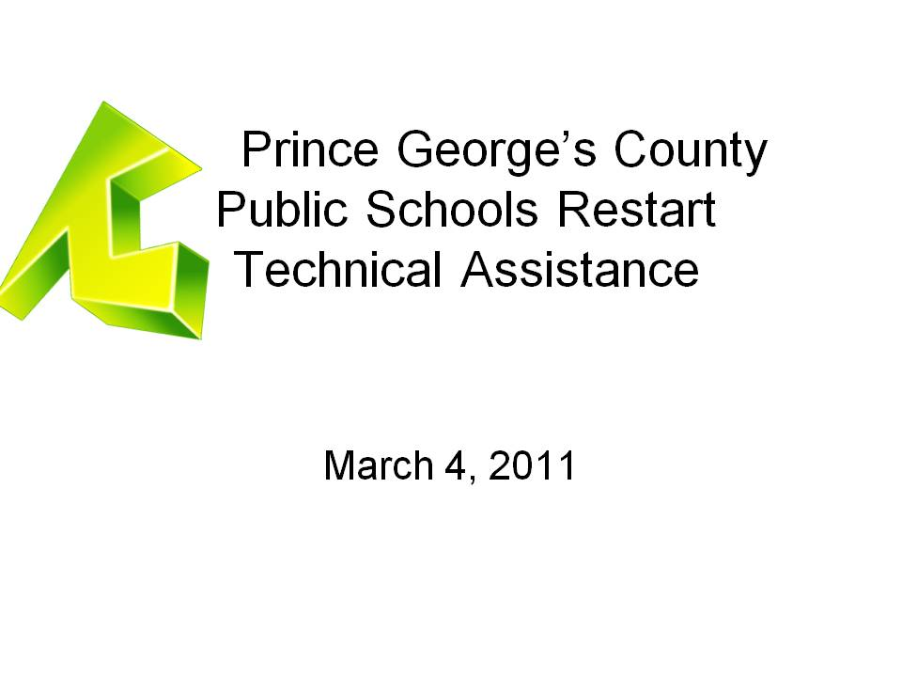

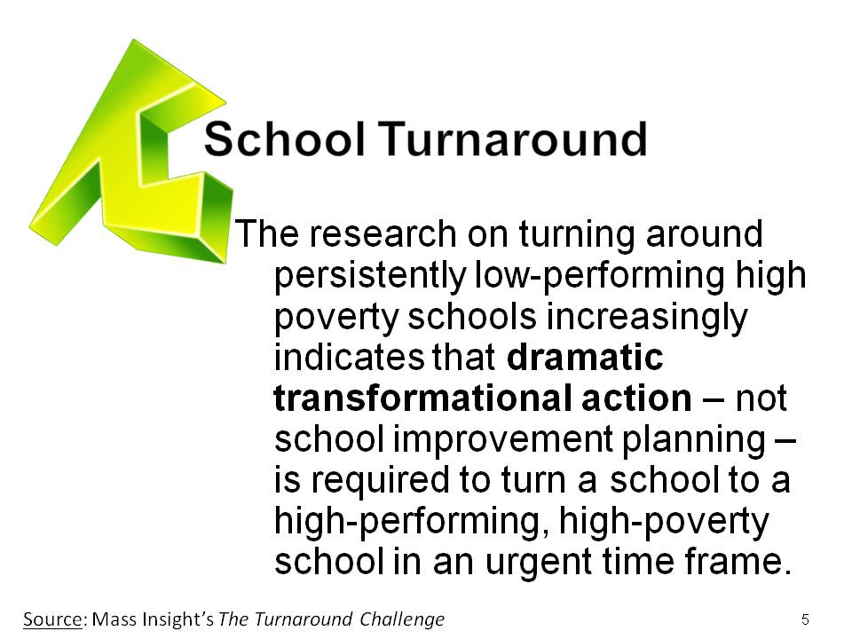

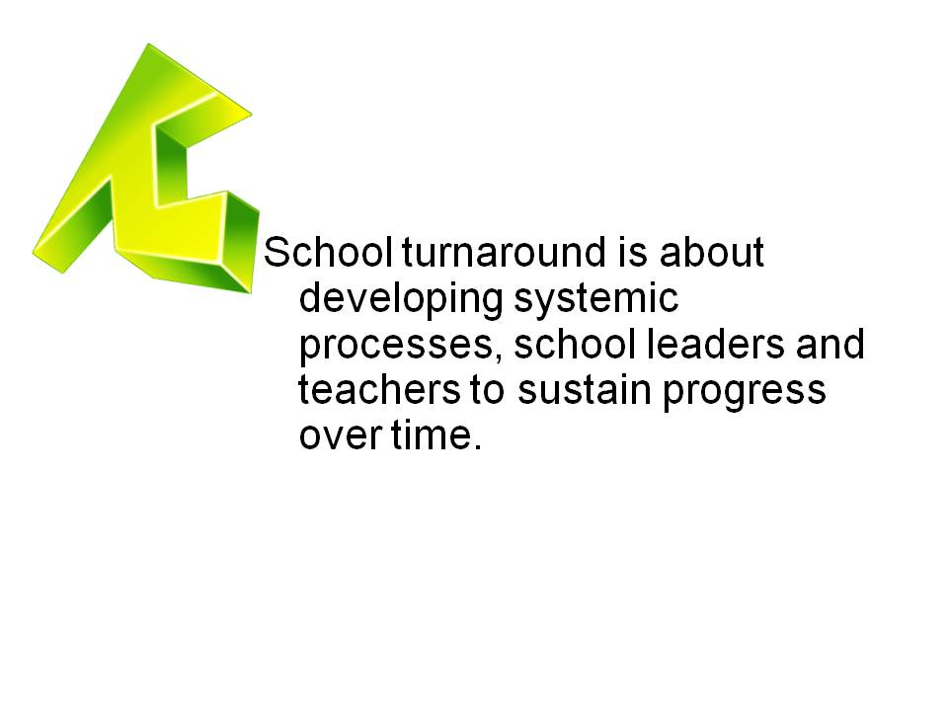

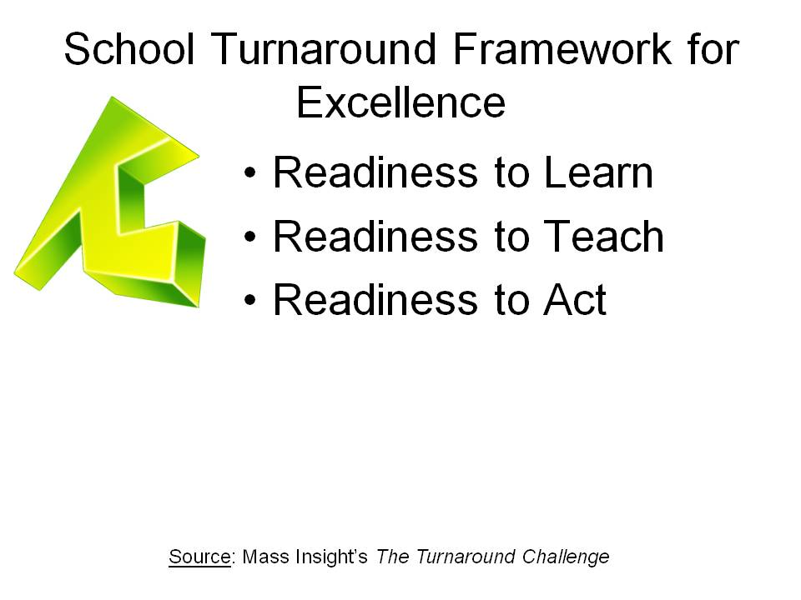

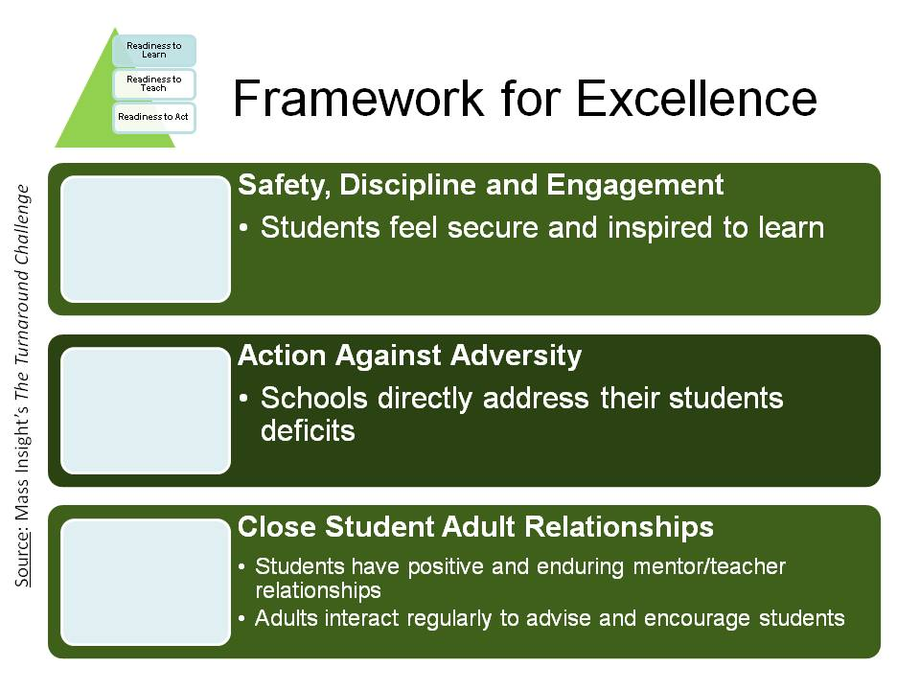
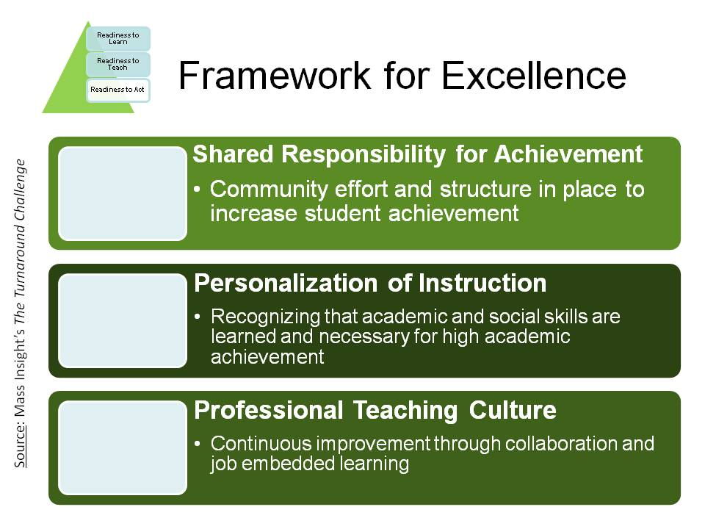

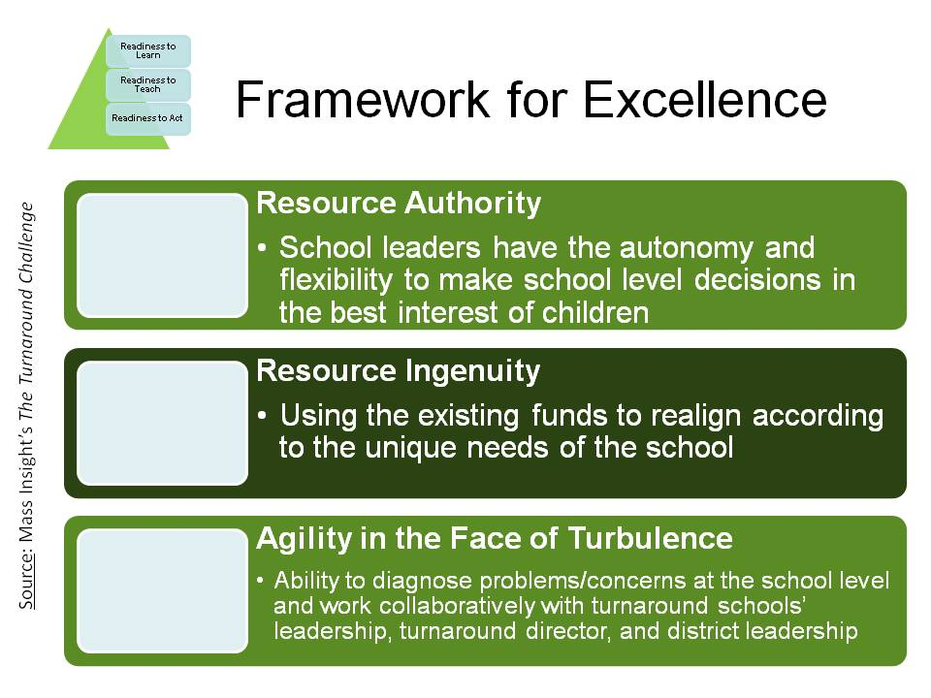

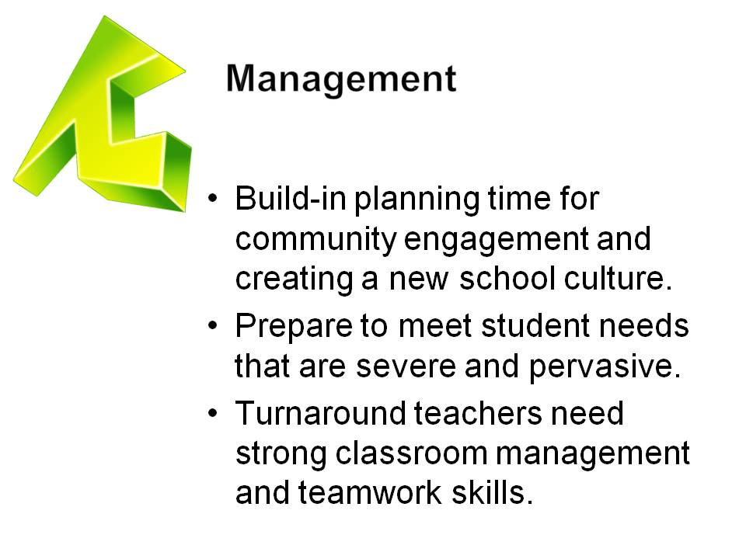

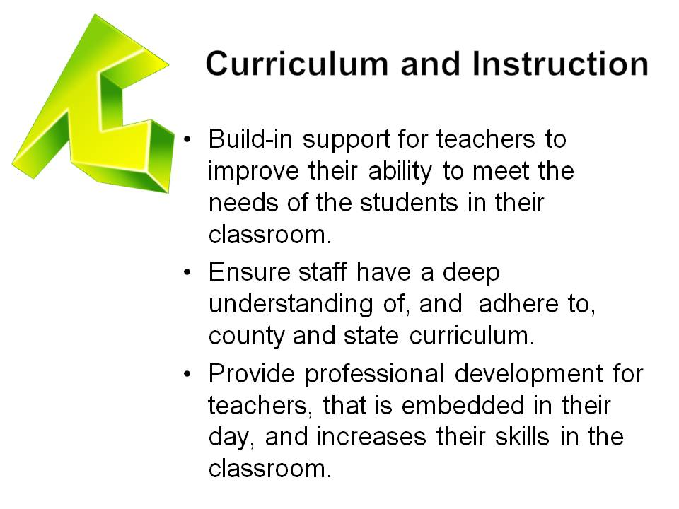

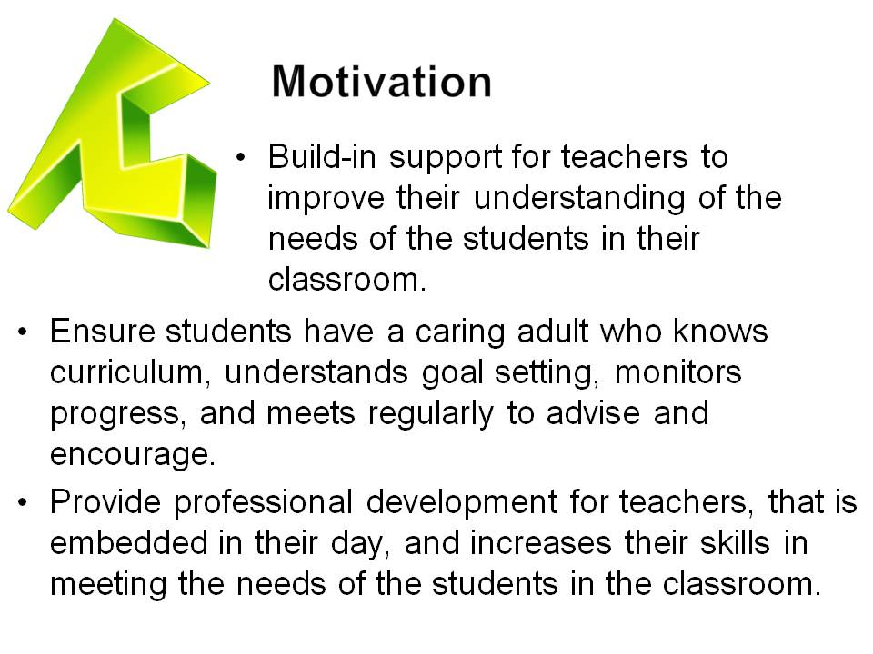

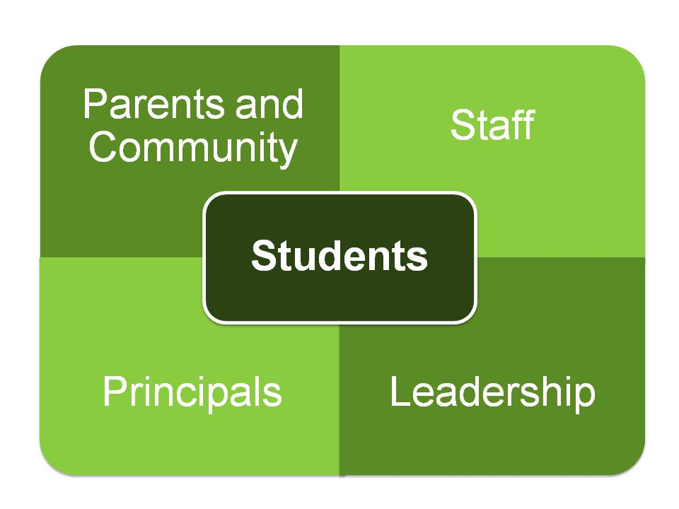

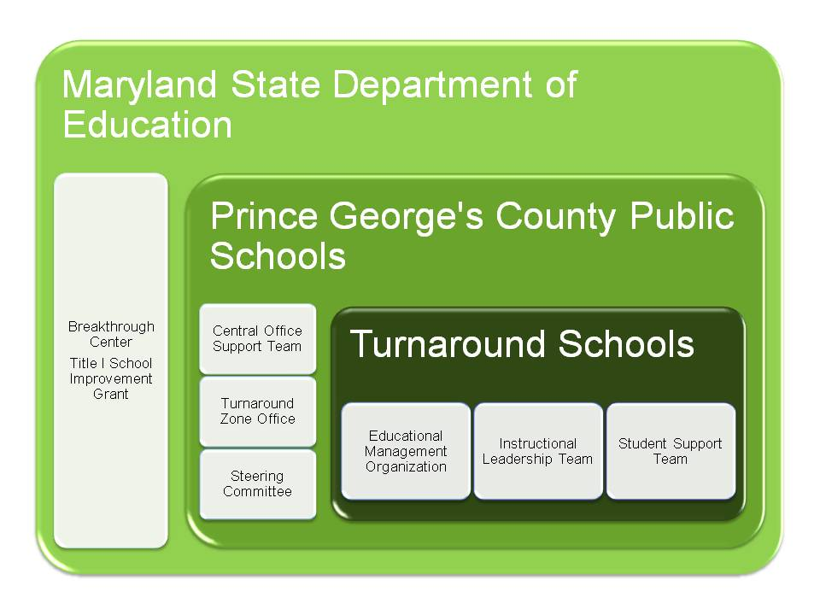

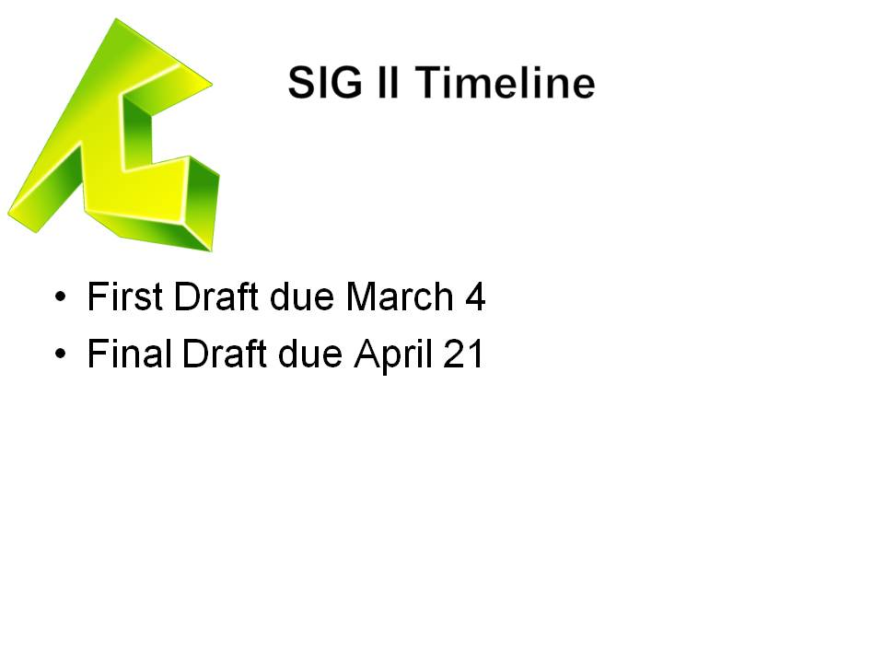

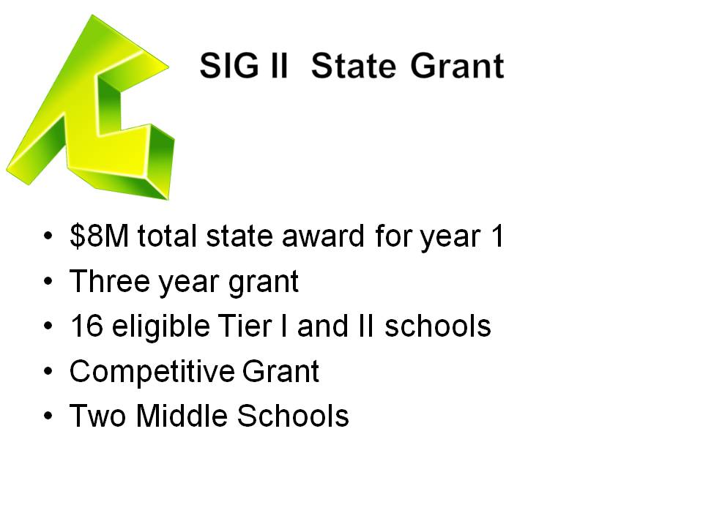

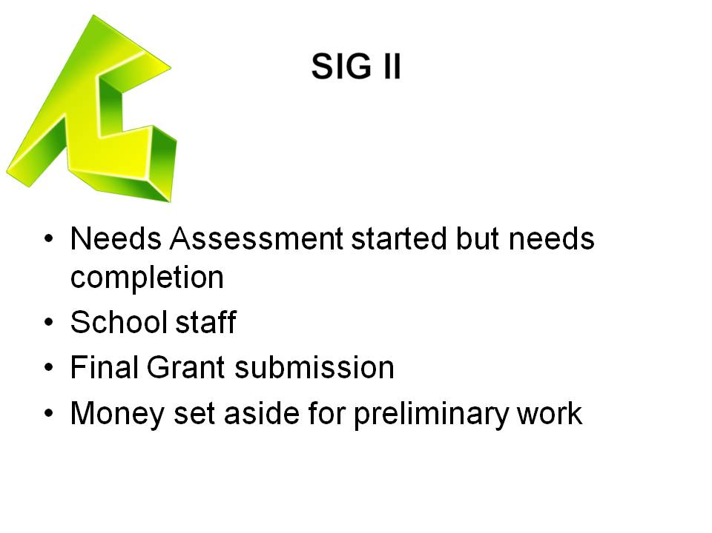

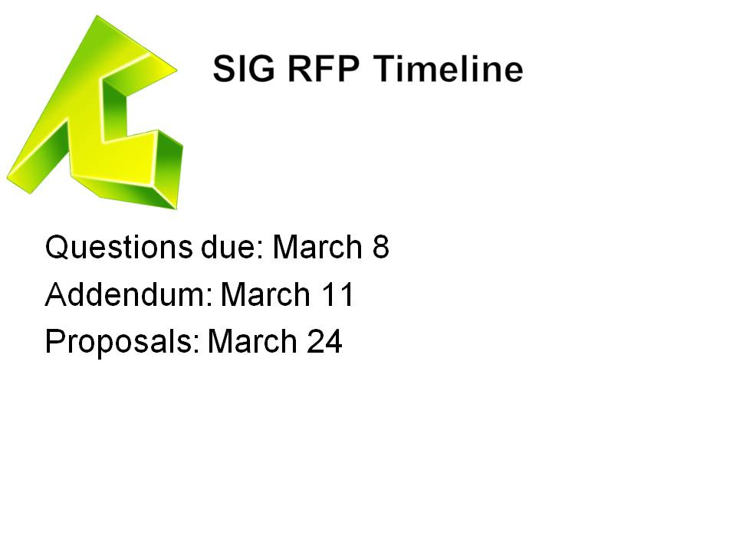

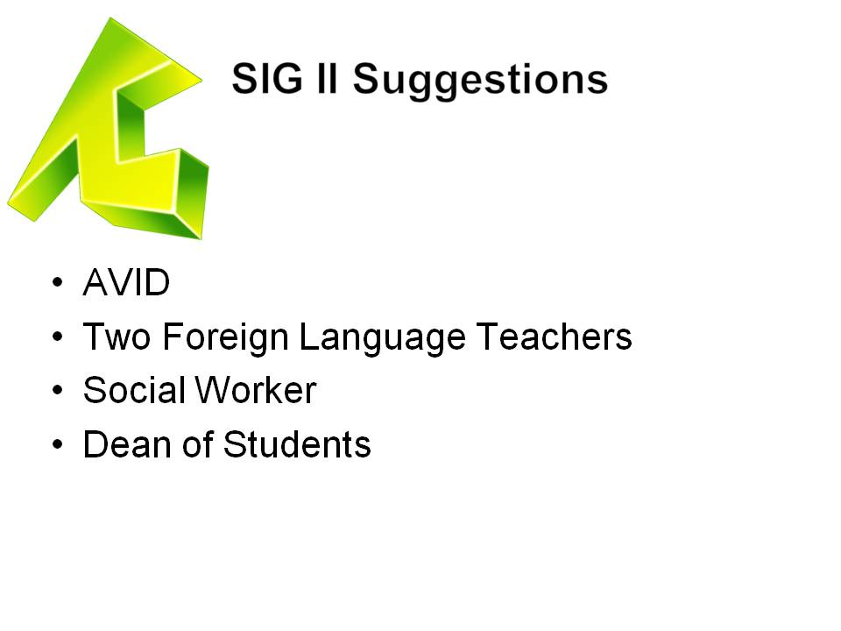

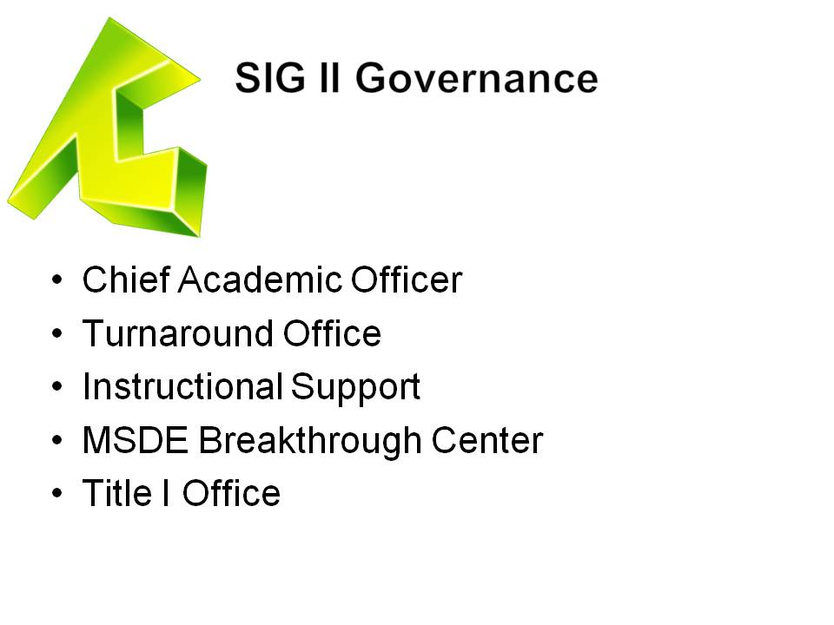

MEMORANDUM OF UNDERSTANDING (MOU)
FINAL
CONTRACT SCHOOL AGREEMENT
RESTART MODEL SCHOOL

Between

PRINCE GEORGE’S COUNTY PUBLIC SCHOOLS
And
Mosaica Turnaround Partners

SY: 2011-2012
School: Thomas Johnson Middle School and Oxon Hill Middle School
WHEREAS, pursuant to the federal School Improvement Grants ("SIG") program as authorized by §I003(g) of Title I of the Elementary and Secondary Education Act of 1965 (2001 Reauthorization of the Elementary and Secondary Education Act, Title I, Part A, Subpart 1), the Prince George’s County Public Schools (‘PGCPS”) has established the implementation of Restart Model Schools within the district;
WHEREAS, in accordance with the Code of Federal Regulations (34 CPR Subtitle B, Chapter IC), a Restart Model School is one in which a local educational agency converts a school or closes and reopens a school under a charter school operator, a charter management organization, or an education management organization that has been selected through a rigorous review process;
WHEREAS, PGCPS issued a Request for Proposals ("RFP #067-11") in order to seek interested organizations to operate Restart Model Schools;
WHEREAS, Mosaica Turnaround Partners submitted a proposal in response to RFP #067-11, attached hereto as Attachment 1, and was selected by the PGCPS to become a restart model School Operator; and
WHEREAS, the School Operator understands that performance under this contract is conditioned upon compliance and accountability requirements set forth in this Agreement and in accordance with both federal, State and PGCPS requirements.
NOW THEREFORE, in consideration of the premises and agreements, provisions and covenants herein contained, the PGCPS and School Operator enter into this Contract School Agreement ("Agreement") as follows:
- Term:
This Agreement shall be effective beginning SY 2011 for a period of three (3) school years, upon complete execution by the PGCPS and the School Operator, subject to earlier termination or renewal in accordance with this Agreement.

- Renewal:
This Agreement may be renewed for up to two (2) years based on meeting the performance criteria and following the process set by the PGCPS, and subject ⁻to appropriations and funds availability. There are no appeal rights in instances of non-renewal. See Attachment B for performance criteria.
2.1 Renewal Procedure:
The School Operator will be eligible for contract renewal during the final school year of the existing contract period.
The School Operator may apply to the PGCPS for a two (2) year renewal of this Agreement, provided such application is sent at least one-hundred-twenty (120) days prior to the end of the term of this Agreement. The parties recognize that the interests of the students are best served by maintaining a stable learning environment and, therefore, the PGCPS and the School Operator shall apply their best efforts toward such a renewal and shall conduct the renewal process in good faith. The PGCPS will consider such renewal requests based on, but not necessarily limited to, the school's academic performance, achievement of goals in the School Improvement Plan (if applicable) and/or Accountability Plan, student enrollment, parent and community engagement, and compliance with applicable local, state, and federal laws and regulations and the terms of this Agreement. The PGCPS will make a decision on the application and communicate it to the School Operator at least sixty (60) days prior to the end of the term of this Agreement.
- Facility:
PGCPS agrees to provide the School Operator sufficient space to implement its approved model, Space provided will meet all appropriate inspections. The PGCPS will ensure that the School is located in a facility that can house the approved number of students for each year of growth and that appropriate science labs and internet connectivity will be provided.
PGCPS is responsible for maintaining, and ensuring all aspects of the facility are in good operating condition (i.e. HVAC, plumbing).
To the extent the PGCPS has ancillary property in the form of desks, tables, or chairs it will make that available for the efficient provision of educational services.
- Operating Funding:
PGCPS, through its partnership with the State, local foundations, and benefactors shaft provide the Restart school with start-up funding for the first year in an amount up to $777,350, the second year $399,000 and third year $399,000 in addition to the normal general fund expenditures allotted to each school in the district.
The School Operator will maintain proper inventory and accounting of all materials purchased with startup funding and other PGCPS' funding. Inventory will include identifying the property as "PGCPS Property" and maintaining a control system showing purchase price and location in building. The School Operator must comply with all EDGAR regulations regarding equipment as stipulated in 34CFR Part 74 and school specific policies and procedures.
The School Operator agrees to the projected budget for each fiscal year in order to receive additional funding from the SIG program. SIG funding is contingent upon appropriations issued by MSDE.
The Restart Model Schools will be eligible for the same centrally supported services as other PGCPS.
The fiscal year for operating funds will be July 1st through June 30th. Each school will participate in the PGCPS internal auditing and State auditing processes.
5. Staffing
The School Operator may recommend its principal to the Superintendent. However, replacement of the principal or any staff must be a joint agreement between the School Operator and PGCPS. For all other staff the School Operator desires to employ, including instructional, administrative, and non-instructional staff, the School Operator has the autonomy to recruit and make recommendation to the Office of Human Resources. The School Operator will comply with the policies and procedures set forth by the Office of Human Resources. The School Operator will use the PGCPS principal and staff evaluation protocols. The School Operator may design and implement orientation around school specific policies and procedures.
The PGCPS requires the following standards of PGCPS employees assigned to each of the School Operator schools:
- The Superintendent retains the authority to assign and transfer educators and administrators as the needs of the system require. No assignments or transfers will be made without mutual consent of the parties. Both the Superintendent and the School Operator will operate in good faith.
- All members of the professional staff assigned to Thomas Johnson and Oxon Hill Middle Schools shall hold the appropriate Maryland certification.
- Employees at Thomas Johnson and Oxon Hill Middle Schools are public school employees of the PGCPS, as defined in §§ 6-401(d) and 6-501(f) of the Education Article, Annotated Code of Maryland and. shall have all rights contained therein.
- Employees are in the bargaining unit(s) with other public school employees in similar job classifications and are entitled to the salaries, benefits and working conditions in the existing negotiated agreement for their job classification, and are entitled to the rights and responsibilities of the appropriate collective bargaining agreement
- Existing employee organizations and the School Operator may mutually agree to negotiate amendments to an existing agreement to address the needs of the particular school. Agreements are subject to PGCPS approval.
- PGCPS employees assigned to the Restart School will be compensated according to the PGCPS compensation policies and existing collective bargaining agreements. Any deviation from the existing collective bargaining agreements shall be negotiated between the School Operator and the appropriate collective bargaining ⁻unit through a Memorandum of Understanding, which is incorporated by reference and attached hereto. The compensation, including salaries, stipends, fringe benefits and any other payments due to the PGCPS employees working at the Restart School shall be taken from the SIG allocation.
6. Autonomy:
The School Operator will have the autonomy to:
- Implement its proposed school model consistent with the application submitted to the PGCPS;
- Determine the staffing necessary for the implementation of its model;
- Manage its budget according to the needs of the school;
- Determine its own schedule for teacher professional development so long as schedules are consistent with current collective bargaining agreements or mutually agreed amendment to the existing agreements.
7. PGCPS Responsibilities
PGCPS will provide opportunities for resolution about questions and concerns regarding compliance and appropriateness through the PGCPS Chief Academic Office in consultation with the Office of the Superintendent.
PGCPS will provide the software and training necessary to School Operator staff and School Operator use of the School System's student data systems, including the Student Management System (SchoolMax), the Human Resources Management Systems (Oracle), and any assessment management system employed by the district (Performance Matters, Edusoft). Furthermore, PGCPS shall provide electrical upgrades and installation or upgrade of computer networking infrastructure to meet new school requirements.
PGCPS will provide health services, food services, information technology services, security, mail delivery and transportation services to the School Operator in the same manner and level as provided to other schools in PGCPS.
PGCPS agrees to provide human resource services to the School Operator and the School System employees assigned to the school, including payroll processing; direct deposit arrangements; leave processing; certification processing; benefits processing; employee requests for information and assistance; and retirement services consistent with PGCPS procedures and policies.
8. Compliance Requirements:
The School Operator agrees to comply with all PGCPS Administrative Procedures and Board Policies and PGCPS guidance and memoranda, including, but not limited to the PGCPS's Promotion Policy and Code of Student Conduct, unless waived (The PGCPS has authority to waive policies and procedures and the Superintendent has authority to waive guidance and memoranda.). In the event the School System or the PGCPS considers or adopts a new policy, procedure, and/or circular during the term of this agreement, the PGCPS or the Superintendent shall provide notice of it to the School Operator.
The School Operator agrees to participate in compliance monitoring and program evaluation requirements as determined by the PGCPS including data collection on staff, students, academic strategies/interventions, recovery/remediation, partnership and service contracts and internal audits conducted by PGCPS.
The School Operator will abide by all provisions of collective bargaining agreements (as they may be modified from time to time) and other existing contracts, copies of which the PGCPS agrees to furnish or make available to the School Operator.
The School Operator will follow the established procurement procedures of the PGCPS for the procurement of all supplies, equipment and other materials purchased through the PGCPS.
The School Operator will maintain compliance with all federal and state laws and regulations and will not discriminate on the basis of race, religion, color, national origin or ancestry, sex, gender identity, sexual orientation, age, marital or disability. This applies to all educational programs and extra-curricular activities.
9. Student Records:
PGCPS, its officers, and agents reserve the right to review at any and all times the records of any or all students enrolled in each School Operator school. Student records must be cumulative and continuous. A Transfer Form must accompany a student record at the time of transfer from one school to another. The entire cumulative record must be sent to the receiving school.
The School Operator shall obtain any necessary approvals and consents required in order for personnel employed by the School Operator (as distinguished from PGCPS employees who work at the School) to have access to personnel, student, and other records confidential by law, as necessary for the performance of this Agreement. PGCPS agrees to cooperate and assist the School Operator in obtaining such approvals and consents.
The School Operator will maintain and secure all student records relevant to PGCPS procedures and consistent with the Family Educational Rights and Privacy Act (FERPA) 20 U.S.C. § 1232g, State requirements as set forth in applicable statutes and regulations, and MSDE requirements as set forth in the Maryland Student Records Manual. The School Operator, its officers, and employees shall comply with the FERPA and State laws and regulations at all times, including when responding to subpoenas for student records. School Operator will comply with all MSDE yearly timelines for accountability as set forth in the Supplemental Accountability Data Manual and in the Maryland Public School Data Collection Manual. School Operator will comply with School System directed timelines for electronic data reporting. School Operator must use the student identification number assigned to the student for all record-keeping purpose. The School Operator shall maintain and keep up-to-date all student information data in a timely manner and in a format required by PGCPS, as well as the physical student records. The School Operator must use the School System's data for all special education reporting requirements, including Court Orders.
Should the School Operator enter into any contracts in which a 3rd party, not a party to this Agreement, may view, disseminate, review, or otherwise becomes privy to data protected from public disclosure under applicable federal and State laws and regulations, the School Operator and subcontractor must enter into a non-disclosure or confidentiality agreement protecting the rights of the parties with respect to such data. (See Sample Non-Disclosure/Confidentiality Agreement attached hereto as Attachment 3).
The School Operator will collect and maintain accurate and up-to-date data as requested by federal or state educational agencies or as directed by the School System, including, but not limited to, the following information: Annual Enrollment for Funding; Student Data Attendance; Student Data Discipline; Data Truancy; Length of School Year; Length of School Day; Special Education Student Count; Free and Reduced Meals Eligibility; Title I Information; English as a Second Language (ESL); 504 Eligibility; and Office of Civil Rights System Report. The School Operator will report this specific data for each school to the School System and by the deadlines reasonably set by the PGCPS. The data must be submitted in the same electronic format as required by MSDE and/or other reporting agencies.
The School Operator will report the attendance data for all enrolled students daily to PGCPS using the software provided by the School System.
10. Educational Program:
The School Operator commits to implementing the educational program as described in the application attached to this Agreement in Attachment 1.
PGCPS shall be notified of any substantive changes to the curriculum in the application or proposal as needed through a letter to the ONI.
11. Student with Disabilities:
- Students with disabilities who are enrolled in each School shall be provided with programs implemented in accordance with federal and state laws and local policies and procedures, specifically, 20 U.S.C. §§ 1400 et seq., the Individuals with Disabilities Education Act ("IDEA"); Section 504 of the Rehabilitation Act of 1973; and Title 8, Subtitle 4 of the Education Article of the Maryland Annotated Code.
- PGCPS will provide certain special education services to students with disabilities who require them as indicated on their individualized education program ("IEP”). These services include IEP services such as related services and staff in support of related services, extended school year (ESY) services, assistive technology, and related support, non-public placement, and temporary support assistants. IEP mandated transportation services will also be provided to the students requiring such services on their IEP.
11.1 Free Appropriate Public Education. The School Operator will provide a "free appropriate public education" (as defined in Section 8-401 of the Education Article of the Maryland Annotated Code) to each student with disabilities enrolled in the School.
11.2 Individualized Education Programs. The School Operator will utilize all of the PGCPS's forms and procedures related to pre-referral activities, referral, special education eligibility, IEP, development, and placement. The School Operator, in coordination with PGCPS, will develop an IEP and conduct an IEP meeting with the student's family for each eligible special education student enrolled in the School.
11.3 Least Restrictive Environment. Students with disabilities enrolled in the School will be educated in the least restrictive environment appropriate to their needs as indicated in their IEP, and will be segregated only if the nature and severity of the disability is such that education in regular classes with the use of supplementary aides and services cannot be achieved satisfactorily. Students whose needs cannot be adequately addressed at the School and require a regional, Public Separate Day Programs, or Non-public placements, as determined by the IEP Team in consultation with the PGCPS, will be appropriately referred; and the School's staff will work together with the PGCPS's personnel to meet the needs of these students.
11.4 Records. The School Operator shall maintain all records on enrolled students with disabilities and shall provide parents with copies of such records as requested and in accordance with the Special Education Compliance Manual. PGCPS has the right, at any time pursuant to Section 11.2 hereof, to review any documentation maintained by the School Operator pertaining to children with disabilities. PGCPS will provide to the School Operator all records pertaining to School's students with disabilities who have transferred from other School System schools to the School. Likewise, the School Operator will provide to PGCPS all records pertaining to School's students with disabilities who have transferred from the School to another School System school.
11.5 Cooperation. The School Operator will work closely with PGCPS's staff to discuss the needed services (including all related services and programs) of the School's students with disabilities. The School Operator will cooperate with the PGCPS in any legal or quasi-judicial activity regarding the educational program or placement afforded special education students attending or admitted to the School, including but not limited to a due process hearing request or a formal complaint.
11.6 Procedural Safeguards. Parents of students with disabilities will be afforded notice of procedural safeguards by the School Operator in their native language, which safeguards will include the areas of notice and consent, due process hearings, and discipline procedures. Materials describing procedural safeguards will be provided by the School System to the School Operator for School students with IEPs and their families.
11.7 Third Party Billing. PGCPS shall be primarily responsible for recovery of Part B and Part C Medicaid costs, for Medicaid-eligible students receiving IEP/Interagency Family Service Plan services, as per guidance published by the School System's Office of Third Party Billing. The School Operator shall ensure that all necessary on-site documentation is completed and provided to the PGCPS in a timely fashion. This includes documenting and submitting direct service encounter data for all special education students enrolled in the School (or Infants and Toddlers serviced in the School) regardless of Medicaid eligibility; providing a case manager, identified by name and title on all special education records, for each special education student; documenting and submitting monthly service coordination claims by the case manager to Third Party Billing; submitting copies of all IEP meeting minutes to Third Party Billing; ensuring that all service providers and case managers are appropriately licensed or certified as required by State of Maryland Medicaid regulations; ensuring that all professional notes and attendance records are maintained for seven (7) years; having appropriate staff attend regular Third Party Billing training activities; and responding to all requests to comply with self-monitoring, review, and audit activities. All federal reimbursements in the Third Party Billing program are made to PGCPS, and will be used by the School System to defray the cost of providing this service.
12. Homeless Students:
The school Operator will provide support for the academic success and personal development of homeless students enrolled in Restart school. The School Operator will comply with Title X, McKinney-Veto Homeless Assistance Act to ensure school stability and equal access to FAPE, as well as comply with PGCPS Administrative Procedure 5010 regarding educational services for homeless students.
13. Student Safety
The School Operator will comply with all PGCPS safety rules and regulations.
14. Review Process/Evaluation:
The schools will be expected to meet accountability standards set forth by the school system and defined by the ESEA, as amended by the No Child Left Behind Act of 2001 ("NCLB") and such standards shall be revised in accordance with any changes resulting from the reauthorization of NCLB.
The School Operator's and the School's performance shall be evaluated in accordance with the performance standards set forth in its Application, approved Accountability Plan, and its state mandated School Improvement Plan, if applicable.
The School Operator will participate in state and local site reviews to evaluate the school's progress and develop priorities for the remainder of the fiscal year.
15. Assessment:
The schools will be expected to meet accountability standards set forth by the school system and those defined by NCLB. Performance targets are set forth in Attachment B.
The School Operator will comply with all assessment requirements of Maryland State Department of Education (MSDE) and PGCPS. The School Operator will comply with all test administration and test security procedures, including appropriate documentation mandated by MSDE. The School Operator will administer MSDE assessments in accordance with MSDE requirements and the school calendar developed by PGCPS. The calendar for these assessments is subject to change at any time, with prior notification, at the sole discretion of PGCPS.
16. Insurance:
The School Operator shall, at its sole expense, procure and maintain during the life of this Agreement the following required insurance coverage:
- Business Automobile Liability at limits of not less than One Million Dollars ($l,000,000) per occurrence for all claims arising out of bodily injuries or death and property damages. The insurance shall apply to any owned, non-owned, leased, or hired automobiles used in the performance of this Agreement.
- Workers’ Compensation coverage as required by the State of Maryland, as well as any similar coverage required for this work by applicable Federal or "Other States' State Law.
- Professional Liability, Errors and Omissions Insurance at a limit of not less than One Million Dollars ($1,000,000.00) in the event the service delivered pursuant to this Agreement, either directly or indirectly, involves or requires professional services. "Professional Services" for the purpose of this Agreement shall mean any services provided by a licensed professional.
- PGCPS, and their respective elected/appointed officials, employees, departments, agencies, agents and volunteers shall be covered, by endorsement, as additional insureds as respect to liability arising out of activities performed or to be performed by or on behalf of the School Operator in connection with this Agreement.
- The School Operator's insurance shall apply separately to each insured against whom a claim is made and/or lawsuit brought.
- The School Operator's insurance coverage shall be primary. Any insurance and/or self-insured program maintained by PGCPS and their respective elected/appointed, officials, employees, departments, agencies, agents and volunteers, shall not contribute with the School Operator 's insurance or benefit the School Operator in any way.
- Coverage shall not be suspended, voided, canceled, reduced in coverage or in limits, except by the reduction of the applicable aggregate limits by claims paid, until after forty-five (45) days prior written notice has been given to PGCPS. There will be an exception for non-payment of premium, which is ten (10) days notice of cancellation.
- Insurance is to be placed with insurers with a Best's rating of no less than A:VII, or, if not rated with Best's with minimum surpluses the equivalent of Bests' surplus size VII and must be licensed/approved to do business in the State of Maryland.
- The School Operator shall furnish the PGCPS's Director of Procurement, a "Certificate of Insurance” with a copy of the additional insured endorsement as verification that coverage is in force. PGCPS reserves the right to require complete copies of insurance policies at any time.
- Failure to obtain insurance coverage as required or failure to furnish Certificate(s) of Insurance as required may render this Agreement null and void; provided, however, that no act or omission of PGCPS shall in any way limit, modify or affect the obligations of School Operator under any provision of this Agreement.
17. Indemnification:
The School Operator shall defend, indemnify and hold harmless PGCPS, their departments and their elected/appointed officials, officers, employees and agents against and from any and all claims, actions, damages, injuries, losses, expenses, and costs of every nature and description, including reasonable attorney's fees, litigation expenses, including the fees of expert witnesses, and court costs, to which PGCPS, their departments and their elected/appointed officials, officers, employees or agents may be subjected as a result of, arising from, or in connection with non-intentional tortuous conduct of the School Operator or its consultants, employees, agents, servants (who are not also employees of or volunteers to PGCPS) which conduct results in personal injury or property damage to a third-party.
18. Financial Review/Audit:
The School Operator will be responsible for conducting an annual audit and providing that to PGCPS on a timetable required by PGCPS.
Upon thirty (30) days written notice, the School Operator, shall be responsible for providing a financial report of all expenditures to date, including but not limited to finances received from PGCPS and other revenue sources related to the operation of the schools, in a format acceptable to PGCPS.
19. Amendment:
This Agreement maybe amended in writing and signed by the parties.
20. Termination:
PGCPS may terminate this agreement upon forty-five (45) days written notification for any of the following reasons:
- The School Operator has not fulfilled a condition imposed in writing by PGCPS in connection with this Agreement or the School Operator fails to comply with this agreement or provisions of federal, state, or local law.
- The fiscal condition of the school is deficient in accordance with PGCPS policy and procedures.
- The academic condition of the school is deficient as defined by PGCPS policies and procedures or the school fails to meet AYP as defined by the Federal "No Child Left Behind Act” for two (2) consecutive years.
- The continuation of the operation of the school is not in the best interests of the public, or of the students of the School System,
- Failure of the School Operator to grant access to the School or to records as requested by the Superintendent's designees.
20.1 PGCPS Termination for Convenience:
The performance of work under this Agreement may be terminated by PGCPS or its designee in accordance with this clause, in whole or in part, at any time, whenever PGCPS shall determine that such termination is in the best interest of PGCPS, upon no less than forty five (45) days prior written notice.
Should PGCPS terminate this Agreement in accordance with this provision, the School Operator shall have no other right to compensation or payment except for actual services rendered with actual expenses paid prior to the date of termination that has been approved by PGCPS and reasonable costs associated with the termination of the contract. However, the School Operator shall not be reimbursed for any anticipatory profits that have not been earned up to the date of termination. Upon receipt of the notice and unless otherwise directed by PGCPS, the School Operator shall immediately terminate the performance of services under this Agreement on the date and to the extent specified in the notice but shall complete performance of any services not terminated by the notice and shall take any other action directed in the notice or by PGCPS.
20.2. School Operator Termination for Convenience:
The School Operator may terminate this Agreement by notifying the School System by March 1 of a given school year of its intent to cease operations the following school year.
20.3. Termination Procedure:
- Should the Superintendent initiate termination pursuant to one or more of the causes listed above PGCPS shall first provide written notice to the School Operator of the basis for termination including:
(1) a full description of the basis for termination,
(2) instructions for correcting the deficiency or failure that is the basis for termination, which may include a request for a corrective action plan, and
(3) a specified, reasonable period of time during which the School Operator may remedy the problem. If the school fails to remedy the problem within the specified time, the Superintendent may recommend in writing to PGCPS that it terminate the School Operator's Agreement. The Superintendent shall provide a copy of this written recommendation to the School Operator. The School Operator shall then have ten (10) business days upon receipt in which to file objections with the Superintendent and PGCPS' Contract Monitor. If any objections are filed, PGCPS must hold a hearing on the recommendation and objection(s) thereto, or it may refer the matter to a designated impartial hearing officer for adjudication. PGCPS is authorized to accept, reject, or to modify the designated hearing officer's decision.
- The Superintendent shall provide a copy of this written recommendation to the School Operator and efforts will be made to make the termination effective at the end of an academic school year.
- If, however, the basis for revocation involves an immediate threat to the health, safety, or welfare of students at the school, PGCPS may immediately suspend operation of the school and revoke the agreement. The School Operator School shall be granted the opportunity for a hearing before PGCPS or an impartial designated hearing officer. PGCPS is authorized to accept, reject, or modify the designated hearing officer's decision.

21. Invalidity of provisions of this Agreement:
The invalidity of any particular provision of this Agreement shall not affect any other provision hereof and this Agreement shall be construed as if such invalid provision were omitted.
22. Drafting of provisions:
The Agreement shall not be construed or interpreted for or against any party hereto because the party drafted or caused that party's legal representative to draft any of its provisions.
23. No Waiver:
No waiver of any breach of any provision of this Agreement shall operate as a waiver of such provision of this Agreement or as a waiver of subsequent or other breaches of the same or any other provision of this Agreement, nor shall any action or non-action by either party be construed as a waiver of any provisions of this Agreement or of any breach thereof unless the same has been expressly declared or recognized as a waiver by such party in writing.
24. Entire Agreement:
This Agreement supersedes all prior oral and written proposals and communications between School Operator and PGCPS related to School Operator's services to be performed and unless validly executed Amendments are herein incorporated by reference to this Agreement.
IN WITNESS WHEREOF, the parties have signed and sealed this Memorandum of Agreement as of the day first written above.

______________________________________ __________________________
John Q. Porter, President Date
Mosaica Turnaround Partners

______________________________________ __________________________
William R. Hite, Superintendent Date
Prince George’s County Public Schools

______________________________________ __________________________
Keith Miles, Director of Procurement Date
Prince George’s County Public Schools

MEMORANDUM OF UNDERSTANDING (MOU)
Attachment A
Mosaica RFP

Note: This is a comprehensive response to the RFP. It does not represent the final agreement. Please refer to the MOU and Attachment B to the MOU for the final structure and agreement.

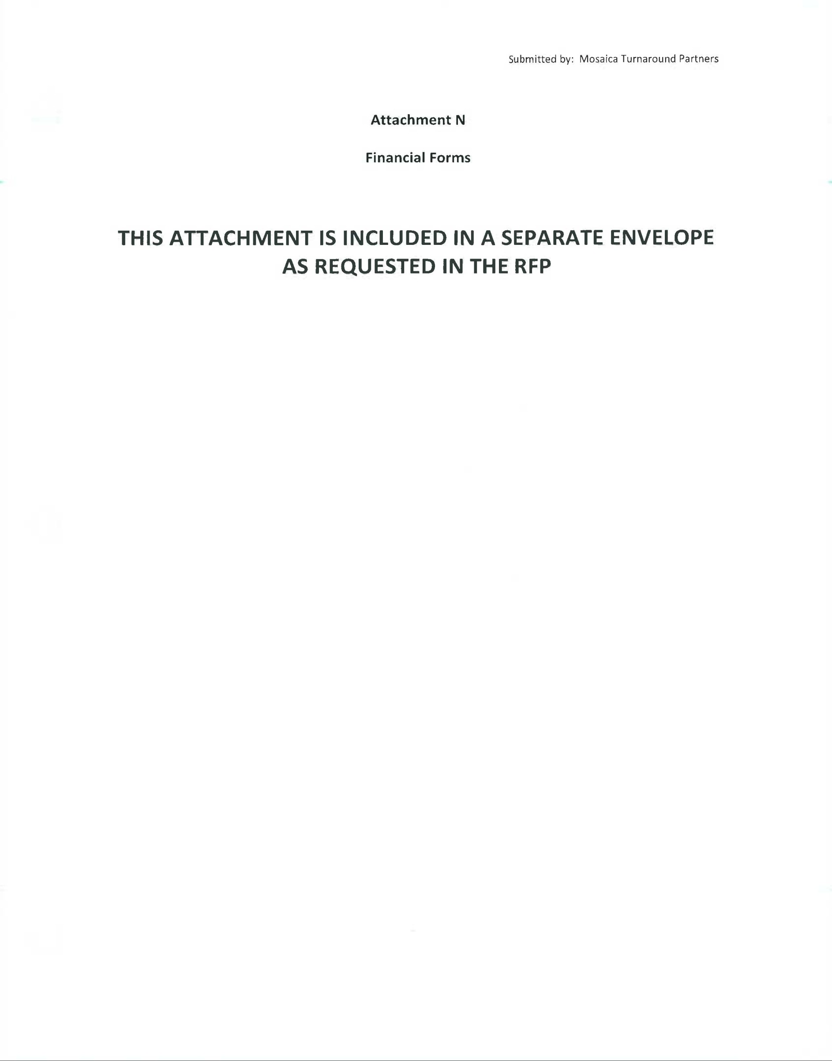

MEMORANDUM OF UNDERSTANDING (MOU)
Attachment B
ATTACHMENT B
Agreement
Mosaica Turnaround Partners and Prince George’s County Public Schools
Deliverables

Mosaica Turnaround Partners (MTP)
Prince George’s County Public Schools (PGCPS)

PGCPS agrees to:
- Provide staffing up to the staffing ratios for the district;
- Provide and maintain the facility;
- Provide access to all technology allotted to each middle school in the system;
- Allow access to all district-wide professional development opportunities;
- Provide all curricular documents allotted to district middle schools;
- Provide access to all assessments allotted to district middle schools;
- Provide access to an Executive Steering Committee to address district policy.

MTP agrees to:
- Complete preliminary work prior to opening the school in August, to include:
- Observations of all staff between April 25 and May 30, to make recommendations for staff changes;
- Input into securing new staff for the coming year;
- Hosting parent meetings (at least four) between May, 2011 and August 2011;
- Pre-service orientation of staff to include climate and culture protocols and routines and rituals for classroom instruction;
- A student schedule to maximize learning time, including a plan for extended learning opportunities;
- Placement of two content specialists, a community engagement specialist, a behaviorist, and a data coach in each school.
- Implement a collaborative planning/data analysis protocol for teachers;
- Personal Student Achievement Plans for each student by September 30, 2011;
- Full implementation of PBIS by March 2012;
- Full implementation of Compass Learning by October 2011;
- Access to a leadership coach, bi-monthly beginning in September 2011;
- Establishing a Character Education Program by March 2012;
- Implement a Managed Performance/Empowerment approach by November 2011;
- Implement computer adaptive assessments by January 2012;
- Provide professional development on multiple intelligences by April 2012;
- Provide professional development on differentiation by January 2012;
- Establish Professional Development Goals for each professional staff member by October 2011.
Performance Criteria
- Attain growth in the following metrics:
- Decrease in suspension rates from March 2011 to March 2012;
- Increase in FAS scores from FAS I 2010 to FAS I 2011 by three percentage points in reading and math at each grade;
- Increase in FAS scores from FAS II 2011 to FAS II 2012 by three percentage points in reading and math at each grade;
- Decrease in the number of chronic absenteeism from March 2011 to March 2012. Chronic absenteeism defined as 10 days absent or more on March 31.
- Conduct a satisfaction survey for staff and the community by March 31, 2012. Target is 75% satisfaction.
- Review SIG Monitoring notes. Target is 80% met or partially met in all criteria.

