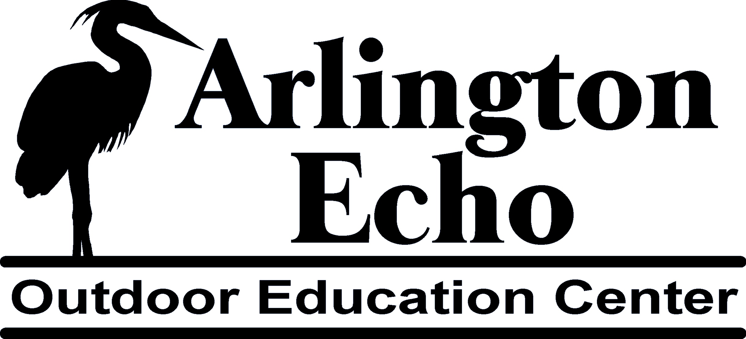

Chesapeake Choices: Eat Locally for the Bay

- Introduction: Ask “How many students have had a garden?” “How many students have been to a farm or farm stand?” “What are students’ favorite fresh fruits and vegetables? Let students know that this is ‘Maryland Homegrown Lunch Week”. (see Supplement A) Ask them why they think Arlington Echo might be celebrating this week as part of their environmental project.

- Where does your food come from?

Part A: Food Processing
Materials: 5-10 examples of food products (i.e. a bag of baby carrots, a Lunchable, a Capri Sun), a small symbol or picture of each product, a “you are here” symbol, tacks or tape, a large map of the United States, with a scale in miles, ruler.
Procedures: Distribute one food product and its corresponding symbol to each student. Ask students to read the labels to determine where their food originated. (if it is a processed food, we are looking for the place it was packaged) One at a time, have students place the symbol or picture of their product on the map with tack or tape. Have students measure the distance their food has traveled to reach the school. Once all symbols are on the map, have students discuss the distances foods have traveled and what resources are involved in transporting items from processing plant to Maryland. Ask “What are the environmental consequences of this transportation?”

Part B. Dissecting Cheese Pizza
Materials: A box of Cheese Pizza, small symbols representing the plants/animals that contribute ingredients for Cheese Pizza, tape or tacks, 2 colors of yarn or string.
Procedures: Ask Students if they can name the plants or animals who are involved in ingredients for Cheese Pizza. As a student names an ingredient plant or animal (i.e. tomato), give that student the small symbol of that ingredient and place it on the map where most of that plant/animal are grown. For example most tomatoes come from California or Florida. Once all ingredients are named, use one color of string to connect ingredients to processing plant, and then a different color string from processing plant to MD. Adding all of the collective distances will give you the miles that food has traveled before reaching your plate.

- Local Food Lore
Materials: True/False Food Statements (see Supplement B), blank surface for posting statements.
Procedures: Divide students into pairs or groups. Give each pair one true and one false statement and time to decide which is true. Discuss the ways eating locally grown fruits and vegetables can benefit the Bay (see resource information).

- Using Local Food: cooking or eating any of the many fruits and vegetables available during this bountiful time in Maryland. (See Supplement C)

Supplement A

Maryland Profile
A new program being developed by the Maryland Department of Agriculture and the Maryland State Board of Education will bring more Maryland-grown products to school lunches and help educate students about where their food comes, how it is produced, and the benefits of a healthy diet. The Jane Lawton Farm to School Program, so named in honor of the late Maryland House of Delegates member Jane Lawton of District 18, Montgomery County, was created during the 2008 Session of the Maryland General Assembly when *SB 158 Farm-to-School Program – Activities and Promotional Events, *sponsored by Senator Jamie Raskin, was signed into law by the Governor in May.
The Jane Lawton Farm-to-School Program will promote the sale of nutritious locally grown farm goods to our schools; solicit farmers to participate and keep a database of those participating along with their farm products and harvest schedules; connect school systems and farmers; and establish "Maryland Homegrown School Lunch Week" to promote Maryland agriculture through school meal and classroom programs and interaction between students and local farmers.
In 2008, the first Maryland Homegrown School Lunch Week will be held September 22nd through September 26th with a kickoff event tentatively scheduled for Wednesday, September 24th in Montgomery County. The program will also provide educational materials for teachers to integrate into their lessons to help students make the connection between their lunch menus and the agricultural process. Thus far, approximately 400 schools in Montgomery, Cecil, Carroll, and Anne Arundel Counties are planning to feature local produce in their menus during Homegrown School Lunch Week and as the program develops, more school systems will undoubtedly take part as well. For more information on the Jane Lawton Farm to School Program and where to find Maryland-grown meats and produce, please visit www.marylandsbest.net or call 410-841-5770.

Supplement B

(The following are a few True/False Statements pertaining to local food. Feel free to supplement.)

True & False

- Oranges, lemons, and bananas are some of the fruits grown locally. (F)

- A typical dinner has traveled 1500 miles from the source to your table. (T)

- One fourth of all meals consumed in the U.S are fast food. (T)

- Crops grown with and without pesticides have the same nutrient values. (F)

- Coal, oil, and natural gas are fossil fuels. (T)

- We have an unlimited supply of fossil fuels. (F)

- Burning fossil fuels releases carbon dioxide into the air. (T)

- Burning fossil fuels has no effect on global warming. (F)

- Buying local means shopping at the closest supermarket. (F)

- A farmer’s market usually has locally produced fruits and vegetables. (T)

- The money spent at a farmers market does not go to local farmers. (F)

- Food shipped long distances are fortified with ingredients to help preserve and protect the food. (T)

- Food shipped long distances usually needs extra packaging to protect the food. (T)

Supplement C

Lunch Box Ideas

*** Anything kids can roll, stack or dip.
~Try mini veggie sticks (carrot, pepper, broccoli) that can be dipped in a different sauce each day – yogurt/lime/curry, salsa/cream cheese, Ranch Dressing “dressed up” with some chili powder, garlic and lime juice, cream cheese and raspberry jam… the possibilities are ENDLESS)
~Try veggie Kabobs, raw (such as cherry tomatoes, mozzarella cheese and olive) or cooked such as peppers, mushrooms, broccoli marinated in sesame ginger marinade and grilled.
~ Apple wedges dipped in peanut/cream cheese dip (8 oz cream cheese, 1 C. marshmallow fluff, ¼ C. peanut butter; mix until smooth. Adjust ratio of ingredients to your taste.

*** Ask your child to help you cook a dinner for their lunch. On Sunday, make a large batch of any of the following, then pack some in your child’s lunch each day. These “hot” dinner suggestions are also great served cold in a lunch box.

~ Veggie Pizza – Use store bought dough, crust or even English Muffins. Spread on Sauce (pizza, spaghetti or even pesto), top with mozzarella cheese and veggies of your child’s choosing, grated or finely chopped.
~Veggie Fried Rice
~Veggie Quiche or Frittata

Recipes

Carrot Roll-Ups
1 carrot
1 large lettuce leaf
Peanut butter or cream cheese
Raisins or Craisins

Spread lettuce leaf with a healthy layer of peanut butter or cream cheese (it is helpful to soften the PB or Cream Cheese in the microwave for a few seconds). Sprinkle raisins or Craisins on top. Place carrot on one edge of the leaf and roll until Carrot is happily covered by its lettuce blanket. Enjoy!
*** You can essentially roll anything in lettuce. Be Creative. If your child loves pepperoni, roll that along with the veggies. Chances are the pepperoni taste will over-power the veggies.

Happy Face Tortillas (a healthy local food alternative to the Lunchable!)
1 whole grain flour tortilla (the small thick kind are best)
Sauce (taco sauce, veggie cream cheese, sour cream with salsa mixed in, or even ranch dressing)
Various fresh veggies grated or chopped very small (carrots, broccoli, peppers, tomatoes, scallions, cilantro) and packed in re-used yogurt, sour cream or margarine containers. Pack in a re-useable cooler lunch bag with a cold pack.
Other festive decorations such as olive slices, shredded cheese, craisins.
Spread a thin layer of sauce on tortilla. Create a face or other scene such as a flower, dog or sunset, using the veggies and other decorations. When finished, fold tortilla in half and chomp!!!
*** The same thing can be done with a pita pocket, minus the decorating. Stuff Pitas with veggies, cheese and try different sauces to top (yogurt-curry lime, raspberry vinaigrette, Mexican ranch)

Apple Sauce
Use McIntosh or Grimes Golden apples – not Red Delicious. Cut out the bad spots and remove skin and core. Cut into quarters and put in a kettle with a bit of water. Cover and cook over medium heat (almost at a boil, but not quite), stirring occasionally. Cook to desired consistency (if you want your sauce chunky, stop cooking while chunks still exist; otherwise, cook until smooth. Remove from heat. Add sugar and cinnamon to taste (I usually put only a few T. of sugar, if any. Let it set, covered, until flavors meld and sauce is cool – approx. 1 hour. Stir occasionally. Spoon into zip lock bags and freeze. You can serve apple sauce warm or partially frozen in a pretty glass bowl. It’s a nice complement to a heavy meal.

Simple Roasted Broccoli or Cauliflower
Toss Broccoli or Cauliflower spears in olive oil and arrange on 9 X 12 baking pan. Sprinkle lightly with sea salt, Old Bay or your favorite seasoning. Bake at 350 for 15 minutes, or until tender and begin to brown.

Trees and Raisins Salad
Salad:
1 handful smoked shaved turkey (or bacon) -cooked to death and crumbled
2 lbs. broccoli florets
½ C. golden raisins or craisins
½ C. sunflower kernels
½ C. red onion, diced
Dressing:
¾ C. sugar
1 t. dry mustard
1 t. salt
1/3 C. vinegar
1 C. vegetable oil
Process in blender for 1 minute. Toss with salad and allow to marinate in refrigerator. The longer it sits, the better it is.

Macaroni and “Cheese” Surprise
1 butternut squash, peeled, seeded and chopped
Vegetable or chicken broth
1 C. milk
1 C. lowfat cottage cheese
1 C. sharp cheddar cheese, grated (plus more for topping casserole)
¼ C. grated parmesan cheese.
4 C. cooked macaroni (cook only partially, since noodles will finish cooking when casserole is baked.)
Salt, pepper and nutmeg to taste.

Place squash and milk in a medium saucepan. Add broth until squash cubes are covered. Simmer over medium heat, uncovered until squash is tender when pricked by a fork. Remove from heat, cool slightly. Dump contents of saucepan into a blender or food processor. Blend until smooth. Add cottage cheese, parmesan cheese and spices. Blend again until smooth. Stir in shredded cheddar. Drain macaroni into a casserole dish. Pour sauce over noodles, stirring to incorporate. Top with additional cheese or your favorite crumb topping. Bake at 350 until bubbly (about 30 min.)

Spaghetti Squash with Sausage, Apples and Leeks
1 medium spaghetti squash
½ lb. sausage (I used roasted garlic chicken sausage from Trader Joe’s)
olive oil
1 bunch leeks, chopped (in a pinch, you can also use a few onions)
1 t. (or more) thyme (fresh is best!)
salt and pepper to taste
½ C. sherry
1-2 apples, peeled and chopped (I use Granny Smith)
Cut Spaghetti Squash in half, length-wise. Place cut side down on a baking dish. Add enough water so that it is ¼ inches deep. Cover with foil. Bake at 350 until tender (about 45 min.- 1 hour). Remove from oven and cool until you can handle it. Remove seeds and gently scrape out “spaghetti”. Set aside. (Sometimes I do this the night before.)
In a skillet, brown sausage in olive oil. Remove from skillet. Add leeks, thyme and season with salt. You may need a bit more olive oil. Cook until tender (8 min.). Add sherry and apple. Be sure to scrape all the good brown bits from the bottom of the pan. Cook 4 minutes, or until apples are slightly tender. Add sausage and squash. Heat, stirring, another 4-5 min. Season with salt and pepper. Serve with freshly grated Parmesan.
*** Once cooked, you can top spaghetti squash with any sauce. Sometimes the squash “noodles” are a bit crisp for kids. If this is the case, continue to cook the squash in the over or on the stove-top. after it has been tossed with the sauce. This allows squash to absorb the flavor of the sauce.

Chocolate Zucchini Cake
2 cups all-purpose flour
2 cups white sugar
3/4 cup unsweetened cocoa powder
2 teaspoons baking soda
1 teaspoon baking powder
1/2 teaspoon salt
1 teaspoon ground cinnamon (optional)
4 eggs
1 1/2 cups vegetable oil
3 cups grated zucchini
- Preheat oven to 350 degrees F (175 degrees C). Grease and flour a 9x13 inch baking pan.
- In a medium bowl, stir together the flour, sugar, cocoa, baking soda, baking powder, salt and cinnamon. Add the eggs and oil, mix well. Fold in the nuts and zucchini until they are evenly distributed. Pour into the prepared pan.
- Bake for 50 to 60 minutes in the preheated oven, until a knife inserted into the center comes out clean. Cool cake completely before frosting with your favorite frosting.

