Consolidated Local
Implementation Grant (CLIG)
SFY 2014
To Support the Provision of Early Intervention Services

To Infants, Toddlers, and Preschool Children with Disabilities

And Their Families in Maryland

July 1, 2013 to September 30, 2014

_____________________________________________________________

JURISDICTION/ DUNS NUMBER

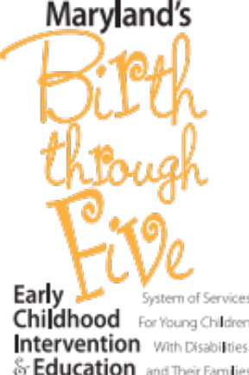

MARYLAND STATE DEPARTMENT OF EDUCATION
Division of Special Education/Early Intervention Services
Maryland Infants and Toddlers Program



With the support of the:
Maryland Department of Health and Mental Hygiene
Maryland Department of Human Resources

Lillian M. Lowery
State Superintendent of Schools

Marcella E. Franczkowski
Assistant State Superintendent
Division of Special Education/Early Intervention Services

Martin O’Malley
Governor

Contents

Overview
Introduction
Funding Sources
Submission Instructions
CLIG Requirements Submission Checklist

Section 1–Authorizations
Local Early Intervention System Contact List
Federal Certifications Certificate

Local Interagency Coordinating Council (LICC) Review Statement

General Education Provisions Act (GEPA), Section 427 Statement

Section 2–Annual Plan Requirements

Documentation of Local Lead Agency Designation, if applicable.
Local Interagency Agreement
Local Interagency Agreement Private Agency Attachment
Signed Assurance of Continuous Service

Local Interagency Coordinating Council Membership and Meetings
Directing the Use of Funds: Linking Funds to Program Improvement
Comprehensive System of Personnel Development (CSPD) Plan
Public Awareness (PA) Plan (Not required unless a local jurisdiction was required to provide an
Improvement Plan for Indicator 5 or Indicator 6 during SFY 2012)
Family Support Network/Preschool Partners

Section 3–Budget

Funding for Local Infants and Toddlers Programs: Guidelines for Budgeting and Planning
(Budget and Reporting Documents)
http://www.marylandpublicschools.org/MSDE/divisions/earlyinterv/fmb

Section 4–Assurances

Assurance of Continuation of Services

Section 5–Reporting Requirements

Local Reporting Requirements
Cumulative Variance Report and Semi-Annual Program Report
Final/Annual Program Narrative
Local Interagency Coordinating Council Annual Report
Data Collection
Federal Part C Reporting (as of October 25, 2013)
Finance Reports
MITP Reports Checklist for Consolidated Local Implementation Grants

Overview

Introduction
As the lead agency for Maryland’s early intervention system, the Maryland State Department
of Education (MSDE), Division of Special Education/Early Intervention Services (DSE/EIS) is pleased to present the Consolidated Local Implementation Grant (CLIG) for State fiscal year 2014 (SFY 2014), which begins July 1, 2013 and ends September 30, 2014 for federal funds and ends June 30, 2014 for State general funds.
Maryland's statewide system of early intervention is required to be implemented in accordance with Part C of the Individuals with Disabilities Education Act, 34 Code of Federal Regulations Part 303, Education Article §8-416, and the Proposed Code of Maryland Regulations, Title 13A, Subtitle 13., Chapter .01 and .02. Regulatory authority for distribution of funds in support of early intervention services to eligible infants and toddlers and preschool children in the Early Intervention System of Services and their families is provided in Proposed COMAR 13A.13.02.06 and 13A.13.02.08C.
The CLIG is designated as the single grant mechanism through which local jurisdictions receive federal and State funds to implement local early intervention programs in compliance with federal and State regulations, policies, and procedures.
Funds are made available to local jurisdictions to:
- Implement a local system of early intervention;
- Provide funding for direct services that are not otherwise provided from public sources;
- Enhance statewide capacity to provide quality early intervention services and expand and improve existing early intervention services being provided to young children with disabilities and their families (34 CFR §303.1); and
- Enhance the capacity of local programs and service providers to identify, evaluate and meet the needs of all children, including historically underrepresented populations, particularly minority, low-income, homeless, inner city and rural children, and young children in foster care (34 CFR §303.1).

Funding Sources

Part C
Of the
Individuals
With Disabilities Education Act
Part B
Section 611
Discretionary
Of the
Individuals
With Disabilities
Education Act
Part B
Section 619
Discretionary
of the
Individuals
With Disabilities
Education Act

Maryland
State
General
Funds

*Additional Funding Sources: Medical Assistance, and “Other Sources” (Other federal, other State, local funds & private funds)

I. Part C of the Individuals with Disabilities Education Act (IDEA)
The U.S. Department of Education provides Part C funds to the State of Maryland to:
(1) develop and implement a statewide, comprehensive, coordinated, multidisciplinary, interagency system that provides early intervention services for infants, toddlers and preschool children with disabilities and their families as part of a Birth through 21 System of Services; (2) facilitate the coordination of payment for early intervention services from federal, State, and local sources; and (3) enhance the State’s capacity to provide quality early intervention services and expand existing services provided to infants, toddlers and preschool children with disabilities, and their families.

Part C funds are provided annually by the U.S. Department of Education to the State Lead Agency responsible for early intervention services to eligible infants, toddlers and preschool children in the Early Intervention System of Services and their families under IDEA. The State Lead Agency in Maryland is the Maryland State Department of Education/Maryland Infants and Toddlers Program. The Part C allocation from MSDE/MITP to local lead agencies is based on the Part C Annual Child Count of children served on an IFSP, including those children from birth to their third birthday. The Part C allocation to the local lead agency includes:

- A fixed allocation of $5,000 to support the position of local Family Support Network (FSN) Coordinator and FSN activities, unless the State approves a local early intervention system to utilize a different funding source or to reduce the amount dedicated to the FSN; and
- A fixed allocation of $1,000 to support participation in the 2013 Special Education/Early Intervention Services Leadership Conference or other professional development activities.

II. Part B of the Individuals with Disabilities Education Act
MSDE determines the amount of Part B funding available annually and distributes the funding based on the Part C Annual Child Count. When the local lead agency (LLA) is not the local school system (LSS), the LLA shall transfer these funds to the LSS through local procedures to be described and included in this application.

III. Part B of the Individuals with Disabilities Education Act, Section 619 (Preschool)
MSDE distributes Part B, Section 619 funds based on the size of each jurisdiction that establishes Preschool Partners to support the transition of children and families from early intervention to preschool and from preschool to school age programs. At least part of the allocation must be used to support employment of a parent of a child with a disability on a salaried or contractual basis. It is not required that funds be transferred to the local school system. The CLIG budget should reflect distribution of funds to the agency responsible for implementing Preschool Partners.

IV. Maryland State General Funds
State funding for SFY 2014 available to the Maryland Infants and Toddlers Program will be distributed through this consolidated application. State funds distributed to LLAs through the SFY 2014 CLIG must be budgeted to improve child and family outcomes for children birth through 2 years of age. Specific guidelines for budgeting and expending State funds are included in Section 3 of this application. MSDE distributes the amount of State funding approved through the State budget process to local jurisdictions based on the Child Count*.

*Child Count – Federal and State Funding for Birth to Three (3) - Infants and Toddlers
The Part C Annual Child Count is determined by the number of children, birth to age three (3), served between the day after the last Friday in October and the last Friday in October the following year. Funding (excluding Part B 619) is based on the percentage of children, birth to age three (3), served in each jurisdiction as compared to all children, birth to age three (3), served by the MITP between October 29, 2011 and October 26, 2012.

V. Non-Competitive Discretionary Funds for the Extended IFSP

The MSDE is including discretionary funding for three- and four-year-old children participating in the Extended IFSP Option in the local CLIG application. The funding sources are federal Part C and/or Part B 611 dollars. This discretionary funding can only be utilized for early intervention, administrative or family support staff; professional development for staff and parents; contract staff, supplies/materials and/or adaptive equipment associated with three and four year old children, and their families, receiving services through an Extended IFSP.

Child Count – Noncompetitive Discretionary Funding for the Extended IFSP Option

The Child Count for distributing discretionary funds to each jurisdiction is determined by the number of children, age three (3) to four (4), served between the day after the last Friday in October and the last Friday in October the following year. Funding is based on the percentage of children, age three (3) to a child’s fourth birthday served by each jurisdiction as compared to all children, age three (3) to a child’s fourth birthday, served by the MITP between October 29, 2011 and October 26, 2012.

Submission Instructions for the CLIG Application

Under Regulation 34 CFR §76.708, each local Infants and Toddlers Program is required to submit a local application for federal funds in substantially approvable form and receive written authorization from MSDE prior to obligating funds.

CLIG Submission Due Date: May 15, 2013

The complete CLIG application is due to the MSDE/MITP on or before May 15, 2013. If a substantially approvable application is not submitted by May 15, 2013, the July 1, 2013 grant award start date cannot be guaranteed.

The grant award is contingent upon the submission of required program, financial, and data reports from the previous year.

New in SFY 2014: Beginning with the SFY 2013, Carryover grants will no longer be utilized to extend the availability of unexpended grant funds. All unexpended grant funds will be addressed through the grant extension amendment process.

- SFY2013- Extension request for unexpended funds is due on or before August 15, 2013

- The Local Lead Agency may request to extend the grant period on the CLIG lines that are funded under IDEA Part C, Part B, and Part B 619 through Section A and B of the C-1-25 B (Grant Change Request) budget form.

- Section A- Changes in the Grant Period to July 1, 2013- June 30, 2014,

- Section B- Reason to request a grant extension for each grant line.

How To Request an Extension of the Due Date

All requests for extension of the submission date must be submitted in writing by May 1, 2013 to
Ron Boone, Section Chief, Fiscal Management Branch (rboone@msde.state.md.us). A request for extension will not change the requirement that a substantially approvable application be submitted by May 15, 2013 to ensure the grant award period begins on July 1, 2013.

How To Submit the CLIG Application

Follow the instructions for each section and insert the materials requested. Submit a completed and signed electronic application. The complete application must be submitted electronically and must include all required signatures. Applications will not be reviewed or processed for approval unless they are completed and include the appropriate signatures.
Submit electronically to: MSDE SECURE SERVER at https://sst.msde.state.md.us

CLIG Requirements Submission Checklist

Before submitting the local CLIG application, use this checklist to ensure that all required components are provided. Include the completed checklist with your application.

Jurisdiction:

Section 1– Authorizations
- Local Early Intervention System Contact List
- Federal Certifications Certificate signed by authorized representative
- Local Interagency Coordinating Council Review Statement signed by LICC Chairperson
- General Education Provisions Act (GEPA), Section 427 Statement

Section 2– Annual Plan Requirements
- Documentation of Local Lead Agency Designation, if applicable
- Signed Local Interagency Agreement
- Local Interagency Agreement Private Agency Attachment Services
- Signed Assurance of Continuous Services
- LICC Meeting Schedule With At Least Four Meeting Dates
- LICC Membership List
- Linking of Funds to Program Improvement
- CSPD Plan
- Public Awareness Plan, if applicable
- Preschool Partners Narrative

Section 3– Budget

http://www.marylandpublicschools.org/MSDE/divisions/earlyinterv/fmb

Note: On all budget forms, make sure all columns and rows are added correctly

Note: Most budget forms now include discretionary Part C and/or Part B funding for the Extended IFSP Option
- Form C-1-25 for each funding source with budget totals requires LITP director and financial representative signatures
- Form 100 with correct dollar amounts for all funding sources for all partner agencies* *Partner agencies are local education agencies, departments of health, departments of social services, and in a few jurisdictions other agencies
- LEA/PA Prohibition Against Supplanting Calculation Template combines budget figures for all partner agencies
The following budget forms must be completed for all partner agencies*
- Form 100A agency budget totals for each funding source and when totaled match the Form 100 totals
- Form 100B include the number of FTE’s and the salary amounts for each funding source by job title or classification. Include the fringe cost for each funding source.
- A separate Form 100C-Budget Narrative for each object category (02–05), with the breakdown of costs for specific line items (e.g., separate amounts for office and service supplies) and adequate detail (e.g., description of supplies, such as printer paper and cartridges or assessment tools, toys, or craft items to be purchased).
  - Other Sources - All funding sources which support the local early intervention system, except for Part C, Part B, and State funds distributed through the CLIG and Medical Assistance, are included in the “Other Sources” column on Forms 100, 100A, 100B, and 100C
- Form 100D completed for each partner agency that receives Part C funds

Section 4 – Assurances
- Assurances signed and dated by the director of each agency in the interagency agreement and the local Infants and Toddlers Program director

Section 1 - Authorizations

Required Authorizations

Complete the following required authorizations.

- Local System Contact List
- Federal Certifications Certificate
- Local Interagency Coordinating Council (LICC) Review Statement

Local Early Intervention System Contact List

Jurisdiction: Date:

SINGLE POINT OF ENTRY
Phone:

LOCAL LEAD AGENCY
Agency:
Agency Head:
Agency Address:
City/State/Zip Code:

GRANT CONTACT PERSON
Name: Title:
Address:
City/State/Zip Code:
Phone: Fax: E-mail:

PROGRAM DIRECTOR
Name: Title:
Address:
City/State/Zip Code:
Phone: Fax: E-mail:

FINANCIAL OFFICER
Name: Title:
Address:
City/State/Zip Code:
Phone: Fax: E-mail:

CHAIRPERSON, LICC

Name
Title
Address
City/State/Zip Code
Phone: Fax: E-mail:

Federal Certifications Certificate (Page 1)
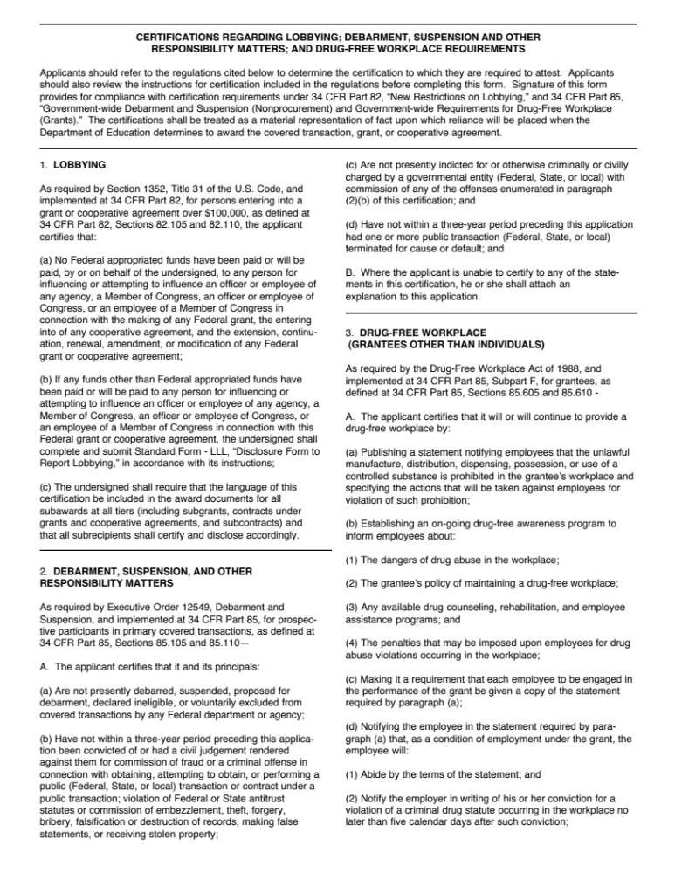

Federal Certifications Certificate (Page 2)

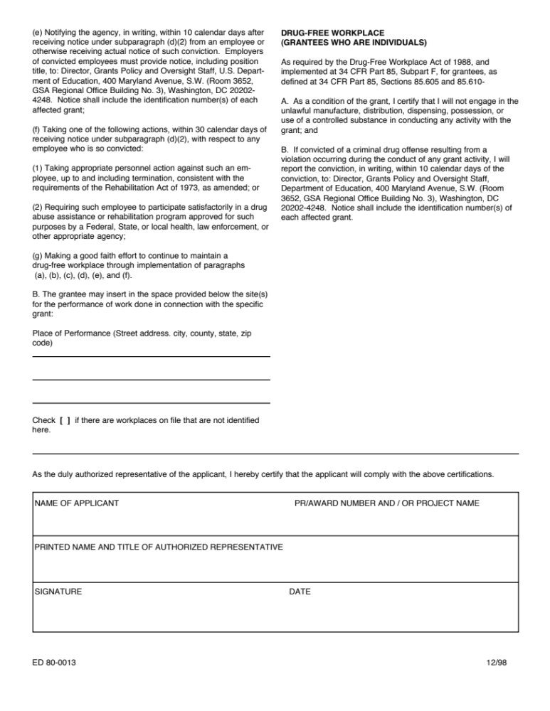

Local Interagency Coordinating Council (LICC)

Review Statement

_______________________________________________________

Jurisdiction

The Local Interagency Coordinating Council (LICC) in the above named jurisdiction
has reviewed the Consolidated Local Implementation Grant (CLIG)
application for SFY 2014.

_______________________________________________________

Signature, LICC Chairperson

_______________________________________________________

Date

GENERAL EDUCATION PROVISIONS ACT (GEPA), Section 427

Section 427 of the U.S. Department of Education’s General Education Provision Act (GEPA) is a provision applicable to all applicants for new grant awards under Department programs. This provision was enacted as part of the improving America’s Schools Act of 1994 (Public Law 103-382). Section 427 requires each applicant for funds to include in its application a description of the steps the applicant proposes to take to ensure equitable access to, and participation in, its Federally-assisted program for students, teachers, and other program beneficiaries with special needs. This provision allows applicants’ discretion in developing required description. The statute highlights six types of barriers that can impede equitable access or participation: gender, race, national origin, color, disability, or age.

In the box below, please include a description of the steps the Local Infants and Toddlers Program proposes to take to ensure equitable access to, and participation in, its Federally-assisted program for infants, toddlers, and young children with disabilities and their families, early intervention service providers, and other program beneficiaries with special needs.

Section 2 – Annual Plan Requirements

Documentation of Local Lead Agency Designation (Blank forms provided at end of section.)

The local governing authority (meaning the executive authority in each jurisdiction) shall appoint an agency to assume the responsibilities of the local lead agency [Proposed COMAR 13A.13.02.08(A)]. The appointment may take the form of a letter, executive order, proclamation, or other method of notification from the executive authority that designates the local lead agency.

A copy of the documentation authorizing the local lead agency for the grant period is required ONLY if the local lead agency has changed from the previous SFY.

Local Interagency Agreement

The local lead agency shall enter into a formal interagency agreement with service providers participating in the local early intervention system. Local Interagency Agreement shall include:

- Assignment of financial responsibility for early intervention services;
- Procedures for achieving timely resolution of intra-agency and interagency disputes about payments for a given service, or disputes about other matters related to the local early intervention system, including a procedure for notifying the MSDE/MITP when resolution is not possible;
- A mechanism to ensure that no service that a child is entitled to receive under IDEA Part C are delayed or denied because of disputes between agencies regarding financial or other responsibilities;
- A description of Medical Assistance (MA) billing procedures for health related services and service coordination including the role(s) of the partner agencies in the interagency agreement;
- Identification of the local government agency/department that will provide legal representation of the local Infants and Toddlers Program when the program is involved in IDEA dispute resolution procedures;
- Additional components necessary to ensure effective cooperation and coordination among all service providers involved in the early intervention system;
- This agreement, which should not expire before June 30, 2014, requires the signatures
of the local Superintendent of Schools, Health Officer, Director of the Department of Social Services and the director of any other participating local public agency; and
- Any language in the interagency agreement that included infants and toddlers should be expanded to also include preschool children in the Early Intervention System of Services.

Provide a copy of the Local Interagency Agreement with appropriate signatures.

Local Interagency Agreements Private Agency Attachment

As an attachment to the Local Interagency Agreement, complete the Local Interagency Agreement Private Agency Attachment.

List the names of private agency partners who provide early intervention services via contract or in-kind arrangements, e.g. direct billing of Medicaid for the IFSP services. In the attachment include the early intervention services provided by these agencies, e.g. physical, occupational and/or speech therapy, and the funding sources for the services. If contracts with private agencies are added during the grant year, please submit the updated form by mail, fax, or electronically to Ron Boone, Section Chief, Fiscal Management Branch at the MSDE. Do not include the contracts with private agencies in the CLIG packet that is submitted to MSDE.

Signed Assurance of Continuous Service
As an attachment to the Local Interagency Agreement, the local early intervention system assures that it has the capacity to provide continuous services in accordance with an IFSP to eligible infants, toddlers, and preschool children in the Early Intervention System of Services and their families during the grant period. This assurance requires the signature of the Director of the local lead agency.

Local Interagency Coordinating Council

The LICC membership must include: at least three parents of children with special needs; representatives from the local education agency, local health department, and local department of social services; public and private early intervention service providers; a person involved in personnel preparation in the field of early intervention; an elected official; a Head Start representative; and a child care representative. The LICC may wish to consider adding a foster care representative; a Medicaid representative; a mental health representative and a person working with children and families who are experiencing homelessness. Other interested persons may also be invited to participate as the LICC members.

The LICC is required to meet at least four times during the SFY.

Provide a list of the LICC members and the scheduled meeting dates for the grant period.

Directing the Use of Funds: Linking Federal Funds to Program Improvement

The MSDE may choose to direct the usage of federal funds toward a specific monitoring priority if non-compliance is not corrected within one year and/or a jurisdiction fails to submit timely reports to the MSDE. In particular, if a public agency has not implemented the corrective actions in the time and manner specified by the MSDE, the MSDE shall:
- Advise the public agency in writing that the corrective actions shall be implemented within a specified time frame to avoid further enforcement action;
- Provide technical assistance to the public agency to assist in the implementation of the corrective actions;
- Withhold or reduce federal funds pending completion of corrective actions;
- Withhold or reduce State funds for early intervention services pending the completion
of corrective actions.

Complete the form: “Linking Federal Funds to Program Improvement”. (Blank form provided at end of section.) If required to designate funds, a short narrative describing the proposed use of federal funds being allocated for program improvement is also required.

Corrective Action Plans/Local Improvement Plans
Under the IDEA 2004, the U.S. Department of Education, Office of Special Education Programs (OSEP) set monitoring priorities and 14 indicators for State Performance Plans and Annual Performance Reports (SPP/APP). The specific compliance and performance indicators established by OSEP focus on timely service provision, natural environments, child and family outcomes, child find, transition, a system of general supervision, timely dispute resolution, and timely and accurate data submission.

New for SFY 2014: MSDE provides local data profiles electronically twice a year (on April 1 and October 1) to all LITPs. Required actions based on local indicator performance, including ongoing monitoring, development of an Improvement Plan, and/or development of a Corrective Action Plan are included on the October 1 data profile only. LITPs are required to periodically track and monitor all State priorities, whether or not a local Improvement Plan or Corrective Action Plan is currently implemented. Progress on Improvement Plans and Corrective Action Plans will be required for the Semi-Annual Program Report.

Improvement Plans (IPs) and Corrective Action Plans (CAPs) will be assigned only once per year in conjunction with the Final Program Report. No IPs or CAPs will be assigned as part of the April 1, 2014 local profile and no new IPs or CAPs will be due with the submission of the Semi-Annual Program Report.
In SFY 2014, local profiles will continue to include data specific to children receiving services in the Extended IFSP Option. The indicators that include children on Extended IFSPs are timely services (1), natural environments (2), child outcomes (3), family outcomes (4), complaints (10, 11, 12, & 13), and submission of timely and accurate data (14). The MSDE will be considering the applicability of current State targets for this population and revising them as necessary.

There are no Improvement Plans due with the SFY 2014 CLIG application on May 15, 2013. Since SFY 2011, all Improvement Plans have been based on local program data and are due in conjunction with programmatic reporting. Improvement Plans and CAPs will be due with the submission of the Semi-Annual Program Report on May 1 as part of the SFY 2013 CLIG submission requirements. To meet SFY 2014 CLIG submission requirements, Improvements Plan and CAPs will ONLY be due in conjunction with the Final Program Report due November 1, 2014.

Comprehensive System of Personnel Development Plan

The purpose of the Comprehensive System of Personnel Development (CSPD) Plan is to describe how the local early intervention system will provide and coordinate training and technical assistance on an interdisciplinary basis, to the extent appropriate for public and private providers, primary referral sources, Family Support Network/Preschool Partners Coordinators, parents, paraprofessionals and service coordinators to improve outcomes for infants and toddlers with disabilities, including children in the Extended IFSP Option, and their families.

The CSPD Plan developed by a local jurisdiction must include, where appropriate, training on the basic components of the early intervention system; the coordination of transition services from the Infants and Toddlers Program to Preschool Special Education services, or another appropriate early childhood program; and the development, implementation, and incorporation of educational outcomes in the IFSP that promote school readiness, including pre-literacy, language, and numeracy skills. Training activities should include parents together with professionals/paraprofessionals and assist families in enhancing specific areas of a child’s development and support participation as a full partner in the development and implementation of the IFSP.

In addition, the local lead agency has the responsibility for ensuring that personnel employed by State, local, and private agencies that provide early intervention services to eligible children and their families in excess of 15% of their employment hours meet the Personnel Standards, Suitable Qualifications requirement of 120 contact hour credits across 9-competency areas (Reference: MD’s Personnel Standards for Early Intervention Service Providers Resource Document). The local jurisdiction’s Suitable Qualifications update report that is issued bi-annually should be reviewed to determine which staff is still in need of additional contact hour credits. The CSPD Plan must include training activities that support these personnel in obtaining the necessary contact hour credits to be deemed suitably qualified to work with this population and their families. In addition, the name of the LITP contact for the suitable qualifications process should be noted.

New in SFY 2014: The CSPD Plan must include local/regional training(s) and/or technical assistance on the utilization of the Child Outcomes Summary (COS) process for all new and experienced staff responsible for completion of the COS integrated into the IFSP process. Jurisdictions can access technical assistance from the Programmatic Support and Technical Assistance Branch in the Division of Special Education/Early Intervention Services to support local/regional planning and implementation efforts for customized COS professional development. Additionally, the online COS tutorial can be accessed to supplement face-to-face training.

The CSPD Plan must align with conclusions drawn from the review and analysis of the local suitable qualifications report, self-monitoring, local data profiles, improvement plans, corrective action plans, complaints and investigations requiring corrective actions, and other data related to program improvement, and should be based on current information.

Complete the Comprehensive System of Personnel Development Planning Template.

(Blank form provided at end of section.)

The CSPD Plan must include:
- A summary of the specific data on which the plan is based that supports the need for the proposed training activities. Data should include the results of the local training needs assessment of public and private providers, primary referral sources, Family Support Network and Preschool Partners coordinators, parents, paraprofessionals, and service coordinators;
- The specific purpose for which the identified training is being sponsored (i.e., areas of non-compliance and performance, program improvement, required corrective actions, suitable qualifications, etc.);
- A description of each training activity, including anticipated dates, training level, topic, presenters, audience, supportive resources, and planned follow-up to evaluate and support transfer of training to practice; and
- Evaluation levels, instruments, methods or procedures, and the anticipated degree of training impact on the local early intervention system.

Public Awareness Plan

All jurisdictions must have a comprehensive Public Awareness (PA) Plan on file and must report on the Plan’s progress in the Final Program Report. However, if a local program was required to provide an Improvement Plan for Indicator 5 or Indicator 6 during SFY 2012 (July 1, 2011 – June 30, 2012), a local program must revise and submit a PA Plan as part of the CLIG application. (Refer to your local program’s Linking Federal Funds for Program Improvement Chart.)

The PA Plan describes how the local early intervention system will inform the public about the local Infants and Toddlers Program and the child find system, including the Single Point of Entry and referral timelines. The PA Plan should be based on current information and aligned with conclusions drawn from self-assessment, required actions from monitoring by the MITP, and other data related to program improvement. A narrative must accompany the PA Plan that includes the data on which the plan is based and describes how the plan aligns with and supports program improvement efforts.

For the PA Plan, analyze local data for the following indicators:
- Percentage of children birth to age one with IFSPs will be equal or greater than the State target for the infants and toddlers of the same age in the general population;
- Percentage of children birth to age three with IFSPs will be equal or greater than the State target for the infants and toddlers of the same age in the general population; and
- Percentage of children from underserved populations who are identified as eligible is comparable to the overall population of infants and toddlers disaggregated by underserved populations.

Based on the analysis of local data for each indicator, develop a PA Plan that incorporates the following outreach activities:
- Increase awareness and participation of all primary referral sources, including procedures for accessing the single point of entry and information about referral timelines;
- Target hospitals, HMOs, pediatricians, and other physicians and medical practitioners to ensure that they are informed about the local early intervention system and procedures for referral to the single point of entry;
- Increase parent awareness and participation in the local early intervention system including parents of premature infants;
- Coordinate with public awareness activities of other early childhood programs (such as home visiting programs, public/private agency partners, the Supplemental Security Income programs, Head Start, child care, and preschool programs) and provide for communication with local public agencies, private providers, parent and advocacy groups, and other organizations; and
Increase awareness and participation of minority and underserved communities (e.g., low-income, rural, homeless, foster care, wards of the State, children abused and neglected, children affected by substance abuse and drug exposure, and English as a Second Language families) in the local early intervention system. (See Assurances Statement 2.)
Family Support Network/Preschool Partners
The Family Support Network (FSN) provides a mechanism to support families of children who receive early intervention services through local Infants and Toddlers Programs. Support can be offered through a variety of strategies and activities to meet the diverse needs of families. Families of young children with disabilities benefit from family-to-family support; a network of resources to help access information pertinent to their child’s disabilities and family circumstance; and better understanding of the Individualized Family Service Plan (IFSP) process. At least a part of the FSN allocation must be used to support the salaried or contractual employment of a parent of a child with a disability.
Family Support Network activities must be embedded within the CSPD plans, PA plans, and Local Improvement Plans (as appropriate). A Family Support Network narrative is not required.
Examples of efforts for the CSPD Plan include:
- Providing joint training and/or technical assistance activities (informal and formal) with families, early childhood professionals, and community providers (i.e., parent training modules - Social Emotional Foundations for Early Learning (SEFEL)).
- Encouraging “families as educators” by assisting family members to provide training and/or technical assistance to other families and early childhood professionals (i.e., families who have been through the transition process provide insight into what is helpful/not helpful during transition).
Examples of efforts for the PA Plan include:
- Use positive family experiences to reach out to other families, professionals and the community (i.e. families educating physicians).
- Plan and implement public awareness activities collaboratively between Family Support Network (FSN), Preschool Partners (PP) and Partners for Success (PFS) staff.
Examples of efforts to support program improvement efforts include:
- Family Survey: Specific strategies are identified for the FSN Coordinator in coordination with other program staff to improve the response rate and representativeness of responses to the statewide family survey (i.e., reminder phone calls to families, direct assistance with completing the survey).
Preschool Partners supports the transition of children and families from early intervention to preschool, and from preschool to school age programs. Preschool Partners activities serve as the bridge between FSN and PFS efforts by promoting family involvement during the preschool years for children continuing early intervention services and for children receiving preschool special education services under an IEP. Preschool Partners provides ongoing support and training to families of children 3 through 5, focusing on family understanding of the transition process and the importance of family involvement during transition at age 3, between age 3 and age 4, age 4 to kindergarten, and kindergarten to first grade. At least a part of the Preschool Partners allocation must be used to support the salaried or contractual employment of a parent of a child with a disability.

Provide a brief narrative of how Preschool Partners operates in the local jurisdiction, including the collaboration with Partners for Success. The narrative should include how families are linked to Part C and Part B support services and what activities support transition from early intervention to preschool, preschool to kindergarten, and kindergarten to first grade.
NOTE: Section 619 funds allocated through the CLIG do not need to be transferred to the Local School System. The CLIG budget should reflect distribution of funds to the agency responsible for implementing Preschool Partners. Section 619/Preschool Partners funds must support activities whereby families focus on the transition of children into and from local school system preschool special education services, and may not be used to supplement Family Support Network staff time or activities dedicated to supporting families’ and children’s participation in early intervention services.

Attachments for this Section

Designation of Local Lead Agency

Include a copy only if the Local Lead Agency changed from the previous SFY.

LOCAL INTERAGENCY AGREEMENT

Provide a copy of the Local Interagency Agreement with appropriate signatures.

Local INterAgency AGreement Private agency Attachment

_______________________________________________________

Jurisdiction

Contracting  Agency | Private Agency Partners or Contractors | Services Provided by Discipline Including Service Coordination | Funding Mechanism  (e.g. Contract, Direct-Billing of Medicaid, etc.)

Maryland State Department of Education
Division of Special Education/Early Intervention Services
Maryland Infants and Toddlers Program

Consolidated Local Implementation Grant (CLIG) Application
FY 2014

Assurance of Local Capacity Attachment
For

________________________________________________________________________
Jurisdiction

As the Head of the Local Lead Agency for the local Infants and Toddlers Program in this jurisdiction, I assure that the local early intervention system will have the capacity to provide continuous services in accordance with an Individualized Family Service Plan (IFSP) to eligible infants, toddlers, and preschool children participating in the Extended IFSP Option, and their families during the grant period.

Signed:

___________________________________________________________________
Local Lead Agency Head

____________________________________________________________________
Name of Local Lead Agency

____________________________________________________________________
Date

LICC membership directory

Complete this form or include your membership directory.

Jurisdiction: Date:

PARENT MEMBERS
Name:
Address:
City/State/Zip:
Phone: Email:

Name:
Address:
City/State/Zip:
Phone: Email:

Name:
Address:
City/State/Zip:
Phone: Email:

LOCAL EDUCATION AGENCY REPRESENTATIVE
Name/Title:
Agency:
Address:
City/State/Zip:
Phone: Email:

LOCAL HEALTH DEPARTMENT
Name/Title:
Agency:
Address:
City/State/Zip:
Phone: Email:

LOCAL DEPARTMENT OF SOCIAL SERVICES
Name/Title:
Agency:
Address:
City/State/Zip:
Phone: Email:

PUBLIC/PRIVATE SERVICE PROVIDERS
Name/Title:
Agency:
Address:
City/State/Zip:
Phone: Email:

Name/Title:
Agency:
Address:
City/State/Zip:
Phone: Email:

EARLY INTERVENTION PERSONNEL PREPRATION
Name/Title:
Agency:
Address:
City/State/Zip:
Phone: Email:

ELECTED OFFICIAL
Name/Title:
Address:
City/State/Zip:
Phone: Email:

HEAD START
Name/Title:
Agency:
Address:
City/State/Zip:
Phone: Email:

CHILD CARE
Name/Title:
Agency:
Address:
City/State/Zip:
Phone: Email:
HOMELESS POPULATIONS (Optional)
Name/Title:
Agency:
Address:
City/State/Zip:
Phone: Email:
MENTAL HEALTH (Optional)
Name/Title:
Agency:
Address:
City/State/Zip:
Phone: Email:
FOSTER CARE (Optional)
Name/Title:
Agency:
Address:
City/State/Zip:
Phone: Email:
MEDICAID (Optional)
Name/Title:
Agency:
Address:
City/State/Zip:
Phone: Email:

LICC meeting dates

Complete this form or include the notice for each meeting.

Jurisdiction: Date:

List the date and location (if known) for each scheduled meeting. Must include at least four scheduled meetings during the grant fiscal period.

LINKING Federal FUNDS TO PROGRAM IMPROVEMENT

An electronic version of this form is provided with your CLIG

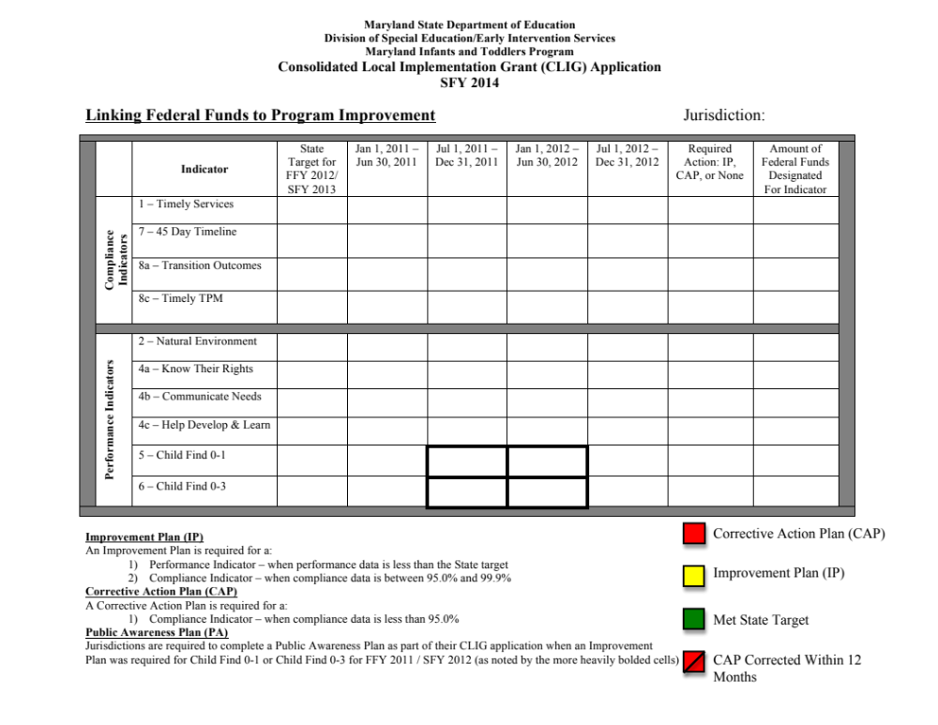

Directions:

This is the third year that MSDE is requiring documentation of federal funding assigned to local non-compliant performance. This documentation will provide data for decision-making regarding future funding application requirements.

- Add data to Column “Jul 1, 2012 – Dec 31, 2012” provided on the Local Date Profiles to jurisdictions on April 1, 2013.

- Complete Column “Required Action: IP, CAP, or None” by adding IP for Improvement Plan, CAP for Corrective Action Plan or None if an IP or CAP is not required. The option inserted in each cell for which there is data is determined by comparing the data percentage in Column “Jul 1, 2012 – Dec 31, 2012” with the State Target in the Column “State Target for FFY 2012/SFY 2013.”

For example, if the 45 Day Timeline percentage is 100%, insert “None” in Column “Required Action: IP, CAP, or None” for this indicator.

If the percentage for Child Find 0-1 is 1.33%, insert “IP” for Improvement Plan in Column “Required Action: IP, CAP, or None” for this indicator.

- In the Column “Amount of Funds Designated For this Indicator,” insert an amount of grant funds that your local early intervention system will utilize in order to correct non-compliance for Compliance Indicators or meet State targets for Performance Indicators. The specific source of funding does not need to be specified.

Designate specific Part C funds to improve programmatic data when:
- Local jurisdiction data shows a history of 2 or more required Corrective Action Plans for a Compliance Indicator over a 2-year period; and/or
- Local jurisdiction data results in the assignment of a Corrective Action Plan for the most recent data period “Jul 1, 2012 – Dec 31, 2012”; and/or
- Local jurisdiction data shows a history of not meeting the State target for a Performance Indicator, as determined by the requirement of an Improvement Plan in 2 or more data periods over a 2-year period.

- A jurisdiction is required to complete a Public Awareness Plan for the SFY 2014 CLIG when an Improvement Plan is required for Child Find 0-1 or Child Find 0-3 for FFY 2011/SFY 2012 (as noted by the more heavily bolded cells).

- If required to designate funds, a short narrative describing the proposed use of federal funds being allocated for program improvement is also required.

It is not necessary for the content of the Column “Required Action: IP, CAP, or None” to be color-coded when submitting this attachment to MSDE.

Jurisdictions will still be required to complete Corrective Action Plans or Improvement Plans as assigned in October 1st Local Profile.

Comprehensive system of personnel development (CSPD) Plan

Use the CSPD Plan Template
or complete this form or insert your own CSPD Plan template.

Summary of data and other relevant findings supporting proposed CSPD Plan

Purpose of PD:
Training Topic/Presenters:
Training Level(s):
Audience:
Supporting Resources:
Date(s):
Evaluation Level(s) & Instrument(s):
Projected Program Impact/Results:
Planned Follow-Up to Support Implementation:

Purpose of PD:
Training Topic/Presenters:
Training Level(s):
Audience:
Supporting Resources:
Date(s):
Evaluation Level(s) & Instrument(s):
Projected Program Impact/Results:
Planned Follow-Up to Support Implementation:

Purpose of PD:
Training Topic/Presenters:
Training Level(s):
Audience:
Supporting Resources:
Date(s):
Evaluation Level(s) & Instrument(s):
Projected Program Impact/Results:
Planned Follow-Up to Support Implementation:

Purpose of PD:
Training Topic/Presenters:
Training Level(s):
Audience:
Supporting Resources:
Date(s):
Evaluation Level(s) & Instrument(s):
Projected Program Impact/Results:
Planned Follow-Up to Support Implementation:

Maryland State Department of Education

Division of Special Education/Early Intervention Services
Maryland Infants and Toddlers Program

Comprehensive System of Personnel Development (CSPD)
Planning Template
SFY 2014

Summary of data and other relevant findings supporting proposed CSPD Plan

Purpose of PD | Training Topic  & Presenter(s) | Training Level(s) | Audience | Supporting  Resource(s) | Date(s) | Evaluation Level(s) & Instrument(s) | Projected Program Impact/Results | Planned Follow-up to Support Implementation

Professional Development
Effective professional development programs should be designed to facilitate learning and be delivered in more than one event over an extended period of time. Selected delivery models should include the presentation of new material, demonstration, practice, feedback, and follow-up for evaluation and accountability. Delivery should involve a variety of instructional modes and activities (individual and group learning, lecture, discussion, video and/or role-play, etc.) As part of the design participants should learn collegially, in cooperative situations, with and from each other.

Purpose
The purpose of professional development (PD) provides the context and framework for structuring the training/technical support event. Indicate whether the proposed activity will address areas of non-compliance and performance (be specific), identified areas for program improvement (i.e., program enhancements), and/or provide the basis for staff meeting Suitable Qualifications requirements.

Training Level(s)
Awareness Level- Indicate this level if the goal is to raise interest or concern about a new topic or recent development. At this level some information is absorbed, some ideas are stored for later use, and others spark interest in immediate action.

Knowledge to Skill Level- Indicate this level if the goal is to extend learning, training, build skills, and/or conceptual understanding.

Transfer Level- Indicate this level if the purpose is to provide support and/or assistance in the actual transfer of new knowledge/skills to practice. Examples of this level include: observation, coaching, mentoring, and technical assistance. Follow-up should include some type of accountability to assure that implementation actually takes place and transfer is maintained.

Topic(s)/Presenter(s)
Indicate the title or area(s) that the training/technical support activity will address (e.g., evaluation and assessment strategies, transition planning). The type of training/technical support activity should be indicated (e.g., presentation, workshop, extended training). Include the names and titles of the presenter(s) (if known).

Audience
Indicate the target audience (e.g., families, public and private providers, primary referral sources, paraprofessionals, family support/preschool partners and service coordinators).

Supportive Resources
List any material (i.e., curriculums, developmental assessment tools. brochures, etc.) or human resources (i.e., consultants) that will be used to support the training activity.

Evaluation Level(s) and Instrument(s)
Reaction-Indicate this level if participants will assess the training/technical support activity and give their level of satisfaction with the training, typically at the end of the training activity (e.g., rating scale about the workshop/course content, context, processes, & presenter, etc.).

Learning-Indicate this level if participants will demonstrate knowledge or skills they have acquired (e.g., observation, pre/post knowledge/skill tests, follow-up projects, portfolios, learning logs, presenting information to others, etc.).

Results-Indicate this level if the impact of training/technical support on the early intervention/ special education systems will be assessed through multiple data sources (e.g., children’s performance data, family surveys, questionnaires, interviews, record reviews, monitoring activities [state or local], observation, etc.).

Program Impact/Results
Indicate in which area(s) and to what degree positive changes to the early intervention system are anticipated as a result of the training/technical support activity. (e.g., ___ % or number(s) of assessments are completed within the 45 day timeline, ___% or numbers of children exiting Part C had a transition meeting within six months and no later than 90 days prior to their third birthday).

Follow-up to Support Implementation
Changing practice is a slow process, which requires continued and sustained effort. Supportive feedback is essential for successful implementation of the desired change. To enhance professional development application, regular opportunities to problem solve and share perspectives with colleagues are a critical part of the professional development process. For new practices and techniques to be generalized, guidance and support need to be provided for incorporation/ application into daily practice.

Observation/Reflection-provides the opportunity to see a new practice implemented in the intended setting and a chance for reflection regarding its effectiveness

Coaching-encourages individuals to incorporate new strategies into their personal repertoire of professional skills by providing expert or peer feedback/support during implementation and gaining new insights from another point of view

Mentoring-provides the opportunity for pairing an experienced service provider with a less experienced one in order to share practices, experiences, and observations and reflections regarding performance

Community of Learners-parents, family support professionals, service providers, and administrators learn together to improve outcomes for children and youth with disabilities

PUBLIC AWARENESS PLAN

Required ONLY if the local jurisdiction was required to submit
an Improvement Plan for Indicator 5 or Indicator 6 during SFY 2012.

Jurisdiction:

Approved:

Requirements | Supported by Data  Yes/No | Comments | Approved  Yes/ No
Indicator #5 - The percentage of children birth to one identified as eligible is equal to or greater than 1.50% of the general population birth to one.
- Increase awareness and participation of all primary referral sources
- Target hospitals, pediatricians, and other physicians and medical practitioners
- Increase parent awareness and participation in the local EIS.
- Coordinate with public awareness activities of other EC programs
- Increase awareness and participation of minority and underserved communities in the EIS.
Indicator #6 - The percentage of children birth to 3 identified as eligible is equal to or greater than 2.88% of the general population birth to 3.
- Increase awareness and participation of all primary referral sources.
- Target hospitals, pediatricians, and other physicians and medical practitioners.
- Increase parent awareness and participation in the local EIS.
- Coordinate with public awareness activities of other EC programs
- Increase awareness and participation of minority and underserved communities in the EIS.
The percentage of children from underserved populations who are identified as eligible is comparable to the overall population of infants and toddlers disaggregated by underserved population.
- Increase awareness and participation of all primary referral sources.
- Target hospitals, pediatricians, and other physicians and medical practitioners
- Increase parent awareness and participation in the local EIS.
- Coordinate with public awareness activities of other EC programs
- Increase awareness and participation of minority and underserved communities in the EIS.

PRESCHOOL PARTNERS NARRATIVE

This blank form may be used for your local Preschool Partners narrative.

Section 3 – Budget

Funding for Local Infants and Toddlers Programs

Guidelines for Budgeting and Planning

SFY 2014 federal and State funding available to the Maryland Infants and Toddlers Program will be distributed to local lead agencies through the Consolidated Local Implementation Grant (CLIG) with a grant period of July 1, 2013 - September 30, 2014 for federal funds and a grant period of July 1, 2013 – June 30, 2014 for State general funds.

√ MSDE is required to transfer funds from each jurisdiction’s State allocation to the Department of Health and Mental Hygiene as the State match portion under the Intergovernmental Transfer mechanism for Medicaid billing for health-related services. Local lead agencies should continue to budget the full State allocation in SFY 2014 because the transferred State funds will be included in Medicaid reimbursements for health-related services and service coordination.

√ Federal and State funds may not be used to decrease local funding support for local Infants and Toddlers Programs. CLIG Budgets will be approved if:

- Local jurisdictions maintain local effort in support of early intervention under Part C of IDEA by budgeting at least the same amount of local government funds in
SFY 2014 as was expended in SFY 2012. The LEA/PA Prohibition Against Supplanting Calculation Template will assist an LEA/PA to demonstrate compliance with this requirement in order to be eligible to receive IDEA federal funding for this fiscal year’s application.
- Federal and State funds budgeted must not supplant local funds utilized to support all positions and does not result in a decrease in local funding and staffing support for direct services.
- All outstanding financial and program reports from the previous SFY are submitted, including Form 500 which documents local expenditures for the previous grant year.

√ Funds in the SFY 2014 CLIG must be budgeted to improve outcomes for infants, toddlers, and preschool children in the Early Intervention System of Services and their families. Additionally, priorities previously identified by the MSDE through monitoring may need to be reflected in the budget of the LITP. Allowable expenditures include salaries and fringe benefits for direct service positions, purchase of early intervention services through contracts or other locally approved procurement mechanism, purchase of administrative or early intervention supplies and/or equipment used to support the provision of or to provide direct services to eligible children and their families, and staff/parent training.

√ Indirect costs are allowable for State funds to the extent of the Restricted Indirect Cost Rate approved for federal programs, not to exceed a maximum of 2%. State funds may not be used for administrative positions, computer technology for administrative purposes, furniture, or capital improvements.

√ State Funds included in the CLIG cannot be extended beyond the approved grant period. State funds that have not been expended by the end of the grant period will revert to the State treasury.

√ Part C, Part B 611, and Part B 619 can be carried over to June 30, 2015 using the grant extension process.

√ MITP Form 100D must appropriately assign direct services and administrative costs only for Part C funds. The MSDE views service coordination and the time spent taking a referral as a direct service.

√ For equipment (Object 5 on the C-1-25 Grant Budget form): Equipment includes tangible personal property having a useful life of more than one year and/or an acquisition cost equal to the lesser of the per unit minimum dollar amount established by the grantee for financial statement purposes, or $5,000 ($500 if a sensitive item). Sensitive items are capital or non-capital items that are prone to theft such as recording devices, portable tools, cameras and other small items that may be concealed in a handbag or briefcase, or larger items such as typewriters, projectors, printers and the like, for which there is a history of theft or loss.

- Descriptions should be specific and represent individual terms (i.e., IBM PS/2 Model 50Z computer system: package includes color VGA monitor, dual 3.5 disk drives and mouse, etc.).
- Equipment associated with the contracted services should be included in this section.
- Federal funds may not be used to purchase furniture (i.e., filing cabinets, storage cabinets, tables, etc.), unless specially designed to implement the goals and objectives of a child’s IFSP or for parent training activities.
- Reflect the unit cost, the number of units to be purchased, if applicable, and the total cost. These costs should be reflected under the appropriate Object and Category/Program on the Grant Budget form (C-1-25).

Budget Documents To Be Completed
- Proposed Budget Form C-1-25
- Part C, Part B/619 and State Consolidated Program Budget
- Part C, Part B/619 and State Agency Budget – Education
- Part C, Part B/619 and State Agency Budget – Health
- Part C, Part B/619 and State Agency Budget – DSS
- Schedule of Salary and Fringe Cost, MITP Form 100B
- Budget Narrative, MITP Form 100C
- MITP Form 100D, Part C Supplemental Budget Form for Direct Services/Administrative Costs
- LEA/PA Maintenance of Effort Calculation Template
- Request Budget Amendment C-1-25 A, applicable
- Grant Change Request Form C-1-25-B, if applicable
- Finance Report-Local Lead Agency Summary Sheet, MITP Form 400 (for non LEA)
- Finance Report-Local Agency Actual Expenditures, MTIT Form 400A (for non LEA)
- Finance Report-Local School Systems Actual Expenditures, Annual Finance Report (AFR) to MSDE Division of Business Services, Local Reporting Office
- MITP Form 500: Expenditures for Early Intervention Services Instructions
- MITP Form 500: Funding Sources
- Cumulative Variance Report and Semi-Annual Program Report

http://www.marylandpublicschools.org/MSDE/divisions/earlyinterv/fmb

Section 4 – Assurances

The Consolidated Local Implementation Grant Application accounts for Part C, Part B, State, and Medical Assistance funds for the jurisdiction, and identifies the budgetary and staff commitment of each agency participating in the local early intervention system.

ASsurance statements for the

consolidated local implementation grant

By receiving funds under this grant award, the signatory agencies, as grantees, agree to comply with the following terms and conditions:

- Program and projects funded in total or in part through this grant will operate in compliance with State and federal laws and regulations, including but not limited to the 1964 Civil Rights Act and amendments, the Code of Federal Regulations (CFR) 34, the No Child Left Behind Act, Education Department General Administrative Regulations (EDGAR), the General Education Provisions Act (GEPA), and the Americans with Disabilities Act.

- The lead agency has in effect policies and procedures that insure appropriate early intervention services based on scientifically based research, to the extent practicable, and effective outreach strategies are available to all infants, toddlers and preschool children with disabilities and their families, including Indian infants, toddlers and preschool children with disabilities and their families residing on a reservation geographically located in the jurisdiction, and infants, toddlers and preschool children with disabilities in the State who are homeless children, or wards of the State and their families in accordance with 34 CFR §303.302(b)(i-ii).
- The lead agency has procedural safeguards with respect to programs under this part, as required by 34 CFR Subpart E-Procedural Safeguards.
- The Maryland State Department of Education (MSDE) may, as it deems necessary, supervise, evaluate, and provide guidance and direction to the grantees in the conduct of activities performed under this grant. However, failure of the MSDE to supervise, evaluate, or provide guidance and direction shall not relieve grantees of any liability for failure to comply with the terms of the grant award.

- The signatory agencies, in collaboration with the MSDE, assure that there is a comprehensive system of personnel development, including the training of paraprofessionals and the training of primary referral sources with respect to the basic components of early intervention services available in the State that
  - Must include –
    - Implementing innovative strategies and activities for the recruitment and retention of early education service providers;
    - Promoting the preparation of early education providers who are fully and appropriately qualified to provide early intervention services under this part; and
    - Training personnel to coordinate transition services for infants, toddlers and preschool children with disabilities who are transitioning from an early intervention service program under Part C of the Act to a preschool program under section 619 of the Act, Head Start, Early Head Start, and elementary school program under Part B of the Act, or another appropriate program receiving funds under 20 U.S.C. 1419, or another appropriate program.
b) May include –
- Training personnel to work in rural and inner-city areas;
- Training personnel in the emotional and social development of your children; and
- Training personnel to support families in participating fully in the development and implementation of the child’s IFSP consistent with 34 CFR §303.118(a)(b).

- The Consolidated Local Implementation Grant Application is the basis for the Local Interagency Plan for Early Intervention Services in the jurisdiction and the Plan is in effect as described.

- All signatory agencies represented by this application will participate in the system of early intervention services, including the use of the Individualized Family Service Plan and Process, the Maryland Infants and Toddlers Program Tracking/Data Collection System, and other components as required by 34 CFR Part 303 and Proposed COMAR 13A.13.01 and 13A.13.02.

- Federal funds received through this application will not be used to supplant or to decrease the level of State and local funds expended for infants and toddlers with disabilities and their families and in no case to supplant those State and local funds, in accordance with 34 CFR §303.225(2). To meet the requirement in §303.225(2), the total amount of State and local funds budgeted for expenditures in the current fiscal year for early intervention services for children eligible under this part and their families must be at least equal to the total amount of State and local funds actually expended for early intervention services for these children.

- Federal funds may be used for activities or expenses that are reasonable and necessary for implementing the jurisdiction’s early intervention program for infants, toddlers and preschool children with disabilities including funds-
- For direct early intervention services; and
- To expand and improve services for infants, toddlers and preschool children with disabilities and their families (34CFR §303.501(a)(b)).

- The jurisdiction will not use federal grant funds to satisfy a financial commitment for services that would have been paid for from another public or private source (34 CFR §303.510(a)). However, if necessary to prevent a delay in the timely provision of appropriate early intervention services to the child or family, federal funds may be used to pay the provider of services, pending reimbursement from the agency that has ultimate responsibility for the payment (34 CFR §303.511(b)).

- The signatory agencies assure that reimbursements from Medical Assistance for service coordination, health-related services, and transportation will be used to support the local early intervention system for infants, toddlers and preschool children receiving services through an IFSP.

- The data which is submitted by the local lead agency represents all eligible infants and toddlers receiving early intervention services in accordance with an IFSP. Early intervention records shall be maintained for each child and shall be available for review by the Maryland Infants and Toddlers Program/Maryland State Department of Education for monitoring purposes.

- Parents of children served under Part C are provided an opportunity to participate in the development of this application.

- Grantees shall establish and maintain fiscal control and fund accounting procedures to ensure proper disbursement of, and accounting for federal funds (34 CFR §303.226).

- Grantees shall adhere to the MSDE reporting requirements and timelines, including the submission of semiannual and final programmatic and financial reports.

- Entities receiving $500,000 or more of federal funds need to have an annual financial and compliance audit in accordance with the OMB Circular A-133.

- Grantees shall retain all records of financial transactions and accounts relating to this grant for a period of five years, or longer if required by federal regulation, after termination of the grant agreement. Such records shall be made available for inspection and audit by authorized representatives of the MSDE.

- Grantees must receive prior written approval from the MSDE Program Monitor before implementing any programmatic changes with respect to the purposes for which the grant was awarded.

- Grantees must receive prior written approval from the MSDE Program Monitor for any budgetary realignment of $1000 or 15% of total object, program, or category of expenditure, whichever is greater. Grantees must support the request with reasons for change. Budget alignments must be submitted at least 45 days prior to the end of the grant period.

- Requests for grant extensions, when allowed, must be submitted at least 45 days prior to the end of the grant period.

- Grantees shall repay any funds which have been determined through a federal or state audit resolution process to have been misspent, misapplied, or otherwise not properly accounted for, and further agree to pay any collection fees that may subsequently be imposed by the federal and/or State government.

- If the grantees fail to fulfill obligations under the grant agreement properly and on time, or otherwise violate any provision of the grant, the MSDE may suspend or terminate the grant by written notice to the grantees. The notice shall specify those acts or omissions relied upon as cause for suspension or termination. Grantees shall repay the MSDE for any funds that have been determined through audit to have been misspent, unspent, misapplied, or otherwise not properly accounted for. The repayment may be made by an offset to funds that are otherwise due grantees.

- The local lead agency assures that the Local Interagency Coordinating Council will conduct meetings at least quarterly. The meeting must:

  - Be publicly announced sufficiently in advance of the dates they are to be held to ensure that all interested parties have an opportunity to attend; and
  - To the extent appropriate, be open and accessible to the general public and that interpreters for persons who are deaf and other necessary services must be provided at Council meetings, both for Council members and participants.

The Maryland Infants and Toddlers Program may choose to direct the usage of funds toward a specific monitoring priority if adequate progress is not made and/or a jurisdiction fails to submit timely reports to the MSDE. In particular, if a public agency has not implemented the corrective actions in the time and manner specified by the Department, the Department shall:

- Advise the public agency in writing the corrective actions shall be implemented within a specified time frame to avoid further enforcement action; and
- Provide additional technical assistance to the public agency to assist in the implementation of the corrective actions.

If, after the implementation of COMAR 13A.05.02.07D of this regulation, a public agency has not implemented the corrective actions or made good faith efforts to correct substantial violations, the Department may initiate sanctions, including, but not limited to the following:

- Redirect or target the use of funds allocated under IDEA funds;

- Reduce or eliminate the use of funds allocated under IDEA funds;
- Withhold or reduce IDEA funds pending completion of corrective action;
- Withhold or reduce State funds for early intervention and education services pending the completion of corrective actions;
- Assign Department staff on-site to assist in the completion of corrective actions; and
- Assign a monitor to oversee the public agency’s early intervention programs, with the responsibility for costs of monitoring to be determined by the Department.

* The law is also applicable to Part C. In particular 20 USC §1442 under Part C of the IDEA, reauthorized in 2004, states that §§1416 – 1418 under Part B now apply to Part C.

The Consolidated Local Implementation Grant Application accounts for Part C, Part B 611, Part B 619, State, and Medical Assistance funds for the jurisdiction, and identifies the budgetary and staff commitment of each agency participating in the local early intervention system. We, the undersigned, have reviewed and approved the Consolidated Local Implementation Grant Application.

Jurisdiction __________________________________________________________

Local Lead Agency ____________________________________________________

_______________________________________________ ________________
Superintendent of Schools Date

_______________________________________________ ________________
Health Officer Date

_______________________________________________ ________________
Director, Department of Social Services Date

_______________________________________________ ________________
Program Director, Local Infants and Toddlers Program Date

Section 5– Reporting Requirements

Submission of program, financial, data, and LICC reports is required as a condition of the Consolidated Local Implementation Grant Award. The format for each report type is described below. Timelines are provided in a chart, which follows.

Cumulative Variance Report and Semi-Annual Program Report (Federal Audit Requirement)
Due: January 31, 2014

Revised in SFY 2014- For semi-annual reporting, fiscal and programmatic reporting requirements have been combined using the “Cumulative Variance Report and Semi-Annual Program Report.” Local lead agencies must complete Section I, Section II, and Section III by January 31, 2014. This report should include:
- Section I – The traditional CLIG funding sources, i.e. Part C, Part B 611, Part B 619 and State general funds; and
- Section II - Discretionary Extended IFSP funding.
These reports are to be completed and signed by the Finance Officer and Lead Agency Director. The purpose of these reports is to:
(a) report the budget amount that has been expended to date; and
(b) verify that spending is consistent with budget projections.

The reporting form should be used for the total budgeted and expended amounts for each expense category for the traditional CLIG funding and the discretionary Extended IFSP funding. For example, if the traditional consolidated grant budget funds an Object, e.g. Salaries, and is supported by four (4) funding sources, complete only one form that combines the dollar amount for the Salary Object from the four (4) funding sources (Section I – Cumulative Variance Report). If discretionary Extended IFSP funding supports the salary of a staff person providing early intervention services to three- and four-year-old children, the funding amount for the staff person should be included in the Salary Object for the discretionary Extended IFSP (Section II – Cumulative Variance Report).

New for SFY 2014: Improvement Plans (IPs) and Corrective Action Plans (CAPs) will be assigned only once per year in conjunction with the Final Program Report. No IPs or CAPs will be assigned as part of the April 1, 2014 local profile and no new IPs or CAPs will be due with the submission of the Semi-Annual Program Report.

Using the new “Cumulative Variance Report and Semi-Annual Program Report” form, local lead agencies must complete Section III by January 31, 2014. This report should include:
        - For the time period of July 1 to December 31, data analysis that includes:
- The number of children evaluated;
- The number of children determined to be infants and toddlers with developmental delays and/or disabilities; and
- The number of children receiving IFSP services after age 3.

        - A description of the progress on the Improvement Plans for each performance indicator assigned in the previous local profile.

        - A description of the progress on the correction of noncompliance for each incidence of noncompliance identified in the previous local profile.

        - A description of any challenges that impeded progress in the delivery of services to infant and toddlers with developmental delays and disabilities.

        - A description of the challenges that impeded the delivery of services to preschool age children receiving services on an Extended IFSP.

        - A description of technical assistance requests associated with reported challenges.

For Fiscal Assistance, contact:
Claudette Harvey
Grants Coordinator
410-767-0946
charvey@msde.state.md.us

For data analysis assistance, contact:
Brian Morrison Dan Szczepaniak
Lead Monitoring Specialist Data Specialist
410-767-0863 410-767-0641
bmorrison@msde.state.md.us dszczepa@msde.state.md.us

SFY 2014-SEMI-ANNUAL CUMLATIVE VARIANCE/PROGRAM REPORT- Link to Website

Submit electronically via the MSDE Secure Server at https://sst.msde.state.md.us

FINAL/ANNUAL Program Narrative

Due: November 1, 2014 (for grant ending 9/30/2014 or 6/30/2015)

Local lead agencies must submit a Final/Annual Program Report of the activities of the Local Infants and Toddlers Program for the grant period, which includes the following:
A. Improvement Plans, including:
- Data analysis for July 1, 2013 through June 30, 2014 for monitoring priorities and indicators for which improvement plans are required including numbers and percentages.
- Strategies and activities to be implemented.
- Explanation of progress or slippage.

B. Corrective Action Plan Templates, including:
a) Strategies and activities to be implemented.
b) Steps to ensure noncompliance does not reoccur.

C. A summary of how the PA Plan or PA activities, if a PA plan was or was not required as part of the CLIG submission for this grant period, were implemented to support effective outreach to all population groups, geographic areas and potential referral sources in the local jurisdiction. The Public Awareness Plan activities implemented as part of the Local Improvement Plans may be incorporated into the relevant sections of these plans. An analysis of data that demonstrates the effect of public awareness efforts on the local early intervention system must be included.
D. A summary of how the CSPD Plan was implemented during the grant period to support Improvement Plan activities. The CSPD Plan activities implemented as part of the Improvement Plans/Corrective Action Plans may be incorporated into the relevant sections of these plans. An analysis of data that demonstrates the effect of training efforts on the local early intervention system must be incorporated. For each training activity conducted, identify the topic, date, and number of participants from each category (parents, service providers, service coordinators, primary referral sources, and paraprofessionals). The CSPD Plan may be updated to include the required reporting information and submitted in lieu of developing a separate reporting format.
E. A summary of how Family Support Network/Preschool Partners activities were implemented during the grant period to support Corrective Action/Improvement Plan activities. Jurisdictions should use local Family Support Services (FSS) data collection requirement (FSS semi-annual data collection form) as the foundation for this summary. Include an analysis of data that demonstrates the effect of efforts on the local early intervention system. If your jurisdiction has been awarded Part B Section 619 funds, a detailed description of how Preschool Partners supported the transition of children and families from early intervention to preschool and from preschool to school age programs must be incorporated.
F. A summary of the implementation of the Extended IFSP Option including:
- Provision of services/supports to preschool children and their families describing innovative service delivery models and age appropriate service delivery environments (school/community);
- Expansion of local infrastructure to support services to preschool children and their families; and
- Facilitation of a seamless transition to preschool special education and/or community programs.
G. An analysis of local data that demonstrates the provision of continuous service compared to the frequency on the IFSP for a sample of at least 5% of the children served or 25 children, whichever is smaller (Note: smaller jurisdictions should report on at least 5 children).
For data analysis assistance, contact:
Brian Morrison Dan Szczepaniak
Lead Monitoring Specialist Data Specialist
410-767-0863 410-767-0641
bmorrison@msde.state.md.us dszczepa@msde.state.md.us

Submit electronically via the MSDE Secure Server at https://sst.msde.state.md.us

Annual LICC Report (Federal Audit Requirement)

Due: November 1, 2014
To facilitate compliance with federal requirements, the State Interagency Coordinating Council requests that each LICC submit an annual report of its activities during the grant period. Information from the LICC Annual Reports is included in the Annual Report of the State Interagency Coordinating Council to the U.S. Department of Education and the Governor. The LICC Annual Report must include the following components:
      - A summary of how the LICC has advised and assisted the local lead agency to develop and implement the local early intervention system during the grant period;
      - Successful LICC efforts that may be helpful to other LICCs;
      - Issues to be considered by the State Interagency Coordinating Council; and
      - The dates that the meetings were held, at a minimum, on a quarterly basis.
Copies of the LICC meeting minutes are not required and will not meet the requirements for the LICC Annual Report.

Submit electronically via the MSDE Secure Server at https://sst.msde.state.md.us
Data Collection
Due: December 14, 2013

Federal Part C Reporting
The data collection date for federal reporting is the last Friday of October in each year. By December 12, local lead agencies are expected to have entered all data generated up to and including the last Friday in October, run audit reports, and fill in missing data. Shortly after that date, MSDE will extract data from the data system to complete federal reports. Part of the federal reporting requirement mandates the submission of timely and accurate data. As a result, it is extremely important that the LITPs enter all available program data by the December 12 deadline. Note that the submission of timely and accurate data is one factor that impacts the annual determination of each Local Infants and Toddlers Program.

Early Intervention Personnel Count
An annual interagency count of early intervention personnel employed in full-time equivalents is due annually. Forms and instructions will be distributed to local lead agencies prior to the submission date.

Submit electronically to the Data Specialist at: dszczepa@msde.state.md.us.

Final Finance Report (Federal Audit Requirement)
Due: June 30, 2014-State General funds
Due: November 30, 2014-Federal Funds (for grant ending September 30, 2014)
Due: June 30, 2015-Federal Funds (only for grants extended to June 30, 2015)
Instructions for the submission of financial reports required during the grant period are included in the MSDE Financial Reporting Manual.

Form C-1-25 A-Budget Amendment/Grant Extension:
- A budget amendment is required if the spending plan increased by $1,000 or 15% of the total expenditures by category, program or object, whichever is greater.
- A budget amendment only reallocates the total agency budget among budget line items. It does not increase the total grant award.

Form C-1-25B- Grant Extension:
- A request to extend the grant period may be submitted for up to one additional year (12 months to June 30 of the following year) from the date of the original grant period.

Financial Form 400, 400A & Annual Finance Report (AFR):
  - All recipients of the MITP grant funds are required to submit year-end finance reports. The local lead agencies, other than Local School Systems, must submit a MITP Form 400, a consolidated report for the CLIG, and a separate MITP Form 400A from each agency receiving funds through the CLIG, signed by the financial representative from each of the agencies who signed the local interagency agreement and received federal and/or State funds.
  - Local school systems must submit the Grant Annual Finance Report (AFR) to the MSDE, Division of Business Services, and Local Financial Reporting Office.
  - The MSDE will compare actual expenditures reported on the MITP Form 400A with the approved agency budget and will request a written justification if there are variances greater than allowed by the budget amendment procedures.

Expenditures for Early Intervention Services Form 500:
- The MSDE is requested to provide statewide information on funds expended for early intervention services in Maryland to the U.S Department of Education, Office of Special Education Programs, legislators, and other stakeholders.
- The local lead agency is required to report information on expenditures for early intervention services on or before November 30 of each fiscal year. (See instruction on completing the MITP form 500 in the budget section of the CLIG.)
- The information collected for this report is also used to document compliance with the federal Maintenance of Effort Requirement and the level of expenditures from local sources for legislative reports.

Claudette Harvey
Grants Specialist
410-767-0946
charvey@msde.state.md.us

Required Reporting Budget forms on the Website

Submit electronically via the MSDE Secure Server at https://sst.msde.state.md.us

SFY 2014-MITP REPORTS CHECKLIST
For Consolidated Local Implementation Grants
CALENDAR OF SUBMISSION DATES
 | Reports/Items Due | Due Date:
 | Consolidated Local Implementation Grant (CLIG) | 5/15/2013
Program Narrative/Finance Reports
 | Budget Amendments & Grant Extensions (for SFY 2013 CLIG Unexpended federal funds)  (No later than 45 days from the end of the grant award period) | 8/15/2013
 | New-Cumulative Variance Report  (Only for SFY 2013 grants extended to June 30, 2014) | 1/31/2014
 | Revised-SFY2014-Cumulative Variance Report/Semi-Annual Program Report | 1/31/2014
 | Budget Amendments & Grant Extensions (for SFY 2014 CLIG Unexpended federal funds)  (No later than 45 days from the end of the grant award period) | 8/15/2014
 | Final Finance Report  (Grants Extended to June 30, 2014)  (Reporting period –July 1, 2012-June 30, 2014) | 9/30/2014
 | FINAL Program Report  (Reporting period –July 1, 2013-September 30, 2014)  OR  ANNUAL Program Report (for grants extended to June 30, 2015)  (Reporting period –July 1, 2013-September 30, 2014) | 11/01/2014
 | Annual LICC Report | 11/01/2014
 | FINAL Finance Report  (Reporting period –July 1, 2013-September 30, 2014) | 11/30/2014
 | Form 500–Expenditures for Early Intervention Services | 11/30/2014
 | Final Finance Report  (Only for Grants Extended to June 30, 2015)  (Reporting period - July 1, 2013-June 30, 2015) | 9/30/2015
Data Collection
 | Early Intervention Personnel Count  (as of the last Friday in October) | 12/14/2013
 | Federal Part C Reporting  (as of last Friday in October) | 12/14/2013

